MEETINGS RECORD - Committee | Wombourne Kayak Club

Copies to anyone involved by the minutes. | DATE: 4th April 2021
ATTENDANCE:
Present: |  |  | Apologies:
John Teuwen | Paul Elkington
Tim Kelly
Rich Dowen
Mick O’Brien

AGM Agenda Items:

Review |  | - BC Strategy 2017-2021 Review – Meeting 23rd March 2020.
- Appointment of Committee  - Website Officer?  - Contingency Planning - Committee |  | - Review Coaching & Training requirements; Phil Hadley, Ian Dallaway  - White water Award: assessment modules
- Finance  - Pool & Jackfields (Payments)  - Membership update |  | 9. Future Planning of activities at Jackfields
- Review: Kit Inventory, Aztec Adventure Suppliers Kit Offer: |  | 10. Scotland Update
- Review of website documents:  - Small working party |  | 11.Go Paddling 17th-24th July
- Update Ironbridge |  | 12. AOB
- “Clean-Up” Ironbridge – Easter, Autumn, Magnificent 7, River Gam |  | 13.
SUMMARISED MINUTES AND ACTION POINTS |  |  | Action by | For when
Review:  Committee  Chair – Tim Kelly  Deputy – Rich Dowen  Treasurer – Mick O’Brien – resigned, Paul Elkington to replace.  Secretary – John Teuwen  Equipment – Paul Elkington  Health & Safety - Tim Kelly, John Teuwen  Welfare – John Teuwen  Website Officer –  - Finance:  Mick provided current Annual Statement.  - Review: Club Kit:  Kit Inventory; Pool storage kit inventory check, also to see whether a lock is there or needs replacing.  PDF & helmets standards to be researched.  Additional kit; Purchase two sets of PFD’s & helmets to be used for offering Introduction of Whitewater Coaching.  Club boats Review?  Aztec Adventure Kit Offer:  Palm Equipment & Dagger Kayaks: This year we are starting to work more closely with Palm as one of our Main suppliers. as such we can offer staff better prices on Palm Equipment (5% off trade price + VAT.)  Action: Club boats at Centre.  - Review of Website documents briefing:  - “Access” – Ironbridge.  - “Clean-Up” Ironbridge 15th June 2020. & River Gam:  - BC Strategy 2017-2021 Review – Meeting 23rd March 2020.  “Quality Paddle Club”.  As part of our work in helping clubs improve the quality of their services and support to their members, we will be replacing the existing Club Quality Mark with a new club improvement programme called “Quality Paddle Club”. The purpose is to support clubs in improving their practice in safeguarding, water and programme safety and good governance. Resources and templates will be provided by British Canoeing through a special club support site on a revised British Canoeing website. Assessment will be managed through submission of a self-evaluation form and club action plan.  Clubs that have met published criteria demonstrating good practice in their governance, safeguarding, water and programme safety will have the option to move on to “Champion Club” status.  This further development will be open to those clubs that have achieved Quality Club status and that wish to demonstrate their specialism and expertise in a particular area or areas of development such as Talent Development, Coaching & Leadership, #ShePaddles, Clear Access, Clear Waters, Go Paddling Club; Paddle ability Club, Junior Development, Event Safety, etc.  Clubs will be asked to nominate “Club Champions” who will lead these specialist areas. These Club Champions will receive support from British Canoeing to develop plans and a programme of activity in the area of interest. Clubs delivering programmes of good practice to agreed standards will receive recognition and the rights to use accredited badges on their publications and digital communications. Their achievements in doing so will be recognised and celebrated.  Action: Allocation of Documents to be reviewed by The Committee.  - Review Coaching & Training requirements:  WMRDT- Ian Dallaway, update in future  WWSR – November 2021  - Jackfields: Thursday April – October 2021, not informed about pool sessions by Leisure Centre  10. Scotland Update: Tim will provide a future action plan because of Covid 19 lockdown in Scotland  - Go Paddling 17th-24th July – inform members and provide information if it runs. |  |  | T.K  M. O’Brien  P.E  J.T.  J. Wilkinson  J.T.  J.T.  The Committee  J.T  R.D  T.K.  J.T.
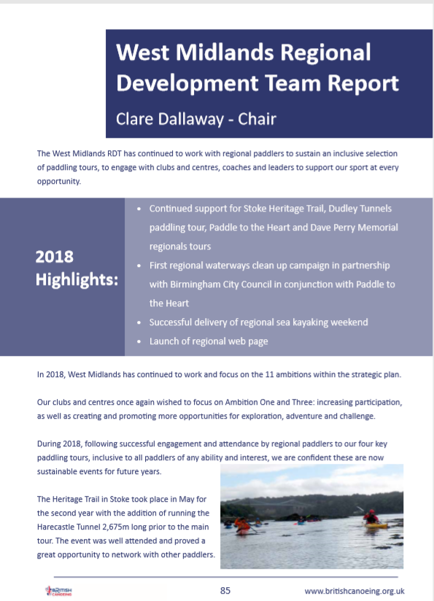

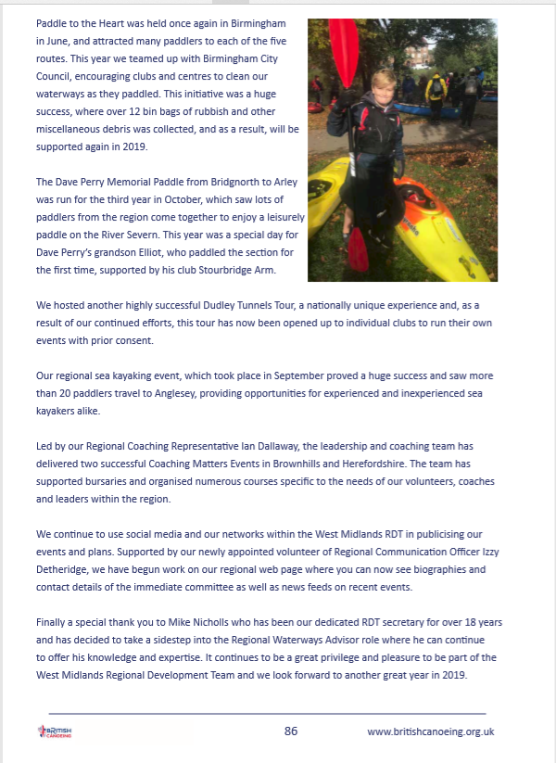
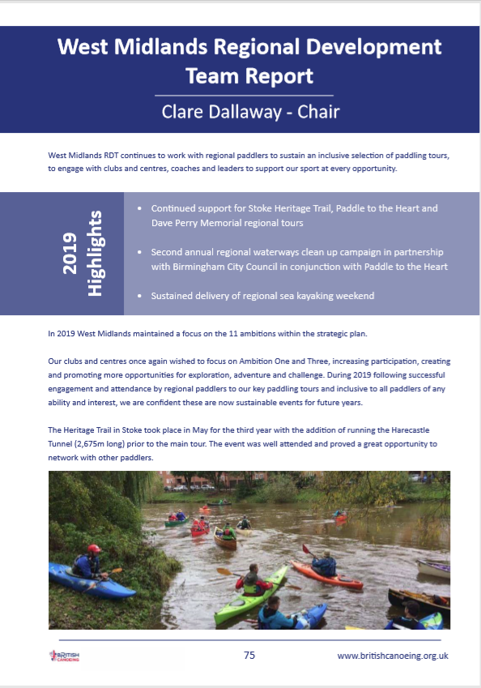

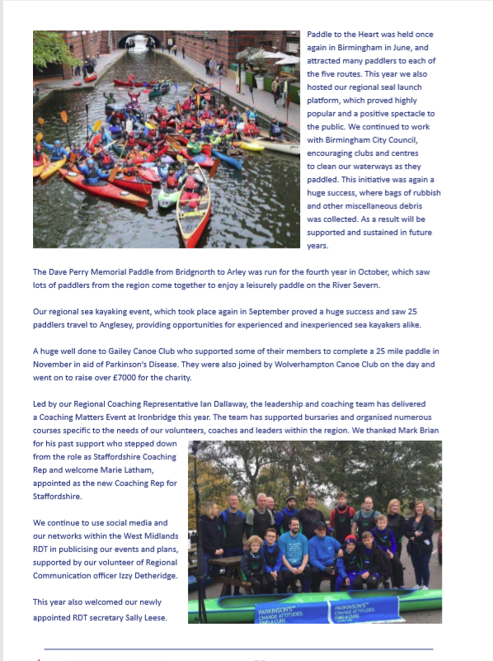
Emergency Plan
1. Communication; compile contact (Mobile Phone: preset) and necessary medical information (Application Forms) for each member of your group.

1a. Have someone at home aware of your plan: WhatsApp group, and senior paddler (Text – Start time, when you reach half way & when off the river) Access & Egress location with vehicle registrations. Paddler's partners numbers to remain with Mick and senior paddler to contact if necessary.

1b. At least two paddlers on each trip to have a fully charged mobile on their person (not in the boat).

1c. Produce laminated mobile phone sized cards for each paddler with mobile numbers of club leaders, paddlers, paddlers next of kin and emergency services on (if you have no signal/battery and are using a farmer’s landline you probably won’t know somebody’s mobile number)

1d. Senior member to action call for help if nobody has contacted them by a preset time (Within a fail-safe time period), give or take an hour.

1e. Have 999 SMS registered to your phone.

Preplanning:
2. Find out about where you are going, the type of run you will be on and who you are with:
- Environment; narrow river, trees & branches, isolated location, river grade -
- UK River Levels - Rainchasers

https://www.ukriversguidebook.co.uk

River levels - https://naturalresources.wales/riverlevels?lang=en

https://flood-warning-information.service.gov.uk/river-and-sea-levels
- Paddlers’ ability

Weather forecast - https://www.metoffice.gov.uk/

Safety – produce a risk assessment; dynamic, specific, generic
2a.Pre-paddle briefing - is it worth showing the team a map of the paddle - indicating the route, names of where we put in and get off, and possible villages or landmarks along the way?

2b Pre-defined Escape routes down the river where to go if one or more paddlers are separated from the group? For example “go to a road junction and stay there, or go to a village or landmark identified above and stay there”.
2c. A way to contact the outside world (cell phone if it works or a sat phone), the protocol that you set up to handle any emergency as well as making sure you all have the necessary safety gear to work with.

Equipment:
3. One person or group shelter or emergency blanket/bag as standard.

3a. Every paddler carries an emergency £10 note for food / taxi / lift from a farmer?
3b. Every paddler carry a head torch (Autumn, Winter, Spring)
3c. First Aid kit.
3d. Split paddle
3e. Rations, hot drink (Flask)

ON THE WATER EMERGENCY PLAN
- Notify on present “What’s App” to nominated person the “Start time & when off the river”.
- ACTION – Senior member to ring individual members on river trip, before ACTION CALL for help.

- When to make ACTION CALL?
- Senior member to ACTION CALL for help if nobody has contacted them by a PRESET TIME (Within a fail-safe time period) give or take an hour.

- Capsized boat and being “Chased”, but paddler safe on bank.
- ACTION – Safe Paddler on the bank follows the river for 10 minutes to look for retrieved boat. Not retrieved walk to the nearest car either at “Access or Egress” point.
Boat chasing paddlers only undertaken with a minimum of two paddlers in line of “Sight” of other paddler!

- Safety Box with “Car key” attached to the car to enable paddler to access vehicle.
- ACTION – Remain with vehicle at “Access” or drive to “Egress” if agreed by group.

- Signal and search for “What Three Word” App.
- ACTION – Identify present location and coordinates.

- Communicate to all members of the group by mobile phone to individual numbers on listed laminated card
- ACTION –Identify individual location, being safe or require assistance.

- No mobile phone signal.
- ACTION – Use nearest land phone to inform senior paddler at home of current situation, they should attempt to contact mobile phones of individuals on trip and update them.

- Signal and when to contact emergency services.
- ACTION – Text 999 by all members of the group if lost or injured but stay at nearest escape route or in difficulty remain in safe place.

- Injured paddler requiring “First Aid”.
- ACTION – Use “Casualty Card” to record and monitor paddler and kept in group 1st aid kit.

- Necessary medical information for each member and check membership forms up to date.
- ACTION – Identify medical history (membership forms) by group leader which are listed and kept in group 1st aid kit.

WOMBOURNE KAYAK CLUB TRIP PARTICIPANT STATEMENT
CLUB TRIPS/CLUB NIGHT: Weekdays or Weekends, Jackfields DATE: 2020 – January 2021
CLUB TRIPS/CLUB NIGHT LEADERS:
Grade 1-2 Sheltered Water: John Teuwen, Nigel Lunn, and Rob Phillips (River Severn: Arley, Bewdley)
Grade 2-3 Moderate Water: Rich Dowen, Tim Kelly (River Vyrnwy)

‘Go Canoeing’ Tour Participant Declaration

- I have watched and understood the safety brief given by the leader(s) for the trip I am taking part in and including the reading of the Risk Assessment.
- I have asked the leader(s) to clarify any points I am uncertain of.
- I am aware that the activities I am to take part in are strenuous and an adventurous nature. I
acknowledge such risk and therefore accept the need for responsible behaviour, including listening to and following safety instructions.
- I have no medical condition or disability, which may be relevant to me participating in this activity.
- I have been advised on the water quality issues.
- I am not under the influence of Alcohol or Drugs.
- Inform the club, if you can’t swim in order for the river leader to manage a capsized situation in open water, and note that all paddlers will not be allowed to participate in the activity without wearing a buoyancy aid, helmet and appropriate kit suitable for the weather conditions; drysuit for winter paddling.
- I am aware that the session may be cancelled for operational, weather or environmental related safety issues.
- I agree to abide by British Canoeing’s ‘Go Canoeing’ Code of Practice.” see Code of Conduct for Coaching Workforce.

https://www.britishcanoeingawarding.org.uk/code-of-conduct-for-coaching-workforce/
file:///C:/Users/John/Downloads/Code_of_Conduct_Coaches_Nov_2018%20(2).pdf

In signing below I declare that I agree with the above statements and I am aware of the risks associated with participating in this activity. By filling in my email address I agree to receive future updates from British Canoeing through the Clubs’ Administrators.
Name | Signature | Emergency  contact | Email address

