MEETINGS RECORD – Committee -AGM | Wombourne Kayak Club

Copies to anyone involved by the minutes. | DATE: 17/01/22
ATTENDANCE:
Present: |  |  | Apologies:  Mick O’Brien,  Dave Bennett  Peter Whatley  Steve Mason,  Tim Kelly
John Teuwen | Paul Elkington | Jon Edwards | Alex Zeigler | Rob Benton
Paul Elkington | Suzy Kirby-Webber | Zahid Hussain | James Wilkinson | David Allen
Rich Dowen | Rob Stewart | Chris Earle | Steve Dowdeswell | Neil Robinson
Simon Binks | Zoey Rowe | Rob & Charlotte Statham | Tony Clarke

AGM Agenda Items:

- Presentation  - Review – previous minutes |  |  | - Club Policy Guidelines Development:  What “Etiquette” guidelines do we apply for –  - Social Media  - Text, emails  - Photographs, filming (YouTube)  - Code of Ethics  - T1 Safeguarding Policy  - BC Social Media Guidelines (Young People)  - Text & Email young people  - Guidelines for Photos & Filming young people
- Appointment of Committee |  |  | - AOB
- Finance
- Pool & Jackfields (Payments)
- Membership update
- Review: Kit Inventory
- Update CACW Action Plan & Ironbridge DMMO, River Gam
- Review Coaching & Training requirements:

- 1st Aid 1-day or 2-day 4th June.
- White Water Award & Module evidence.
- Regional Autumn Training
- Any others?

- Future Activities:

- Trips: e.g., Scotland or other locations?
- Jackfields
- Pool
- Go Paddling – (RDT) Paddle to Heart

 | SUMMARISED MINUTES AND ACTION POINTS |  |  | Action by | For when
 | - Presentation of BC Awards. BC Chris Earle Head of Recreational Paddlers, 1st club in UK to achieve both awards.  - Stage 2 – Quality Club  - Stage 3 – CACW Champion Club  - Review – previous minutes were a true reflection:  - AGM General Meeting 09/03/20  - Committee Meeting 02/04/21  West Midlands RDT Chairperson Claire Dallaway report: 36 clubs in W. Mids., develop and restructure locally, Paddle to the Heart 2020/21  - Appointment of Committee: See Appendix 1  Tim Kelly – Chair: Management & development of club, e.g., Ethos/Values/Beliefs, Assets: update of boats, healthy bank balance.  Mick O’Brien – Treasurer: Effective, efficient, and professional management of Financial A/c’s & bank records.  ACTION:  - Timescale for each role: 1 year “Rollover”, except Chair, Secretary, Treasurer maximum 3 years, but staggered. Note Welfare requires a transition for replacement to undertake course and DBS checks  - Finance  - Bank Mandate – change of signatures  - Pool & Jackfields (Payments) covered costs and in credit by a small balance  - Membership update – Fees, numbers 13 paid 05/01/22  - Discuss Membership criteria, e.g., paddle 3 club trips before being asked to join club to ensure they are covered by insurance.  - Preparation of End of Year Statement prepared by Mick O’Brien Appendix 2  - Review: Kit Inventory – boats, see Appendix 3  - Update CACW Stage 3 - Action Plan, see attachment  Example: Regular Clean-up at Jackfield Rapids and encourage local clubs to participate, e.g., Bridgnorth, Shrewsbury  Ironbridge DMMO, scheduled for 20/12/21 by Telford & Wrekin Council, no progress  River Gam – remove branches on upper section, plan accordingly, but depends on river levels  - 6. Review Coaching & Training requirements:  - 1st Aid 1-day or 2-day 4th -5th June 2022, Trysull Village Hall, Rich’s Orchard 2nd day?  Cost per person for 1 day if max12 attend, includes a venue fee £27.50 + BC Fee £8.00 & 2-day £15, non-members £12 & £20. Cost for 2-day depends on numbers.  ACTION: Email Members to contact & confirm Bookings  White Water Award Practical– set a date (TBC) but depends on demand  Six Modules to complete: Varied Evidence: written, verbal Q&A, planning a trip, practical, video, ACTION: Design & produce a statement tick box.  Regional Autumn (September) Training; WWSR, White Water Leader Training  Phil Hadley Dates: Weekday 19th-20th Sept.22, Weekend 12th-13th November 22  Advanced WWSR Jamie Greenhaigh Summer: Suzy, Zoey, RD, Jon, Steve Mason  Any others training needs? Bursary applications. May 1st |  |  | R.D  S.B  R.D  J. T  J. T  R.D  J.T  J. T  J.T  P. E  J. T  J. T  RD  J.T  P.E  J. T | 17/01/22  17/01/22  17/01/22  17/01/22  31/01/22  05/01/22  05/01/22  17/01/22  31/12/21  15/01/22  17/01/22  20/12/21  2022  4th/5th/06/22  Summer 22  Autumn 22  01/05/22
SUMMARISED MINUTES AND ACTION POINTS | Action by | For when
- Future Activities:  Q. What do we consider as a “Peer or Club Trip”? Phil Hadley’s definition?  “PEER” = Communicate with paddlers by PERSONAL mobile, WhatsApp, email but NOT through the CLUB social media, such as WhatsApp, Facebook, website, emails etc.  “CLUB TRIP” = Communicate through CLUB social media, mobiles, CLUB emails etc.  How many trips before non-members asked to join Wombourne Kayak Club? See BC model  Appendix 6  ACTION: 3 club trips.  Trips: e.g., Scotland or other locations TBC  Club Night, Jackfields: (Personal safety- Females) ACTION: 2 male members to remain.  Pool: Jon mentioned that Tim was negotiating an additional session to accompany the “Rolling” training. Tim’s WhatsApp was discussed that Rich had queried that not all members are able to access or knew how to book with Tim and the session at times was offered to non-members. The capacity for the pool was 15. Alternative pools were discussed, but logistical issues would be created in transporting and cleaning boats.  ACTION: More variety suggested to allow Paddle Sport Instructors to support delivery of “Beginners “and a discussion with Tim to be organised.  Go Paddling: June 11th Paddle to the Heart, Birmingham, using canals.  BC Big Paddle Clean up week – June 5-11th ACTION: Thursday Club night at Jackfields.  BC support Surfers Against Sewage, next Spring and Autumn ACTION: Repeat Dale End to Jackfields TBC  River Guides in place, e.g., Vyrnwy on website ACTION: Building up a portfolio and available on the website.  - Club Policy Guidelines Development:  - Q. What “Etiquette” guidelines do we apply for –  Social Media – Facebook, WhatsApp, Instagram, web collect, Text, emails, Photographs, filming (YouTube) See - Appendix 4 Devizes Policy  ACTION: Working party to develop a “Social Media - Etiquette” guidelines policy.  - Devise a “Near Miss” Procedure & how it is recorded by the club. E.g., BC Incident Near Miss Form as a starting point.  Q. What do we mean by a “Near Miss”? e.g. More than 2 capsized boats at the same time at a drop? River Gam in which the club reviewed “The Emergency Plan”.  ACTION: Working party to develop a “Near Miss” Review Process.  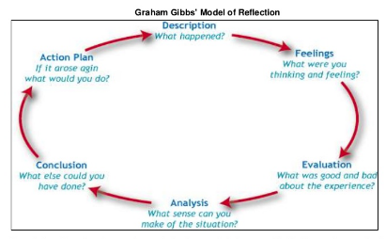  Resource  Graham Gibbs Model of Reflection | RD  J.E.  R.D  Z.R.  R.D  J.T  J.T  R.D  Dave Bennett  J.T  J.T, A.Z  Z.R  S.B, J.T  R.D | 17/01/22  17/01/22  Feb.,22  11/06/22  09/06/22  On-going  Feb. 22  Feb 22

SUMMARISED MINUTES AND ACTION POINTS | Action by |  | For when
- GDPR Guidance: Use of Club Communication, e.g. Club Social Media, emails, website  ACTION: GDPR Statement, design new club members email that complies.  - Club Boat Insurance?  - Devise “Loaning procedures” policies? Working Party? (JT) See Appendix 3  - Value boats for insurance purposes. See spreadsheet√ See Appendix 3  ACTION: Devise a Booking procedures, Contact Insurance natalie.wale@bluefinsport.co.uk  - Data Barring Service (DBS) as a coach to operate as an instructor, leader, or coach for the club. Organisation PIN: 168877 – (JT) to contact members.  - AOB:  Future Review?  - Design new website, Update “Website” Domain, owned by a Tim’s friend, P.E investigating “What” needs to be done.  - Welcome Pack – update: Vision, Values, Aims, Objectives? Working Party.  - New Paddlers Code (Check, Clean, Dry) Working Party – included above.  - BC Equality, Diversity, Inclusive Policies – “Quality Club” Future Discussions Working Party - TBC  - “Japanese Knotweed”, right of “Rock” launch area to “Seal Launch”. Telford Canoe Club (TCC) responsible for “Removal”. Zoey Rowe to check progress with (TCC)  - R.D demonstrated range of Club Clothing and asked whether we investigate further purchase.  - Mick O’Brien former Treasurer made Honorary Member of Wombourne Kayak Club, J.T. mentioned we need to reimburse him for this year’s subscriptions. J.T to inform Mick.  - Trysull Village Hall Room Hire payment; J.T has paid Z.R Cash £24.00, needs to be reimbursed from club funds.  - Pool Payment J.T has paid Wombourne Leisure Centre by Credit Card £66.40, needs to be reimbursed from club funds. |  | J.T  J.T  S.B  J.T, P.E  J.T.  J.T  P.E, J.W  J.T, Z.R  J.T, Z.R  J.T  Z.R  R.D  R.D  J.T  J.T, Z.R | 17/01/22  19/01/22  Feb., 22  2022  18/01/22  Feb., 22

Committee Members 2022 Appendix 1
Name | Position | Job Description – Click onto role | Nominated by | Seconded by
Paul Elkington | Chair | Role | John Teuwen | Rich Dowen
Rich Dowen | Vice-Chair | As for Chair in his absence | John Teuwen | Rob Stewart
John Teuwen | Secretary | Role | Rich Dowen | Suzy  Kirby-Webber
John Teuwen  NB. Undertaken a course to fulfil role. | Welfare | Role  Role2
John Teuwen  Completed verifiers process | Disclosure Barring Service (DBS) Verifier | Processes (DBS) checks: e.g., River leaders, Paddle sports Instructors/Leaders
Simon Binks | Health & Safety | Role | Rich Dowen | John Teuwen
Rich Dowen | Trips Organiser | Role | John Teuwen | Zoey Rowe
Paul Elkington | Treasurer | Role | John Teuwen | Suzy  Kirby-Webber
John Teuwen | Coaching Coordinator | Role | Simon Binks | Suzy  Kirby-Webber
David Allen | Equipment |  | Rich Dowen | Rob Stewart
Zoey Rowe | Media (Social) & Publicity | Role
James Wilkinson | Website | May need to design one | Rich Dowen | Paul Elkington
Zoey Rowe | Access & Environment | Role click on CACW role descriptors in “The Clubhouse” | John Teuwen | Simon Binks
Alex Zeigler | Equality, Diversity & Inclusion | May need to design one | John Teuwen | Rich Dowen

Appendix 2
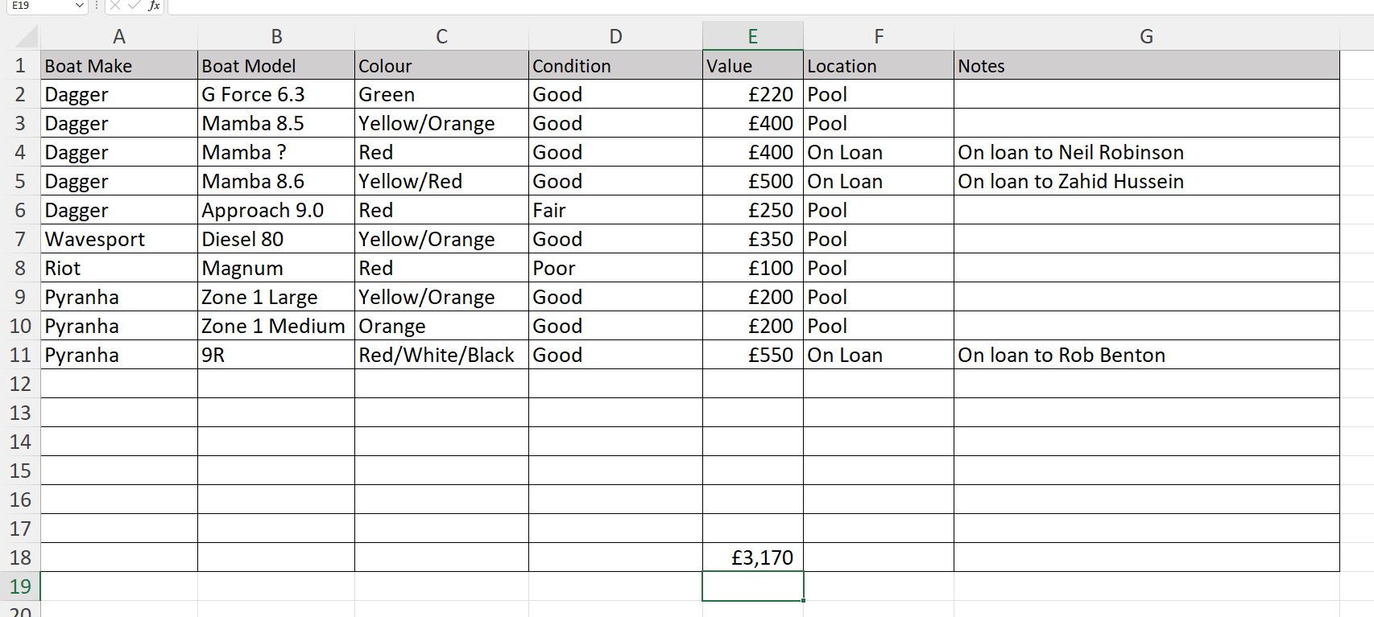
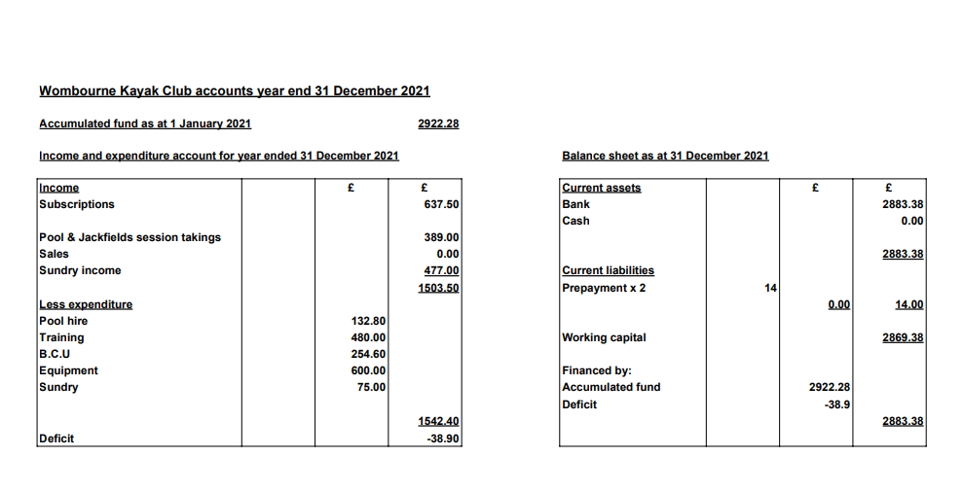
Appendix 3
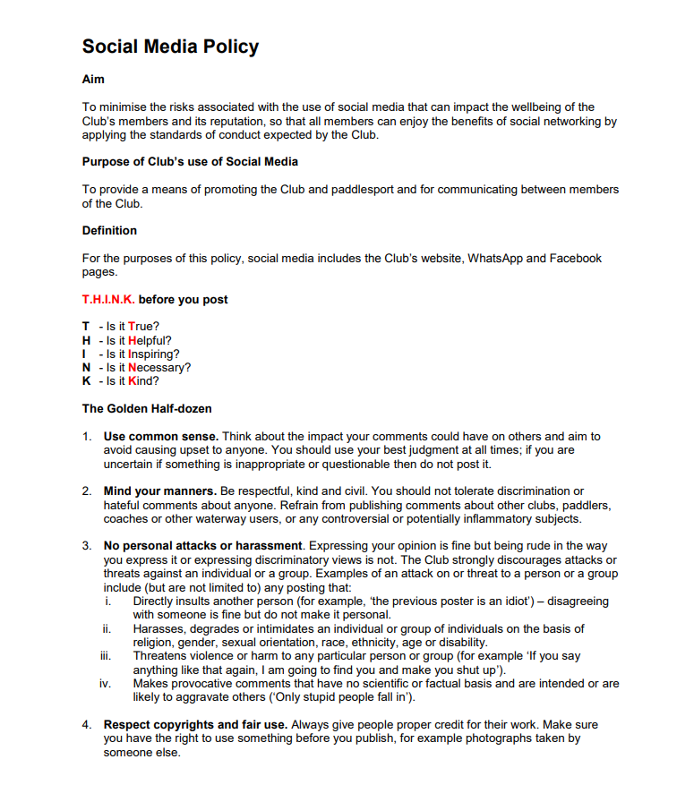
Appendix 4 Devizes Canoe Club
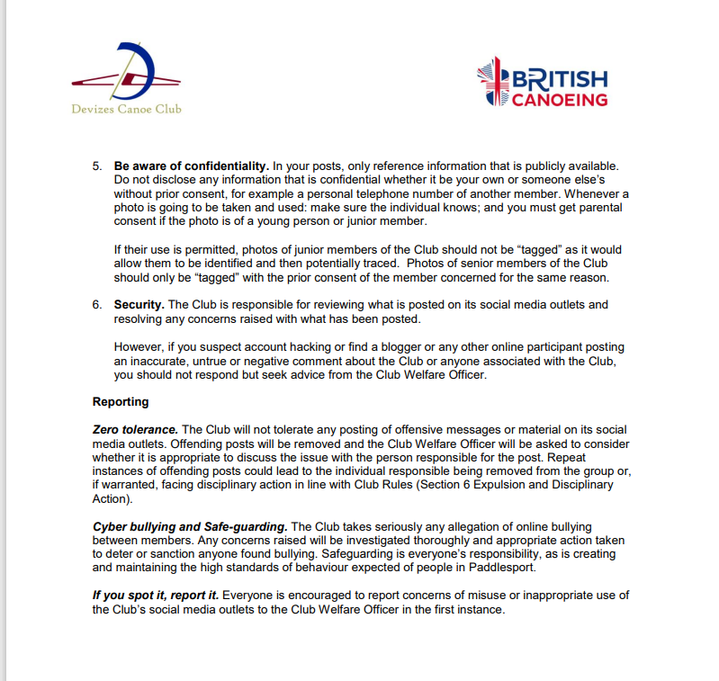

Appendix 5

Boat Insurance

Wombourne Kayak Club Boat Booking System

Definition:

A long-term Loan of a club boat 2 - 6 months?

If equipment is lost or damaged the responsibility for arranging repairs or replacement by a boat of the same manufacturer and condition rather than new is the member who has loaned the boat.

If a person wishes to borrow the club boat equipment long term, then should they arrange their own insurance cover for the item borrowed!

Note: The use of the club boat equipment long term, is limited to be used i.e., for club paddles only? and/or peer paddles?

Loan to be negotiated with Committee member responsible for the “Equipment” and “Chairman, Vice-Chair, Secretary”?

A short - term Loan of a club boat to be used on “Club Night” or arranged day club trip, to be returned either by a committee member or member to the Club’s Equipment storage area at Wombourne Leisure Centre.

Phil Hadley’s definition:

“PEER” = Communicate with paddlers by PERSONAL mobile, WhatsApp, email but NOT through the CLUB social media, such as WhatsApp, Facebook, website, emails etc.

“CLUB TRIP” = Communicate through CLUB social media, mobiles, CLUB emails etc.

Question - why should a member who has been loaned an uninsured boat by an experienced & knowledgeable white-water club aware of the associated risks (Documented & published Risk Assessments) be expected to cover the cost of replacements? This could apply to any club equipment.

Maybe the easiest way to address this is for the club to arrange its own insurance cover and have a robust booking out system (may already have a booking out system).

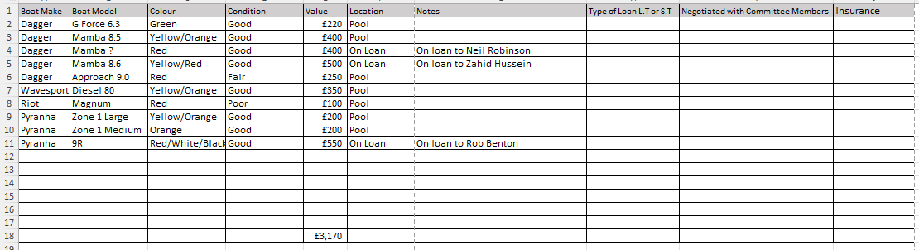
Appendix 5
Appendix 6

