Wombourne Kayak Club Risk Assessment
Location: | River Rea –  Paddle points: | Grid Reference: | 674774  Neen Savage  Neen Sollars  663723
Types of Trip: | Club Night or Friends recreational kayak trip
Video Footage: | John: https://www.youtube.com/watch?v=V95fqfGgBuU  Rich: https://youtu.be/x2Zx9VvVJC0 | Date: | 08/05/21
Assessor Name: | John Teuwen | Review: | 14/05/21
Position in Club: | Health & Safety | Date Checked & updated:
Date Completed: | 14/05/21 | Signed: | JohnTeuwen.

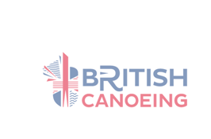
Wombourne Kayak Club Risk Assessment – COVID 19 Specific Risks
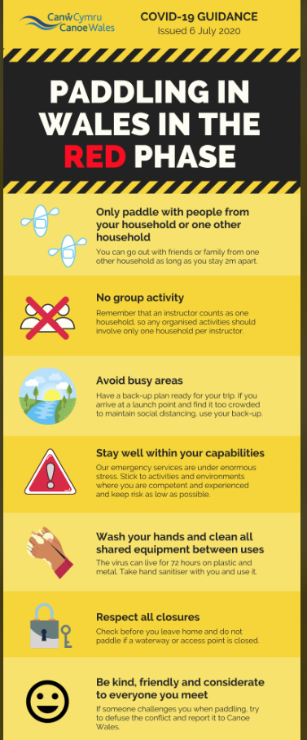
Risk ratings Low, medium or high: 3 * 3 Risk Matrix


What is the hazard? | Who might be harmed? | How may the risk be adequately controlled? | Risk Ratings:  Low, Medium, High  Grade based 3*3 Risk Matrix & calculation of risk severity chart | Action by whom | What further action is necessary?
COVID 19 Transmission – travel to and from River Rea:  Neen Savage to Neen Sollars  Check British Canoeing guidelines; refer to Wales-Red phase. | Club Members | All members to travel independently to and from the location– no shared vehicles  Any member displaying symptoms, or who thinks they may have been in recent contact with somebody with symptoms, should not attend the session  All briefings and buddy checking to be done in compliance with 2m distancing  Members to arrive as prepared as possible to avoid long changing periods in shared areas  Debriefing to be done after the session if necessary, by WhatsApp or conference call | S = 3 L = 3 = 9 Medium  Unlikely, Harmful | Club coaches & senior members.

Wombourne Kayak Club Risk Assessment – COVID 19 Specific Risks
What is the hazard? | Who might be harmed? | How may the risk be adequately controlled? | Risk Ratings:  Low, Medium, High  Grade based 3*3 Risk Matrix & calculation of risk severity chart | Action by whom | What further action is necessary?
COVID 19 Transmission – shared equipment | Club Members | Members to bring all own equipment. Any equipment that needs to be loaned from the club should only be used by that member for that session, and should be cleaned before returning to store | S = 3 L = 3 = 9 Medium  Unlikely, Harmful | Club coaches & senior members.
COVID 19 Transmission –rescue | Club Members | All club members to paddle strictly within their own ability, in river levels that are manageable and unlikely to lead to capsizes, injuries or incidents.  In the event of a capsize, members should be encouraged to self rescue to the bank with boat and paddle if possible. If required another member should rescue the boat and paddle using their own boat to move the equipment | S = 3 L = 3 = 9 Medium  Unlikely, Harmful | Correct supervision and group control by instructor, safety brief.
COVID 19 Transmission from club members to members’ family who may be at risk or vulnerable | Club Members’ household | Ask each member attending if they are part of a household which contains somebody who is categorised as “at risk, “vulnerable”, or “shielding”. If they are then that member should not attend the session | S = 4 L = 3 = 12 Medium  Unlikely, Extremely Harmful | Club coaches & senior members.
COVID 19 Transmission –first aid | Club Members | All club members to paddle strictly within their own ability, in river levels that are manageable and unlikely to lead to capsizes, injuries or incidents.  In line with government advice, make sure you wash your hands or use an alcohol gel, before and after treating a casualty also ensure that you don’t cough or sneeze over a casualty when you are treating them  Wear gloves or cover hands when dealing with open wounds  Cover cuts and grazes on your hands with waterproof dressing  Dispose of all waste safely  Do not touch a wound with your bare hand  Do not touch any part of a dressing that will come in contact with a wound  Observe the below protocol for CPR:  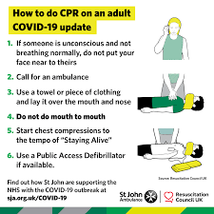 | S = 4 L = 3 = 12 Medium  Unlikely, Harmful | Correct supervision and group control by instructor, safety brief.

Wombourne Kayak Club Risk Assessment
Risk ratings Low, medium, or high: 3 * 3 Risk Matrix

What is the hazard? | Who might be harmed? | How may the risk be adequately controlled? | Risk Ratings:  Low, Medium, High  Grade based 3*3 Risk Matrix & calculation of risk severity chart | Action by whom | What further action is necessary?
Weather & Environmental Conditions: Floods/  Spate conditions | Club Members | Check weather forecast & river levels.  - Dynamic risk assessment.  Re-locate or cancel if inappropriate to group ability  Weather Forecast:  River Levels: | S = 5 L = 5 = 25 High  Likely, Extremely Harmful | - Club coaches & senior members.
Drowning | Club Members | - Buoyancy Aids & Helmets must be worn & fitted correctly for all paddlers.  - All club buoyancy aids & helmets are checked & their condition recorded annually.  - Apply “Buddy” checks on helmets & buoyancy aids, boats  - Parental Consent Forms T4 & Adult T4a Trip Participant Statement signed | S = 3 L = 3 = 9 Medium  Likely, Slightly Harmful | - Club coaches & senior members.  - Club equipment officer to undertake checks.  - Club members.  - Club coach’s/secretary
Weather related injury  Hyperthermia.  Hypothermia | Club Members | - Check weather forecast.  - Dynamic risk assessment  - Advised on appropriate clothing to wear.  - Adjustment to clothing as required, e.g. use of wet to dry suit depending on weather forecast, temperature & time of year.  - Sun block, extra water, change of clothing,  - Hyperthermia; offer a cold drink  - Hypothermia; offer a hot drink, Group shelter or emergency bag | S = 4 L = 4 = 16 Medium  Likely, Harmful | - Club coaches & senior members

Wombourne Kayak Club Risk Assessment
Risk ratings Low, medium, or high: 3 * 3 Risk Matrix

What is the hazard? | Who might be harmed? | How may the risk be adequately controlled? | Risk Ratings:  Low, Medium, High  Grade based 3*3 Risk Matrix & calculation of risk severity chart | Action by whom | What further action is necessary?
Sprains, strains, soft tissue injuries | Club Members | Trained to lift boat correctly  - Ask for help.  - Trained to paddle correctly.  Dynamic risk assessment | S = 2 L = 3 = 6 Low  Likely, Slightly Harmful | - Club coaches & senior members.  - Include in initial Induction & Club Training
Medicinal risks | Club Members | - Members inform club on Application form.  - Ensure Members have and are taking necessary medication. | S = 2 L = 2 = 4 Low  Likely, Slightly Harmful | - Agreed action between participants & coaches of routine consumption of necessary medication.  - Coaches may hold any necessary medication on request/agreement of participant involved.
Slips, trips & falls  NB – Steep incline from portage 1 & 2, see Paddle Points for locations | Club Members | - Safety Brief  - Create awareness of river/bank hazards  - Identify hazard areas to paddlers.  - Dynamic risk assessment. | S = 3 L = 3 = 6 Med.  Likely, Slightly Harmful | - Club coaches & senior members.
Wombourne Kayak Club Risk Assessment
Risk ratings Low, medium, or high: 3 * 3 Risk Matrix

What is the hazard? | Who might be harmed? | How may the risk be adequately controlled? | Risk Ratings:  Low, Medium, High  Grade based 3*3 Risk Matrix & calculation of risk severity chart | Action by whom | What further action is necessary?
Pollution & water quality | Club Members | Risks higher in “Spate” conditions  Avoid intentional capsize in poor conditions  Advised to bath/shower after paddle  Made aware of flotsam  Dynamic risk assessment | S = 4 L = 3 = 12 Medium  Likely, Harmful | - Club coaches & senior members.
Water borne disease’s | Club Members | - All paddlers should shower after paddling and wash their hands before eating. | S =4 L = 2 = 4 Low  Likely, Harmful | - Club Safety Officer to publicise guidelines and provide hand washing and shower facilities on site
Possible Fisherman from Mawley Hall Estate; various spots between Mawley Hall Footbridge and Cheese Grater weir; line & hook causing facial injuries | Club Members | - Identify & inform participants & instructors.  Safety brief  - Dynamic risk assessment | S = 2 L = 2 = 4 Low  Likely, Harmful | - Club coaches & senior members.
Swans | Club Members | - Avoid paddling near them in nesting period in Spring  Safety brief  - Dynamic risk assessment | S = 4 L = 3 = 12 Med  Likely, Harmful | - Club coaches & senior members.
Over hanging tree or strainers, fallen trees but passable. Note 3 portages | Club Members | - Identify hazard areas to paddlers.  Dynamic risk assessment  - Advised to avoid & informed how to escape entrapment. | S = 4 L = 3 = 12 Med  Likely, Harmful | - Club coaches & senior members.
Wombourne Kayak Club Risk Assessment
Risk ratings Low, medium, or high: 3 * 3 Risk Matrix

What is the hazard? | Who might be harmed? | How may the risk be adequately controlled? | Risk Ratings:  Low, Medium, High  Grade based 3*3 Risk Matrix & calculation of risk severity chart | Action by whom | What further action is necessary?
Possible other paddlers or users on the river? | Club Members | Safety brief  - Navigation rules of the river & awareness of other craft.  Paddlers instructed to be aware of other uses & how to take appropriate action to avoid them.  - Fraying paddles, boats  - Dynamic risk assessment. | S = 3 L = 3 = 9 Medium  Likely, Slightly Harmful | - Club coaches & senior members.
Illness & fatigue | Club Members | Safety brief  Paddlers to inform instructor  - Dynamic risk assessment  - First aid kit, food and water, evacuation procedures and assistance. | S = 3 L = 3 = 9 Medium  Likely, Slightly Harmful | - Club coaches & senior members.
Road Traffic accident  Breakdown | Club Members | Dynamic risk assessment  - First aid kit, food and water, evacuation procedures and assistance. | S = 5 L = 4 = 20 High  Likely, Harmful to extreme | - Club coaches & senior members.
Equipment: unserviceable | Club Members | - Loose seat, footrest, ratchets, missing bung  - Periodic safety checks of equipment, | S = 2 L = 3 = 6 Low  Likely, Slightly Harmful | - Club coaches & senior members.
Weir- Cheese Grater  See Video (1):  16.39 minutes |  | - Need to egress from boats to check routes, see video information.  - Also check to see if there is any fallen trees. | S = 4 L = 4 = 20 High  Likely, Extremely Harmful | - Club coaches & senior members remind paddlers

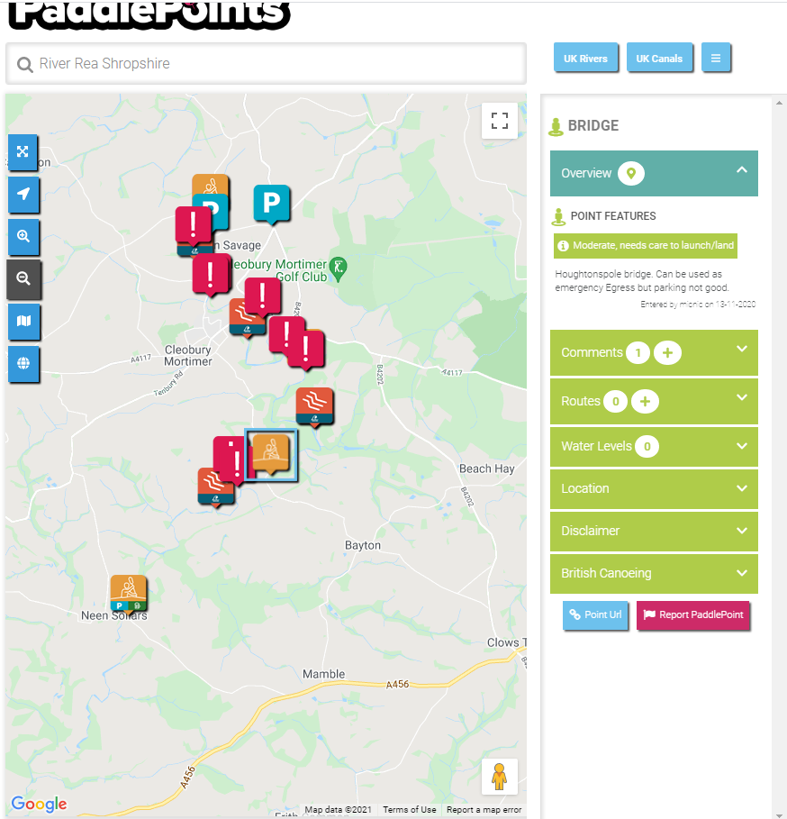
Appendix 1

Handout (1) CALCULATION OF RISK SEVERITY

In assessing a RISK you need to take into account two factors:

(1) How serious could an injury be?
(2) How likely is it to occur?

The following would be a rough guideline:

High Risk: A very serious injury that had a high probability of occurring.

Med. Risk:

Either (a) A serious injury unlikely to occur
(b) A lesser injury likely to occur

Low Risk:
Would be a slight injury that was unlikely to occur.

If you take (1) above as a scale of 1 to 5 (5 = high) Seriousness
(2) above as a scale of 1 to 5 (5 = high) Likelihood

Then, multiply them together, this would give a scale as follows:

Translating into: LOW (1-8) MED. (9-17) HIGH RISKS (18-25)

SERIOUSNESS OF INJURY

5 = Very high potential for multiple death and/or wide spread destruction.
4 = High causing death or serious injury to an individual, i.e. reportable accident under the RIDDOR regulations.
3 = Moderate causing injury or disease capable of keeping an individual off work for three days or more, may require reporting under RIDDOR regulations.
2 = Slight causing minor injuries, i.e. person able to continue work after first aid.
1 = No risk of injury or disease.

LIKELIHOOD OF THE EVENT OCCURRING

5 = Very likely, almost certain.
4 = Likely to occur, i.e. easily precipitated with slight carelessness for external event, e.g. vibration.
3 = Quite possible, the accident is only likely to occur with help, i.e. if somebody slips, failure to replace a light, etc.
2 = Possibly - probably is low or minimal.
1 = Not likely at all, there is really no risk and accidents will only occur under freak conditions.

