Wombourne Kayak Club River Guide: Horseshoe Falls to Mile End Mill, Llangollen
Location: | River Dee – Horseshoe Falls to Mile End Mill  Post Code: Car Park, Horseshoe Falls – pay on display LL20 8BN  Post Code: Mile End Mill, Llangollen - £6 parking/access fee, can do online LL20 8AB  Paddle Points: - River Dee  UK Rivers Guide: Horseshoe Falls to Town Falls including Mile End Mill.  River Levels: 0.46 (Low) - 19/06/21, 0.75 (Medium, fast conditions, “Wave Trains”) 04/12/21  River Gauge: Corwen  - 45 scrape  - 0.52 low  - 0.65 medium  - 0.95 high  - 1.25 huge | Grid Reference: | Access:  OS Ref:  SJ 19747 43309  Egress: (Mile End Mill)  OS Ref:  SJ 20797 42824  Egress:  OS Ref:  SJ 21701 42083
Types of Trips: | Club recreational kayak trip
Video Footage: | See Videos:  - 19/06/21 – John https://youtu.be/BwKD1Q0aPd8  - 04/12/21 – John https://youtu.be/BzMUrFkJxq0  - 14/08/21 – John https://www.youtube.com/watch?v=A1uVcpsXoMs&t=1s  - 19/06/21 – Rich https://www.youtube.com/watch?v=vrv8CFSJjsE  - 04/12/21 – Rich https://www.youtube.com/watch?v=biVUsHNcw0c | Date: | 2021

Feature | Horseshoe Falls  At low level one can run Horseshoe Falls, down the centre  0.10 seconds 19/06/21 – Rich https://www.youtube.com/watch?v=vrv8CFSJjsE 0.46 (Low)  At high levels there is a dangerous tow back, do not run! Take left route of weir and slip down the ledge drop, Avoid the two channels to the left of weir as this may be blocked with trees & debris.  0.10 seconds 04/12/21 – Rich https://www.youtube.com/watch?v=biVUsHNcw0c 0.75 (Med.)
Feature | Chain Bridge Rapids  Grade 2-3 drop & wave train, take left route next to hotel.  0.11 seconds 19/06/21 – John https://youtu.be/BwKD1Q0aPd8 0.46 (Low)  1.02 minutes 04/12/21 – John https://youtu.be/BzMUrFkJxq0 0.75 (Med.)
Feature | Serpents Tail Rapid  Ranges from grades 2-4 depending on river levels, 0.65 to 0.85 can becomes very fast and a succession of wave trains.  2.00 minutes 19/06/21 – John https://youtu.be/BwKD1Q0aPd8 0.46 (Low).  5.14 minutes 04/12/21 – John https://youtu.be/BzMUrFkJxq0 0.75 (Med.)
Feature | Museum Weir  Grade 2 drop & wave train. Note exposed metal in broken weir in centre and right.  6.10 minutes 19/06/21 – John https://youtu.be/BwKD1Q0aPd8 0.46 (Low).  6.16 minutes 04/12/21 – John https://youtu.be/BzMUrFkJxq0 0.75 (Med.)
Feature | Drop after Railway bridge  Grade 2-3 Take left route into eddy prior to drop, re-position and take right slot.  6.19 minutes 19/06/21 – John https://youtu.be/BwKD1Q0aPd8 0.46 (Low).  In medium levels, there is a far river right route drop, which can be taken.  6.18 minutes, 6.56 minutes 04/12/21 – John https://youtu.be/BzMUrFkJxq0 0.75 (Med.)

Feature | Tombstone Weir drop  Grade 2-3 drop, bear to the left about half a metre from stone brock, slightly angled to eddy out.  9.57 minutes 14/08/21 https://www.youtube.com/watch?v=A1uVcpsXoMs&t=1s – John 0.5 (Low).  12.14 minutes 04/12/21 – John https://youtu.be/BzMUrFkJxq0 0.75 (Med.)
Feature | Middle Weir drop opposite Mile End Mill  Grade 2-3 drop, bear to the right about half a metre from rock, slightly angled to eddy out.  11.27 minutes 14/08/21 https://www.youtube.com/watch?v=A1uVcpsXoMs&t=1s – John 0.5 (Low).  12.36 minutes 04/12/21 – John https://youtu.be/BzMUrFkJxq0 0.75 (Med.)
Feature | Bottom Weir drop at Mile End Mill  Grade 2-3 drop, bear to the left first eddy, then drop over into eddy next to rockface to surf wave above main drop. Then drop down to main rock either left or right.  12.24 minutes 14/08/21 https://www.youtube.com/watch?v=A1uVcpsXoMs&t=1s – John 0.5 (Low).  13.18 minutes 04/12/21 – John https://youtu.be/BzMUrFkJxq0 0.75 (Med.)

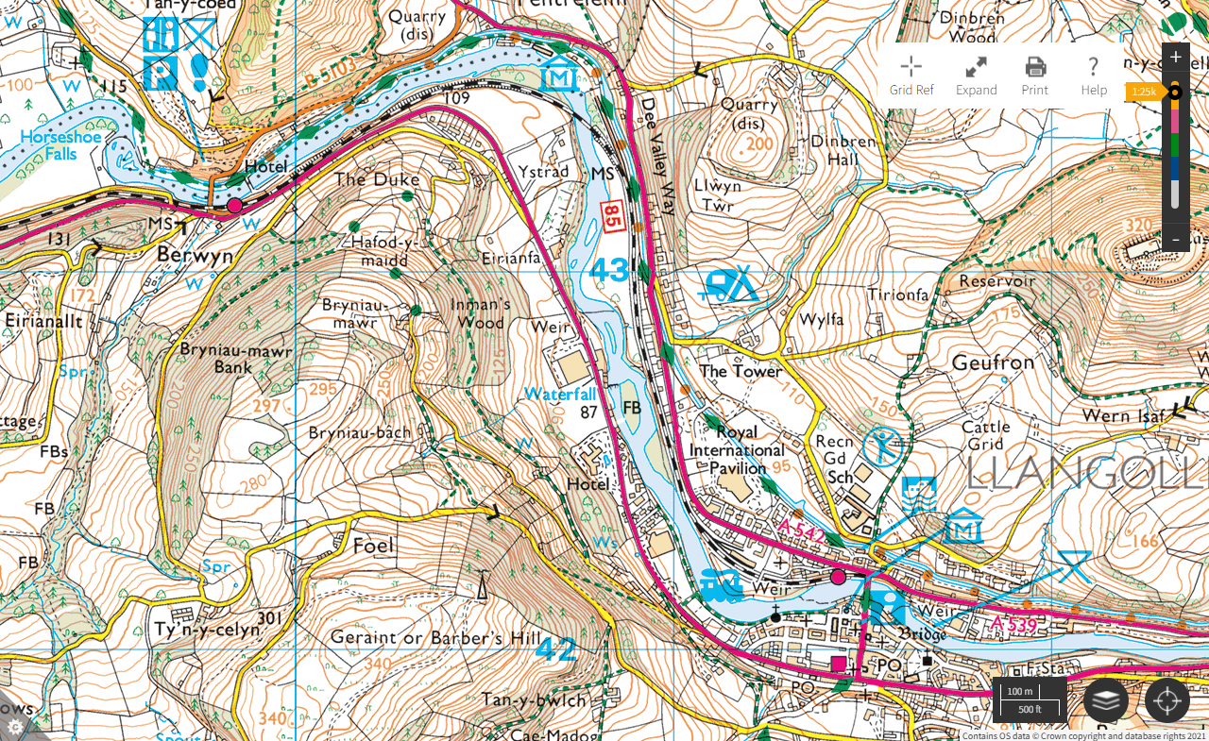
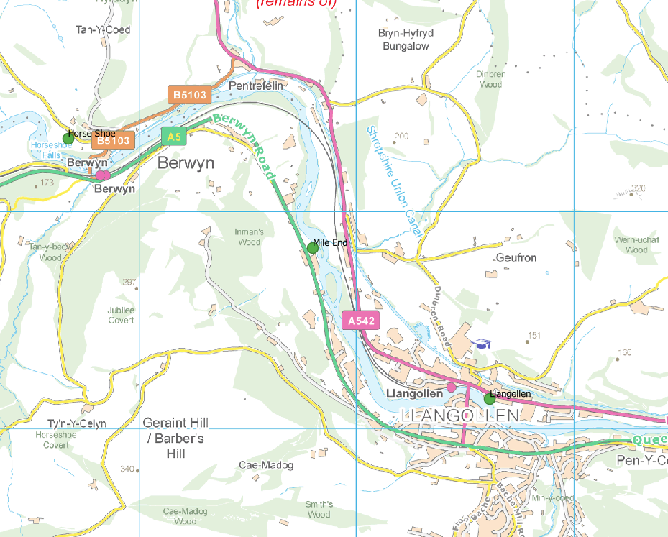
Contains OS Data Crown copyright and database rights 2019

