Location: | River Usk – Wye Usk Foundation: Click on links Talybont on Usk to Llangynidr  Post Code: Talybont on Usk LD3 7JE  Post Code: Llangynidr NP NP8  Paddle points - River Usk  UK Rivers Guide: River Usk-Talybont on Usk to Llangynidr  River Levels: 1.04 - 02/10/21  River Gauge: Llandetty | Grid Reference: | Access:  122234  Egress:  156204
  - 0.80 scrape
  - 0.95 low
  - 1.05 medium
  - 2.89 high
  - 3.00+ huge
Types of Trips: | Club recreational kayak trip
Video Footage: | See Videos:  - Talybont on Usk to Crickhowell (John Part A - 15/03/19) 2.50-7.15 minutes - Flood Conditions  - Talybont on Usk to Crickhowell (John Part B - 15/03/19) Flood Conditions  - Talybont on Usk to Llangynidr (John Part A - 02/10/21) 5.30 – 9.30 minutes  - Talybont on Usk to Llangynidr (John Part B - 02/10/21) | Date: | 2nd October 2021
Wombourne Kayak Club River Guide: Talybont on Usk to Llangynidr

Feature | Mill Falls - 1st Drop before Llangnidr Bridge, take left hand side route by the mill, Grade 3 Rapids: continuous wave trains at this level for 1/2K. (See video 3) 5.30 – 9.30 minutes

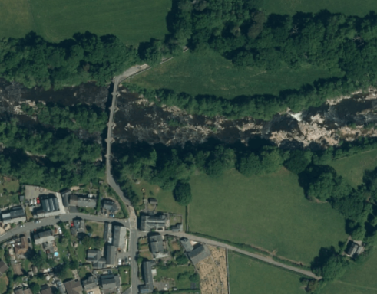
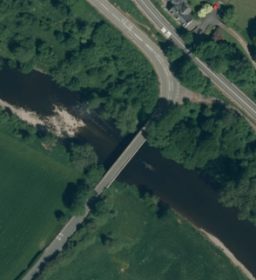
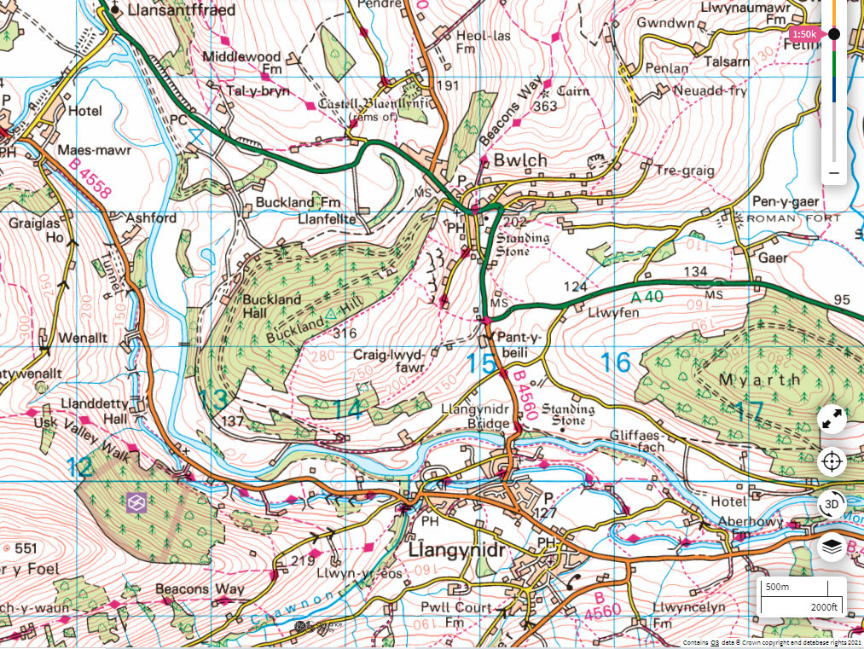
Car Park
On canal

