Location: | River Wye: Dernol to Rhayader  Post Code: Dernol SY18 6RY  Post Code: Rhayader LD6 5PE  Paddle Points:  UK Rivers Guide:  Wye Usk Foundation: Dernol to Marteg  Wye Usk Foundation: Marteg to Rhayader  River Gauge: – Ddol Farm 1.02 at 11.00am. 1.50m at 2.30pm, see Video 5 - Neil | Grid Reference: | Access:  SN 92105 73870  Egress:  SN 96896 67808
  - 0.80 scrape
  - 0.95 low
  - 1.05 medium
  - 1.30 high
  - 1.50+ huge
Types of Trips: | Club recreational kayak trip
Video Footage: | See Videos:  - 11/12/21 “Dernol to Rhayader” – John  - 11/12/21 “Dernol to Rhayader” – Zed  - 14/12/19 “Dernol to Rhayader” – Rich  - 19/02/22 “Dernol to Rhayader” – John  - 19/02/22 “Rhayader Falls” 1 – Neil  - 19/02/22 “Rhayader Falls” – Paul  - 19/02/22 “Dernol to Rhayader” – Paul | Date: | Updated 20th February 2022
Wombourne Kayak Club River Guide: River Wye: Dernol to Rhayader

Feature | Dernol to Marteg  Tree Blockage narrow passage after flood had cleared route where a tree had fallen.  11/12/21 “Dernol to Rhayader” 0.52 minutes video – John  11/12/21 “Dernol to Rhayader” 2.13 minutes – Zed
Feature | Dernol to Marteg  Left riverside slight “Dog Leg”.  11/12/21 “Dernol to Rhayader” 1.33 minutes video – John  11/12/21 “Dernol to Rhayader” 2.55 minutes – Zed
Feature | Dernol to Marteg  Right riverside slight “Dog Leg” to centre, bear right and paddle straight.  11/12/21 “Dernol to Rhayader” 3.19 minutes video – John  11/12/21 “Dernol to Rhayader” –8.33 minutes - Zed
Feature | Dernol to Marteg - near house on left.  Left hand side Dog leg move to centre with a narrow drop, be aware of manoeuvring around rocks.  11/12/21 “Dernol to Rhayader” 5.21 minutes video – John  11/12/21 “Dernol to Rhayader” 9.36 minutes – Zed
Feature | Marteg to Rhayader  Drop prior to “Letter box”, take centre route  11/12/21 “Dernol to Rhayader” – 15.40 minutes – Zed

Feature | Marteg to Rhayader  “Letter box”, take right route at lower levels.  At higher levels take left route but at least 1-2m from rock where Paul is standing as a “Stopper” would hold the paddler, see 19/02/22 – John  11/12/21 “Dernol to Rhayader” 7.21 minutes video – John  11/12/21 “Dernol to Rhayader” – 16.32 minutes – Zed  19/02/22 “Dernol to Rhayader” 6.45 7.18minutes – John  19/02/22 “Dernol to Rhayader” 2.22 -2.50 minutes – Paul
Feature | Marteg to Rhayader  Section up to the drop – Higher levels a succession of “Wave” trains”! See 19/02/22 “Dernol to Rhayader” 10.45 – 11.20 minutes – John  Drop under bridge near to the rock, be careful of corkscrew flow from the right as you enter can flip you. Can take route left of boulder.  Higher levels, turns into a wave train under bridge, follow centre route.  11/12/21 “Dernol to Rhayader” 10.39 minutes video – John  11/12/21 “Dernol to Rhayader” – 20.30 minutes – Zed  19/02/22 “Dernol to Rhayader” 11.28 – 12.59 minutes – John
Feature | Marteg to Rhayader  Falls: Easy route to the left down “Chicken Run or centre right over drop, for the latter take channel left of island bush and right ledge, see Zed’s video, be aware of bubby water at the bottom through a narrow gap.  Higher levels the level and features change– see 19/02/22 “Rhayader Falls” 1 – Neil  Falls: lead into falls via the chicken run “Wave” train increases. At higher levels the “Stopper” increases with a “Tow back”. See John’s and Paul’s video.  11/12/21 “Dernol to Rhayader” 11.11 minutes video – John  11/12/21 “Dernol to Rhayader” – 20.48 minutes – Zed  19/02/22 “Dernol to Rhayader” 13.01 - 14.08minutes – John  19/02/22 “Dernol to Rhayader” – Paul


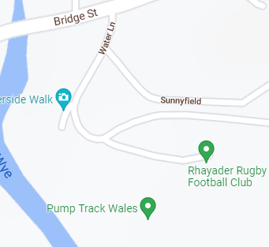
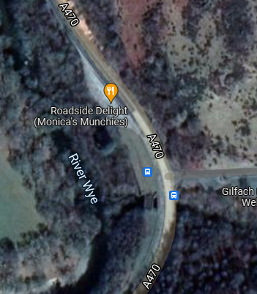
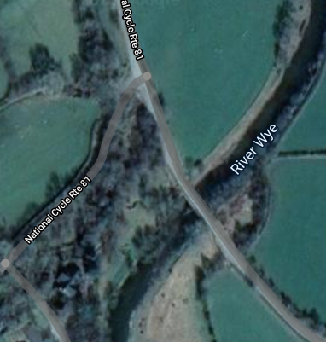
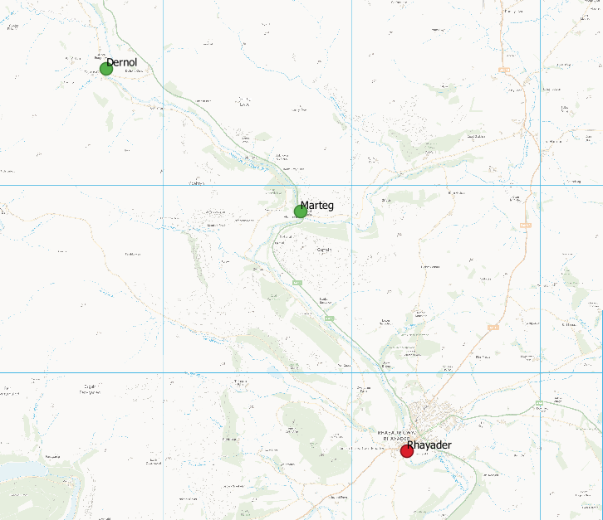
Contains OS open data mapping Crown Copyright reserved 2019
