Wombourne Kayak Club River Guide: Upper Tryweryn
Location: | River Upper Tryweryn – National Water Centre Wales to Bala  Post Code: LL23 7NU  Paddle points - River Tryweryn - Upper  UK Rivers Guide: River Tryweryn - Upper  National Water Centre Wales: National Whitewater Centre Wales  Note: check with centre & book with club code through Paul Elkington  River Levels: - 12/06/21,  River Gauge: | Grid Reference: | Access:  Upper Car Park  Or  Middle Car Park  Egress:  Raft Get out  Or  Above Chapel Falls
Types of Trips: | Club recreational kayak trip
Video Footage: | See Videos:  (1) 17th July 2021 - Rich  https://www.youtube.com/watch?v=VSEHi46SZ1Q  (2) 17th July 2021 - Paul  https://www.youtube.com/watch?v=N4k2g_mReoE  (3) 17th July 2021 - John  https://www.youtube.com/watch?v=DdNbTuWzo2I | Date: | 28th December 2021

Features | National Water Centre Wales: “Upper Tryweryn”. Grade 3 drops continuously.  Top Carpark above “Chipper” area (Eddy Hopping) to “The Graveyard”.  (1) 0.00-4 mins, 11.40-17.19 mins 17th July 2021 https://www.youtube.com/watch?v=VSEHi46SZ1Q – Rich.  (2) 0.00-1.06 mins, 2.11-2.51 mins. 17th July 2021 – https://www.youtube.com/watch?v=N4k2g_mReoE - Paul  (3) 0.00-5.03 Mins. 17th July 2021 https://www.youtube.com/watch?v=DdNbTuWzo2I - John
Features | National Water Centre Wales: “Upper Tryweryn”. Grade 3 drops continuously.  “The Graveyard”.  - 17th July 2021 4.00-6.45 mins, 11.40-17.19-20.38 mins. https://www.youtube.com/watch?v=VSEHi46SZ1Q – Rich.  - 17th July 2021 1.06-1.14 mins, 2.51-3.25 mins. https://www.youtube.com/watch?v=N4k2g_mReoE - Paul  (3) 17th July 2021 https://www.youtube.com/watch?v=DdNbTuWzo2I - John
Features | National Water Centre Wales: “Upper Tryweryn”. Grade 3 drops continuously.  “The Ski Slope”.  - 17th July 2021 1.13-1.20 mins, 3.29-3.35 mins. https://www.youtube.com/watch?v=N4k2g_mReoE - Paul
Features | National Water Centre Wales: “Upper Tryweryn”. Grade 3 drops continuously.  “Mrs. Davis’s Bridge”.  - 17th July 2021 6.45-7.48 mins https://www.youtube.com/watch?v=VSEHi46SZ1Q – Rich.  - 17th July 2021 4.36-4.45 mins. https://www.youtube.com/watch?v=N4k2g_mReoE - Paul  (3) 17th July 2021 5.42-6.49 mins. https://www.youtube.com/watch?v=DdNbTuWzo2I - John  - Note: Right “Eddy” unseen as you approach the bridge & re-circulating “Eddy”, effects management of positioning & angle. Consequently, time to look “Upstream”, particularly as there is a “Blind spot” if paddler has started from previous eddies above final left eddy before the bridge and takes a closer route to “Bridge” stanchion creates further risks from “Oncoming” paddlers or rafts into right “Eddy”. When busy advised to “Eddy” left pass bridge, set up “Lookouts” before bridge to signal clear to proceed.
Features | National Water Centre Wales: “Upper Tryweryn”. Grade 3 drops continuously.  “Café Wave”.  - 17th July 2021 7.50-8.26 mins https://www.youtube.com/watch?v=VSEHi46SZ1Q – Rich.
Features | National Water Centre Wales: “Upper Tryweryn”. Grade 3 drops continuously.  “Fingers”.  - 17th July 2021 8.26-9.38 mins https://www.youtube.com/watch?v=VSEHi46SZ1Q – Rich.  - 17th July 2021 5.16-6.20 https://www.youtube.com/watch?v=N4k2g_mReoE - Paul  - 17th July 2021 6.55-7.48 https://www.youtube.com/watch?v=DdNbTuWzo2I - John
Features | National Water Centre Wales: “Upper Tryweryn”. Grade 3 drops continuously.  “NRA”.  - 17th July 2021 9.38-10.23 mins https://www.youtube.com/watch?v=VSEHi46SZ1Q – Rich.  - 17th July 2021 5.21-6.05 https://www.youtube.com/watch?v=N4k2g_mReoE - Paul  - 17th July 2021 7.48-8.25 Mins. https://www.youtube.com/watch?v=DdNbTuWzo2I - John
Features | National Water Centre Wales: “Upper Tryweryn”. Grade 3 drops continuously.  “Chapel Falls”.  - 17th July 2021 10.24-11.38 mins https://www.youtube.com/watch?v=VSEHi46SZ1Q – Rich.  - 17th July 2021 6.05 – 6.26 Mins. .https://www.youtube.com/watch?v=N4k2g_mReoE - Paul  - 17th July 2021 8.26 – 9.06 Mins. https://www.youtube.com/watch?v=DdNbTuWzo2I - John

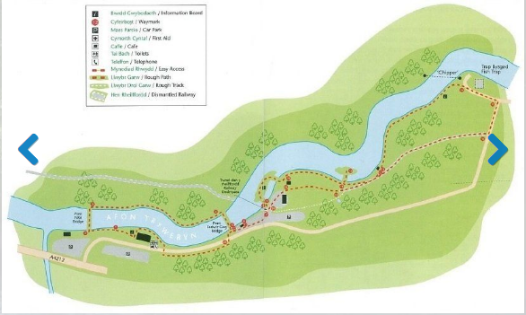
Tryweryn Trail

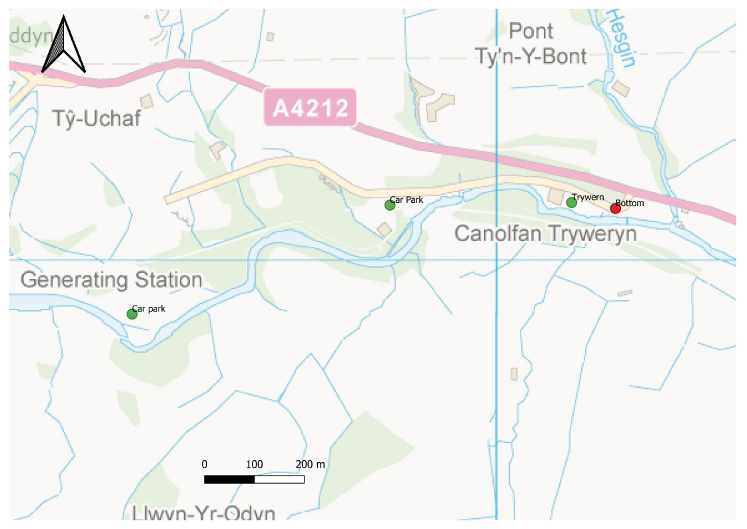
Tryweryn River Map
Backdrop mapping is Ordnance Survey Open Data, Crown Copyright Reserved.

