WHITE-WATER AWARD TRACKING DOCUMENT – Candidate:
Module 1 | Written Evidence | Date  Assessor  Provider | Practical Evidence | Date  Assessor  Provider | “Video” Evidence | Date  Assessor  Provider | Question & Answer | Date  Assessor  Provider
Location  Factor:  River Conditions | Module Guide (1) |  | Planning a river trip:  - Select a river within your assessment remit.  - What grade is your selected river? Does the grade change at any point? |  | Planning a river trip:  - Describe the grade range between 1, 2 and 3 within your video footage. |  | Planning a river trip:  - What grade of river does this qualification assess your performance on?  - What grade is “Jackfield Rapids”? Does the grade change at any point?  - What sections above and below “Jackfield Rapids” can be considered within the grade range 1 to 3?  - What monitoring stations on the River Severn does the club use to check the current water levels at Jackfield Rapids?  - What is the current level today?  - How might we find out this information?  - What features would you expect to see at “Jackfield Rapids”? Do the features “Change” at different levels?  - What features would you expect to see at Ludlow on the river Teme?  - What hazards would you need to be aware of, including birds and humans on the riverbank?
WHITE-WATER AWARD TRACKING DOCUMENT
Module 1 | Written Evidence | Date  Assessor  Provider | Practical Evidence | Date  Assessor  Provider | “Video” Evidence | Date  Assessor  Provider |  | Date  Assessor  Provider
Location  Factor:  Weather Conditions | Module Guide (1) |  | Planning a river trip:  - State source used for gathering a weather forecast, e.g., time, date. |  | Planning river trip:  - Describe the weather footage within your video footage. |  | Planning river trip:  - What is the weather forecast for your planned trip? State source.  - How will this impact your planned trip?  - How did the weather forecast have an impact on your clothing kit decisions when paddling?  - How did the weather forecast impact on the safety precautions for your planned trip?  - List safety equipment worn or carried by you (as a paddler)?  - List safety equipment worn or carried by you (as a group)?

WHITE-WATER AWARD TRACKING DOCUMENT
Module 1 | Written Evidence | Date  Assessor  Provider | Practical Evidence | Date  Assessor  Provider | “Video” Evidence | Date  Assessor  Provider |  | Date  Assessor  Provider
Location  Factor:  Access & Environment | Module Guide (1) |  | Planning a trip:  - State sources used for gathering Access and Environment restrictions. |  | Planning River Trip:  - Describe the Access and Environment restrictions within your video footage. |  | - What restrictions might there be on the water we are paddling? E.g., parking, local access, egress rules, licencing,  - What restrictions have we experienced at Dale End Long-stay car park, Ironbridge when paddling the River Severn from this location down to Jackfield Rapids?  - What environmental factors might affect this decision?  - How would we direct support to us in emergency situations? What communications methods could we use?

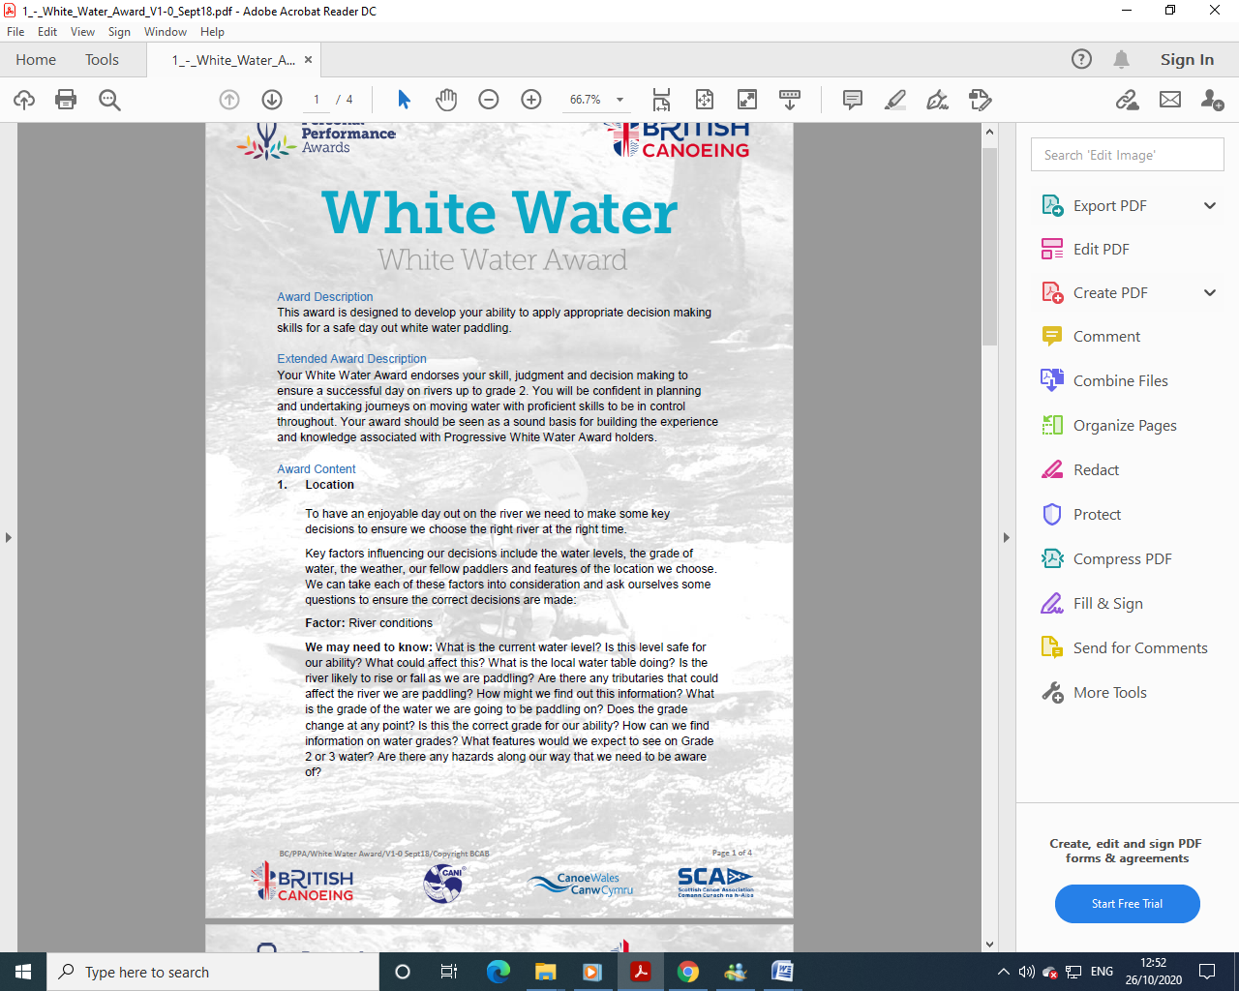

WHITE-WATER AWARD ASSESSORS RECORDING DOCUMENT
Module 1 | Assessor’s Recording Evidence | Date  Assessor  Provider
Location  Factor:  River Conditions |  | 30/03/22  Tutor:  John Teuwen  Assessor:  Rich Dowen

WHITE-WATER AWARD ASSESSORS RECORDING DOCUMENT
Module 1 | Assessor’s Recording Evidence | Date  Assessor  Provider
Location  Factor:  Weather Conditions | 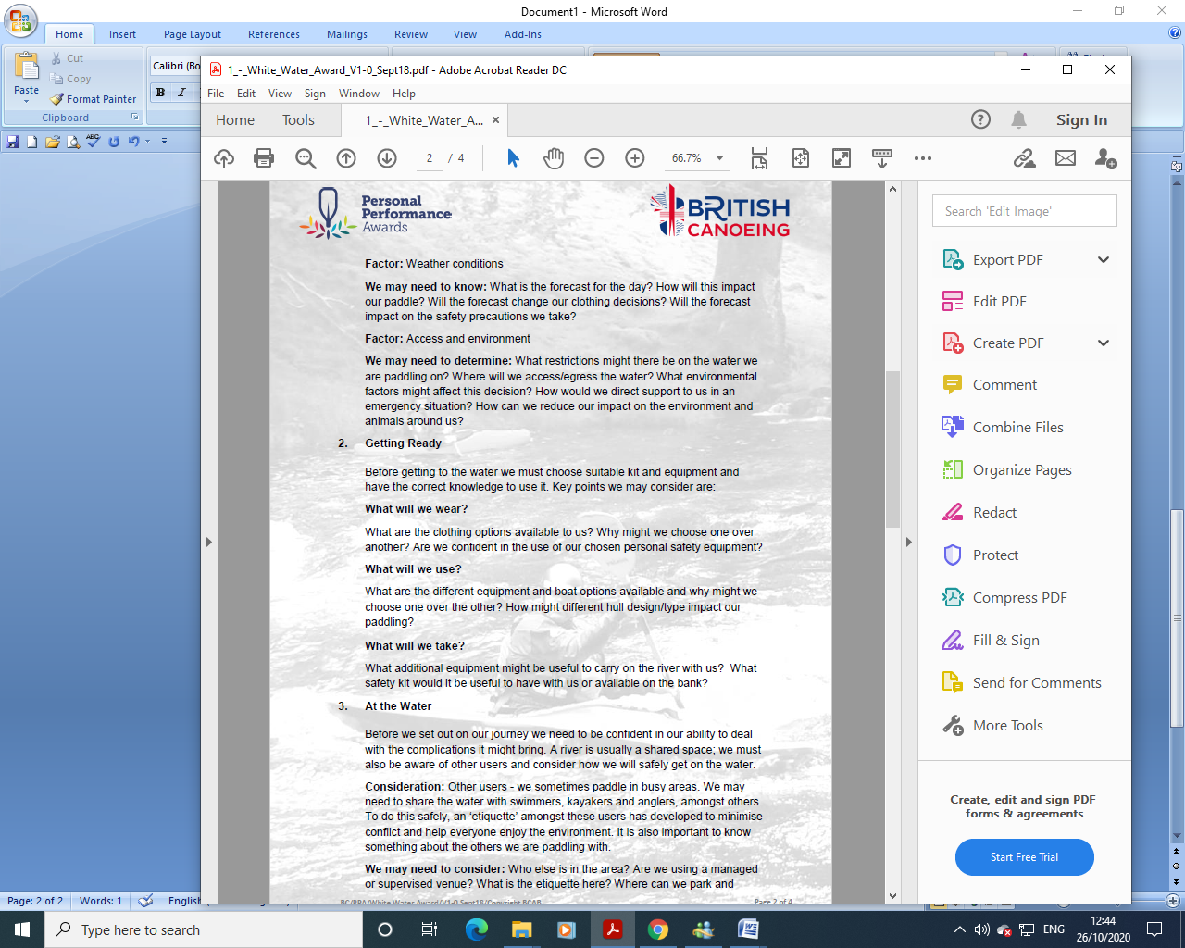 | 30/03/22  Tutor:  John Teuwen  Assessor:  Rich Dowen
Location  Factor:  Access & Environment |  | 30/03/22  Tutor:  John Teuwen  Assessor:  Rich Dowen

Bibliography Reference Resources:
- English River Levels Gov.UK
- Weather Forecast Met. Office
- Weather Report March 2019 Met. Office
- River Hazards Paddling.com
- River Features Palm Bren Orton
- UK Rivers Guide

Wombourne Kayak Club Website – Click on
Risk Assessment – Jackfield Rapids, Banwy, Usk: Talybont to Crickhowell – Search on website
- Health & Safety: Emergency Plan - Pre-planning, On the Water Plan – Search on website
Wombourne Kayak Club: Access issues at dale end car park update?
British Canoeing Resources:
- Course Authorisation & Results video “How to enter”
- Go paddling Paddle points
- Go paddling – Kayaking Safety Checklist
- Major Incident Plan
- Access Charter & Campaign
- CACW Clear Access, Clear Water
- Affiliation & membership provides licensing – English locations
- PROW – Public Rights of way
- (DMMO) Making changes to a Definitive Map Modification Order
- Go paddling – Environment Blog
- Environmental Definitions and Deployment Guidance for Instructors, Coaches and Leaders
- Access and Environment: licensing

- Access and Environment: access to water
- Access and Environment: access to water
- Assess and Environment: good practice
- Invasive and non-invasive species
- Stop the spread of Non-Native species
- Introduction to Paddlesport
Additional Resources for Access and Environment
- Access & Environment – River Usk & Wye
- River Usk & Wye - Issues

Videos
Video Number/ID | Title
1 | Jackfield Rapids 24/07/20
2 | Jackfield Rapids 17/10/20
3 | River Banwy 17/08/19
4 | Specific risk assessment 2018 Trip - Teme
5 | Teme 23/03/2019
6 | Teme 29/08/20 (JT)
7 | Teme 29/08/20 (RD)
8 | River Teme 31/11/20 - Part A
9 | River Teme 31/11/20 Part B
10 | River Usk Part (A) 15/03/19

