Wombourne Kayak Club Risk Assessment
Location: | River Severn – Ironbridge to Half Moon  UK Rivers Guide  Paddle points: search for River Severn | Grid Reference: | 666 036 Access  Egress
Types of Trip: | Club Night or Friends recreational kayak trip -
Video Footage: | https://www.youtube.com/watch?v=EcsrhCwnxhs&t=13s Jackfield Rapids  John: https://www.youtube.com/watch?v=i8gUDz04d9U  Rich:  https://www.youtube.com/watch?v=0kTDusb_OUA | Date: | 1st July 2021
Assessor Name: | John Teuwen | Review:
Position in Club: | Health & Safety | Date Checked & updated:
Date Completed: |  | Signed:

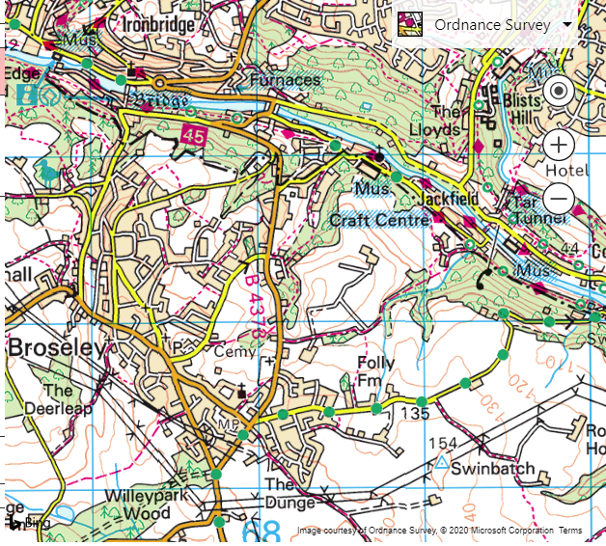
Car Park –
Telford Canoe Club:
Ring John Mills Chairman
Cost: Nominal Car Park Fee
Rapids: 100m

Egress:


Wombourne Kayak Club Risk Assessment – COVID 19 Specific Risks
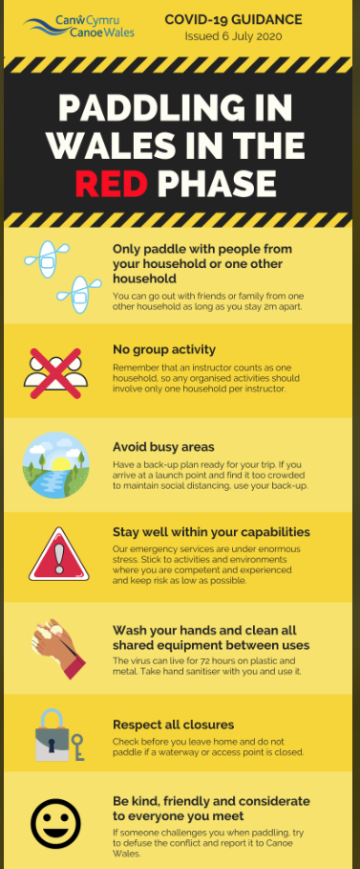
Risk ratings Low, medium, or high: 3 * 3 Risk Matrix

What is the hazard? | Who might be harmed? | How may the risk be adequately controlled? | Risk Ratings:  Low, Medium, High  Grade based 3*3 Risk Matrix & calculation of risk severity chart | Action by whom | What further action is necessary?
COVID 19 Transmission – travel to and from River Severn: Ironbridge-Bridgnorth –  Check British Canoeing guidelines, refer to Wales-Red phase. | Club Members | All members to travel independently to and from the location– no shared vehicles  Any member displaying symptoms, or who thinks they may have been in recent contact with somebody with symptoms, should not attend the session  All briefings and buddy checking to be done in compliance with 2m distancing  Members to arrive as prepared as possible to avoid long changing periods in shared areas  Debriefing to be done after the session if necessary, by WhatsApp or conference call | S = 3 L = 3 = 9 Medium  Unlikely, Harmful | Club coaches & senior members.

What is the hazard? | Who might be harmed? | How may the risk be adequately controlled? | Risk Ratings:  Low, Medium, High  Grade based 3*3 Risk Matrix & calculation of risk severity chart | Action by whom | What further action is necessary?
COVID 19 Transmission – shared equipment | Club Members | Members to bring all own equipment. Any equipment that needs to be loaned from the club should only be used by that member for that session, and should be cleaned before returning to store | S = 3 L = 3 = 9 Medium  Unlikely, Harmful | Club coaches & senior members.
COVID 19 Transmission –rescue | Club Members | All club members to paddle strictly within their own ability, in river levels that are manageable and unlikely to lead to capsizes, injuries or incidents.  In the event of a capsize, members should be encouraged to self rescue to the bank with boat and paddle if possible. If required another member should rescue the boat and paddle using their own boat to move the equipment | S = 3 L = 3 = 9 Medium  Unlikely, Harmful | Correct supervision and group control by instructor, safety brief.
COVID 19 Transmission from club members to members’ family who may be at risk or vulnerable | Club Members’ household | Ask each member attending if they are part of a household which contains somebody who is categorised as “at risk, “vulnerable”, or “shielding”. If they are then that member should not attend the session | S = 4 L = 3 = 12 Medium  Unlikely, Extremely Harmful | Club coaches & senior members.
COVID 19 Transmission –first aid | Club Members | All club members to paddle strictly within their own ability, in river levels that are manageable and unlikely to lead to capsizes, injuries or incidents.  In line with government advice, make sure you wash your hands or use an alcohol gel, before and after treating a casualty also ensure that you don’t cough or sneeze over a casualty when you are treating them  Wear gloves or cover hands when dealing with open wounds  Cover cuts and grazes on your hands with waterproof dressing  Dispose of all waste safely  Do not touch a wound with your bare hand  Do not touch any part of a dressing that will come in contact with a wound  Observe the below protocol for CPR:  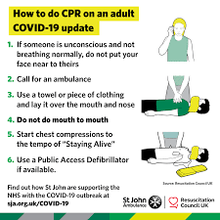 | S = 4 L = 3 = 12 Medium  Unlikely, Harmful | Correct supervision and group control by instructor, safety brief.
Wombourne Kayak Club Risk Assessment
Risk ratings Low, medium, or high: 3 * 3 Risk Matrix

What is the hazard? | Who might be harmed? | How may the risk be adequately controlled? | Risk Ratings:  Low, Medium, High  Grade based 3*3 Risk Matrix & calculation of risk severity chart | Action by whom | What further action is necessary?
Weather & Environmental Conditions: Floods/  Spate conditions | Club Members | Check weather forecast & river levels.  - Dynamic risk assessment.  Re-locate or cancel if inappropriate to group ability  - Weather Forecast:  - River Levels: | S = 5 L = 5 = 25 High  Likely, Extremely Harmful | - Club coaches & senior members.
Drowning | Club Members | - Buoyancy Aids & Helmets must be worn & fitted correctly for all paddlers.  - All club buoyancy aids & helmets are checked & their condition recorded annually.  - Apply “Buddy” checks on helmets & buoyancy aids, boats  - Parental Consent Forms T4 & Adult T4a Trip Participant Statement signed | S = 3 L = 3 = 9 Medium  Likely, Slightly Harmful | - Club coaches & senior members.  - Club equipment officer to undertake checks.  - Club members.  - Club coach’s/secretary
Weather related injury  Hypothermia  Hyperthermia. | Club Members | - Check weather forecast.  - Dynamic risk assessment  - Advised on appropriate clothing to wear.  - Adjustment to clothing as required, e.g. use of wet to dry suit depending on weather forecast, temperature & time of year.  - Sun block, extra water, hot drink, change of clothing, Group shelter | S = 4 L = 4 = 16 Medium  Likely, Harmful | - Club coaches & senior members

Wombourne Kayak Club Risk Assessment
Risk ratings Low, medium, or high: 3 * 3 Risk Matrix

What is the hazard? | Who might be harmed? | How may the risk be adequately controlled? | Risk Ratings:  Low, Medium, High  Grade based 3*3 Risk Matrix & calculation of risk severity chart | Action by whom | What further action is necessary?
Sprains, strains, soft tissue injuries | Club Members | Trained to lift boat correctly  - Ask for help.  - Trained to paddle correctly.  Dynamic risk assessment | S = 2 L = 3 = 6 Low  Likely, Slightly Harmful | - Club coaches & senior members.  - Include in initial Induction & Club Training
Medicinal risks | Club Members | - Members inform club on Application form.  - Members not taking necessary medication.  - Unauthorised consumption of medication | S = 2 L = 2 = 4 Low  Likely, Slightly Harmful | - Agreed action between participants & coaches of routine consumption of necessary medication.  - Coaches may hold any necessary medication on request/agreement of participant involved.
Slips, trips & falls  NB – Jackfield, Steep incline from beach egress, where erosion modifications have been undertaken. | Club Members | - Safety Brief  - Create awareness of river/bank hazards  - Identify hazard areas to paddlers.  - Dynamic risk assessment. | S = 3 L = 3 = 6 Med.  Likely, Slightly Harmful | - Club coaches & senior members.
Wombourne Kayak Club Risk Assessment
Risk ratings Low, medium, or high: 3 * 3 Risk Matrix

What is the hazard? | Who might be harmed? | How may the risk be adequately controlled? | Risk Ratings:  Low, Medium, High  Grade based 3*3 Risk Matrix & calculation of risk severity chart | Action by whom | What further action is necessary?
Pollution & water quality | Club Members | Risks higher in “Spate” conditions  Avoid intentional capsize in poor conditions  Advised to bath/shower after paddle  Made aware of flotsam  Dynamic risk assessment | S = 4 L = 3 = 12 Medium  Likely, Harmful | - Club coaches & senior members. | NB. Pollution from stream at River Cole, Ironbridge; rusty metal colour, paddled above 8th July 2017
Water borne disease’s | Club Members | - All paddlers should shower after paddling and wash their hands before eating. | S =4 L = 2 = 4 Low  Likely, Harmful | - Club Safety Officer to publicise guidelines and provide hand washing and shower facilities on site
Fisherman; various spots below & above rapids; line & hook causing facial injuries | Club Members | - Identify & inform participants & instructors.  Safety brief  - Dynamic risk assessment | S = 2 L = 2 = 4 Low  Likely, Harmful | - Club coaches & senior members.
Swans | Club Members | - Avoid paddling near them in nesting period in Spring  Safety brief  - Dynamic risk assessment | S = 4 L = 3 = 12 Med  Likely, Harmful | - Club coaches & senior members.
Over hanging tree or strainers | Club Members | - Identify hazard areas to paddlers.  Dynamic risk assessment  - Advised to avoid & informed how to escape entrapment. | S = 4 L = 3 = 12 Med  Likely, Harmful | - Club coaches & senior members.

Wombourne Kayak Club Risk Assessment
Risk ratings Low, medium, or high: 3 * 3 Risk Matrix

What is the hazard? | Who might be harmed? | How may the risk be adequately controlled? | Risk Ratings:  Low, Medium, High  Grade based 3*3 Risk Matrix & calculation of risk severity chart | Action by whom | What further action is necessary?
Other paddlers or users on the river; SUP | Club Members | Safety brief  - Navigation rules of the river & awareness of other craft.  Paddlers instructed to be aware of other uses & how to take appropriate action to avoid them.  - Fraying paddles, boats  - Dynamic risk assessment. | S = 3 L = 3 = 9 Medium  Likely, Slightly Harmful | - Club coaches & senior members.
Illness & fatigue | Club Members | Safety brief  Paddlers to inform instructor  - Dynamic risk assessment  - First aid kit, food and water, evacuation procedures and assistance. | S = 3 L = 3 = 9 Medium  Likely, Slightly Harmful | - Club coaches & senior members.
Road Traffic accident  Breakdown | Club Members | Dynamic risk assessment  - First aid kit, food and water, evacuation procedures and assistance. | S = 5 L = 4 = 20 High  Likely, Harmful to extreme | - Club coaches & senior members.
Equipment: unserviceable | Club Members | - Loose seat, footrest, ratchets, missing bung  - Periodic safety checks of equipment, | S = 2 L = 3 = 6 Low  Likely, Slightly Harmful | - Club coaches & senior members.
Wombourne Kayak Club Risk Assessment
Risk ratings Low, medium, or high: 3 * 3 Risk Matrix

What is the hazard? | Who might be harmed? | How may the risk be adequately controlled? | Risk Ratings:  Low, Medium, High  Grade based 3*3 Risk Matrix & calculation of risk severity chart | Action by whom | What further action is necessary?
Jackfield Rapids  704011 – See map | Club Members | Safety brief  - Navigation rules of the river & awareness of other craft.  Paddlers instructed to be aware of other uses & how to take appropriate action to avoid them.  - Fraying paddles, boats  - Dynamic risk assessment. | S = 3 L = 3 = 9 Medium  Likely, Slightly Harmful | - Club coaches & senior members.
Bridge Stanchions’ | Club Members | S = 4 L = 3 = 12 Med  Avoid paddling in front of bridge Stanchions, as this may lead to a capsize. | Correct supervision and group control by instructor, safety brief.  Dynamic risk assessment.

Wombourne Kayak Club Risk Assessment
Risk ratings Low, medium, or high: 3 * 3 Risk Matrix
 | Who might be harmed? | How may the risk be adequately controlled? | Risk Ratings:  Low, Medium, High  Grade based 3*3 Risk Matrix & calculation of risk severity chart | Action by whom | What further action is necessary?
Entrapment | Club Members | Dynamic risk assessment | S = 4 L = 4 = 16 Medium  Likely, Harmful to extreme | - Club coaches & senior members.
Seal Launch | Club Members | Dynamic risk assessment, depending on river level.  - Can cause possible back injury. | S = 3 L = 4 = 12 Medium  Unlikely, harmful | - Club coaches & senior members.
Rolling Practice – Sheltered water | Club Members | Dynamic risk assessment, depending on river level, check using a paddle to ensure enough depth.  - Can cause possible back injury, particularly if taking too many attempts. | S = 3 L = 4 = 12 Medium  Unlikely, harmful | - Club coaches & senior members.
Rolling Practice – Moving water | Club Members | Dynamic risk assessment, depending on river level, check there is enough depth and free from rocks, e.g., centre of “Flow”.  - Can cause possible back injury, particularly if taking too many attempts. | S = 3 L = 4 = 12 Medium  Unlikely, harmful | Club coaches & senior members.

Wombourne Kayak Club Risk Assessment
Risk ratings Low, medium, or high: 3 * 3 Risk Matrix

What is the hazard? | Who might be harmed? | How may the risk be adequately controlled? | Risk Ratings:  Low, Medium, High  Grade based 3*3 Risk Matrix & calculation of risk severity chart | Action by whom | What further action is necessary?
Litter Picking | Club Members | - Protective gloves must be worn when handling litter.  - Use litter pickers to collect litter when possible.  - Instruct participants not to handle any visible sharps and report to relevant authority.  - Warn of the specific risk of fishing hooks and needles.  - In the event of any cuts or scrapes caused by contact with sharp waste, recommend medical care, e.g. qualified 1st aiders amongst paddlers with 1st Aid kit.  - Participants advised not to overload sacks of rubbish and to use opens as intermediate collection points., in the canoes waste bins.  - Participants to use onion sacks or similar Black sacks can be used by open boaters. | S = 3 L = 3 = 9 Medium  Likely, Slightly Harmful | - Club coaches & senior members.

Approved and adopted by Wombourne Kayak Club

Name: John Teuwen Position in Club (e.g. Secretary, Health & Safety Officer)

Signed Date JohnTeuwen.

It is the responsibility of all senior club members to ensure that this guidance is adhered to and where necessary to protect the safety of others.

It is the responsibility of each individual to consider their own safety and to not put others at risk.

Appendix 1

Handout (1) CALCULATION OF RISK SEVERITY

In assessing a RISK you need to take into account two factors:

(1) How serious could an injury be?
(2) How likely is it to occur?

The following would be a rough guideline:

High Risk: A very serious injury that had a high probability of occurring.

Med. Risk:

Either (a) A serious injury unlikely to occur
(b) A lesser injury likely to occur

Low Risk:
Would be a slight injury that was unlikely to occur.

If you take (1) above as a scale of 1 to 5 (5 = high) Seriousness
(2) above as a scale of 1 to 5 (5 = high) Likelihood

Then, multiply them together, this would give a scale as follows:

Translating into: LOW (1-8) MED. (9-17) HIGH RISKS (18-25)

SERIOUSNESS OF INJURY

5 = Very high potential for multiple death and/or wide spread destruction.
4 = High causing death or serious injury to an individual, i.e. reportable accident under the RIDDOR regulations.
3 = Moderate causing injury or disease capable of keeping an individual off work for three days or more, may require reporting under RIDDOR regulations.
2 = Slight causing minor injuries, i.e. person able to continue work after first aid.
1 = No risk of injury or disease.

LIKELIHOOD OF THE EVENT OCCURRING

5 = Very likely, almost certain.
4 = Likely to occur, i.e. easily precipitated with slight carelessness for external event, e.g. vibration.
3 = Quite possible, the accident is only likely to occur with help, i.e. if somebody slips, failure to replace a light, etc.
2 = Possibly - probably is low or minimal.
1 = Not likely at all, there is really no risk and accidents will only occur under freak conditions.
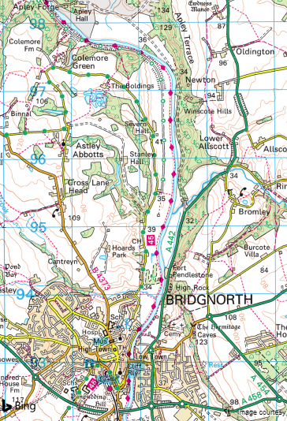
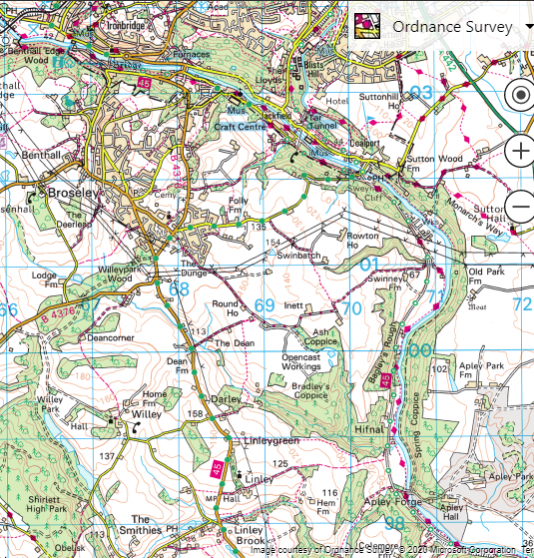
Rapids: 100m
Access:
Egress:
Car Park – Dale End, Long Stay 666 036 Access

Car Park – Severn Park Long Stay 721 933 Egress

