WHITE-WATER AWARD ASSESSORS RECORDING TRACKING DOCUMENT – Candidate:
Module 2 | Written Evidence | Date  Assessor  Provider | Practical Evidence | Date  Assessor  Provider | “Video” Evidence | Date  Assessor  Provider | Question & Answer | Date  Assessor  Provider
Getting Ready – What will we wear?  2.1 | Module Guide (2) |  |  |  |  |  | Planning a river trip:  - What are the clothing options to us during?  - Winter: List and explain “Advantages” & “Disadvantages”.  - Summer: List and explain “Advantages” & “Disadvantages”.  - Explain your choice of clothing for winter and summer.  - What personal safety equipment do you use?  - How confident are you in the use of your chosen personal safety equipment?

WHITE-WATER AWARD TRACKING DOCUMENT
Module 2 | Written Evidence | Date  Assessor  Provider | Practical Evidence | Date  Assessor  Provider | “Video” Evidence | Date  Assessor  Provider |  | Date  Assessor  Provider
Getting Ready – What will we use?  2.2 | Module Guide (2) |  |  |  |  |  | - What are the different equipment and boat options used in white water?  - List and briefly describe the difference:  - Creek  - River runner  - Play boat/rodeo  - Long boats  - Paddle – different materials  - Explain your choice of boat over another?  - Explain your choice of paddle?  - How might different hull design and types impact your paddling? Example: Rich’s Dagger Mamba is different than my Dagger Nomad?

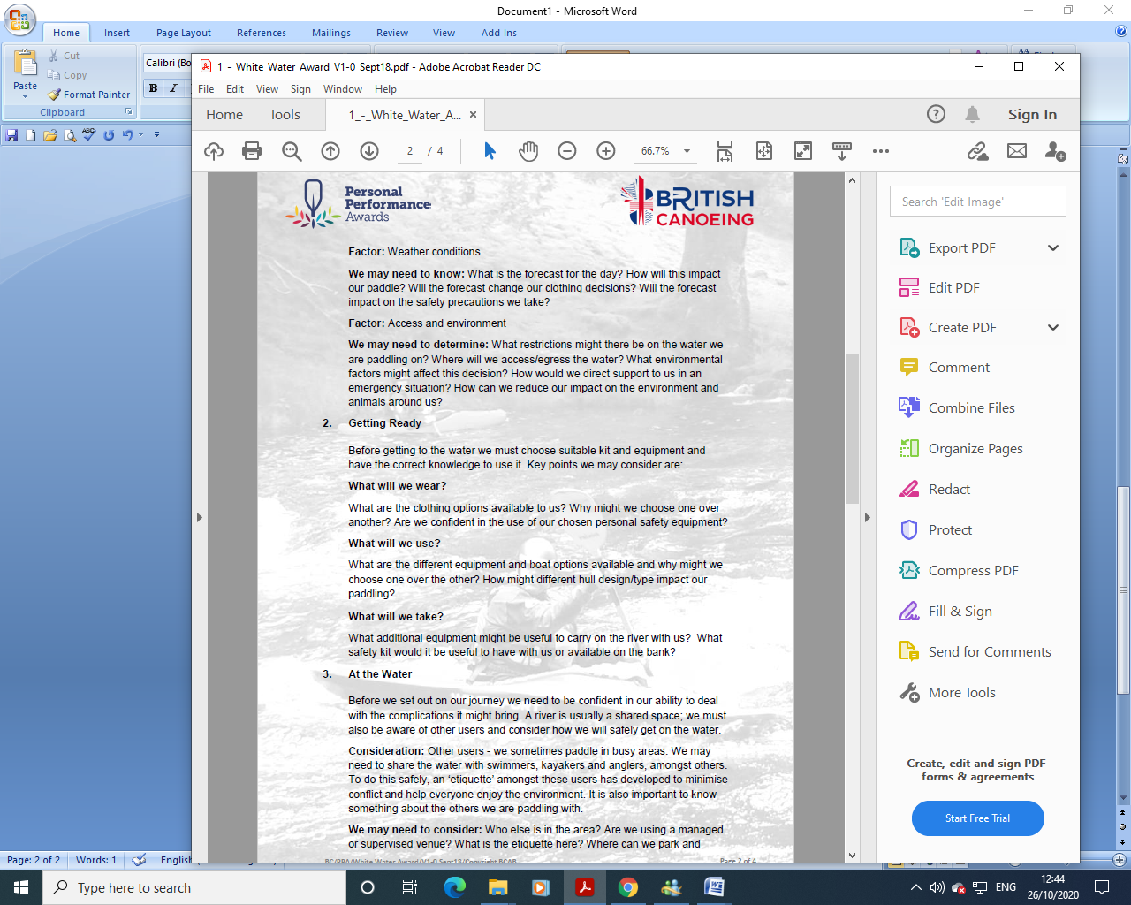
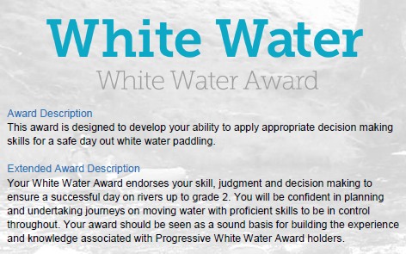
WHITE-WATER AWARD ASSESSORS RECORDING DOCUMENT
Module 2 | Assessor’s Recording Evidence | Date  Assessor  Provider
Getting Ready – What will we wear?  2.1 |  | 31/03/22  Tutor:  John Teuwen  Assessor:  Rich Dowen
Getting Ready – What will we use?  2.2 |  | 31/03/22  Tutor:  John Teuwen  Assessor:  Rich Dowen

Bibliography Reference Resources:
Wombourne Kayak Club Website New site!
Kayak & Paddles
- Equipment & Clothing
- Types of Cagoules
- Types of Dry suits
- Types of Wetsuits
- Types of Footwear
- Types of Trousers
- Types of Spray deck
- Types of PFD's - Buoyancy Aids
- Types of Helmets
- Types of Personal Safety Equipment
- Buoyancy Bags
Miscellaneous
- What does a kayak pinned kit consist of?
- How to set up a pinned kayak rescue
- What does a First Aid kit consist of?
- The difference between kayaks?
- Railed or Displacement?
- Different types of kayak blades
British Canoeing Resources:
- Buying a kayak?
- Ten types of kit to carry on a river trip
- Course Authorisation & Results video “How to enter”

