WHITE-WATER AWARD ASSESSORS RECORDING TRACKING DOCUMENT – Candidate:
Module 3 | Written Evidence | Date  Assessor  Provider | Practical Evidence | Date  Assessor  Provider | “Video” Evidence | Date  Assessor  Provider | Question & Answer | Date  Assessor  Provider
At the Water:  Consideration  3.1  What may we consider? | Module Guide (3) |  |  |  |  |  | - Who should we be considerate of when paddling? For example, what other users may we need to consider at Jackfield?  - Is Wombourne Kayak Club using a managed (Company/Organisation: public, private, voluntary) supervised (Club, Peer Recreationalist, Coach) site at Jackfield Rapids? For example –Who is exactly responsible when club members are paddling?  - Can you consider other managed or supervised sites? For example – man-made sites (Cardiff Whitewater Centre) or “Dam release” locations (Wales National Whitewater Centre) are they managed or supervised?  - How would you describe the paddling “Etiquette” at Jackfield Rapids when using this site?

WHITE-WATER AWARD TRACKING DOCUMENT
Module 3 | Written Evidence | Date  Assessor  Provider | Practical Evidence | Date  Assessor  Provider | “Video” Evidence | Date  Assessor  Provider |  | Date  Assessor  Provider
At the Water:  Consideration  3.1  What may we consider? | Module Guide (3) |  |  |  |  |  | - How can we “Park and change” considerately to other users? For example – Telford Canoe Club site, small public car park or Half Moon Pub  - How would you describe the current paddling ability of club members (p6) Jackfield Rapids? For example, related to the Environment: Sheltered or Moderate Water Areas............  - What do you think motivates (Apply Maslow’s theory) Club members to paddle? .................

Module 3 | Written Evidence | Date  Assessor  Provider | Practical Evidence | Date  Assessor  Provider | “Video” Evidence | Date  Assessor  Provider |  | Date  Assessor  Provider
At the Water:  Consideration  3.2 Health & Safety | Module Guide (3) |  |  |  |  |  | - How can we protect ourselves and others from any potential hazards?  - What damage to our health might repeat immersion in cold water cause? ......  - How can we help prevent this becoming an issue?  - What would we do if someone we are paddling with gets really cold or overheats (p21-22)?  - What potential injuries (Risk Assessment – Jackfield Rapids) might we need to treat?  - How might we treat these injuries (British Canoeing eLearning -1st Aid)?
WHITE-WATER AWARD TRACKING DOCUMENT
Module 3 | Written Evidence | Date  Assessor  Provider | Practical Evidence | Date  Assessor  Provider | “Video” Evidence | Date  Assessor  Provider |  | Date  Assessor  Provider
Getting to the Water:  Consideration  3.3  We may need to determine. | Module Guide (3) |  |  |  |  |  | - How will we get our craft and additional equipment to the water? For example – For example “Access” points at Jackfields – Use video footage to demonstrate “Good Practice” ........  - The water and weather conditions, are they what we expected? ...... For Example – How do we Plan for a trip to a specific location during “winter and summer”.  - What river factors do we need to take into consideration before we get on? For example – Plan for a trip to a specific location during “winter and summer” such as Jackfields, do the grades, features change?

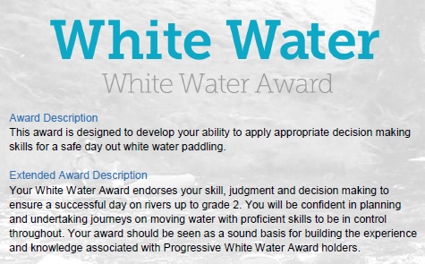
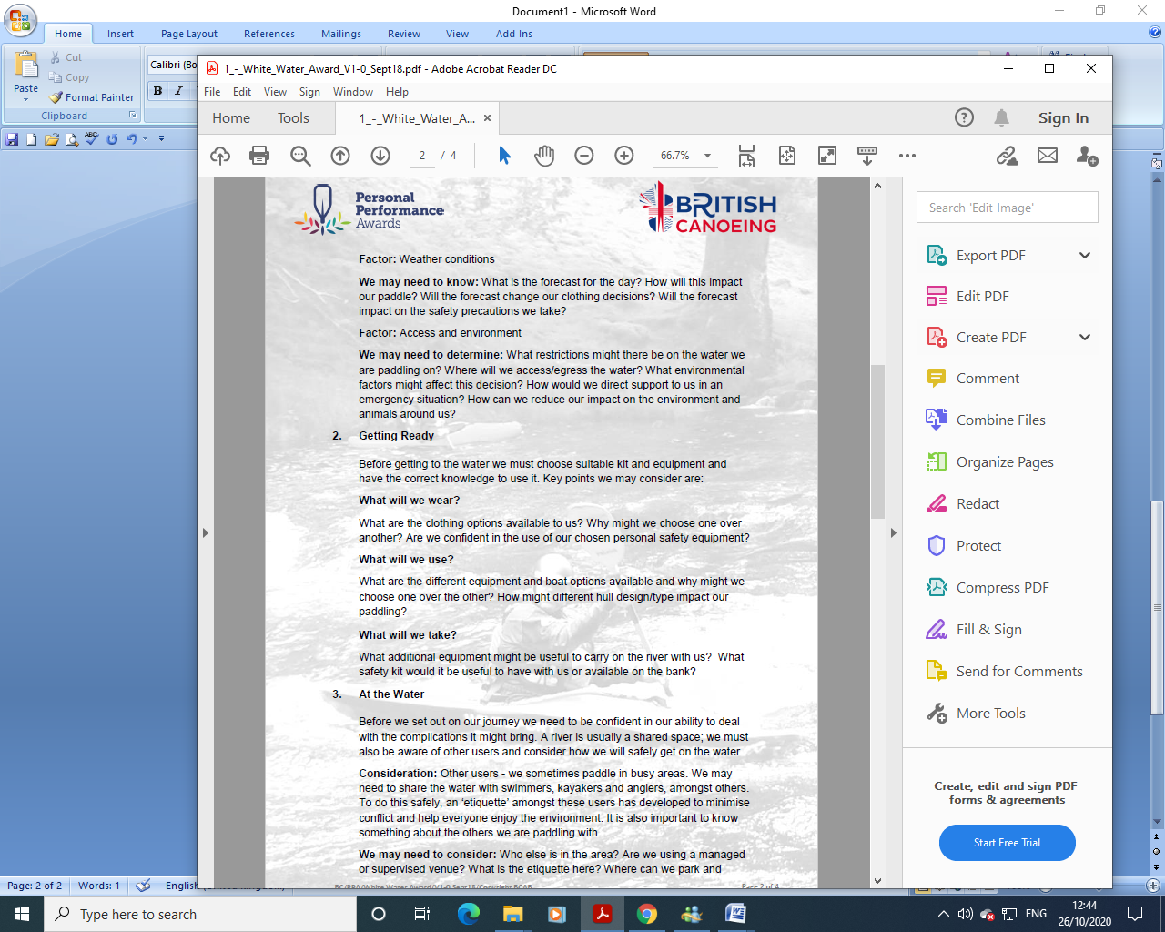
WHITE-WATER AWARD ASSESSORS RECORDING DOCUMENT
Module 3 | Assessor’s Recording Evidence | Date  Assessor  Provider
At the Water:  Consideration  3.1  What may we consider? | 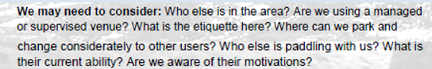 | 31/03/22  Tutor:  John Teuwen  Assessor:  Rich Dowen
WHITE-WATER AWARD ASSESSORS RECORDING DOCUMENT
Module 3 | Assessor’s Recording Evidence | Date  Assessor  Provider
At the Water:  Consideration  3.2 Health & Safety | 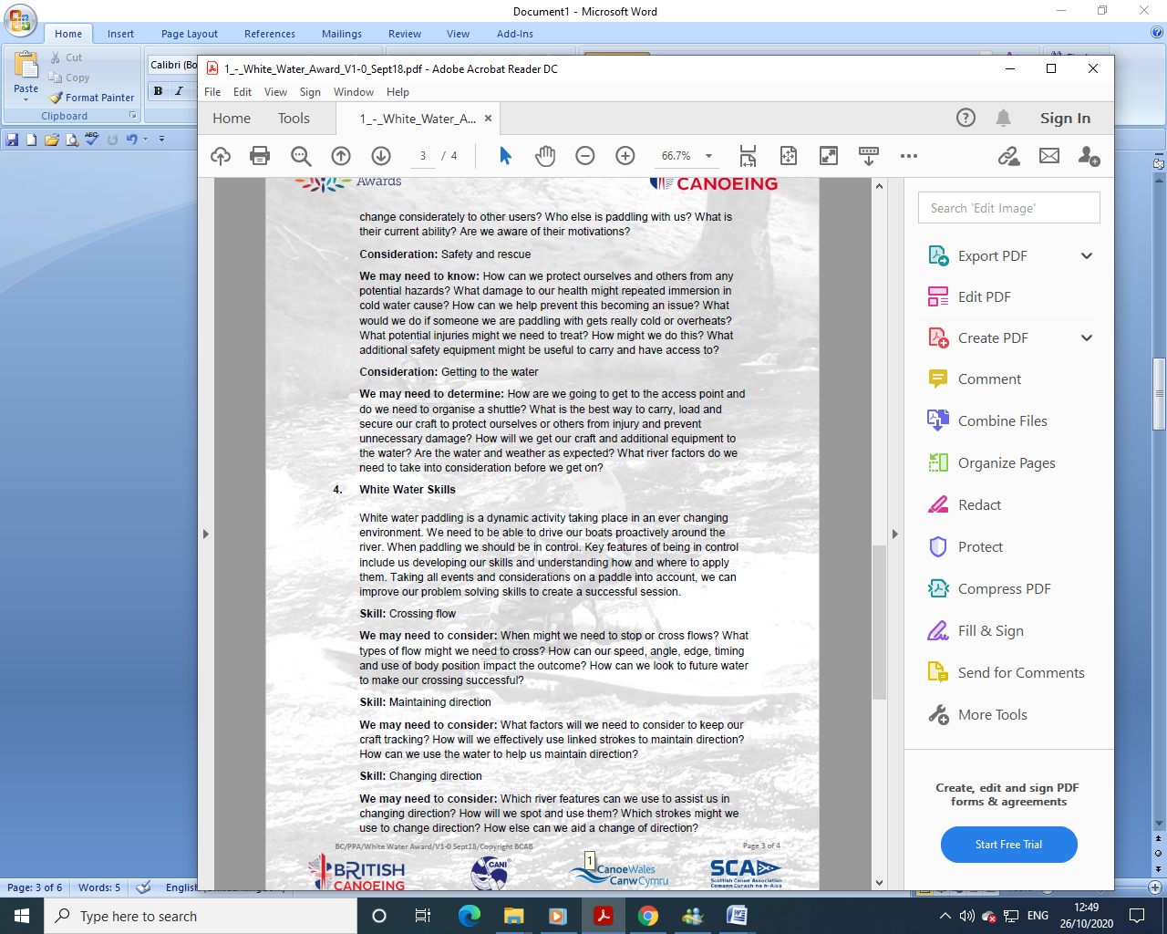 | 31/03/22  Tutor:  John Teuwen  Assessor:  Rich Dowen

WHITE-WATER AWARD ASSESSORS RECORDING DOCUMENT
Module 3 | Assessor’s Recording Evidence | Date  Assessor  Provider
Getting to the Water:  Consideration  3.3  We may need to determine. |  | 31/03/22  Tutor:  John Teuwen  Assessor:  Rich Dowen

Bibliography Reference Resources:

Wombourne Module Guide (2) updated on new website
WHITE-WATER AWARD TRACKING DOCUMENT (2) updated on new website
Wombourne Kayak Club Website use updated version on new website
Course Authorisation & Results video “How to enter”
- English River Levels Gov.UK
- Weather Forecast Met. Office
- Weather Report March 2019 Met. Office
- River Hazards Paddling.com
- River Features Palm Bren Orton
- UK Rivers Guide
- “Etiquette” paddling in a group
- Motivation (Maslow’s Theory)

Wombourne Kayak Club Website - Link
- Risk Assessment – Jackfield Rapids, Banwy, Usk: Talybont to Crickhowell Link
- Health & Safety: Emergency Plan - Pre-planning, On the Water Plan Link
- River Guides Link
Wombourne Kayak Club: Access issues at dale end car park Link

British Canoeing Resources:
- Course Authorisation & Results video “How to enter”
- Go paddling Paddle points
- Ten types of kit to carry on a river trip
- Tips for Staying Warm in Winter
- Kayaking Safety Checklist
- 1st Aid eLearning
- Immersion in cold water
- Prevent Cold Shock
- Environmental Definitions and Deployment Guidance for Instructors, Coaches and Leaders
- Paddlesafer (p21-22)
- Current paddling ability of club members category of ability levels
- Individual & group safety equipment
- Types of Personal Safety Equipment

Videos

Video Number/ID | Title
Video 1 | Jackfield Rapids 17/10/20

