WHITE-WATER AWARD ASSESSORS RECORDING TRACKING DOCUMENT – Candidate:
Module 4 | Written Evidence | Date  Assessor  Provider | Practical Evidence | Date  Assessor  Provider | “Video” Evidence | Date  Assessor  Provider | Question & Answer | Date  Assessor  Provider
White-water Skills  Preparation  Logbook:  - Personal Particulars  - Paddling Experience: record details of sessions, trips, journeys, and expeditions and any other Paddlesport experience  - Courses attended / work with other organisations  - Record the trips, journeys, and expeditions you have led or assisted on.  - Write a short reflection on what you learnt or any developments to consider | Module Guide (4)

WHITE-WATER AWARD TRACKING DOCUMENT
Module 4 | Written Evidence | Date  Assessor  Provider | Practical Evidence | Date  Assessor  Provider | “Video” Evidence | Date  Assessor  Provider |  | Date  Assessor  Provider
White-water Skills  Skill:  4.1  Crossing the flow. | Module Guide (4) |  |  |  |  |  | - When might we need to stop or cross a flow? Describe your moves?  - What type of flows might we need to cross? Describe your moves? E.g., Bottom wave at Jackfields  - How can the speed, angle, edge, timing, and use of body position (Future Water) impact the outcome? Describe your moves?  - How can we look to “Future Water” to make our crossing successful? Describe your moves?

Module 4 | Written Evidence | Date  Assessor  Provider | Practical Evidence | Date  Assessor  Provider | “Video” Evidence | Date  Assessor  Provider |  | Date  Assessor  Provider
White-water Skills  Skill:  4.2  Maintaining Direction. | Module Guide (4) |  |  |  |  |  | - What factors will we need to consider keeping our “Craft Tracking” to maintain direction? Describe your moves?  - How will we effectively use “Linked Strokes” to maintain direction? Describe your moves?  - How can we use the water to help us maintain direction? Describe your moves?

WHITE-WATER AWARD TRACKING DOCUMENT
Module 4 | Written Evidence | Date  Assessor  Provider | Practical Evidence | Date  Assessor  Provider | “Video” Evidence | Date  Assessor  Provider |  | Date  Assessor  Provider
White-water Skills  Skill:  4.3  Changing Direction. | Module Guide (4) |  |  |  |  |  | - What river features can we use to assist us in changing direction? Describe your moves?  - How will we “Spot and Use” river features to assist us in changing direction? Describe your moves? E.g., Eddy behind a rock in the flow of the river?  - What “Strokes” might we use to change direction? Describe your moves?  - What features do we need to avoid?

WHITE-WATER AWARD TRACKING DOCUMENT
Module 4 | Written Evidence | Date  Assessor  Provider | Practical Evidence | Date  Assessor  Provider | “Video” Evidence | Date  Assessor  Provider |  | Date  Assessor  Provider
White-water Skills  Skill:  4.4  Running the river | Module Guide (4) |  |  |  |  |  | - How can we best choose our route down river and identify features that we want to use that aid us?  - What features do we need to avoid?  - How can we use our forward paddling to drive our boat effectively to where we want to be? | 31/03/22  Tutor:  John Teuwen  Assessor:  Rich Dowen

WHITE-WATER AWARD TRACKING DOCUMENT
Module 4 | Written Evidence | Date  Assessor  Provider | Practical Evidence | Date  Assessor  Provider | “Video” Evidence | Date  Assessor  Provider |  | Date  Assessor  Provider
White-water Skills  Skill:  4.5  Dealing with Mishaps. | Module Guide (4) |  |  |  |  |  | - What is our strategy to get back on course and in control? For example – Missing an “Eddy” to position ourselves for the next move down river? Explain your decision.  - What stroke can we use to prevent getting pushed over? Describe your moves?  - Could you roll in “Slacker” water? Use video footage.  - How will you deal with being out of the water? Describe your decisions? (Complete the White-Water Safety and Rescue course.)  - How would we safely get ourselves or others back to shore or into other craft?  - How would we retrieve loose kit, equipment, or boats?  - What factors might affect our decisions on how we retrieve these? Observe tactics. E.g., STVE

White-water Skills  Skill:  4.5  Dealing with Mishaps. | Module Guide (4)  Pages 10: a  Pages 11: b |  | River Vyrnwy 05/09/20 video from 6.36 -6.48mins  River Vyrnwy 05/09/20 video from 10.20 -10.38mins,  Completed the White-Water Safety and Rescue course. |  | https://www.youtube.com/watch?v=PmvEbWvCAco |  | - What is our strategy to get back on course and in control? For example – Missing an “Eddy” to position ourselves for the next move down river? Explain your decision.  - What stroke can we use to prevent getting pushed over? Describe your moves?  - Could you roll in “Slacker” water? Use video footage.  - How will you deal with being out of the water? Describe your decisions?  - How would we safely get ourselves or others back to shore or into other craft?  - How would we retrieve loose kit, equipment, or boats?  - What factors might affect our decisions on how we retrieve these? Observe tactics. E.g., STVE | 31/03/22  Tutor:  John Teuwen  Assessor:  Rich Dowen
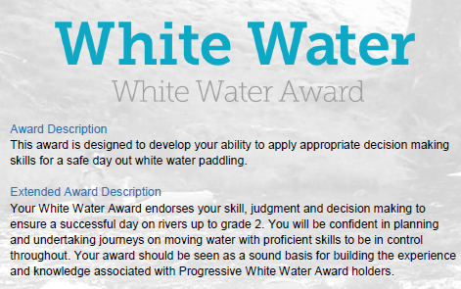

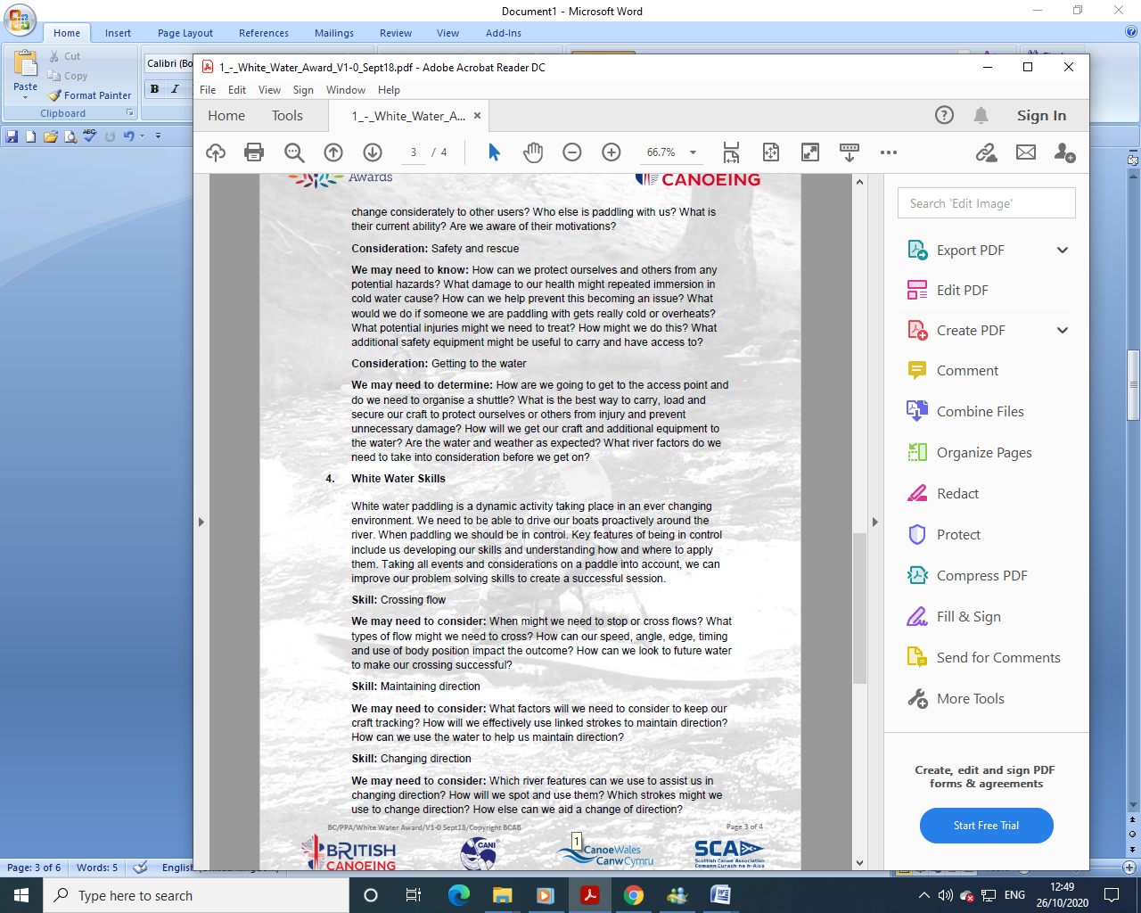
WHITE-WATER AWARD ASSESSORS RECORDING DOCUMENT
Module 4 | Assessor’s Recording Evidence | Date  Assessor  Provider
White-water Skills  Skill:  4.1  Crossing the flow. |  | 31/03/22  Tutor:  John Teuwen  Assessor:  Rich Dowen
WHITE-WATER AWARD ASSESSORS RECORDING DOCUMENT
Module 4 | Assessor’s Recording Evidence | Date  Assessor  Provider
White-water Skills  Skill:  4.2  Maintaining Direction. |  | 31/03/22  Tutor:  John Teuwen  Assessor:  Rich Dowen

WHITE-WATER AWARD ASSESSORS RECORDING DOCUMENT
Module 4 | Assessor’s Recording Evidence | Date  Assessor  Provider
White-water Skills  Skill:  4.3  Changing Direction. |  | 31/03/22  Tutor:  John Teuwen  Assessor:  Rich Dowen
WHITE-WATER AWARD ASSESSORS RECORDING DOCUMENT
Module 4 | Assessor’s Recording Evidence | Date  Assessor  Provider
White-water Skills  Skill:  4.4  Running the river | 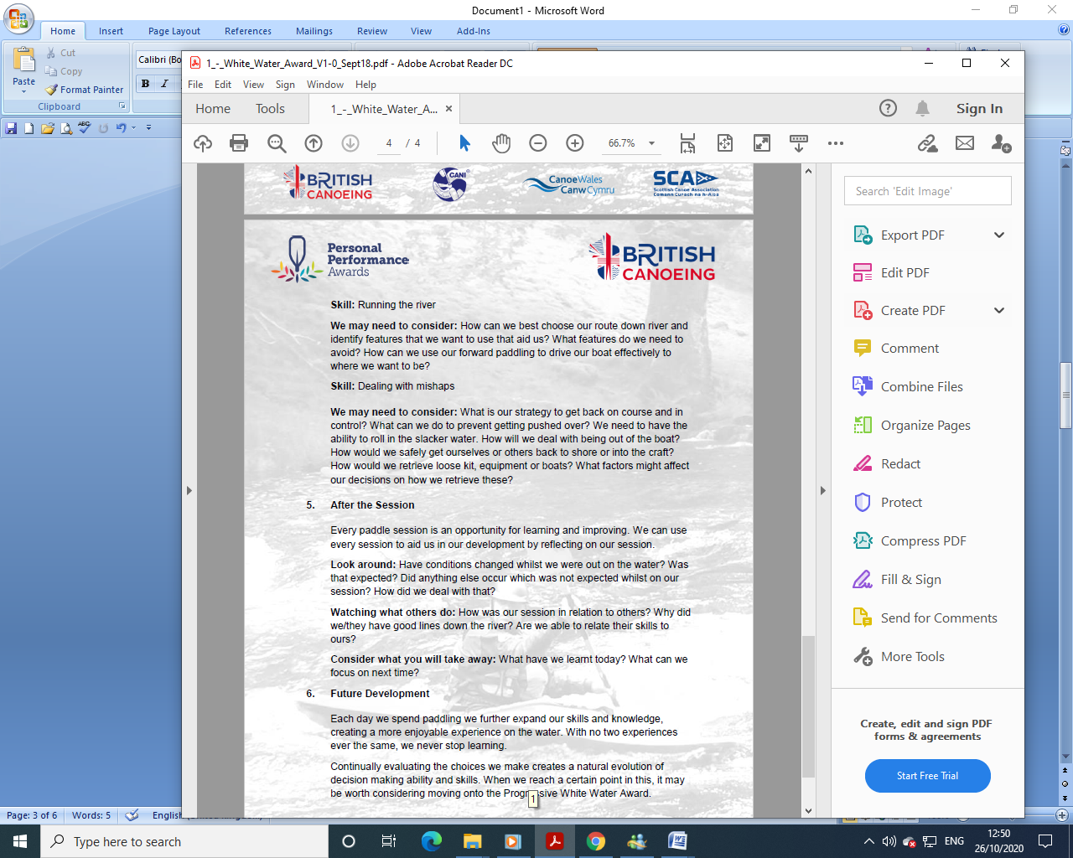 | 31/03/22  Tutor:  John Teuwen  Assessor:  Rich Dowen

WHITE-WATER AWARD ASSESSORS RECORDING DOCUMENT
Module 4 | Assessor’s Recording Evidence | Date  Assessor  Provider
White-water Skills  Skill:  4.5  Dealing with Mishaps. |  | 31/03/22  Tutor:  John Teuwen  Assessor:  Rich Dowen

WHITE-WATER AWARD ASSESSORS RECORDING DOCUMENT

Bibliography Reference Resources:

Wombourne Module Guide (2) updated on new website
WHITE-WATER AWARD TRACKING DOCUMENT (2) updated on new website
Wombourne Kayak Club Website use updated version on new website
Course Authorisation & Results video “How to enter”

Wombourne Kayak Club Website New
logbook New

Videos
Video Number/ID | Title
1 | River Vyrnwy 05/09/20
2 | River Banwy 10/10/20
3 | River Usk Part (A) 15/03/19

