WHITE-WATER AWARD ASSESSORS RECORDING TRACKING DOCUMENT – Candidate:
Module 5 | Written Evidence | Date  Assessor  Provider | Practical Evidence | Date  Assessor  Provider | “Video” Evidence | Date  Assessor  Provider | Question & Answer | Date  Assessor  Provider
After the Session:  Preparation  Logbook:  - Personal Particulars  - Paddling Experience: record details of sessions, trips, journeys, and expeditions and any other Paddlesport experience  - Courses attended / work with other organisations  - Record the trips, journeys, and expeditions you have led or assisted on.  - Write a short reflection on what you learnt or any developments to consider | Module Guide (5)

WHITE-WATER AWARD TRACKING DOCUMENT
Module 5 | Written Evidence | Date  Assessor  Provider | Practical Evidence | Date  Assessor  Provider | “Video” Evidence | Date  Assessor  Provider |  | Date  Assessor  Provider
After the Session:  5.1  Look around on your next river trip.  Identify video footage that demonstrates with times this skill recorded in your logbook.  . | Module Guide (5) |  |  |  |  |  | - Have conditions changed whilst you were on the water? Identify and explain the changes.  - Explain any other unexpected incidents, which were not expected?  - Explain how the group dealt with the unexpected incidents.

Module 5 | Written Evidence | Date  Assessor  Provider | Practical Evidence | Date  Assessor  Provider | “Video” Evidence | Date  Assessor  Provider |  | Date  Assessor  Provider
Watching what others do:  5.2  Identify video footage that demonstrates with times this skill recorded in your logbook. | Module Guide (5) |  |  |  |  |  | - How was our session or trip in relation to other similar sessions or trips?  - Explain how the more experienced paddlers had good lines down the river?  - Explain how you were able to relate their skills to your personal development?

WHITE-WATER AWARD TRACKING DOCUMENT
Module 5 | Written Evidence | Date  Assessor  Provider | Practical Evidence | Date  Assessor  Provider | “Video” Evidence | Date  Assessor  Provider |  | Date  Assessor  Provider
Consider what you will take away:  5.3  Identify video footage that demonstrates with times this skill recorded in your logbook. | Module Guide (5) |  |  |  |  |  | - What have you learnt today? What went well? What needs to be developed?  - How can you focus on your development needs next time?

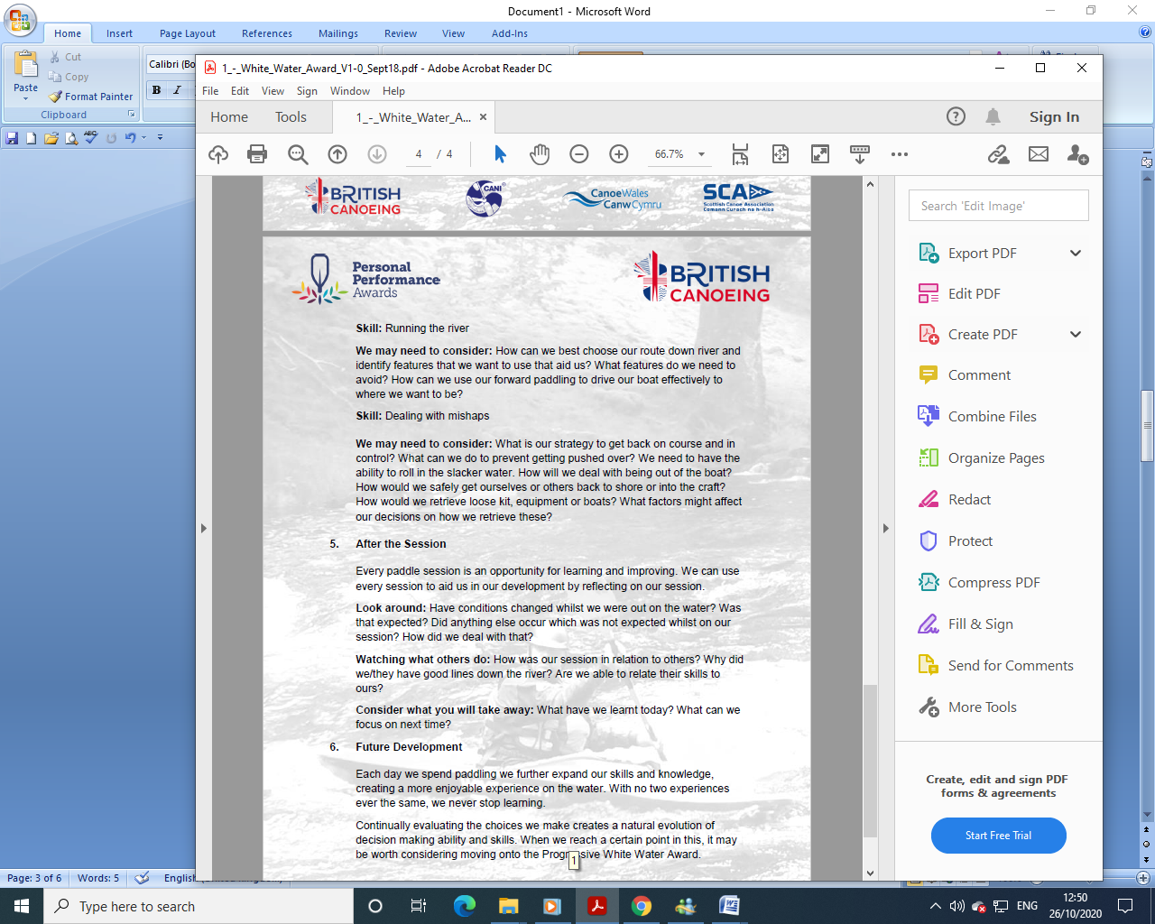
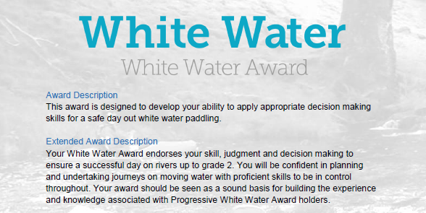
Section 5:

This section is about the continual learning process, how and what do you learn from your paddling experiences? Use videos of club paddles with reference to timings to explain your answers and what you have learned.

WHITE-WATER AWARD ASSESSORS RECORDING DOCUMENT
Module 5 | Assessor’s Recording Evidence | Date  Assessor  Provider
After the Session:  5.1  Look around on your next river trip.  Identify video footage that demonstrates with times this skill recorded in your logbook. |  | 31/03/22  Tutor:  John Teuwen  Assessor:  Rich Dowen

WHITE-WATER AWARD ASSESSORS RECORDING DOCUMENT
Module 5 | Assessor’s Recording Evidence | Date  Assessor  Provider
Watching what others do:  5.2  Identify video footage that demonstrates with times this skill recorded in your logbook. |  | 31/03/22  Tutor:  John Teuwen  Assessor:  Rich Dowen
WHITE-WATER AWARD ASSESSORS RECORDING DOCUMENT
Module 5 | Assessor’s Recording Evidence | Date  Assessor  Provider
Consider what you will take away:  5.3  Identify video footage that demonstrates with times this skill recorded in your logbook. |  | 31/03/22  Tutor:  John Teuwen  Assessor:  Rich Dowen

WHITE-WATER AWARD ASSESSORS RECORDING DOCUMENT

Bibliography Reference Resources:

Wombourne Module Guide (2) updated on new website
WHITE-WATER AWARD TRACKING DOCUMENT (2) updated on new website
Wombourne Kayak Club Website use updated version on new website
Course Authorisation & Results video “How to enter”

Wombourne Kayak Club Website New
logbook New
British Canoeing
Development Pathway Paddlesup
Paddle Award Instructor
Leadership Moderate Water
Coach Self Analysis
Information on Mentors and Coaches
Videos Foundation Safety Rescue Training
Safety and Personal Development
Coach Award
Changes to “Safeguarding”
Digital Library
Coaching Qualifications Courses
Download British Canoeing Adapted Coaching & Leadership Logbook

