WHITE-WATER AWARD ASSESSORS RECORDING TRACKING DOCUMENT – Candidate:
Module 6 | Written Evidence | Date  Assessor  Provider | Practical Evidence | Date  Assessor  Provider | “Video” Evidence | Date  Assessor  Provider | Question & Answer | Date  Assessor  Provider
After the Session:  Preparation  Logbook:  - Personal Particulars  - Paddling Experience: record details of sessions, trips, journeys, and expeditions and any other Paddlesport experience  - Courses attended / work with other organisations  - Record the trips, journeys, and expeditions you have led or assisted on.  - Write a short reflection on what you learnt or any developments to consider | Module Guide (5) |  |  |  |  |  | - Identify areas of Continuous Personal Development (CPD).  For Example, research  British Canoeing "Paddles-Up"  - How do you want to develop?  - Different types of courses  - Continuous Professional Development (CPD) - Kayak Flowchart

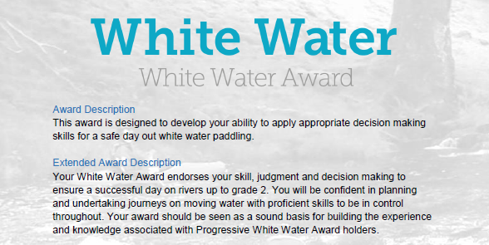

WHITE-WATER AWARD ASSESSORS RECORDING DOCUMENT
Module 6 | Assessor’s Recording Evidence | Date  Assessor  Provider
After the Session:  Preparation  6.1 Logbook | 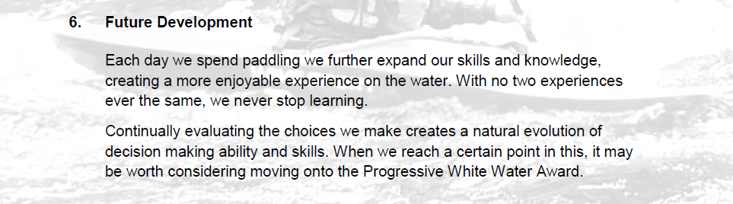 | 31/03/22  Tutor:  John Teuwen  Assessor:  Rich Dowen

WHITE-WATER AWARD ASSESSORS RECORDING DOCUMENT

Bibliography Reference Resources:

Wombourne Module Guide (2) updated on new website
WHITE-WATER AWARD TRACKING DOCUMENT (2) updated on new website
Wombourne Kayak Club Website use updated version on new website
Course Authorisation & Results video “How to enter”

Wombourne Kayak Club Website New
logbook New
British Canoeing
Development Pathway Paddles up
Paddle Award Instructor
Leadership Moderate Water
Coach Self Analysis
Information on Mentors and Coaches
Videos Foundation Safety Rescue Training
Safety and Personal Development
Coach Award
Changes to “Safeguarding”
Digital Library
Download British Canoeing Adapted Coaching & Leadership Logbook
Appendix 1
Continuous Professional Development (CPD) Kayak Flowchart

Leadership | Personal Performance Awards | Coaching | Safety | Continuous Professional Development Validity (CPD)  https://www.britishcanoeingawarding.org.uk/new-continuous-professional-development-system-to-support-you/  20 points = 3 years  10 points = 18 months
 | Paddle Start
 | Paddle Discover  Equivalent 1* |  | FSRT  Foundation Safety & Rescue Training | 18 Months  10 points = 18 months
Paddlesport Leader | Paddle Explore  Equivalent 2* | Paddlesport Instructor  Level 1 Coach |  | 3 years?  20 points = 3 years
 |  | Kayak Coach  Sheltered Water |  | 3 years  20 points = 3 years
White Water Leader  (Moderate White-Water) | White Water Award  Equivalent 5* | White Water Kayak Coach | WWSR  White-water Safety & Rescue | 3 years  20 points = 3 years
 |  | Progressive Water Award  Equivalent 4* |  | 3 years  20 points = 3 years
 |  | Advanced Water Award  Equivalent 5* | Advanced WWSR  White-water Safety & Rescue | 3 years  20 points = 3 years

