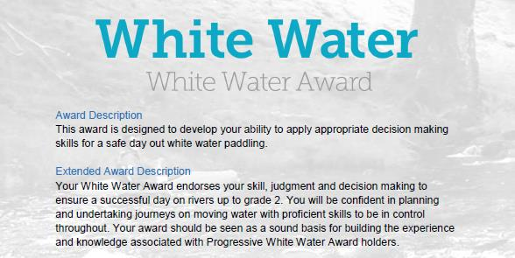
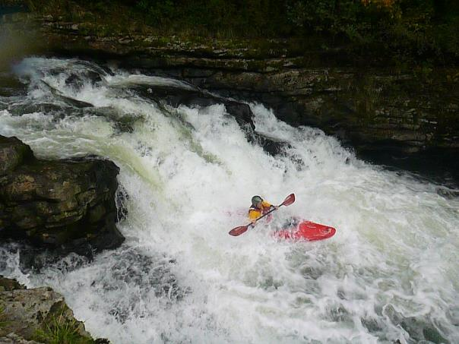
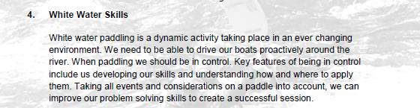

Section 4: White Water Skills:
This section asks us to explain some of the paddling techniques we need when paddling white water. Here we can complete the document with explanations from our own experiences, the resources at the end of the document and with video's from our and club paddles. Please link and reference the relevant video and timings in your answers.
However, depending on the individual there are various options to complete this section:
- Complete the Section 4 - Module Guide Questions. Or........
- Provide a “Video”, recording your actions or visual images explaining your knowledge and understanding within the questions asked. Or....
- Use the available Reference resources listed at the end to support your answers or decision-making for each section.

Preparation:
- Personal Particulars

- Paddling Experience: record details of sessions, trips, journeys, and expeditions and any other Paddlesport experience
- Courses attended / work with other organisations
- Record the trips, journeys, and expeditions you have led or assisted on.

1a. Use the Logbook template to record these particulars. See Wombourne Kayak Club Website
Menu – White Water Award

- Write a short reflection on what you learnt or any developments to consider

White Water Award
Skill: Crossing the Flow
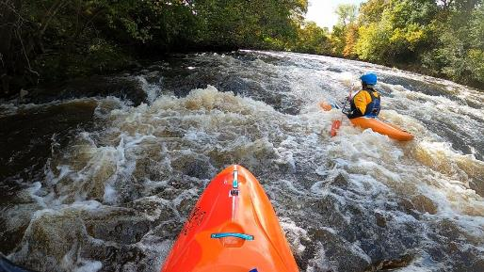

Identify video footage that demonstrates with times this skill recorded in your logbook.
- When might we need to stop or cross a flow? Describe your moves?

Example: Video 1 – watch paddlers from 5.36-5.54 River Vyrnwy, Gorge 05/0920

- What type of flows might we need to cross? Describe your moves?

Example: Video 2 - watch paddlers from 2.15 mins. River Banwy 10/10/20

- How can the speed, angle, edge, timing, and use of body position (Future Water) impact the outcome? Describe your moves?

Example: Video 2 - watch paddlers from 1.30 mins. River Banwy 10/10/20

- How can we look to “Future Water” to make our crossing successful? Describe your moves?

Example: Video 1 – watch paddlers from 2.22-2.49 River Vyrnwy, Gorge 05/0920

Skill: Maintaining Direction
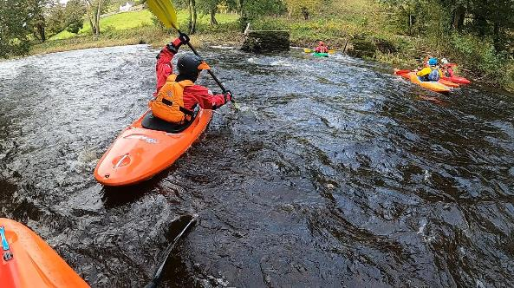

Identify video footage that demonstrates with times this skill recorded in your log book.
- What factors will we need to consider keeping our “Craft Tracking” to maintain direction? Describe your moves?

Example: Video 1 – watch paddlers from 0.22-0.59 River Vyrnwy, Gorge 05/0920

- How will we effectively use “Linked Strokes” to maintain direction? Describe your moves?

Example: Video 1 – watch paddlers from 1.39-1.49 River Vyrnwy, Gorge 05/0920

- How can we use the water to help us maintain direction? Describe your moves?

Example: Video 1 – watch paddlers from 6.36-6.48 River Vyrnwy, Gorge 05/0920

Skill: Changing Direction
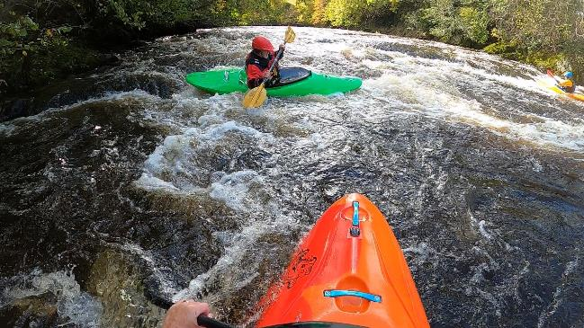
Identify video footage that demonstrates with times this skill recorded in your logbook.
- What river features can we use to assist us in changing direction? Describe your moves?

Example: Video 1 – watch paddlers from 7.50-8.29 River Vyrnwy, Gorge 05/0920

- How will we “Spot and Use” river features to assist us in changing direction? Describe your moves?

Example: Video 1 – watch paddlers from 12.00-12.35 River Vyrnwy, Gorge 05/0920

- What “Strokes” might we use to change direction? Describe your moves?

Example: Video 1 – watch paddlers from 13.35-13.54 River Vyrnwy, Gorge 05/0920

- How else can we aid a change of direction? Describe your moves?

Example: Video 1 – watch paddlers from 4.29-4.54 River Vyrnwy, Gorge 05/0920

Skill: Running the River
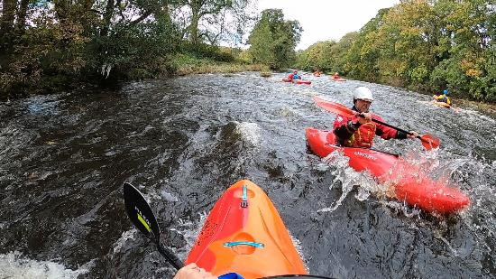

Identify video footage that demonstrates with times this skill recorded in your logbook.
- How can we best choose our route down river and identify features that we want to use that aid us? What are you looking for in “Future” water? Explain your route?
Example: Video 1 – watch paddlers from 12.50-12.58 River Vyrnwy, Gorge 05/0920

- What features do we need to avoid?

Example: Video 1 – watch paddlers from 8.50-9.05, 10.20-12.38, River Vyrnwy, Gorge 05/0920

- How can we use our forward paddling to drive our boat effectively to where we want to be? Describe your moves?

Example: Video 1 – watch paddlers from 10.20-12.38, River Vyrnwy, Gorge 05/0920

Skill: Dealing with Mishaps
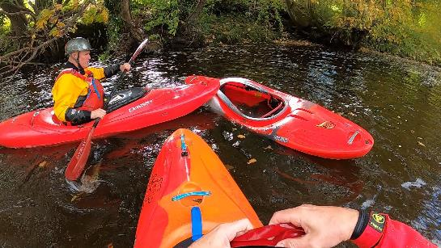

Identify video footage that demonstrates with times this skill recorded in your logbook.
- What is our strategy to get back on course and in control? For example – Missing an “Eddy” to position ourselves for the next move down river? Explain your decision.

Example: Video 1 – watch paddlers from 6.36-6.48, River Vyrnwy, Gorge 05/0920

- What stroke can we use to prevent getting pushed over? Describe your moves?
Example: Video 1 – watch paddlers from 10.20-10.38, River Vyrnwy, Gorge 05/0920

- Could you roll in “Slacker” water? Use video footage.

- How will you deal with being out of the water? Describe your decisions?
(Complete the White-Water Safety and Rescue course.)

Example: Video 3 from 7.10 -10.15 minutes. River Usk 15/03/19

- How would we safely get ourselves or others back to shore or into other craft?

Example: Video 1 – watch paddlers from 3.24, 8.50-9.05, River Vyrnwy, Gorge 05/0920

- How would we retrieve loose kit, equipment, or boats?

Example: Video 1 – watch paddlers from 3.24, 8.50-9.05, River Vyrnwy, Gorge 05/0920

- What factors might affect our decisions on how we retrieve these? Observe tactics.

Example: Video 1 – watch paddlers from 3.24, 8.50-9.05, River Vyrnwy, Gorge 05/0920

.

Reference Resources:
Wombourne Kayak Club Resources:

Wombourne Kayak Club Website

Videos
Video Number/ID | Title
1 | River Vyrnwy 05/09/20
2 | River Banwy 10/10/20
3 | River Usk Part (A) 15/03/19

