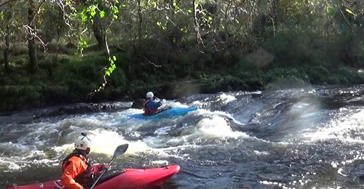
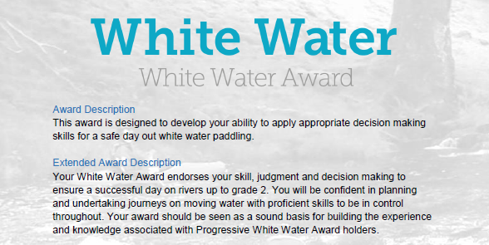
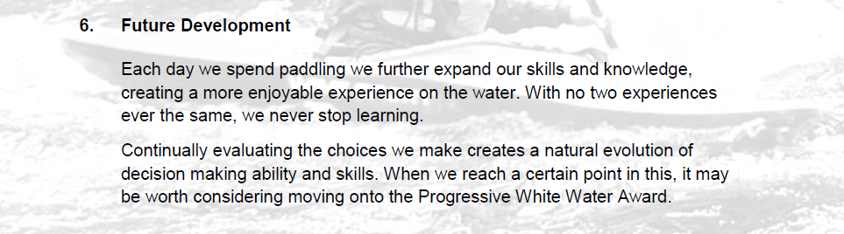

Section 6: Future development:
How do you plan to further expand your knowledge? How will you progress your paddling? This section looks for you to document how you think you will develop yourself as a paddler in future.
However, depending on the individual there are various options to complete this section:
- Complete the Section 5 - Module Guide Questions. Or........
- Provide a “Video”, recording your actions or visual images explaining your knowledge and understanding within the questions asked. Or....
- Plan a “River Trip” during the “Summer” and one for the “Winter” months, providing the necessary information to a “New” club member with limited white-water experience. Or...
- A combination of the “Options” to suit your learning.
Use the available Reference resources listed at the end to support your answers or decision-making for each section.

Preparation:
- Complete sections in British Canoeing Adapted Coaching & Leadership Logbook
See Wombourne Kayak Club Website Menu – White Water Award

- Personal Particulars
- Paddling Experience: record details of sessions, trips, journeys and expeditions and any other Paddlesport experience
- Courses attended / work with other organisations
- Record the trips, journeys and expeditions you have led or assisted on.
- Training & Assessment Record

- Identify areas of Continuous Personal Development (CPD). For Example, research British Canoeing "Paddles-Up"

- How do you want to develop?
- Different types of courses
- Continuous Professional Development (CPD) - Kayak Flowchart

Reference Resources:
Wombourne Kayak Club Resources:
Wombourne Kayak Club Website
See Menu – White Water Award to access Logbook

British Canoeing
Development Pathway Paddles up
Paddle Award Instructor
Leadership Moderate Water
Coach Self Analysis
Information on Mentors and Coaches
Videos Foundation Safety Rescue Training
Safety and Personal Development
Coach Award
Changes to “Safeguarding”
Digital Library
Download British Canoeing Adapted Coaching & Leadership Logbook

Appendix 1

Continuous Professional Development (CPD) Kayak Flowchart

Leadership | Personal Performance Awards | Coaching | Safety | Continuous Professional Development Validity (CPD)  https://www.britishcanoeingawarding.org.uk/new-continuous-professional-development-system-to-support-you/  20 points = 3 years  10 points = 18 months
 | Paddle Start
 | Paddle Discover  Equivalent 1* |  | FSRT  Foundation Safety & Rescue Training | 18 Months  10 points = 18 months
Paddlesport Leader | Paddle Explore  Equivalent 2* | Paddlesport Instructor  Level 1 Coach |  | 3 years?  20 points = 3 years
 |  | Kayak Coach  Sheltered Water |  | 3 years  20 points = 3 years
White Water Leader  (Moderate White-Water) | White Water Award  Equivalent 5* | White Water Kayak Coach | WWSR  White-water Safety & Rescue | 3 years  20 points = 3 years
 |  | Progressive Water Award  Equivalent 4* |  | 3 years  20 points = 3 years
 |  | Advanced Water Award  Equivalent 5* | Advanced WWSR  White-water Safety & Rescue | 3 years  20 points = 3 years

