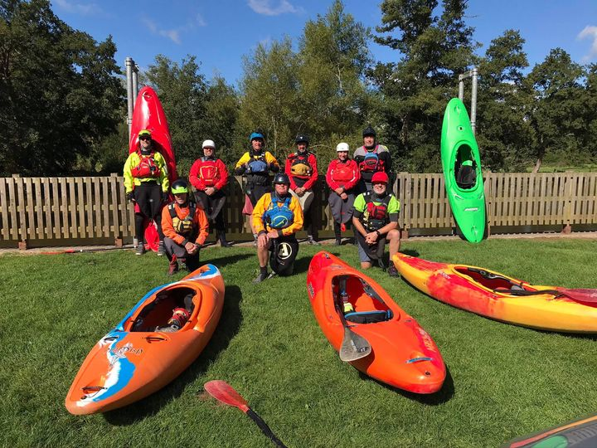
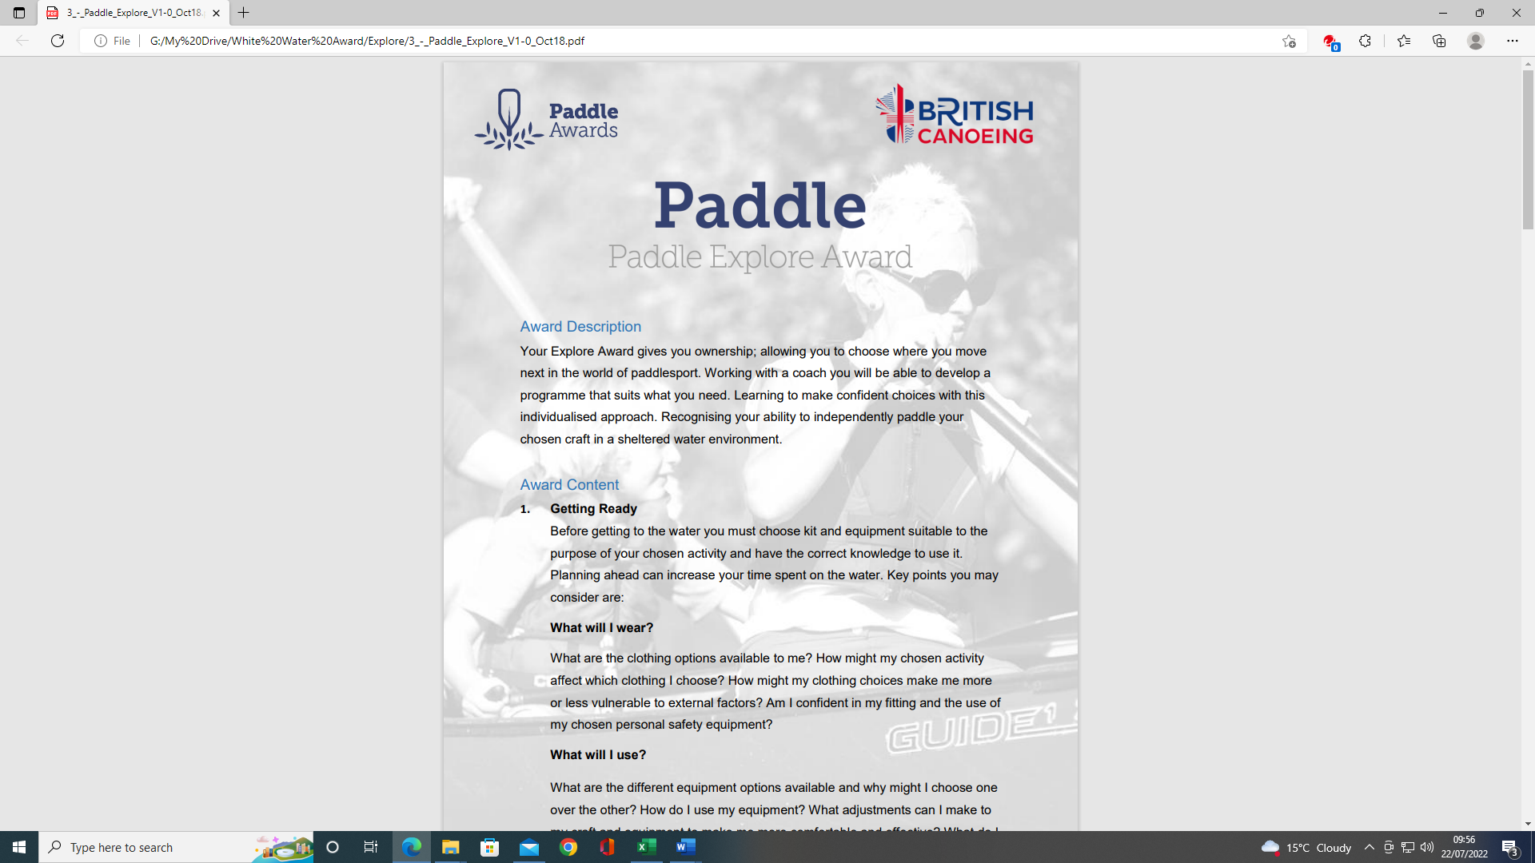
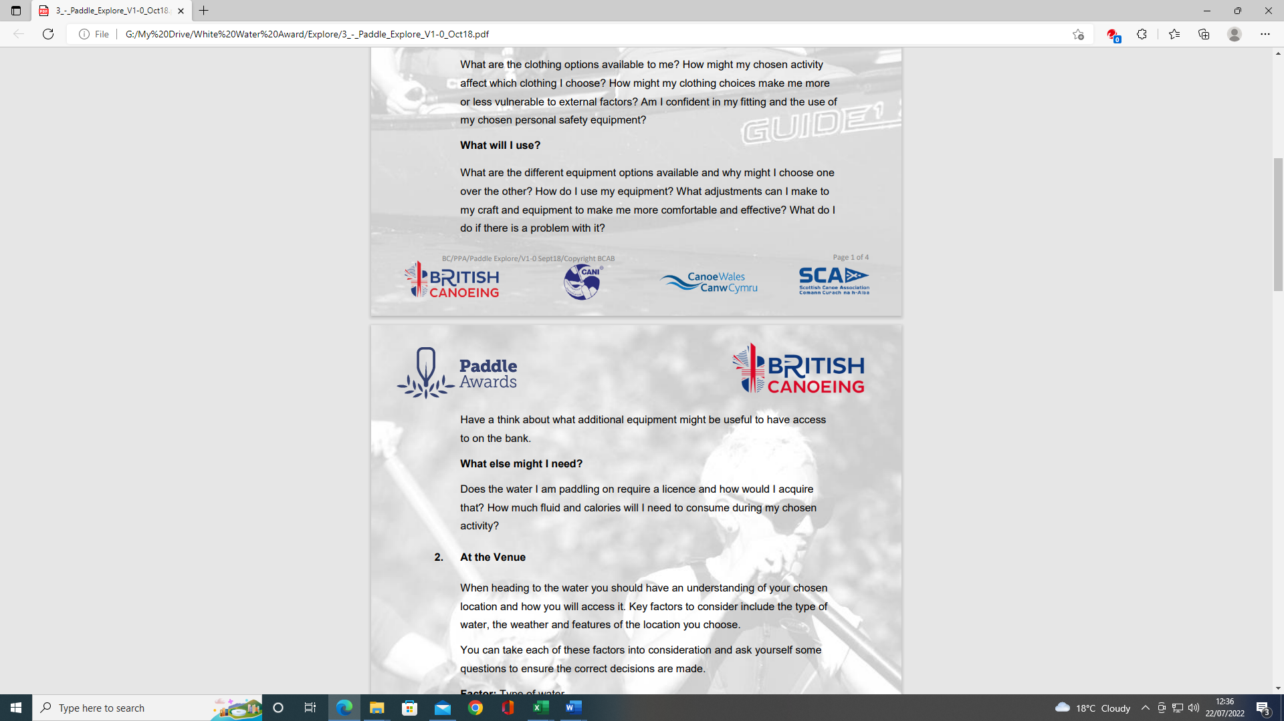
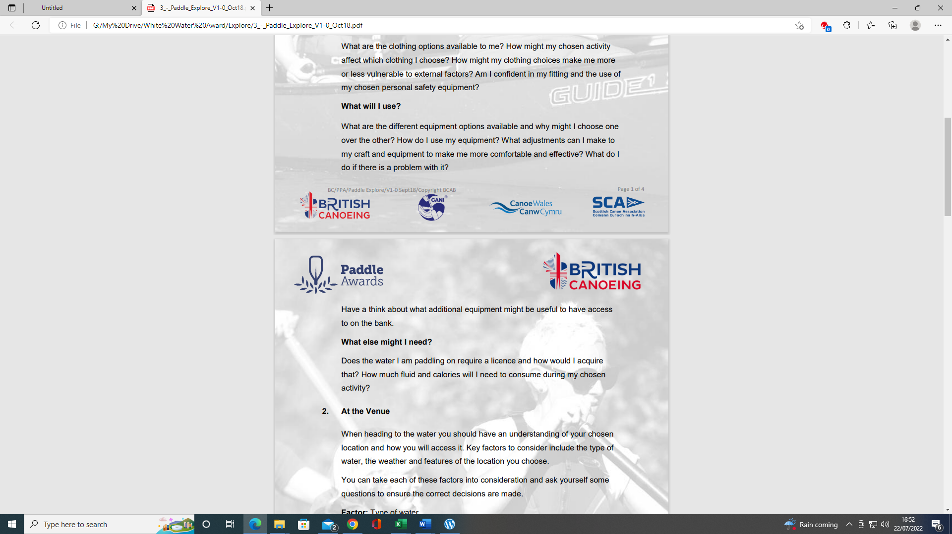
Paddle Explore Award
Paddle Explore Award
Section 1: Getting ready:
This section is about how we prepare to get on the water and what we should consider in our choice of kit and how this might affect the paddle. This section can be completed with your own experiences and knowledge and by using the reading resources listed at the end of the document.
However, depending on the individual there are various options to complete this section:
- Complete the Section 1 - Module Guide Questions. Or........
- Provide a “Video”, recording your actions or visual images explaining your knowledge and understanding within the questions asked
- Use the available Reference resources listed at the end to support your answers or decision-making for each section.

  - Getting Ready – What will I wear?

- What are the clothing options available to me? Equipment & Clothing

- How might my chosen activity affect, which clothing I choose?

- How might my clothing choices make me more aware or less vulnerable to external factors? E.g., Winter or summer paddling. Go paddling – Kayaking Safety Checklist

- Am I confident in my fitting and the use of my chosen personal safety equipment?

- How confident are you in the use of your chosen personal safety equipment?

  - Getting Ready – What will I use?

- What are the different equipment options available and why might I choose one over the other? E.g., BA, paddle, boat, SUP, helmets Equipment & Clothing

- How do I use my equipment?

- What adjustments can I make to my craft and equipment to make me more comfortable and effective?

- What do I do if there is a problem with it? E.g., size, connectivity with boat, volume, hull

- Have a think about what additional equipment might be useful to access to the bank. E.g., trolly, lift & carry? Seal or ramp launch?

1.3 Getting Ready – What else might I need?

- Does the water I am paddling on require a licence and how would I acquire that?
Access and Environment: licensing

- How much fluid and calories will I need to consume during my chosen activity?

Bibliography Reference:
Wombourne Kayak Club
Equipment, Clothing Kayak, & Paddles:
- Equipment & Clothing
- Types of Cagoules
- Types of Dry suits
- Types of Wetsuits
- Types of Footwear
- Types of Trousers
- Types of Spray deck
- Types of PFD's - Buoyancy Aids
- Types of Helmets
- Types of Personal Safety Equipment
- Buoyancy Bags
Miscellaneous:
- Go paddling – Kayaking Safety Checklist
- What does a kayak pinned kit consist of?
- How to set up a pinned kayak rescue
- What does a First Aid kit consist of?
- The difference between kayaks?
- Railed or Displacement?
- Different types of kayak blades
- Access and Environment: licensing
- fluid and calories
British Canoeing Resources:
- Buying a kayak?
- Ten types of kit to carry on a river trip
- Course Authorisation & Results video “How to enter”

