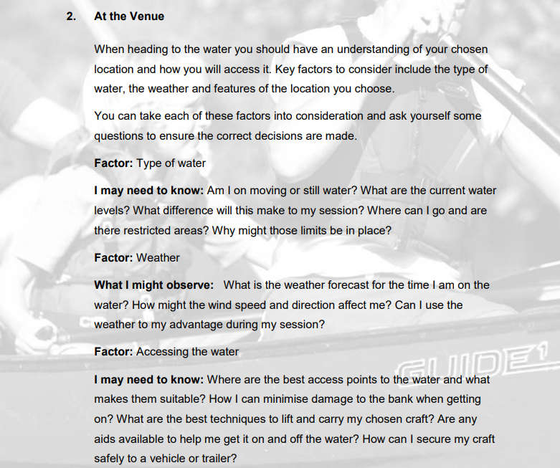
Paddle Explore Award
Section 2: At the Venue
This section is about working with your coach to develop a programme that suits you to move into the world of Paddlesport such as where we paddle, how we get to and from the river and what things we should consider in planning a trip. This section can be completed with your own experiences and knowledge and by using the reading resources listed at the end of the document.
However, depending on the individual there are various options to complete this section:
- Complete the Section 1 - Module Guide Questions. Or........
- Provide a “Video”, recording your actions or visual images explaining your knowledge and understanding within the questions asked. Or...
- A combination of the “Options” to suit your learning.
Use the available Reference resources listed at the end to support your answers or decision-making for each section.

At the Venue
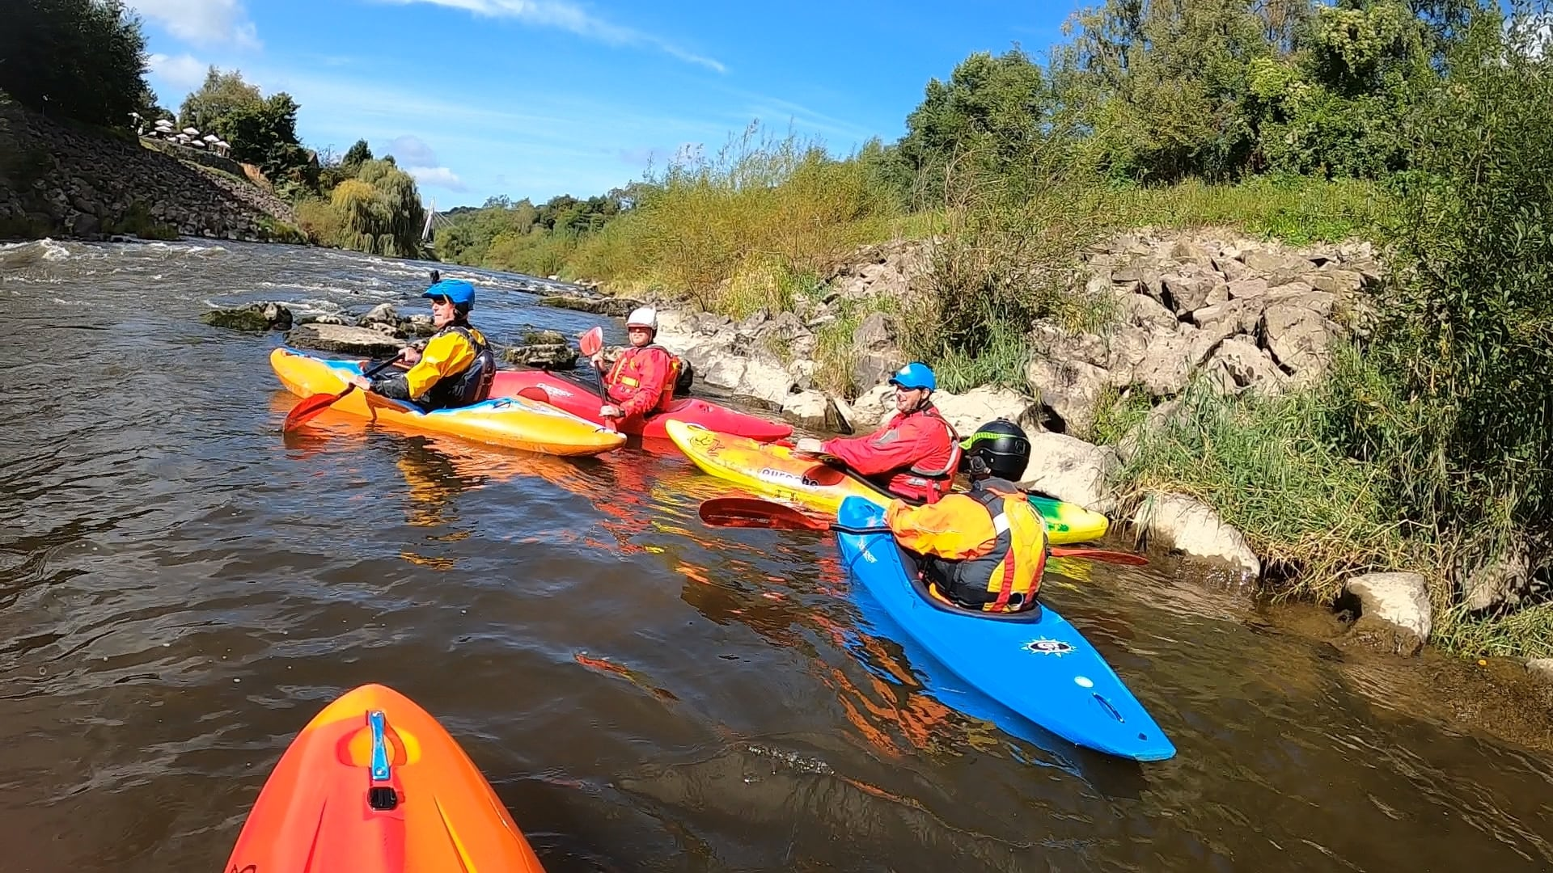

Factor: Type of water

I may need to Know:
- Am I on moving or still water? See Environmental Definitions

- What are the current water levels? E.g., Search Buildwas, Bridgnorth English River Levels

- What difference will this make to the session? See – (1) Jackfield Rapids 24/07/20, (2) Jackfield Rapids 17/10/20

- Where can I go and are there restricted areas? See Access and Environment: licensing

- Why might those limits be in place? See Access and Environment: access to water

Factor: Type of weather

What I might observe:

- What is the weather forecast for the time I am on the water? See weather forecast

- How might the wind speed and direction affect me?

- Can I use the weather to my advantage during my session?

Factor: Accessing the water

I may need to know:
- Where are the best access points to the water and what makes them suitable?

- How can I minimise damage to the bank when getting on? See -Assess and Environment: good practice

- What are the best techniques to lift and carry my chosen craft?

- Are any aids available to help me get it on and off the water? Trolly

- How can I secure my craft safely to a vehicle or trailer? Iain VW set-up

Bibliography Reference Resources:
- English River Levels Gov.UK
- Weather Forecast Met. Office
- Weather Report March 2019 Met. Office
- River Hazards Paddling.com
- River Features Palm Bren Orton
- UK Rivers Guide

Wombourne Kayak Club
Risk Assessment – Jackfield Rapids, Banwy, Usk: Talybont to Crickhowell – Search on website
- Health & Safety: Emergency Plan - Pre-planning, On the Water Plan – Search on website
British Canoeing Resources:
- Course Authorisation & Results video “How to enter”
- Go paddling Paddle points
- Go paddling – Kayaking Safety Checklist
- Major Incident Plan
- Access Charter & Campaign
- CACW Clear Access, Clear Water
- Affiliation & membership provides licensing – English locations
- PROW – Public Rights of way
- (DMMO) Making changes to a Definitive Map Modification Order
- Access Flowchart – John Teuwen update?
- Go paddling – Environment Blog
- Environmental Definitions and Deployment Guidance for Instructors, Coaches and Leaders
- Access and Environment: licensing
- Access and Environment: access to water
- Assess and Environment: good practice
- Invasive and non-invasive species
- Stop the spread of Non-Native species
- Introduction to Paddlesport
- Terms of reference coaches, leaders - guidance
Additional Resources for Access and Environment
- Access & Environment – River Usk & Wye
- River Usk & Wye - Issues

Videos
Video Number/ID | Title
1 | Jackfield Rapids 24/07/20
2 | Jackfield Rapids 17/10/20
3 | River Banwy 17/08/19
4 | Specific risk assessment 2018 Trip - Teme
5 | Teme 23/03/2019
6 | Teme 29/08/20 (JT)
7 | Teme 29/08/20 (RD)
8 | River Teme 31/11/20 - Part A
9 | River Teme 31/11/20 Part B
10 | River Usk Part (A) 15/03/19

Appendix 1 - Wombourne Kayak Club: Access issues at dale end car park

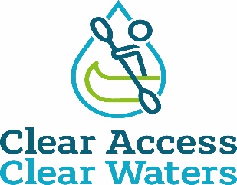

Dale End Car Park - Ironbridge

British Canoeing has been made aware by the paddling community that an access point at Dale End Carpark to the River Severn used by paddlers of all ages, abilities, and interests, for many decades, is being restricted. It is also of great interest to touring paddlers who love the world-famous Ironbridge.

British Canoeing has met with and formally written to the landowner twice, however the landowner remained fixed in their view.

The next step continues to be investigation locally for evidence of use in order to make a claim for a right of way based on public use, the law (section 31 of the Highways Act 1980) requires that you’re able to meet the following criteria:

- A period of at least 20 years' uninterrupted use by the public (this is the public as a whole, not just one person, though applications where single users have used the route for 20+ years is stronger) from the date it was brought into question.
- Use must be 'as of right', which means without secrecy, force, or the express permission of the landowner
- Use must be by the public at large, not just certain tenants or employees of an estate
- From a public highway (in this case Telford and Wrekin Council have now confirmed that Definitive Public Footpath 81 runs close to the access points in question, along the tarmac pathway), along a specified route. It is important to note that users may have used a number of slightly different routes, which may have changed over time due to one reason or another, so user maps accompanying evidence needs to be clear on the precise route taken. A review of the evidence will then be undertaken by British Canoeing and the lead volunteer in liaison with Telford and Wrekin Council with the intention of submitting an application for the Definitive Map to be modified to the council.

This is being co-ordinated by a new lead volunteer John Teuwen to establish if public rights exist, with support from British Canoeing.

In order to secure access at The River Severn it is absolutely essential that anyone who has used the route on a fairly regular basis to access the river and who meets the above criteria, should complete a user evidence form and accompanying map showing the route(s) used. It is also essential to understand the evidence may be used at a Public Inquiry so please do consider all questions thoroughly. Completed evidence forms and accompanying plans should be emailed to access@britishcanoeing.org.uk clearly titled ‘User Evidence – Dale End - Ironbridge’ or posted to Chantelle Grundy, British Canoeing, Adbolton Lane, Holme Pierrepont, Nottingham, NG12 2LU.

British Canoeing is committed to protecting and enhancing places to paddle as detailed in our Access and Environment Charter - Clear Access Clear Waters . British Canoeing will continue to work towards retaining this location as a launch spot which has been used respectfully and responsibly by paddlers over the years.

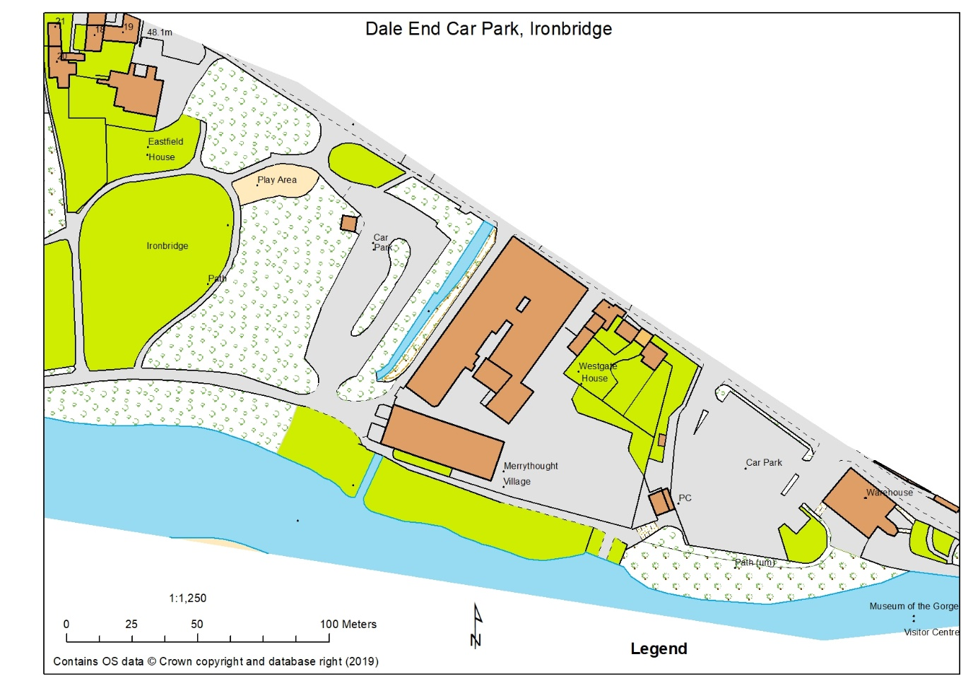

Plan of area provided by D Bennett. Note: Merrythought Village Company (Teddy bears) own the river bank for a 100m from the River Cole running along the “Car Park” into Dale End Park.

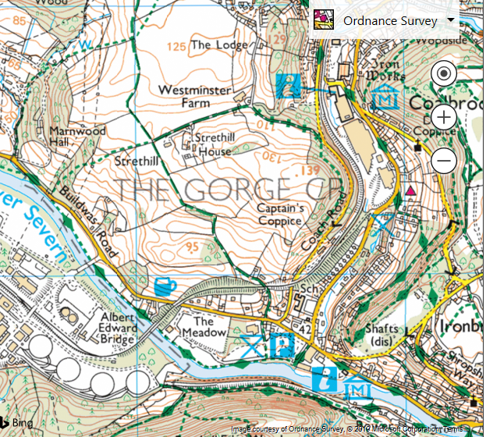
66 67

04

03

666038 Dale End Long Stay Car Park

