Paddle Explore Award
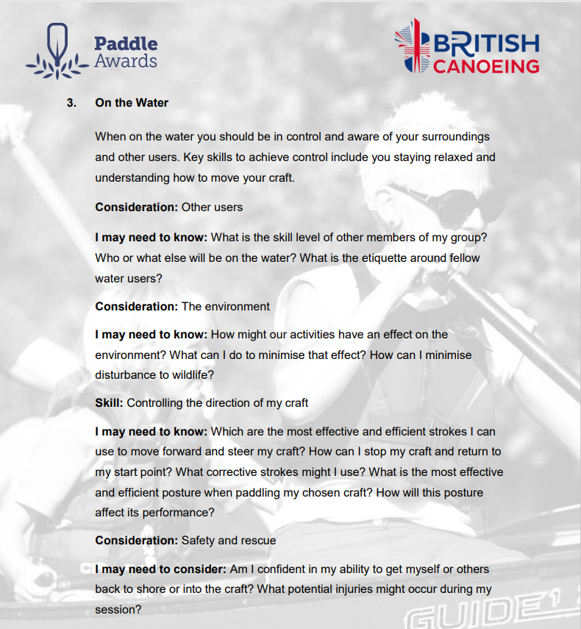

Section 3: On the Water:
This section asks us to explain some of the paddling techniques we need when paddling white water. Here we can complete the document with explanations from our own experiences, the resources at the end of the document and with video's from our and club paddles. Please link and reference the relevant video and timings in your answers.
However, depending on the individual there are various options to complete this section:
- Complete the Section 4 - Module Guide Questions. Or........
- Provide a “Video”, recording your actions or visual images explaining your knowledge and understanding within the questions asked. Or....
- Use the available Reference resources listed at the end to support your answers or decision-making for each section.

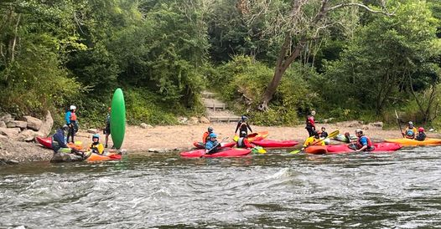

Preparation:
- Personal Particulars

- Paddling Experience: record details of sessions, trips, journeys, and expeditions and any other Paddlesport experience
- Courses attended / work with other organisations
- Record the trips, journeys, and expeditions you have led or assisted on.

1a. Use the Logbook template to record these particulars. See Wombourne Kayak Club
https://wombournekayakclub.files.wordpress.com/2022/05/logbook_final-new-version-adapted.docx

- Write a short reflection on what you learnt or any developments to consider.

On the Water:

3.1 Consideration: Other users

I may need to know:

- What is the skill level of other members of my group? See Environmental Definitions and Deployment Guidance for Instructors, Coaches and Leaders

- Who or what else will be on the water?

- What is the etiquette around fellow water users?

3.2 Consideration: The Environment

I may need to know:

- How might our activities influence the environment? Assess and Environment: good practice E.g., pollution; noise, water, litter, soil

- What can I do to minimise that effect?

- How can I minimise disturbance to wildlife?

3.3 Skill: Controlling the direction of my craft

I may need to know:

- Which are the most effective and efficient strokes I can use to move forward and steer my craft? E.g., Understand fundamentals: connectivity, posture, feel, power transfer and its relationship to the five B’s: boat, body, blade, brain, background (type of water)

- How can I stop my craft and return to my start point? E.g., reverse, or sweep stroke

- What correction strokes might I use? E.g., Half sweep, stern rudder, half reverse, forward downstream more than once.

- What is the most effective and efficient posture when paddling my chosen craft? E.g., strong core; upright or leaning to maintain balance, use of trunk rotation, look for future water

- How will my posture affect performance? E.g., edge, balance, power transfer,

3.4 Consideration: Safety & rescue

I may need to consider.

- Am I confident in my ability to get myself or others back to shore or into the craft?

- What potential injuries might occur during my session?

Bibliography Reference Resources:
Website Wombourne Kayak Club

- Environmental Definitions and Deployment Guidance for Instructors, Coaches and Leaders
- Code of Conduct - Adults
- Code of Conduct- Juniors
- Code of Conduct – Coaches, Leaders
British Canoeing Resources:
- Paddle safely in the summer
- Stay safe on the water
- Paddling safely
- Course Authorisation & Results video “How to enter”
- Go paddling Paddle points
- Go paddling – Kayaking Safety Checklist
- Major Incident Plan
- Access Charter & Campaign
- CACW Clear Access, Clear Water
- Affiliation & membership provides licensing – English locations
- PROW – Public Rights of way
- (DMMO) Making changes to a Definitive Map Modification Order
- Access Flowchart – John Teuwen update?
- Go paddling – Environment Blog
- Environmental Definitions and Deployment Guidance for Instructors, Coaches and Leaders
- Access and Environment: licensing
- Access and Environment: access to water
- Assess and Environment: good practice
- Invasive and non-invasive species
- Stop the spread of Non-Native species
- Introduction to Paddlesport

