Paddle Explore Award
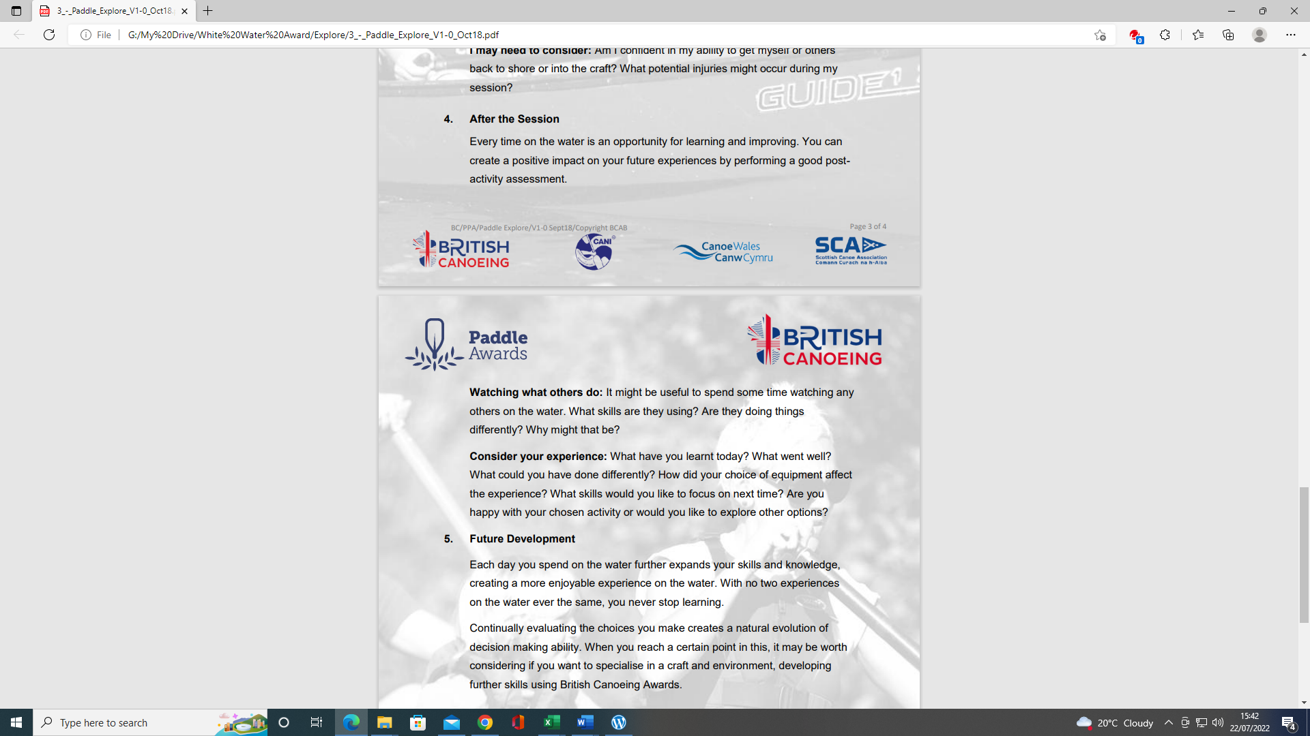
Section 4: After the session:
This section is about the continual learning process, how and what do you learn from your paddling experiences? Use videos of club paddles with reference to timings to explain your answers and what you have learned.
However, depending on the individual there are various options to complete this section:
- Complete the Section 5 - Module Guide Questions. Or........
- Provide a “Video”, recording your actions or visual images explaining your knowledge and understanding within the questions asked. Or....
- A combination of the “Options” to suit your learning.
Use the available Reference resources listed at the end to support your answers or decision-making for each section.

After the Session:
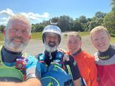
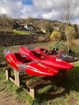

Preparation
This section is about the continual learning process, how and what do you learn from your paddling experiences? Use videos of club paddles with reference to timings to explain your answers and what you have learnt.

Logbook:

See Wombourne Kayak Club
https://wombournekayakclub.files.wordpress.com/2022/05/logbook_final-new-version-adapted.docx

- Personal Particulars
- Paddling Experience: record details of sessions, trips, journeys, and expeditions and any other Paddlesport experience
- Courses attended / work with other organisations
- Record the trips, journeys, and expeditions you have led or assisted on.
- Write a short reflection on what you learnt or any developments to consider

4.1 After the Session:

Watching what others do:

Identify video footage that demonstrates with times this skill recorded in your logbook.

- It might be useful to spend some time watching any others on the water.

- What skills are they using?

- Are they doing things differently?

- Why might that be?

4.2 Consider your experience:

Identify video footage that demonstrates with times this skill recorded in your logbook.

- What have you learnt today?

- What went well?

- What could you have done differently?

- How did your choice of equipment affect the experience?

- What skills would you like to focus on next time?

- Are you happy with your chosen activity or would you like to explore other options?

Reference Resources:
Wombourne Kayak Club Resources:
See Wombourne Kayak Club

British Canoeing
Development Pathway Paddlesup
Paddle Award Instructor
Leadership Moderate Water
Coach Self Analysis
Information on Mentors and Coaches
Videos Foundation Safety Rescue Training
Safety and Personal Development
Coach Award
Changes to “Safeguarding”
Digital Library
Coaching Qualifications Courses

