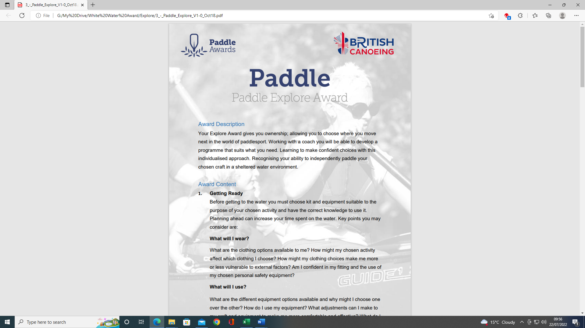
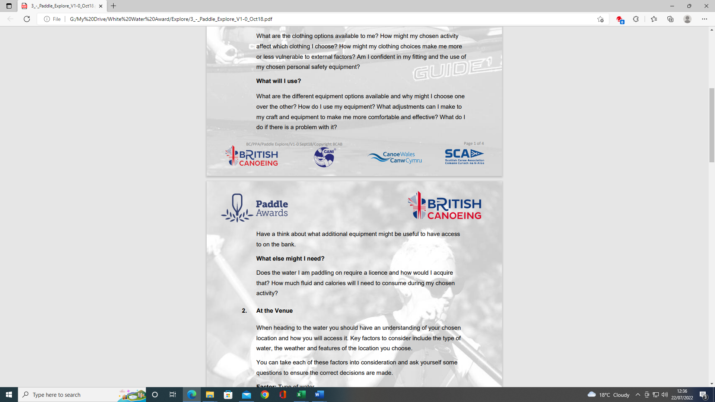
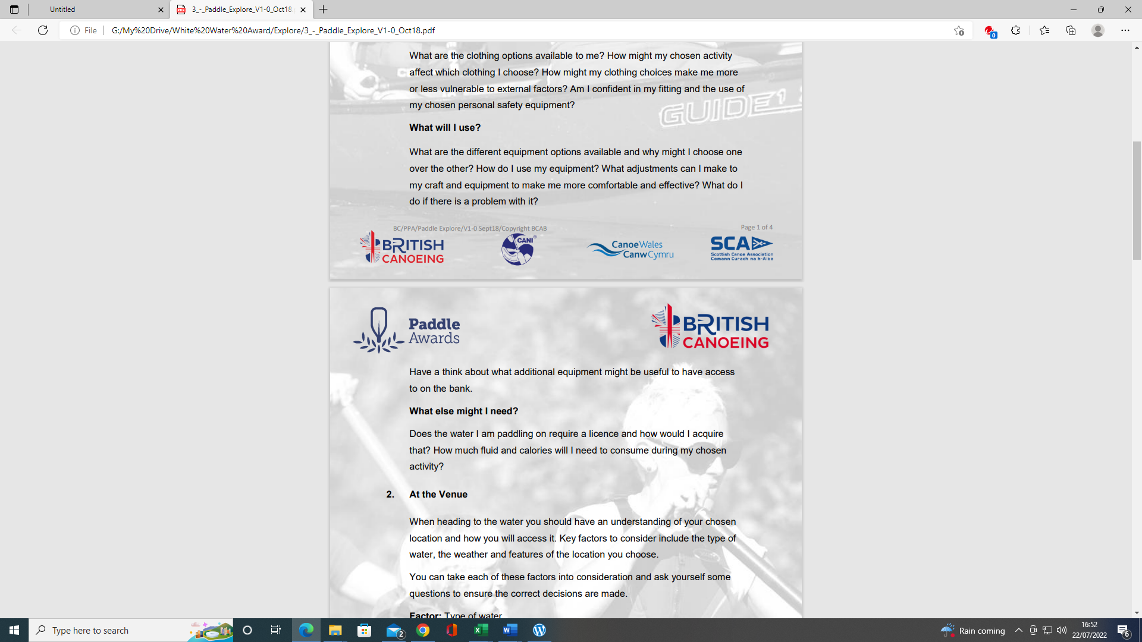
PADDLE EXPLORE AWARD ASSESSORS RECORDING TRACKING DOCUMENT – Candidate:
Module 1 | Written Evidence | Date  Assessor  Provider | Practical Evidence | Date  Assessor  Provider | “Video” Evidence | Date  Assessor  Provider | Question & Answer | Date  Assessor  Provider
Getting Ready –  What will I wear?  1.1 | Module Guide (1) |  |  |  |  |  | - What are the clothing options available to me?  - How might my chosen activity affect, which clothing I choose?  - How might my clothing choices make me more aware or less vulnerable to external factors? E.g., Winter or summer paddling  - Am I confident in my fitting and the use of my chosen personal safety equipment?  - How confident are you in the use of your chosen personal safety equipment?

PADDLE EXPLORE AWARD TRACKING DOCUMENT
Module 1 | Written Evidence | Date  Assessor  Provider | Practical Evidence | Date  Assessor  Provider | “Video” Evidence | Date  Assessor  Provider |  | Date  Assessor  Provider
Getting Ready –  What will I use?  1.2 | Module Guide (1) |  |  |  |  |  | - What are the different equipment options available and why might I choose one over the other? E.g., BA, paddle, boat, SUP, helmets  - How do I use my equipment?  - What adjustments can I make to my craft and equipment to make me more comfortable and effective?  - What do I do if there is a problem with it? E.g., size, connectivity, volume, hull  - Have a think about what additional equipment might be useful to access to the bank. E.g., trolly, lift & carry? Seal or ramp launch?

PADDLE EXPLORE AWARD TRACKING DOCUMENT
Module 1 | Written Evidence | Date  Assessor  Provider | Practical Evidence | Date  Assessor  Provider | “Video” Evidence | Date  Assessor  Provider |  | Date  Assessor  Provider
Getting Ready –  What else might I need?  1.3 | Module Guide (1) |  |  |  |  |  | - Does the water I am paddling on require a licence and how would I acquire that?  - How much fluid and calories will I need to consume during my chosen activity?

PADDLE EXPLORE AWARD ASSESSORS RECORDING DOCUMENT
Module 1 | Assessor’s Recording Evidence | Date  Assessor  Provider
Getting Ready –  What will we wear?  1.1 |  | Tutor:  Assessor:
Getting Ready –  What will I use?  1.2 |  | Tutor:  Assessor:

PADDLE EXPLORE AWARD ASSESSORS RECORDING DOCUMENT
Module 1 | Assessor’s Recording Evidence | Date  Assessor  Provider
Getting Ready –  What else might I need?  1.3 |  | Tutor:  Assessor:

Bibliography Reference Resources:
Wombourne Kayak Club Website

Kayak & Paddles
- Equipment & Clothing
- Types of Cagoules
- Types of Dry suits
- Types of Wetsuits
- Types of Footwear
- Types of Trousers
- Types of Spray deck
- Types of PFD's - Buoyancy Aids
- Types of Helmets
- Types of Personal Safety Equipment
- Buoyancy Bags
Miscellaneous
- What does a kayak pinned kit consist of?
- How to set up a pinned kayak rescue
- What does a First Aid kit consist of?
- The difference between kayaks?
- Railed or Displacement?
- Different types of kayak blades

British Canoeing Resources:
- Buying a kayak?
- Ten types of kit to carry on a river trip
- Course Authorisation & Results video “How to enter”

Calories, fluids

