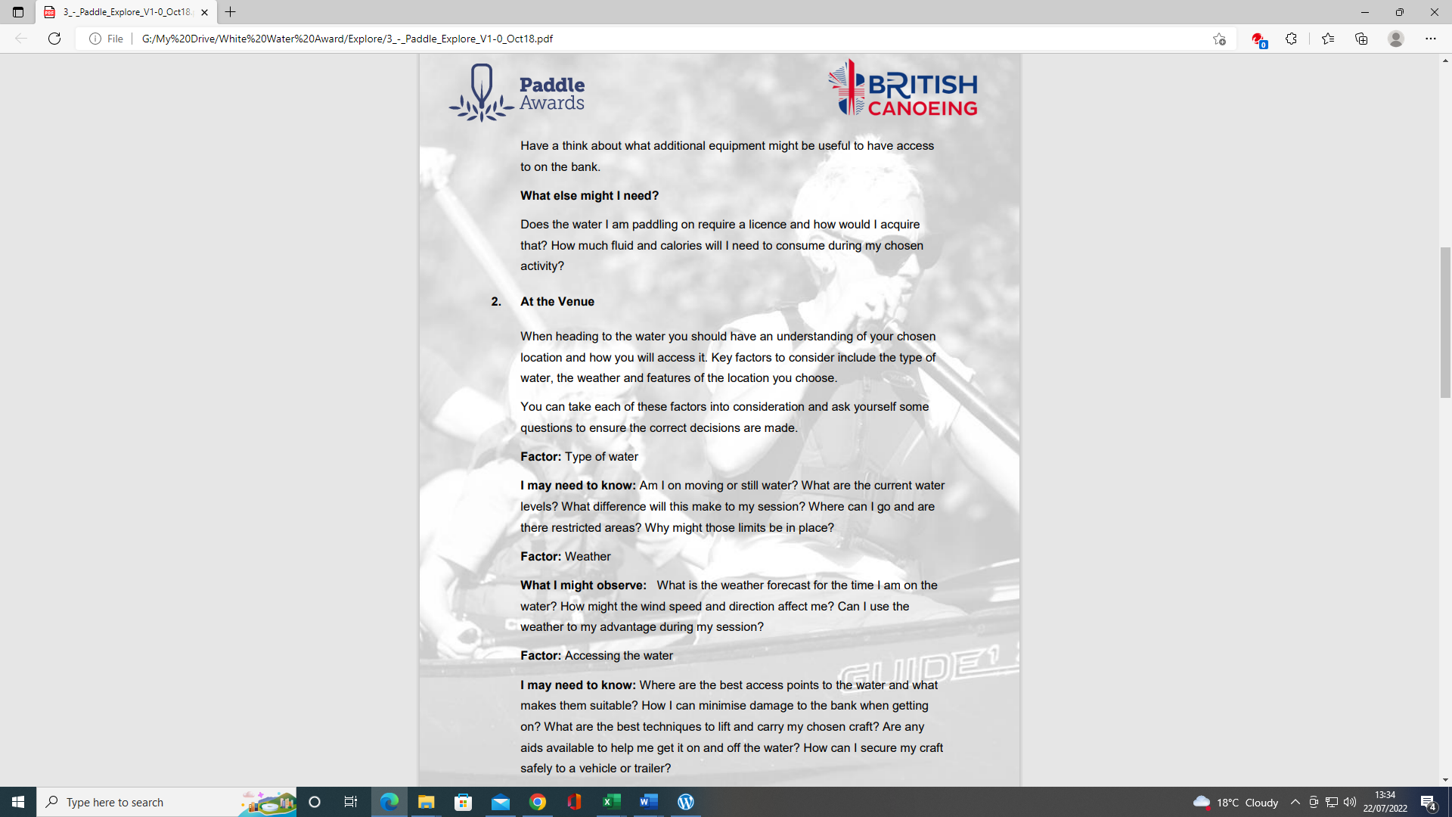
PADDLE EXPLORE AWARD TRACKING DOCUMENT – Candidate:
Module 2 | Written Evidence | Date  Assessor  Provider | Practical Evidence | Date  Assessor  Provider | “Video” Evidence | Date  Assessor  Provider | Question & Answer | Date  Assessor  Provider
At the Venue  Factor:  Type of water  I may need to Know: | Module Guide (2) |  |  |  |  |  | - Am I on moving or still water?  - What are the current water levels?  - What difference will this make to the session?  - Where can I go and are there restricted areas?  - Why might those limits be in place?
Factor:  Weather  What I might observe: |  |  |  |  |  |  | - What is the weather forecast for the time I am on the water?  - How might the wind speed and direction affect me?  - Can I use the weather to my advantage during my session?

WHITE-WATER AWARD TRACKING DOCUMENT
Module 2 | Written Evidence | Date  Assessor  Provider | Practical Evidence | Date  Assessor  Provider | “Video” Evidence | Date  Assessor  Provider |  | Date  Assessor  Provider
Factor:  Accessing the water  I may need to know: | Module Guide (1) |  |  |  |  |  | - Where are the best access points to the water and what makes them suitable?  - How can I minimise damage to the bank when getting on?  - What are the best techniques to lift and carry my chosen craft?  - Are any aids available to help me get it on and off the water?  - How can I secure my craft safely to a vehicle or trailer?

PADDLE EXPLORE AWARD ASSESSORS RECORDING DOCUMENT
Module 2 | Assessor’s Recording Evidence | Date  Assessor  Provider
At the Venue  Factor:  Type of water  I may need to Know |  | Tutor:  Assessor:
2.2 Factor:  Weather  What I might observe: |  | Tutor:  Assessor:
Factor:  Accessing the water  I may need to know: |  | Tutor:  Assessor:

Bibliography Reference Resources:
- English River Levels Gov.UK
- Weather Forecast Met. Office
- Weather Report March 2019 Met. Office
- River Hazards Paddling.com
- River Features Palm Bren Orton
- UK Rivers Guide

Wombourne Kayak Club Website – Click on
Risk Assessment – Jackfield Rapids, Banwy, Usk: Talybont to Crickhowell – Search on website
- Health & Safety: Emergency Plan - Pre-planning, On the Water Plan – Search on website
Wombourne Kayak Club: Access issues at dale end car park update?
British Canoeing Resources:
- Course Authorisation & Results video “How to enter”
- Go paddling Paddle points
- Go paddling – Kayaking Safety Checklist
- Major Incident Plan
- Access Charter & Campaign
- CACW Clear Access, Clear Water
- Affiliation & membership provides licensing – English locations
- PROW – Public Rights of way
- (DMMO) Making changes to a Definitive Map Modification Order
- Go paddling – Environment Blog

- Environmental Definitions and Deployment Guidance for Instructors, Coaches and Leaders
- Access and Environment: licensing
- Access and Environment: access to water
- Access and Environment: access to water
- Assess and Environment: good practice
- Invasive and non-invasive species
- Stop the spread of Non-Native species
- Introduction to Paddlesport
Additional Resources for Access and Environment
- Access & Environment – River Usk & Wye
- River Usk & Wye - Issues

Videos
Video Number/ID | Title
1 | Jackfield Rapids 24/07/20
2 | Jackfield Rapids 17/10/20
3 | River Banwy 17/08/19
4 | Specific risk assessment 2018 Trip - Teme
5 | Teme 23/03/2019
6 | Teme 29/08/20 (JT)
7 | Teme 29/08/20 (RD)
8 | River Teme 31/11/20 - Part A
9 | River Teme 31/11/20 Part B
10 | River Usk Part (A) 15/03/19

