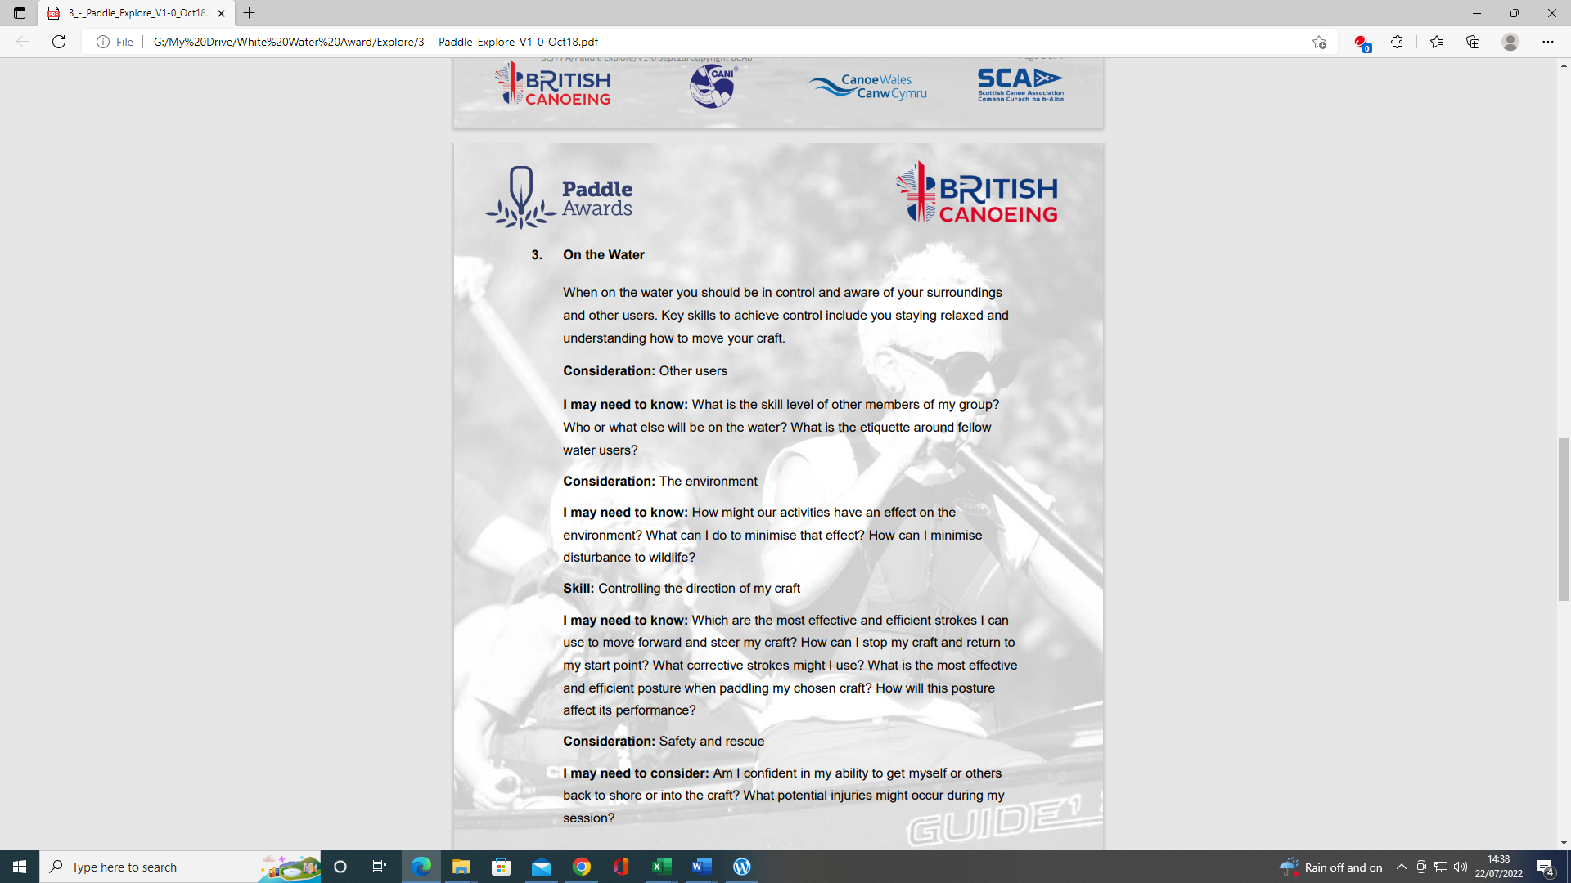
PADDLE EXPLORE AWARD ASSESSORS RECORDING TRACKING DOCUMENT – Candidate:
Module 3 | Written Evidence | Date  Assessor  Provider | Practical Evidence | Date  Assessor  Provider | “Video” Evidence | Date  Assessor  Provider | Question & Answer | Date  Assessor  Provider
Paddle Explore Skills  Preparation  Logbook:  - Personal Particulars  - Paddling Experience: record details of sessions, trips, journeys, and expeditions and any other Paddlesport experience  - Courses attended / work with other organisations  - Record the trips, journeys, and expeditions you have led or assisted on.  - Write a short reflection on what you learnt or any developments to consider | Module Guide (3)

PADDLE EXPLORE AWARD TRACKING DOCUMENT
Module 3 | Written Evidence | Date  Assessor  Provider | Practical Evidence | Date  Assessor  Provider | “Video” Evidence | Date  Assessor  Provider |  | Date  Assessor  Provider
On the Water:  3.1  Consideration:  Other users  I may need to know: | Module Guide (3) |  |  |  |  |  | - What is the skill level of other members of my group?  - Who or what else will be on the water?  - What is the etiquette around fellow water users?
On the Water:  3.2  Consideration:  The Environment  I may need to know: |  |  |  |  |  |  | - How might our activities have an effect on the environment? E.g., pollution; noise, water, litter, soil  - What can I do to minimise that effect?  - How can I minimise disturbance to wildlife?

Module 3 | Written Evidence | Date  Assessor  Provider | Practical Evidence | Date  Assessor  Provider | “Video” Evidence | Date  Assessor  Provider |  | Date  Assessor  Provider
On the Water:  3.3 Skill  Controlling the direction of my craft  I may need to know: | Module Guide (3) |  |  |  |  |  | - Which are the most effective and efficient strokes I can use to move forward and steer my craft? E.g., Understand fundamentals: connectivity, posture, feel, power transfer and its relationship to the five B’s: boat, body, blade, brain, background (type of water)  - How can I stop my craft and return to my start point? E.g., reverse, or sweep stroke  - What correction strokes might I use? E.g., Half sweep, stern rudder, half reverse, forward downstream more than once  - What is the most effective and efficient posture when paddling my chosen craft? E.g., strong core; upright or leaning to maintain balance, use of trunk rotation, look for future water  - How will my posture affect performance? E.g., edge, balance, power transfer,

PADDLE EXPLORE AWARD TRACKING DOCUMENT
Module 3 | Written Evidence | Date  Assessor  Provider | Practical Evidence | Date  Assessor  Provider | “Video” Evidence | Date  Assessor  Provider |  | Date  Assessor  Provider
On the Water:  3.4  Consideration:  Safety & rescue  I may need to consider. | Module Guide (3) |  |  |  |  |  | - Am I confident in my ability to get myself or others back to shore or into the craft?  - What potential injuries might occur during my session?

PADDLE EXPLORE AWARD ASSESSORS RECORDING DOCUMENT
Module 3 | Assessor’s Recording Evidence | Date  Assessor  Provider
On the Water:  3.1  Consideration:  Other users  I may need to know |  | Tutor:  Assessor:
On the Water:

3.2

Consideration:

The Environment

I may need to know:

PADDLE EXPLORE AWARD ASSESSORS RECORDING DOCUMENT
Module 3 | Assessor’s Recording Evidence | Date  Assessor  Provider
On the Water:  3.3 Skill  Controlling the direction of my craft  I may need to know: |  | Tutor:  Assessor:
On the Water:

3.4

Consideration:

Safety & rescue

I may need to consider.

WHITE-WATER AWARD ASSESSORS RECORDING DOCUMENT
Module 4 | Assessor’s Recording Evidence | Date  Assessor  Provider
White-water Skills  Skill:  4.3  Changing Direction. | 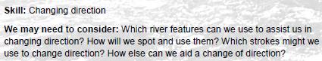 | 31/03/22  Tutor:  John Teuwen  Assessor:  Rich Dowen
WHITE-WATER AWARD ASSESSORS RECORDING DOCUMENT
Module 4 | Assessor’s Recording Evidence | Date  Assessor  Provider
White-water Skills  Skill:  4.4  Running the river | 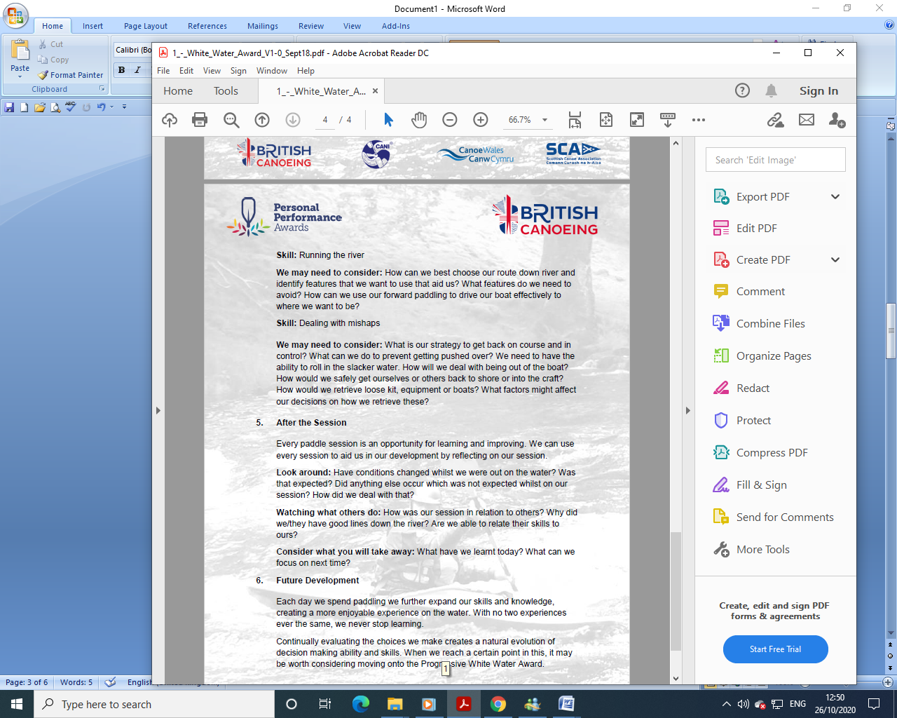 | 31/03/22  Tutor:  John Teuwen  Assessor:  Rich Dowen

WHITE-WATER AWARD ASSESSORS RECORDING DOCUMENT
Module 4 | Assessor’s Recording Evidence | Date  Assessor  Provider
White-water Skills  Skill:  4.5  Dealing with Mishaps. |  | 31/03/22  Tutor:  John Teuwen  Assessor:  Rich Dowen

WHITE-WATER AWARD ASSESSORS RECORDING DOCUMENT

Bibliography Reference Resources:

Wombourne Module Guide (2) updated on new website
WHITE-WATER AWARD TRACKING DOCUMENT (2) updated on new website
Wombourne Kayak Club Website use updated version on new website
Course Authorisation & Results video “How to enter”

Wombourne Kayak Club Website New
logbook New

Videos
Video Number/ID | Title
1 | River Vyrnwy 05/09/20
2 | River Banwy 10/10/20
3 | River Usk Part (A) 15/03/19

