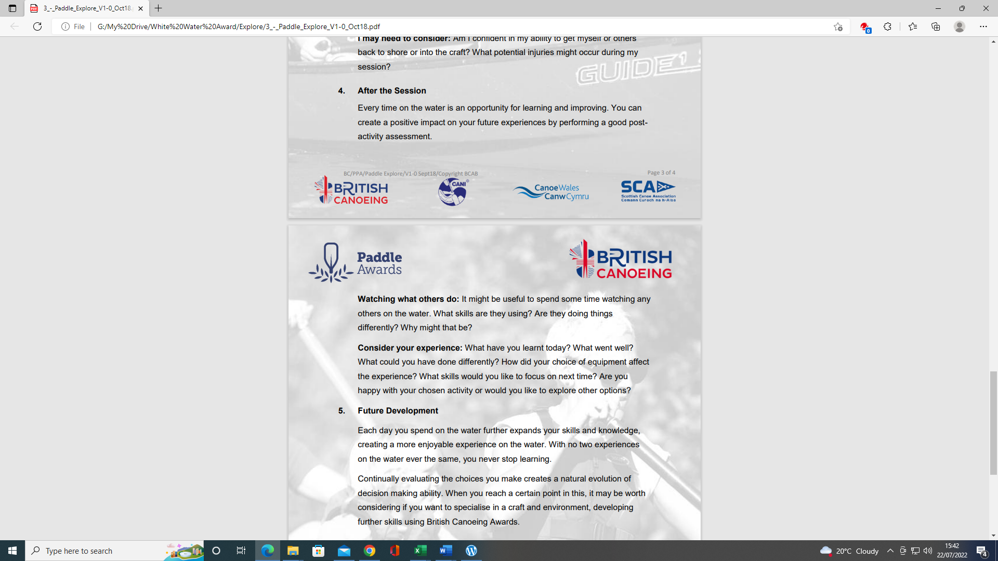
PADDLE EXPLORE AWARD ASSESSORS RECORDING TRACKING DOCUMENT – Candidate:
Module 4 | Written Evidence | Date  Assessor  Provider | Practical Evidence | Date  Assessor  Provider | “Video” Evidence | Date  Assessor  Provider | Question & Answer | Date  Assessor  Provider
After the Session:  Preparation  Logbook:  - Personal Particulars  - Paddling Experience: record details of sessions, trips, journeys, and expeditions and any other Paddlesport experience  - Courses attended / work with other organisations  - Record the trips, journeys, and expeditions you have led or assisted on.  - Write a short reflection on what you learnt or any developments to consider | Module Guide (4)

PADDLE EXPLORE AWARD TRACKING DOCUMENT
Module 4 | Written Evidence | Date  Assessor  Provider | Practical Evidence | Date  Assessor  Provider | “Video” Evidence | Date  Assessor  Provider |  | Date  Assessor  Provider
After the Session:  4.1  Watching what others do:  Identify video footage that demonstrates with times this skill recorded in your logbook.  . | Module Guide (5) |  |  |  |  |  | - It might be useful to spend some time watching any others on the water.  - What skills are they using?  - Are they doing things differently?  - Why might that be?

Module 4 | Written Evidence | Date  Assessor  Provider | Practical Evidence | Date  Assessor  Provider | “Video” Evidence | Date  Assessor  Provider |  | Date  Assessor  Provider
After the Session:  4.2  Consider your experience:  Identify video footage that demonstrates with times this skill recorded in your logbook. | Module Guide (4) |  |  |  |  |  | - What have you learnt today?  - What went well?  - What could you have done differently?  - How did your choice of equipment affect the experience?  - What skills would you like to focus on next time?  - Are you happy with your chosen activity or would you like to explore other options?

PADDLE EXPLORE AWARD ASSESSORS RECORDING DOCUMENT
Module | Assessor’s Recording Evidence | Date  Assessor  Provider
After the Session:  4.1  Watching what others do:  Identify video footage that demonstrates with times this skill recorded in your logbook |  | Tutor:  Assessor:
After the Session:  4.2  Consider your experience: |  | Tutor:  Assessor:

Bibliography Reference Resources:
Course Authorisation & Results video “How to enter”
Wombourne Kayak club website
British Canoeing (Adapted) logbook

British Canoeing
Development Pathway Paddles up
Paddle Award Instructor
Leadership Moderate Water
Coach Self Analysis
Information on Mentors and Coaches
Videos Foundation Safety Rescue Training
Safety and Personal Development
Coach Award
Changes to “Safeguarding”
Digital Library
Coaching Qualifications Courses

