 | River Clywedog – Bryn y Tail Falls, Lead Mine to River Severn confluence  Post Code: Bryn y Tail Falls SY186NU  Post Code: Llanidloes SY186AS  (Turn left down after Texaco garage before island to reach parking area by river below town bridge)  Paddle Points - Bryn y Tail Falls, River Clywedog  UK Rivers Guide Bryn y Tail Falls, Lead Mine to River Severn confluence  River Levels: 0.51 - 13/08/22, 0.44 - 02/10/21, 0.54 - 21/07/18  River Gauge: Bryn y Tail Falls | Grid Reference: | Access:  SN 91358 86733  Egress:  SN 95514 84764
  - 0.30 scrape
  - 0.45 low
  - .55 medium
  - .80 high
  - 1.00+ huge
 | Club recreational kayak trip
 | See Videos:  - 21st July 2018 Part A – John https://www.youtube.com/watch?v=KBZJ87eaQr8&t=2s  - 21st July 2018 Part B – John https://youtu.be/yZmDgFD4HZs  - 14th Sept 2021 – Paul https://www.youtube.com/watch?v=NhFRh2BcjMA  - 14th Sept. 2021 – Rich https://www.youtube.com/watch?v=Hz88wlwn0Ns  - 14th Sept 2021 – Tim https://www.youtube.com/watch?v=fIRU6kpfi6c  - 14th Sept. 2021 – John https://youtu.be/ciStpyzYjJA  - 13th August 2022 – John https://youtu.be/TZNC69WZBNo 0.51m river level Bryntail y Tail falls  - 13th August 2022 – Paul https://www.facebook.com/paul.elkington.31/videos/1049982615721515  - 13th August 2022 – Rich https://www.youtube.com/watch?v=QjfPh6vnSbQ | Date: | 13th August 2022

Wombourne Kayak Club River Guide: River Clywedog - Bryn y Tail Falls, Lead Mine to River Severn confluence
Feature | Bryntail Falls  Grade 4, access from left or right bank depending on tree, follow river left to right, but maintain left position as flow draws one to the magnetic rock. See wrong approach:  0.10 seconds 14th Sept. 2021 – John https://youtu.be/ciStpyzYjJA  Note good approach:  21st July 2018 - Keeping left slide down the pour over rock into Channel avoiding the “Hole” on right of falls.  NB. Tree and rock after drop.  0.10 seconds (Pre-falls warm-up) 1.30 minutes 21st July 2018 Part A – John https://www.youtube.com/watch?v=KBZJ87eaQr8&t=2s  2.38 seconds 14th Sept. 2021 – John https://youtu.be/ciStpyzYjJA See Tim’s approach.
Feature | Grade 3 section after falls to bridge  4.30 minutes 21st July 2018 Part A – John https://www.youtube.com/watch?v=KBZJ87eaQr8&t=2s  Tree branch third of the way down, try to position left or “Duck” 5.15 minutes, although it has been trimmed down. 5. seconds 14th Sept. 2021  3.50 minutes 14th Sept. 2021 – John https://youtu.be/ciStpyzYjJA - 3.30minutes 13th August 2022 – Rich https://www.youtube.com/watch?v=QjfPh6vnSbQ
Feature | Tree across river  1st - take right side route and slip through.  12.56 minutes 14th Sept. 2021 – John https://youtu.be/ciStpyzYjJA
Feature | 1st Natural Weir Drop –1 metre height, possible Portage as trees are across left and right routes and danger of “Pinning”.  11.25 minutes 13th August 2022 – John https://youtu.be/TZNC69WZBNo  Can slip through between 2 tufts of grass centre right over drop
Feature | Wire across river, next to metal gates after 1st weir  17.32 minutes 14th Sept. 2021 – John https://youtu.be/ciStpyzYjJA  13.18 minutes 13th August 2022 – John https://youtu.be/TZNC69WZBNo Can slip through under wire at 0.51 gauge.

Feature | 2nd Man-made Weir Drop  13th August 2022 – John https://youtu.be/TZNC69WZBNo  Take left route “Tow back” ok. 15.17 minutes.
Feature | Trees across river:  13th August 2022 – John https://youtu.be/TZNC69WZBNo  Tree removed near footbridge at “Access” - 0.05 minutes.  Branch – grade 3 - 2.54 minutes.  Fallen Trees - 10.19, 11.07, 11.25, 17.30, (Portage)19.00 minutes
Drops before Llanidloes
Take right route
3.42 minutes 21st July 2018 Part B – John https://youtu.be/yZmDgFD4HZs
8.10 minutes 14th Sept. 2021 – Rich https://www.youtube.com/watch?v=Hz88wlwn0Ns

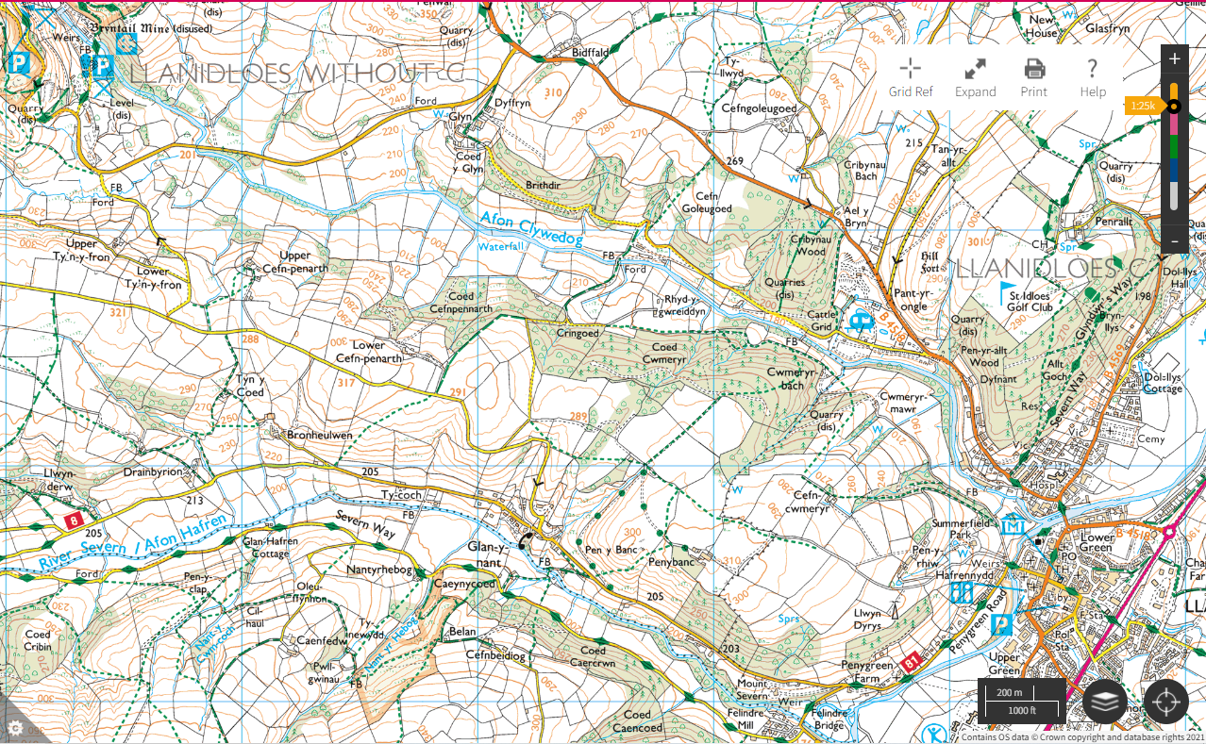

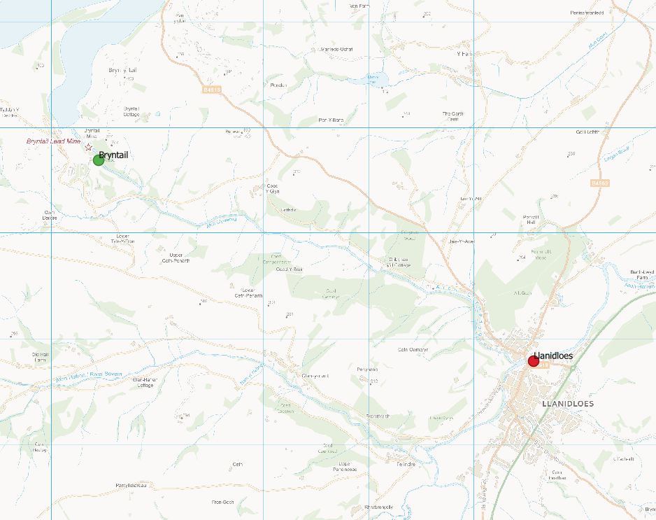
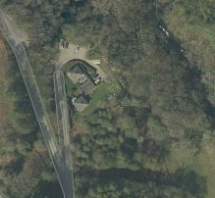
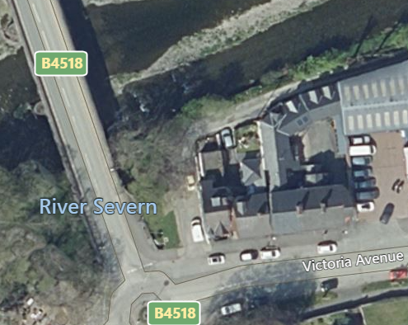
Backdrop mapping created using OS Open data Crown Copyright and database rights 2019
Access
Get out

