Wombourne Kayak Club Risk Assessment
Location: | River Banwy – Llanfair to Meifod-Bridge  Paddle Points – River Banwy  UK Rivers Guide Llanfair -Meifod-Bridge  River Levels: 1.40 - 08/10/22  River Gauge: Llanerfyl | Grid Reference: | 031098 Access  103066 Egress
  - 1.20 scrape
  - 1.30 low
  - 1.50 medium
  - 1.90 high
  - 2.00+ huge
Types of Trip: | River Leaders Training
Video Footage: | https://www.youtube.com/watch?v=pQ360iaqjh8&t=2s Part A  https://www.youtube.com/watch?v=PtM1k5T5OdY&t=16s Part B  https://www.youtube.com/watch?v=oIkBQcf79wk John Oct. 2022 | Date: | 14/03/20  08/10/22
Assessor Name: | John Teuwen | Review: | 08/10/22
Position in Club: | Health & Safety | Date Checked & updated: | 08/10/22
Date Completed: |  | Signed: | JohnTeuwen.
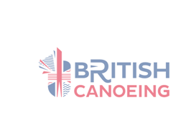

Wombourne Kayak Club Risk Assessment
Risk ratings Low, medium or high: 3 * 3 Risk Matrix
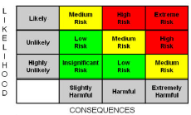

What is the hazard? | Who might be harmed? | How may the risk be adequately controlled? | Risk Ratings:  Low, Medium, High  Grade based 3*3 Risk Matrix & calculation of risk severity chart | Action by whom | What further action is necessary?
Access: after bridge at Llanerfyl  Grid Reference: 031098 | Club Members |  | S = 2 L = 2 = 4 Low  River Level = | Correct supervision and group control by instructor, safety brief
Egress: after bridge at Llanfair Railway Station  Grid Reference: 103066  NB. Check at station for permission to park. | Club Members |  | S = 2 L = 2 = 4 Low  River Level = | Correct supervision and group control by instructor, safety brief.
Natural Weir -, grade 2  Ideal level: 1.5 – 1.7  High Levels: 1.8- 2m+ | Club Members | Check Environment Agency for Current River levels:  Llanfair https://rloi.naturalresources.wales/ViewDetails?station=2062  Grade 1 -2 Rapids Broken Weir: just after camp site & bridge at the top of the hill before Llanfair; Take route to the right. Can reach grade 3 in flood.  Note: main danger are “Overhanging” branches, particularly in the Spring, Summer & Autumn months just before Llanfair village & bridge as you descend from the grade 2 drop & islands in the middle of river, usually left side, but “Line of Sight “uncertain & possible fallen trees. Right side taken but at low levels a little bit “Scrappy”. | S = 3 L = 3 = 9 Medium  Likely, Slightly Harmful | Correct supervision and group control by instructor, safety brief.
Wombourne Kayak Club Risk Assessment
Risk ratings Low, medium or high: 3 * 3 Risk Matrix

What is the hazard? | Who might be harmed? | How may the risk be adequately controlled? | Risk Ratings:  Low, Medium, High  Grade based 3*3 Risk Matrix & calculation of risk severity chart | Action by whom | What further action is necessary?
Weather & Environmental Conditions: Floods/  Spate conditions | Club Members | Check weather forecast & river levels.  - Dynamic risk assessment.  Re-locate or cancel if inappropriate to group ability  - Weather Forecast:  - https://www.metoffice.gov.uk/ | S = 5 L = 5 = 25 High  Likely, Extremely Harmful | - Club coaches & senior members.
Drowning | Club Members | - Buoyancy Aids & Helmets must be worn & fitted correctly for all paddlers.  - All club buoyancy aids & helmets are checked & their condition recorded annually.  - Apply “Buddy” checks on helmets & buoyancy aids, boats  - Parental Consent Forms T4 & Adult T4a Trip Participant Statement signed | S = 3 L = 3 = 9 Medium  Likely, Slightly Harmful | - Club coaches & senior members.  - Club equipment officer to undertake checks.  - Club members.  - Club coach’s/secretary
Weather related injury  Hypothermia  Hyperthermia. | Club Members | - Check weather forecast.  - Dynamic risk assessment  - Advised on appropriate clothing to wear.  - Adjustment to clothing as required, e.g. use of wet to dry suit depending on weather forecast, temperature & time of year.  - Sun block, extra water, hot drink, change of clothing, Group shelter | S = 4 L = 4 = 16 Medium  Likely, Harmful | - Club coaches & senior members

Wombourne Kayak Club Risk Assessment
Risk ratings Low, medium or high: 3 * 3 Risk Matrix

What is the hazard? | Who might be harmed? | How may the risk be adequately controlled? | Risk Ratings:  Low, Medium, High  Grade based 3*3 Risk Matrix & calculation of risk severity chart | Action by whom | What further action is necessary?
Sprains, strains, soft tissue injuries | Club Members | Trained to lift boat correctly  - Ask for help.  - Trained to paddle correctly.  Dynamic risk assessment | S = 2 L = 3 = 6 Low  Likely, Slightly Harmful | - Club coaches & senior members.  - Include in initial Induction & Club Training
Medicinal risks | Club Members | - Members inform club on Application form.  - Members not taking necessary medication.  - Unauthorised consumption of medication | S = 2 L = 2 = 4 Low  Likely, Slightly Harmful | - Agreed action between participants & coaches of routine consumption of necessary medication.  - Coaches may hold any necessary medication on request/agreement of participant involved.
Slips, trips & falls | Club Members | - Safety Brief  - Create awareness of river/bank hazards  - Identify hazard areas to paddlers.  - Dynamic risk assessment. | S = 2 L = 3 = 6 Low  Likely, Slightly Harmful | - Club coaches & senior members.
Wombourne Kayak Club Risk Assessment
Risk ratings Low, medium or high: 3 * 3 Risk Matrix

What is the hazard? | Who might be harmed? | How may the risk be adequately controlled? | Risk Ratings:  Low, Medium, High  Grade based 3*3 Risk Matrix & calculation of risk severity chart | Action by whom | What further action is necessary?
Pollution & water quality | Club Members | Risks higher in “Spate” conditions  Avoid intentional capsize in poor conditions  Advised to bath/shower after paddle  Made aware of flotsam  Dynamic risk assessment | S = 4 L = 3 = 12 Medium  Likely, Harmful | - Club coaches & senior members. | NB. Pollution from stream at River Cole, Ironbridge; rusty metal colour, paddled above 8th July 2017
Water borne disease’s | Club Members | - All paddlers should shower after paddling and wash their hands before eating. | S =4 L = 2 = 4 Low  Likely, Harmful | - Club Safety Officer to publicise guidelines and provide hand washing and shower facilities on site
Fisherman; various spots below & above rapids; line & hook causing facial injuries | Club Members | - Identify & inform participants & instructors.  Safety brief  - Dynamic risk assessment | S = 2 L = 2 = 4 Low  Likely, Harmful | - Club coaches & senior members.
Swans | Club Members | - Avoid paddling near them in nesting period in Spring  Safety brief  - Dynamic risk assessment | S = 4 L = 3 = 12 Med  Likely, Harmful | - Club coaches & senior members.
Over hanging tree or strainers | Club Members | - Identify hazard areas to paddlers.  Dynamic risk assessment  - Advised to avoid & informed how to escape entrapment. | S = 4 L = 3 = 12 Med  Likely, Harmful | - Club coaches & senior members.
Wombourne Kayak Club Risk Assessment
Risk ratings Low, medium or high: 3 * 3 Risk Matrix

What is the hazard? | Who might be harmed? | How may the risk be adequately controlled? | Risk Ratings:  Low, Medium, High  Grade based 3*3 Risk Matrix & calculation of risk severity chart | Action by whom | What further action is necessary?
Other paddlers or users on the river; SUP | Club Members | Safety brief  - Navigation rules of the river & awareness of other craft.  Paddlers instructed to be aware of other uses & how to take appropriate action to avoid them.  - Fraying paddles, boats  - Dynamic risk assessment. | S = 3 L = 3 = 9 Medium  Likely, Slightly Harmful | - Club coaches & senior members.
Illness & fatigue | Club Members | Safety brief  Paddlers to inform instructor  - Dynamic risk assessment  - First aid kit, food and water, evacuation procedures and assistance. | S = 3 L = 3 = 9 Medium  Likely, Slightly Harmful | - Club coaches & senior members.
Road Traffic accident  Breakdown | Club Members | Dynamic risk assessment  - First aid kit, food and water, evacuation procedures and assistance. | S = 5 L = 4 = 20 High  Likely, Harmful to extreme | - Club coaches & senior members.
Equipment: unserviceable | Club Members | - Loose seat, footrest, ratchets, missing bung  - Periodic safety checks of equipment, | S = 2 L = 3 = 6 Low  Likely, Slightly Harmful | - Club coaches & senior members.
Wombourne Kayak Club Risk Assessment
Risk ratings Low, medium or high: 3 * 3 Risk Matrix

What is the hazard? | Who might be harmed? | How may the risk be adequately controlled? | Risk Ratings:  Low, Medium, High  Grade based 3*3 Risk Matrix & calculation of risk severity chart | Action by whom | What further action is necessary?
Fisherman; various spots below & above rapids; line & hook causing facial injuries | Club Members | Identify & inform participants & instructors. | S = 2 L =2 = 6 Low  Likely, Slightly Harmful | - Club coaches & senior members.
Bridge Stanchions’ | Club Members | Avoid paddling in front of bridge Stanchions, as this may lead to a capsize. | S = 4 L = 3 = 12 Medium  Likely, Slightly Harmful | - Club coaches & senior members.
Cattle Stock wire identified on the Llanerfyl road bridge by the River Gam “Egress”; left to right before passing through. I suspect placed across river during low levels during the spring summer months. | Club Members | Avoid paddling in front “Stock Wire across river”. As a result this may lead to a capsize; take “Portage” action if necessary. | S = 4 L = 3 = 12 Med  Likely, Harmful to extreme | - Club coaches & senior members.
Mobile Phone Signal | Club Members | Good reception; used what3words to identify location used for a “Rest break” and informed senior paddler at home. | S = 2 L =2 = 6 Low  Likely, Slightly Harmful | - Club coaches & senior members.

Approved and adopted by Wombourne Kayak Club

Name ..John Teuwen Position in Club (e.g. Secretary, Health & Safety Officer)

Signed Date JohnTeuwen.

It is the responsibility of all senior club members to ensure that this guidance is adhered to and where necessary to protect the safety of others.

It is the responsibility of each individual to consider their own safety and to not put others at risk.

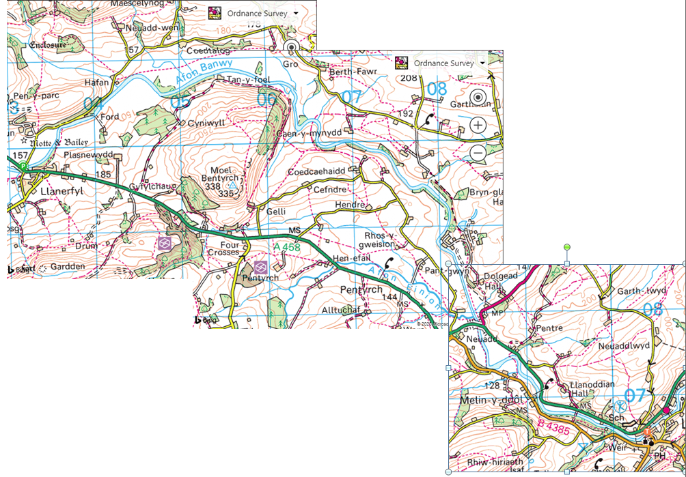
Access point
Egress at Car Park at Railway Station

Appendix 1

Handout (1) CALCULATION OF RISK SEVERITY

In assessing a RISK you need to take into account two factors:

(1) How serious could an injury be?
(2) How likely is it to occur?

The following would be a rough guideline:

High Risk: A very serious injury that had a high probability of occurring.

Med. Risk:

Either (a) A serious injury unlikely to occur
(b) A lesser injury likely to occur

Low Risk:
Would be a slight injury that was unlikely to occur.

If you take (1) above as a scale of 1 to 5 (5 = high) Seriousness
(2) above as a scale of 1 to 5 (5 = high) Likelihood

Then, multiply them together, this would give a scale as follows:

Translating into: LOW (1-8) MED. (9-17) HIGH RISKS (18-25)

SERIOUSNESS OF INJURY

5 = Very high potential for multiple death and/or wide spread destruction.
4 = High causing death or serious injury to an individual, i.e. reportable accident under the RIDDOR regulations.
3 = Moderate causing injury or disease capable of keeping an individual off work for three days or more, may require reporting under RIDDOR regulations.
2 = Slight causing minor injuries, i.e. person able to continue work after first aid.
1 = No risk of injury or disease.

LIKELIHOOD OF THE EVENT OCCURRING

5 = Very likely, almost certain.
4 = Likely to occur, i.e. easily precipitated with slight carelessness for external event, e.g. vibration.
3 = Quite possible, the accident is only likely to occur with help, i.e. if somebody slips, failure to replace a light, etc.
2 = Possibly - probably is low or minimal.
1 = Not likely at all, there is really no risk and accidents will only occur under freak conditions.

