OVERVIEW

Understanding the Theories is like a “Puzzle” because the Theorists have “Pinched” ideas from each other to justify their own. However, the “Puzzle” pieces sometimes fit or don’t from theories of motivation, leadership, teaching and learning. I will try and explain them to allow you if you wish to introduce them into your Profile, Points to Improve, Strategies and Lesson Plan.
Motivation Definition
What makes people act and behave in the way they do.

The Cycle of Motivation

BEHAVIOUR
Achieves
Create

NEEDS
GOALS

Satisfy

Motivation Theories linked to learning
What is Stimulus and Response theory of learning?

The learning theory of Thorndike represents the original S-R framework of behavioural psychology: Learning is the result of associations forming between stimuli and responses. ... The paradigm for S-R theory was trial and error learning in which certain responses come to dominate others due to rewards.

What is Skinner's theory?

Skinner was one of the most influential of American psychologists. A behaviourist, he developed the theory of operant conditioning -- the idea that behaviour is determined by its consequences, be they reinforcements or punishments, which make it more or less likely that the behaviour will occur again.

What is “Needs” theory related to learning?

Maslow's hierarchy of needs is a motivational theory in psychology comprising a five-tier model of human needs, often depicted as hierarchical levels within a pyramid.
Needs lower down in the hierarchy must be satisfied before individuals can attend to needs higher up. From the bottom of the hierarchy upwards, the needs are: physiological, safety, love and belonging, esteem and self-actualization.
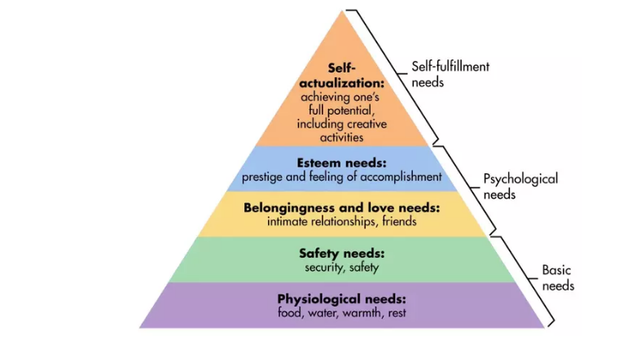

Deficiency needs vs. growth needs
This five-stage model can be divided into deficiency needs and growth needs. The first four levels are often referred to as deficiency needs (D-needs), and the top level is known as growth or being needs (B-needs).
Deficiency needs arise due to deprivation and are said to motivate people when they are unmet. Also, the motivation to fulfil such needs will become stronger the longer the duration they are denied. For example, the longer a person goes without food, the hungrier they will become.
https://www.simplypsychology.org/maslow.html

What is “Drive” theory related to learning?
Hull suggested that all motivation arises because of these biological needs. In his theory, Hull used the term drive to refer to the state of tension or arousal or stimulus caused by biological or physiological needs. Thirst, hunger, and the need for warmth are all examples of drives. A drive creates an unpleasant state, a tension that needs to be reduced.
To reduce this state of tension, humans and animals seek out ways to fulfil these biological needs. We get a drink when we are thirsty. We eat when we are hungry. We turn up the thermostat when we are cold. He suggested that humans and animals will then repeat any behaviour that reduces these drives.
Hull based his theory on the concept of homeostasis, the idea that the body actively works to maintain a certain state of balance or equilibrium. For example, your body regulates its temperature to ensure that you don't become too hot or too cold. Hull believed that behaviour was one of the ways that an organism maintains this balance.
https://www.verywellmind.com/drive-reduction-theory-2795381
Homeostasis involves three key features:
- A clear set points.
- The ability to detect deviations from this set point
- Behavioural and physiological responses designed to return the body to the set point
Your body has set points for a variety of things including temperature, weight, sleep, thirst, and hunger.
One prominent theory of human motivation, known as drive reduction theory, suggests that homeostatic imbalances create needs. This need to restore balance drives people to perform actions that will return the body to its ideal state.
https://www.verywellmind.com/what-is-homeostasis-2795237

Intrinsic and extrinsic motivation

The simplest distinction between extrinsic and intrinsic motivation is the type of reasons or goals that lead to an action. While intrinsic motivation refers to doing something because it is inherently interesting or enjoyable, extrinsic motivation, refers to doing something because it leads to a separable outcome.

What is “Intrinsic” motivation theory to learning?

Intrinsic motivation refers to behaviour that is driven by internal rewards. In other words, the motivation to engage in behaviour arises from within the individual because it is naturally satisfying to you. ... "Intrinsic motivation occurs when we act without any obvious external rewards.

What Does Intrinsic Motivation Mean? - Verywell Mind
www.verywellmind.com/what-is-intrinsic-motivation-2795…

What is “Extrinsic” motivation theory to learning?
Extrinsic means external or outside of yourself. This type of motivation is everywhere and frequently used within society throughout your lifetime. When you are motivated to behave, achieve, learn or do based on a highly regarded outcome, rather than for the fun, development or learning provided within an experience, you are being extrinsically motivated.
https://www.livestrong.com/article/174305-the-difference-between-intrinsic-motivation-extrinsic-motivation/
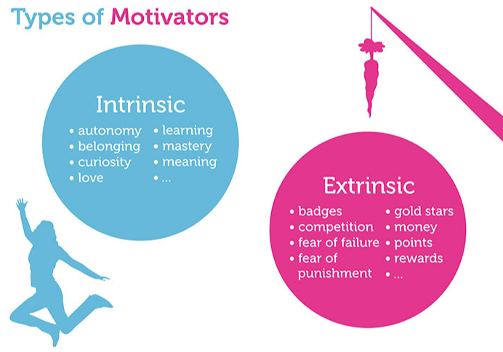
What is “Goal” Theory related to learning?
In 1960’s, Edwin Locke put forward the Goal-setting theory of motivation. This theory states that goal setting is essentially linked to task performance. It states that specific and challenging goals along with appropriate feedback contribute to higher and better task performance.
In simple words, goals indicate and give direction to an employee about what needs to be done and how much efforts are required to be put in.
The important features of goal-setting theory are as follows:
The willingness to work towards attainment of goal is main source of job motivation. Clear, particular and difficult goals are greater motivating factors than easy, general and vague goals.
Specific and clear goals lead to greater output and better performance. Unambiguous, measurable and clear goals accompanied by a deadline for completion avoids misunderstanding. There are three types:
- Process; how to develop an efficient and effective forward paddle stroke
- Outcome; to pass White Water Award
- Performance; to participate and achieve a placing in the national rankings for slalom.
Goals should be realistic and challenging. This gives an individual a feeling of pride and triumph when he attains them and sets him up for attainment of next goal. The more challenging the goal, the greater is the reward generally and the more is the passion for achieving it.
Better and appropriate feedback of results directs the employee behaviour and contributes to higher performance than absence of feedback. Feedback is a means of gaining reputation, making clarifications and regulating goal difficulties. It helps employees to work with more involvement and leads to greater job satisfaction.
Employees’ participation in goal is not always desirable.
Participation of setting goal, however, makes goal more acceptable and leads to more involvement.
Goal setting theory has certain eventualities such as:
- Self-efficiency- Self-efficiency is the individual’s self-confidence and faith that he has potential of performing the task. Higher the level of self-efficiency, greater will be the efforts put in by the individual when they face challenging tasks. While, lower the level of self-efficiency, less will be the efforts put in by the individual or he might even quit while meeting challenges.
- Goal commitment- Goal setting theory assumes that the individual is committed to the goal and will not leave the goal. The goal commitment is dependent on the following factors:
  - Goals are made open, known, and broadcasted.
  - Goals should be set self by individual rather than designated.
  - Individual’s set goals should be consistent with the organizational goals and vision.

https://worldofwork.io/2019/02/vrooms-expectancy-theory-of-motivation/
Vroom = Motivation
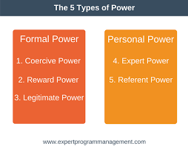plus 5 more, see below, merge into definitions and types of motivation.
https://www.indeed.com/career-advice/career-development/types-of-power-in-leadership

Teaching Styles

Behaviourism is primarily concerned with observable behaviour, as opposed to internal events like thinking and emotion:
While behaviourists often accept the existence of cognitions and emotions, they prefer not to study them as only observable (i.e., external) behaviour can be objectively and scientifically measured.
Therefore, internal events, such as thinking should be explained through behavioural terms (or eliminated altogether).
https://www.simplypsychology.org/behaviorism.html

Cognitive
Cognitive learning is learning by experiencing, touching, listening, or otherwise perceiving. This is differentiated from other theories of learning, such as behaviourist, by the fact it requires only the learner's brain and a stimulus. Cognitive learning is based on Gestalt psychological theories and Jean Piaget's developmental psychology. Mar 9 2019
Reference: www.wisegeek.com/what-is-cognitive-learning.htm
Humanism
Humanism, a paradigm that emerged in the 1960s, focuses on the human freedom, dignity, and potential. A central assumption of humanism, according to Huitt (2001), is that people act with intentionality and values [1].
This is in contrast to the behaviourist notion of operant conditioning (which argues that all behaviour is the result of the application of consequences) and the cognitive psychologist belief that the discovering knowledge or constructing meaning is central to learning. Humanists also believe that it is necessary to study the person as a whole, especially as an individual grows and develops over the lifespan. It follows that the study of the self, motivation, and goals are areas of particular interest.
https://www.learning-theories.com/humanism.html
Comment
What I find is that you apply all three depending on the situation in hand:
- Safety: Behaviourism, don’t go near “Strainers”.
- Prior knowledge: Cognitive David’s sailing experience used on the Banwy swam with his boat then “Pushed” it into eddy and he swam into it. Transfer of knowledge and experience.
- Assumption based on David’s needs; Humanism Parkinson’s? Actively participating in kayaking to stem the development?

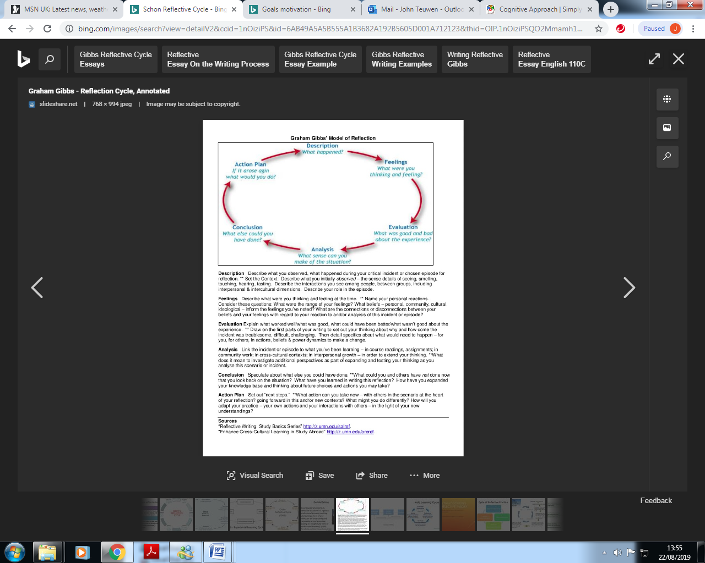
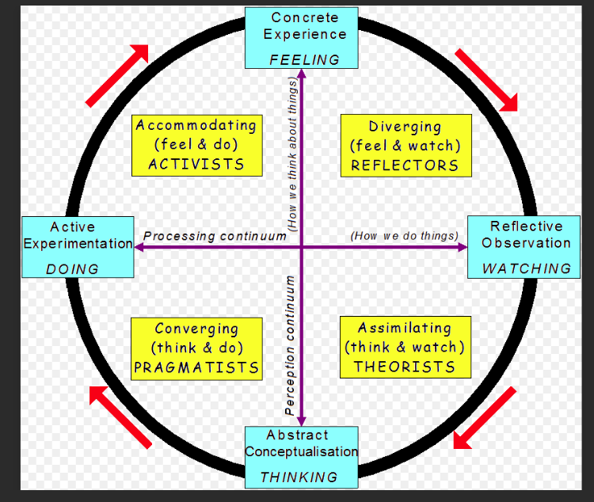
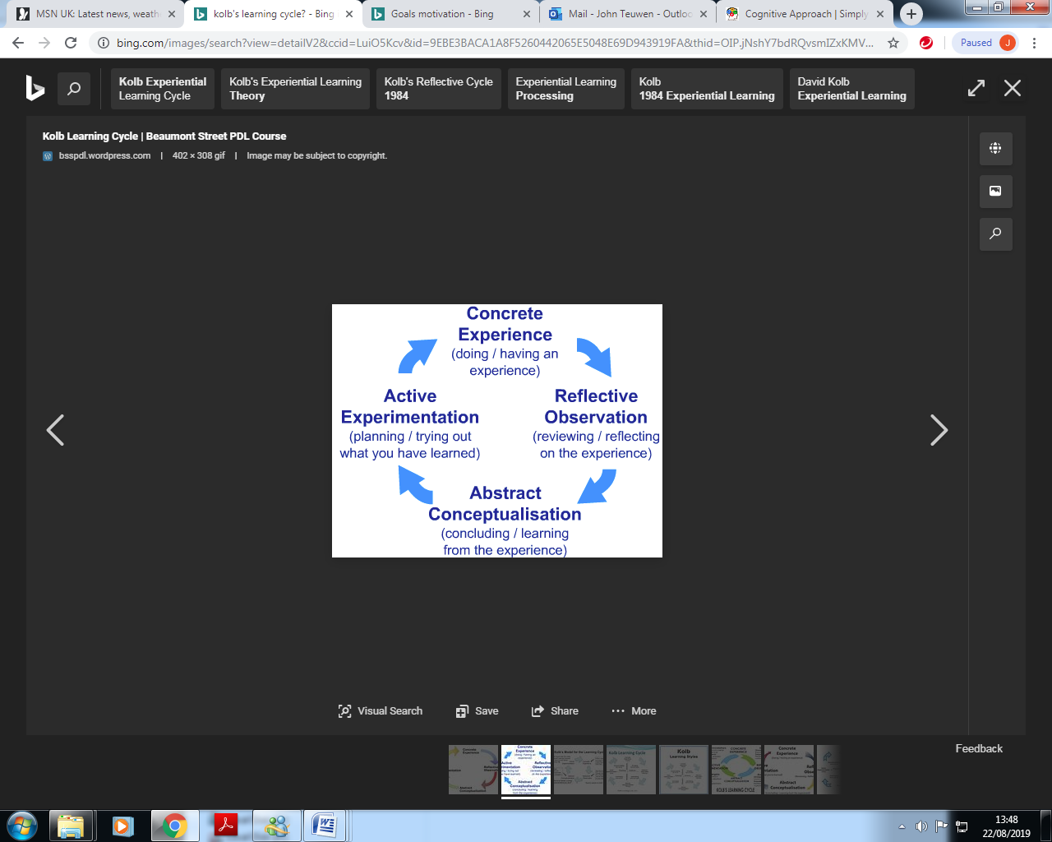
Kolb’s Learning Cycle
What is situational style leadership?

Situational leadership is a leadership style that has been developed and studied by Kenneth Blanchard and Paul Hersey. Situational leadership refers to when the leader or manager of an organization must adjust his style to fit the development level of the followers he is trying to influence. With situational leadership, it is up to the leader to change his style, not the follower to adapt to the leader’s style. In situational leadership, the style may change continually to meet the needs of others in the organization based on the situation. See Development level of followers:
https://smallbusiness.chron.com/define-situational-leadership-2976.html
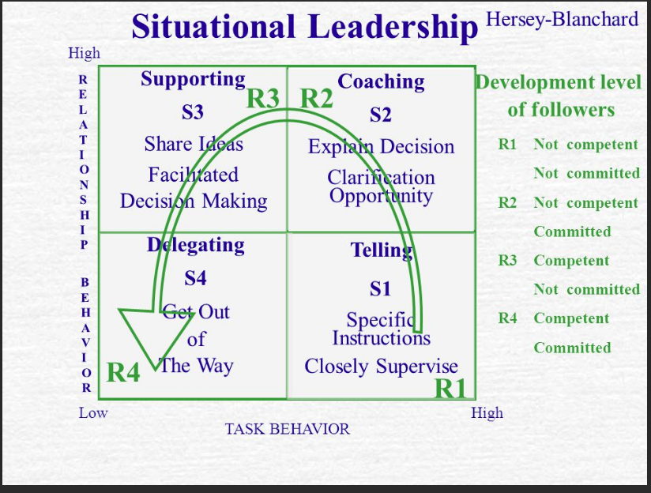
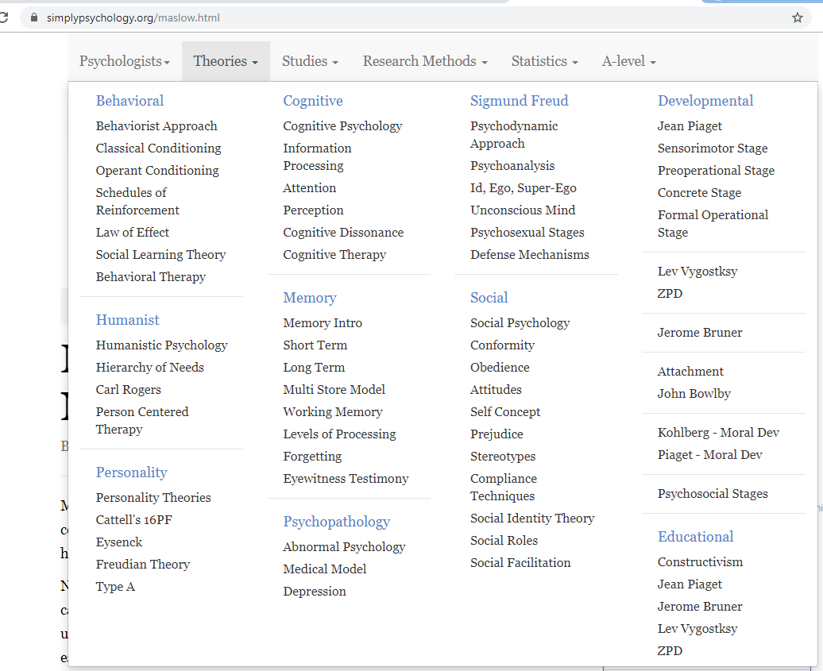
Good Web site to links on theory.

https://www.ckju.net/en/dossier/qualities-transformational-leaders-and-what-distinguishes-them-transactional-leaders
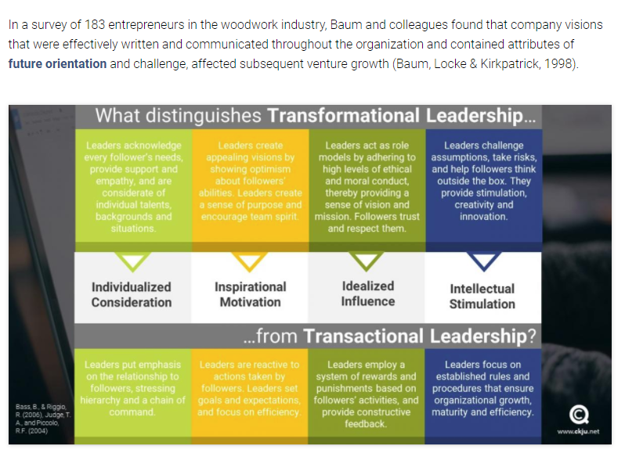
British Canoeing “Transactional” leadership.

Transactional Leadership shortcomings and weaknesses
You should be aware that Transformational Leadership and other leadership approaches that rely on a similar set of assumptions (e.g. charismatic leadership and authentic leadership) have considerable shortcomings and weaknesses. We will have a look at three of these shortcomings and introduce some alternative leadership concepts you should be aware of.
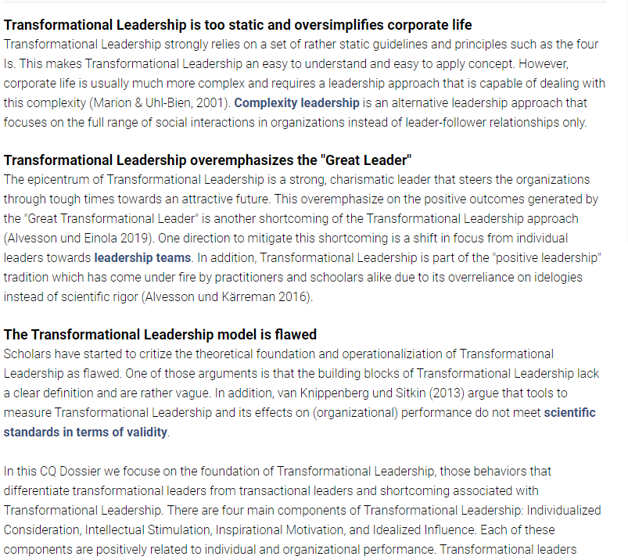

Transformational leaders enable their followers to go beyond expectations whereas transactional leaders merely provide contingent rewards in exchange for effort and are less effective than transformational leaders.
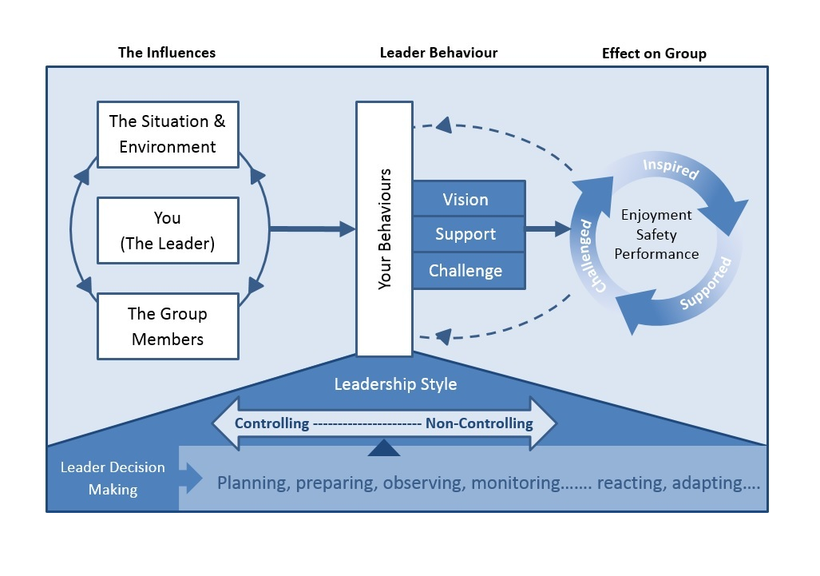
British Canoeing – Leadership Model
prelevant

British Canoeing Level 2 Session Planner
Coach: |  |  |  |  |  | Date:
Session title:  Personal Development: White Water |  |  | Session number:

Session Summary
Session aim/s: Kayak  Aim:  To enjoy, learn and improve technical and tactical skills in a safe environment.  Objective  To understand and develop personal technical and tactical skills in a white water environment safely. |  |  | Length of session: 2*45 minute
 |  |  | Discipline: White Water Award - Development Session
 |  |  | Number in group: 3
Summary of content:

Introduce: Aims, objectives, safety brief; “Buddy” check buoyancy aid, paddle check, Risk assessment talk on hazards at beach, How to lift a canoeWarm-up: Up & over line game with a “Throw-line bag”. Rich
Preparatory Activities: Leet area; initial personal warm-up, paddle up Leet & return. Tim
Activity & Skill: Skill development? Reading of water, position to move from behind concrete eddy up stream? TTPP? Rich
Games: Follow my leader. “Reciprocal method”. E.g. Between Paul & Rob? Tim,
Move to bottom “Rafting Eddy” – “Ferry Gliding” Rich & “S” turns Tim, (Covering breaking in & out, changing & maintain direction) get use to flow.
Games: How “High “can individuals “Break in & out” of flow from one eddy to the opposite side?
Move to upper “Eddy” access via bottom Leet entry. Repeat “Ferry Gliding” & “S” turns - get use to flow above previous final drop.
Games: “Break in & out” through slalom poles with a straight upright paddle stroke.
Challenge: Move up eddy on opposite side to Leet entry. Use appropriate skill to “Break in & out” to eddy below “slalom Poles” and hole. Return to opposite side – performance tested by How “High “can individuals “Break in & out” of flow from one eddy to the opposite side?
Running the river Top Leet entry area down to the bottom raft area eddy. Dealing with any mishaps.
Repeat; “Break in & out” of flow to “Eddy” before and opposite Lower Leet entry & final drop
Cool-down & Clear Away:
Conclusion: clear down; boats & buoyancy aids
Any notes from last session: None,

Safety, Equipment and Venue
Equipment required for participants: Paddle, KayakBuoyancy Aid, |  |  |  | Venue: Upton Warren
Teaching and safety equipment: 1st Aid Kit, Throw Line”, buoyancy aid, spare clothing, group shelter |  |  |  | Support staff roles: Qualified L2 Coach, 1st Aider
Any medical or particular individual needs: |  |  |  | Parental consent forms collected: Y / N
 |  |  |  | Medical declaration forms checked: Y / N
 |  |  |  | Access checked: Y / N/A
Any specific safety considerations/hazards or safety control measures:

See Risk Assessment
Develop below according to above.


