Wombourne Kayak Club River Guide: River Avon - Nafford Weir
Location: | River Avon – Nafford Weir  Post Code: WR10 3AE  Paddlepoints:  English River Levels:  Grade 2: Evesham 0.52, Pershore 3.27, Eckington S., 2.09, Bredon 0.74-gauge High - | Grid Reference: | Access:  948422
Types of Trips: | Club Night or Friends recreational kayak trip
Video Footage: | See Videos:  - 19/11/16 Nafford Weir – John | Date: | 05/02/ 2023
Assessor Name: | John Teuwen | Review: | 05/02/ 2023
Position in Club: | Health & Safety | Date Checked & updated: | 05/02/ 2023
Date Completed: | JohnTeuwen |  | 05/02/ 2023

Feature | Weir; at high levels; tow back at the front of bridge above 3.34
Feature | Parking:  If anyone is thinking of visiting Nafford weir, there have been a few changes since our last visit there.  The track down to the old Nature reserve/fisherman's car park has been improved a little and is less rutted. However, the car park now only has access via a coded padlock (much the same as Telford CC site at Jackfield).  At the bottom of the track is a place to turn around in a gateway and about 30 metres back up the track is another gateway that appears to be unused where we managed to park my van (possibly room for 2 vehicles). Although 2 cars were parked on the car park, we didn't see any fishermen when playing on the weir. A few pictures to help clarify the changes.
Feature | 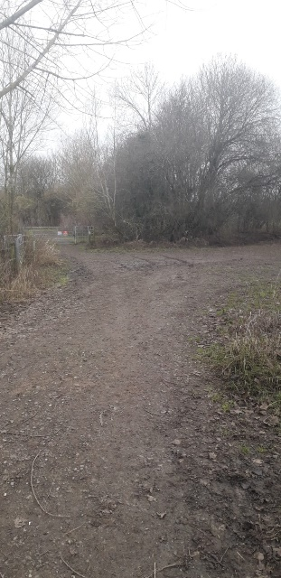  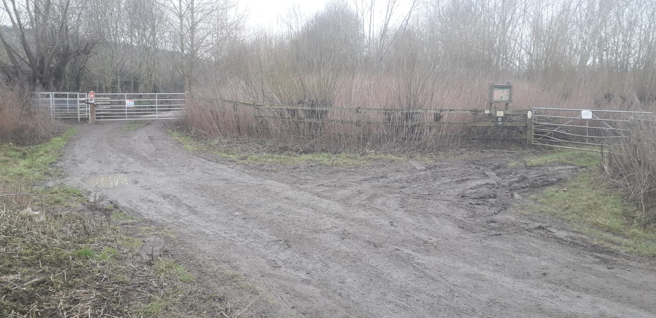  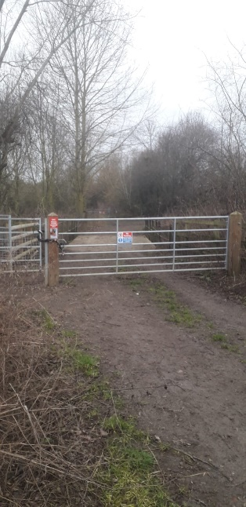
Feature | 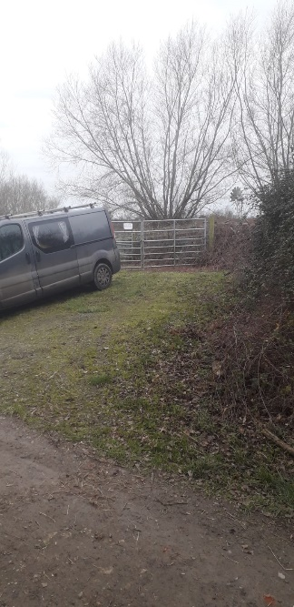  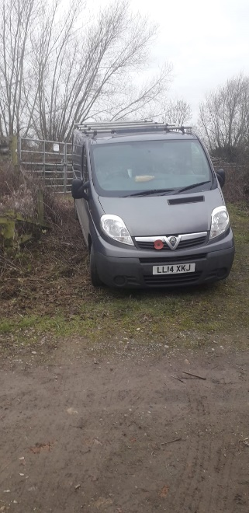  Parking: Further up the lane is another gate, enough space to the gate.  Additional space 2 cars opposite.

