Surfers against Sewage Protest: 20th May 2023 https://gopaddling.info/paddlepoints/ search Essex Bridge
Post Code: ST18 0TT
Post Code: ST18 0TT just scroll to River Trent on the same Meadow Lane towards A513
Schedule:
Arrive at Car Park for 10.00, get changed.
Transport boats down to Trent Mersey Canal, leave 1-2 cars
See maps for journey p2 -p3.
Suggested Route: Take Stafford road A449 to Penkridge from Wolves, take Teddesley Rd. to Milford,turn right on A513, until Meadow lane & sign for Little Haywood. OPPOSITE Meadow Lane, right hand side A513 is the Car Park!

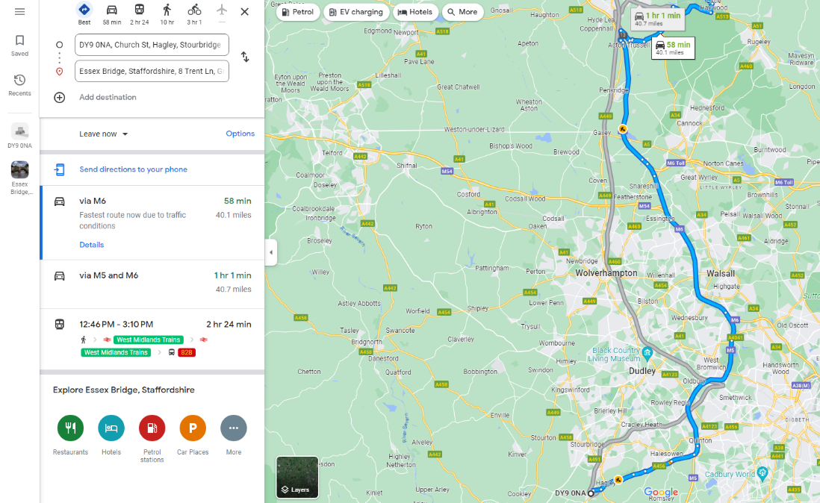
Motorway route, approximately an hour.
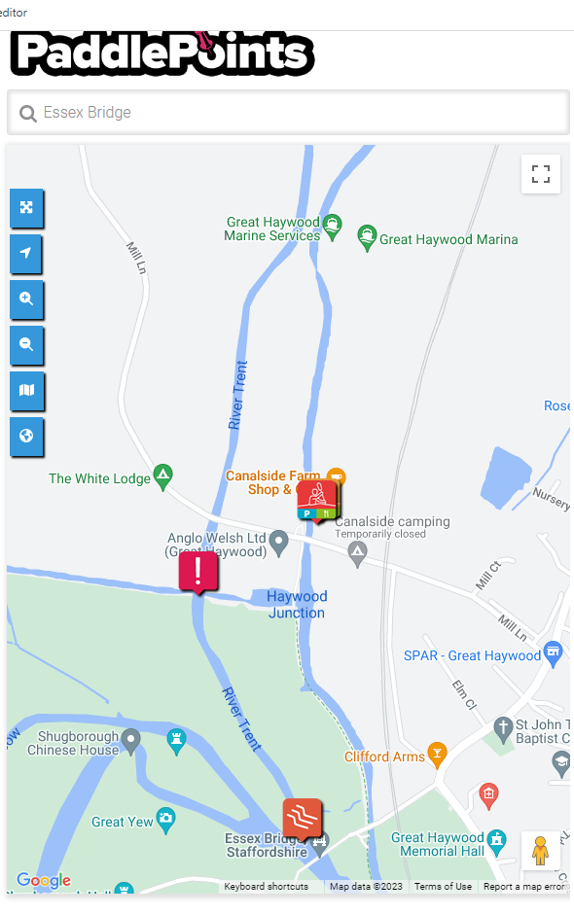
RIVER TRENT Water Levels 1
Name | Level | Downstream
Great Haywood | 0.944 mASD | -

RETURN JOURNEY:
Get off canal & paddle down River Trent to Essex Bridge to join protest between 12-2pm
Weir:
Easy passage or PORTAGE.
OR
RETURN JOURNEY:
travel down the canal to Essex Bridge to join protest by walking from the canal.
RETURN JOURNEY:
At Haywood Junction. turn right and join Staffs Worcester Canal until the bridge over River Trent
OUTWARD JOURNEY:
Paddle past Essex Bridge to Canalside Farm Shop & Café for a break.
RETURN JOURNEY:
Paddle down Trent Mersey Canal to Haywood Junction.
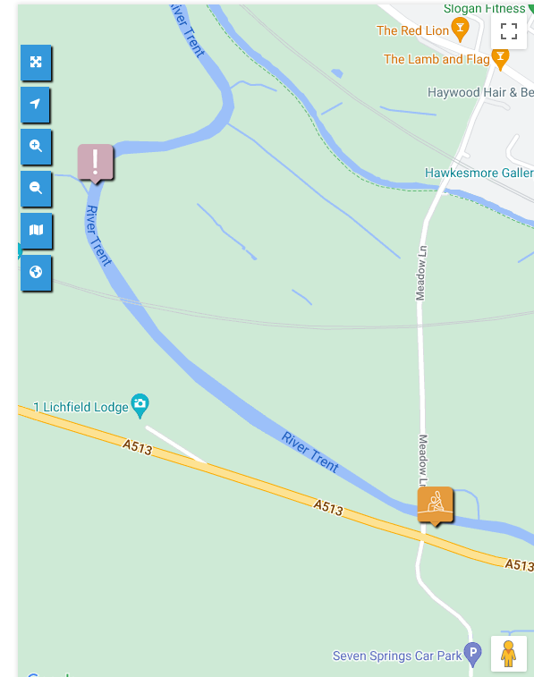
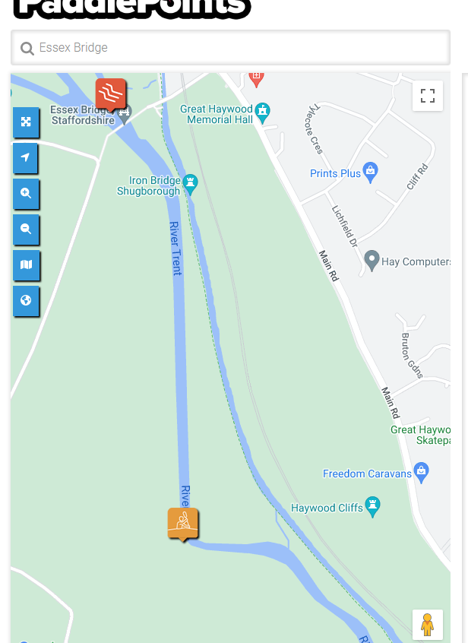
OUTWARD JOURNEY:
Transport boats down to Trent Mersey Canal. Paddle up towards Essex Bridge to Canalside Farm Shop.
Car Park within NT grounds at Shugborough Hall. (On the main road there is a pull in)
RETURN JOURNEY:
Weetsmans Bridge & Car Park. (Carry kayaks over the narrow bridge and enter river on the right side.)
RETURN JOURNEY:
Paddle down the canal to be picked up.
OR
RETURN JOURNEY:
After protest at Essex Bridge paddle down River Trent to Weetsmans Bridge & car park.
RETURN JOURNEY:
Tree across river, pass on left side.

