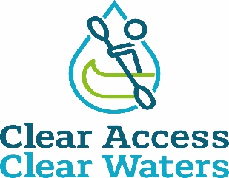

Dale End Car Park - Ironbridge

British Canoeing has been made aware by the paddling community that an access point at Dale End Carpark to the River Severn used by paddlers of all ages, abilities and interests, for many decades, is being restricted. It is also of great interest to touring paddlers who love the world famous Ironbridge.

British Canoeing has met with and formally written to the landowner twice, however the landowner remained fixed in their view.

The next step continues to be investigation locally for evidence of use in order to make a claim for a right of way based on public use, the law (section 31 of the Highways Act 1980) requires that you’re able to meet the following criteria:

- A period of at least 20 years' uninterrupted use by the public (this is the public as a whole, not just one person, though applications where single users have used the route for 20+ years is stronger) from the date it was brought into question.
- Use must be 'as of right', which means without secrecy, force, or the express permission of the landowner
- Use must be by the public at large, not just certain tenants or employees of an estate
- From a public highway (in this case Telford and Wrekin Council have now confirmed that Definitive Public Footpath 81 runs close to the access points in question, along the tarmac pathway), along a specified route. It is important to note that users may have used a number of slightly different routes, which may have changed over time due to one reason or another, so user maps accompanying evidence needs to be clear on the precise route taken. A review of the evidence will then be undertaken by British Canoeing and the lead volunteer in liaison with Telford and Wrekin Council with the intention of submitting an application for the Definitive Map to be modified to the council.

This is being co-ordinated by a new lead volunteer John Teuwen to establish if public rights exist, with support from British Canoeing.

In order to secure access at The River Severn it is absolutely essential that anyone who has used the route on a fairly regular basis to access the river and who meets the above criteria, should complete a user evidence form and accompanying map showing the route(s) used. It is also essential to understand the evidence may be used at a Public Inquiry so please do consider all questions thoroughly. Completed evidence forms and accompanying plans should be emailed to access@britishcanoeing.org.uk clearly titled ‘User Evidence – Dale End - Ironbridge’ or posted to Chantelle Grundy, British Canoeing, Adbolton Lane, Holme Pierrepont, Nottingham, NG12 2LU.

British Canoeing is committed to protecting and enhancing places to paddle as detailed in our Access & Environment Charter.
In addition, the CACW Clear Access, Clear Water campaign. British Canoeing will continue to work towards retaining this location as a launch spot which has been used respectfully and responsibly by paddlers over the years.

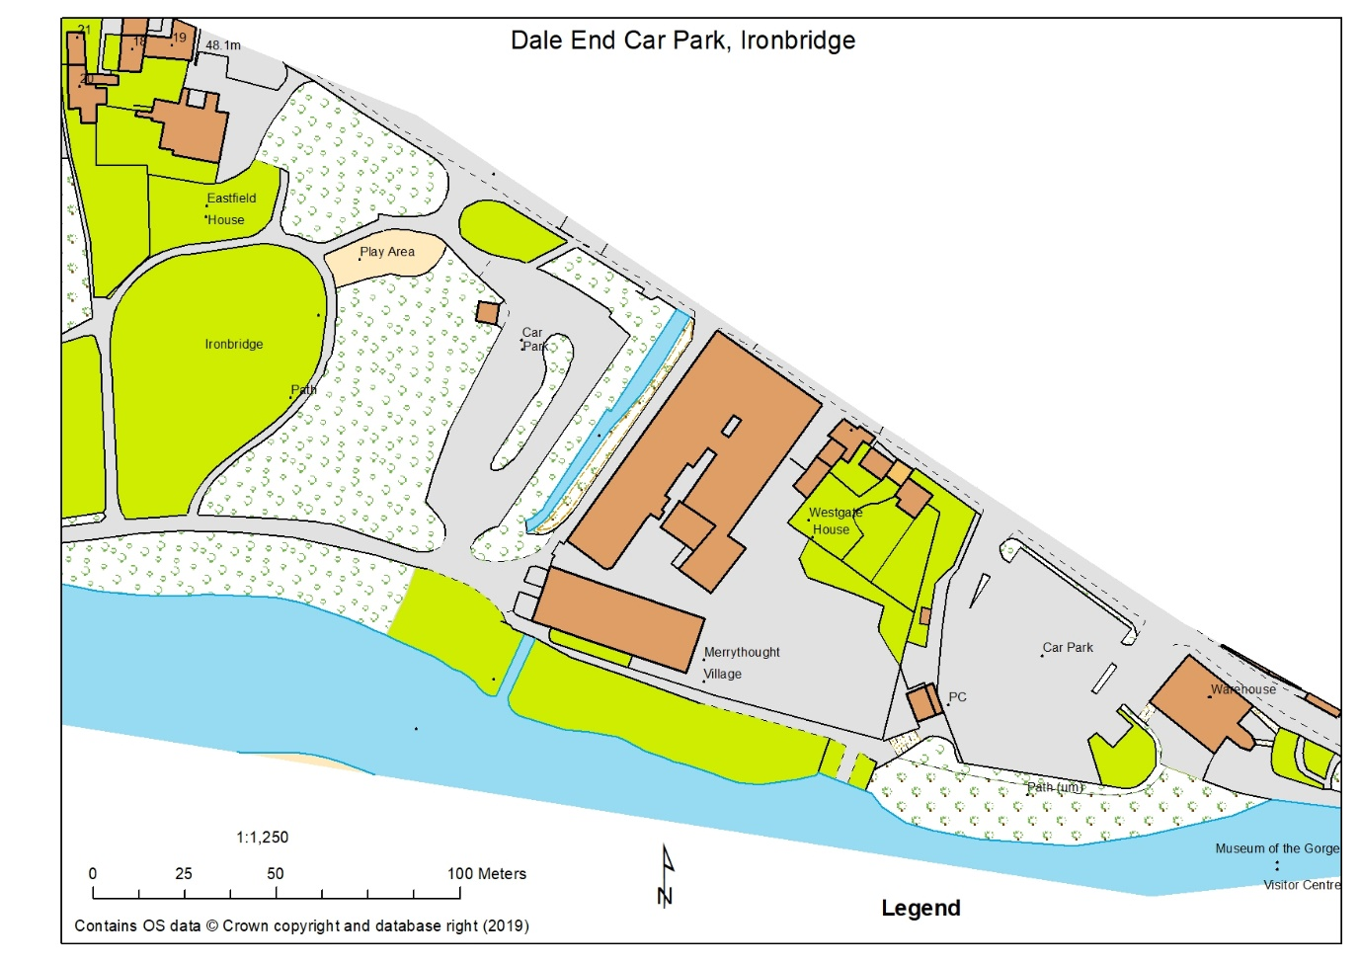

Plan of area provided by D Bennett. Note: Merrythought Village Company (Teddy bears) own the river bank for a 100m from the River Cole running along the “Car Park” into Dale End Park.

West Midlands Paddling Community Facebook – 18th May 2023

Dear all… message from Chantelle, British Canoeing

Reference: Dale End Carpark, Coalbrookdale, Ironbridge

British Canoeing’s Application to add a public footpath to the Definitive Map at Dale End, Coalbrookdale, Ironbridge

Telford and Wrekin Council have taken the decision to make the Order to modify the definitive map to include the application routes, on the Definitive Map.

The Order will be made later this year. The Order will be advertised in the local newspaper, notices will be installed on site, and all statutory consultees will be consulted directly, including landowners, the local Parish Council and Ward Members.

There will then be a statutory right for anyone to comment/object to the made order for a period of 50 days following publication. It is likely that the Order will be objected to and it will then be subjected to a public inquiry.
Full details can be viewed here: https://secure.telford.gov.uk/planning/pa-applicationsummary.aspx?applicationnumber=DMMO/2020/0002

If you have substantial use of the path from the car park to the river Severn for a period of at least 10 years (the legislation requires a 20-year period to be covered) and have not yet provided evidence of use and would be willing too, please email.
chantelle.grundy@britishcanoeing.org.uk

There will be a need for clarity on the route or routes you people have used and evidence form regular use is stronger, evidence forms, and a plan are attached and can be shared.

Thank you for your support.
Chantelle.

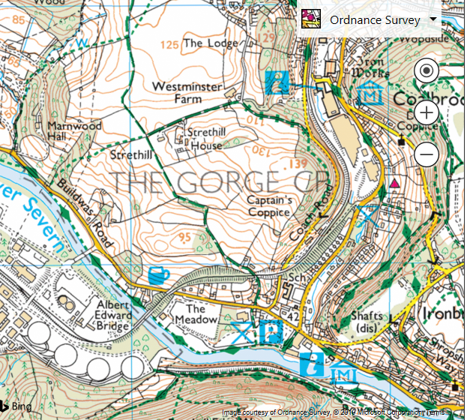
66 67

04

03

666038 Dale End Long Stay Car Park

