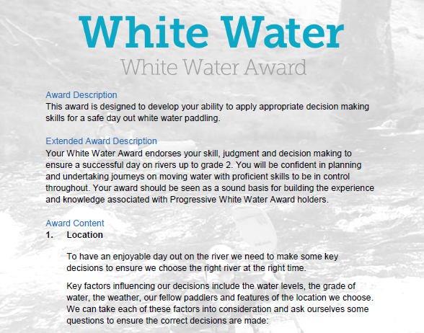
Section 1: Paddling locations:
This section is about paddling locations, where we paddle, how we get to and from the river and what things we should consider in planning a trip. This section can be completed with your own experiences and knowledge and by using the reading resources listed at the end of the document.
However, depending on the individual there are various options to complete this section:
- Complete the Section 1 - Module Guide Questions. Or........
- Provide a “Video”, recording your actions or visual images explaining your knowledge and understanding within the questions asked. Or.........
- Plan a “River Trip” during the “Summer” and one for the “Winter” months, providing the necessary information to a “New” club member with limited white-water experience. Or...
- A combination of the “Options” to suit your learning.
Use the available Reference resources listed at the end to support your answers or decision-making for each section.

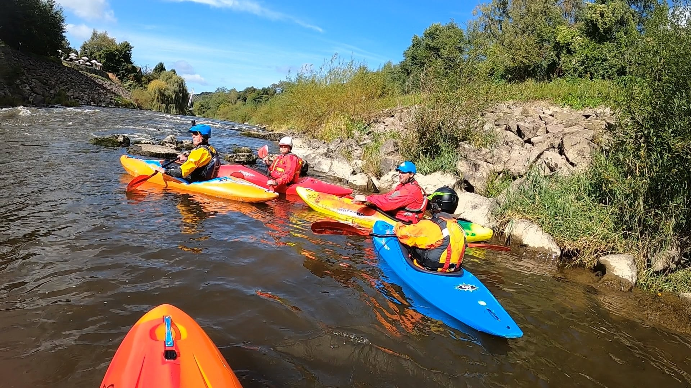
White Water Award

Location

1.1 Factor: River Conditions
- What grade of river does this qualification assess your performance on? See Environmental Definitions

- What grade is “Jackfield Rapids”? Does the grade change at any point? See UK Rivers Guide

- What sections above and below “Jackfield Rapids” can be considered within the grade range 1 to 3?
(Watch the two videos at different river levels – (1) Jackfield Rapids 24/07/20, (2) Jackfield Rapids 17/10/20
Describe the grade range between 1, 2 and 3 within the videos, relating to the date and time.
- What monitoring stations on the River Severn does the club use to check the current water levels at Jackfield Rapids? See English River Levels

- What is the current level today?

- What was the level 2-3 days ago (Is the level increasing or decreasing)?

- Compare the Jackfield Rapids videos: (1) 24/07/20 and (2) 17/10/20. How “safe” is the river level for your ability between the two different conditions? For example, in relation to Covid 19?

- Are there any “Tributaries” nearby, which can affect the river level at “Jackfield Rapids”? ......

- How might we find out this information?

- What features would you expect to see at “Jackfield Rapids”? Do the features “Change” at different levels?

- What features would you expect to see at the “Grade 3 section” on the river Banwy? See Video (3) River Banwy 17/08/19 –Part B
(Descent 0-0.40 minutes), (Play features 0.48-0.56, 1.36-2.50 minutes)

- What features would you expect to see at Ludlow on the river Teme? Do the features vary at different sections of the River Teme?......
See Video (4) from 1 to 2 minutes. Note video (5) 5-5.20 minutes.
What could be a problem near the weir?
See Video (5) from 6 to 8 minutes
See Video (4) from 8.41 to 14.24 minutes.
See Video (5) for the impact using a specific route, 26.31 minutes
See Video (4) from 12.30 to 14 minutes.
See Video (5) from 31.00 to 33.00 minutes.
See Video (6) from 9.57

- What hazards would you need to be aware of, including birds and humans on the riverbank?
White Water Award
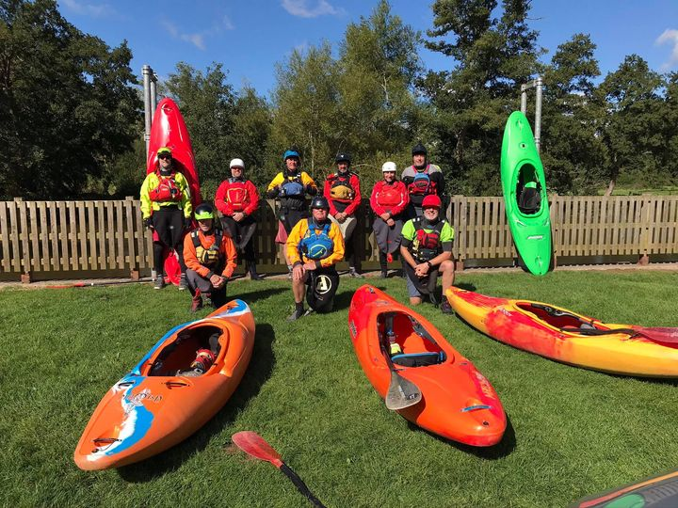

1.2 Location Factor: Weather Conditions

- What is the weather forecast today at Ironbridge if you were paddling at Jackfield Rapids?

- How will this impact if you paddled today?

- What is the forecast at Ironbridge in 5-days’ time?

- How will this impact if you paddled in 5-days’ time?

- What would be the impact if you paddled either the River Teme or River Banwy today and in 5 days’ time?

- How did the weather forecast (Cloudy & overcast, temperatures ranging 16-20 °) have an impact on your clothing kit decisions when paddling?
See Video (1)

- How did the weather forecast (Cloudy & overcast, temperatures ranging 12 °, note wind chill feels like temperature 8°) have an impact on your clothing kit decisions when paddling?
See Video (2)

- How had the weather forecast impact on the safety precautions we undertook on the River Usk (video 10) @ 12.30 -13.40 and15.00 – 16.20 minutes. Weather Report March 2019 .

- List safety equipment worn or carried by you (as a paddler)? Reference

- List safety equipment worn or carried by you (as a group)? Reference

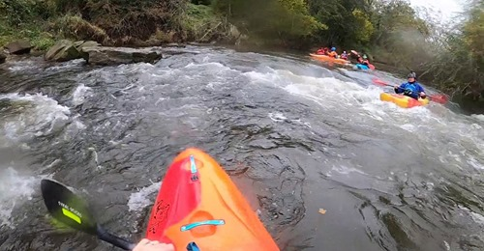
White Water Award

1.3 Location Factor: Access and Environment

- What restrictions might there be on the water we are paddling? Reference

- What restrictions have we experienced at Dale End Long-stay car park, Ironbridge when paddling the River Severn from this location down to Jackfield Rapids? Reference

- Where can we access/egress the Severn? See Paddle points

- What environmental factors might affect this decision? Reference

- How would we direct support to us in emergency situations? What communications methods could we use? Reference

- How can we reduce our impact on the environment and animals around us? Reference

Bibliography Reference Resources:
- English River Levels Gov.UK
- Weather Forecast Met. Office
- Weather Report March 2019 Met. Office
- River Hazards Paddling.com
- River Features Palm Bren Orton
- UK Rivers Guide

WKC Website – Click on
Risk Assessment – Jackfield Rapids, Banwy, Usk: Talybont to Crickhowell – Search on website
- Health & Safety: Emergency Plan - Pre-planning, On the Water Plan – Search on website
British Canoeing Resources:
- Course Authorisation & Results video “How to enter”
- Go paddling Paddle points
- Go paddling – Kayaking Safety Checklist
- Major Incident Plan
- Access & Environment Charter
- CACW Clear Access, Clear Water
- Affiliation & membership provides licensing – English locations, rivers, canals.
- PROW – Public Rights of Way
- DMMO - Making changes to a Definitive Map Modification Order
- Access Flowchart – John Teuwen update?
- Go paddling – Environment Blog
- Environmental Definitions and Deployment Guidance for Instructors, Coaches and Leaders
Additional Resources for Access and Environment
- Access & Environment – River Usk & Wye
- River Usk & Wye - Issues

Videos
Video Number/ID | Title
1 | Jackfield Rapids 24/07/20
2 | Jackfield Rapids 17/10/20
3 | River Banwy 17/08/19
4 | Specific risk assessment 2018 Trip - Teme
5 | Teme 23/03/2019
6 | Teme 29/08/20 (JT)
7 | Teme 29/08/20 (RD)
8 | River Teme 31/11/20 - Part A
9 | River Teme 31/11/20 Part B
10 | River Usk Part (A) 15/03/19

Appendix 1 - Wombourne Kayak Club: Access issues at dale end car park

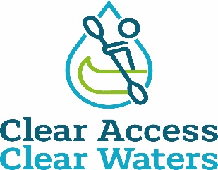

Dale End Car Park - Ironbridge

British Canoeing has been made aware by the paddling community that an access point at Dale End Carpark to the River Severn used by paddlers of all ages, abilities, and interests, for many decades, is being restricted. It is also of great interest to touring paddlers who love the world-famous Ironbridge.

British Canoeing has met with and formally written to the landowner twice, however the landowner remained fixed in their view.

The next step continues to be investigation locally for evidence of use in order to make a claim for a right of way based on public use, the law (section 31 of the Highways Act 1980) requires that you’re able to meet the following criteria:

- A period of at least 20 years' uninterrupted use by the public (this is the public as a whole, not just one person, though applications where single users have used the route for 20+ years is stronger) from the date it was brought into question.
- Use must be 'as of right', which means without secrecy, force, or the express permission of the landowner
- Use must be by the public at large, not just certain tenants or employees of an estate
- From a public highway (in this case Telford and Wrekin Council have now confirmed that Definitive Public Footpath 81 runs close to the access points in question, along the tarmac pathway), along a specified route. It is important to note that users may have used a number of slightly different routes, which may have changed over time due to one reason or another, so user maps accompanying evidence needs to be clear on the precise route taken. A review of the evidence will then be undertaken by British Canoeing and the lead volunteer in liaison with Telford and Wrekin Council with the intention of submitting an application for the Definitive Map to be modified to the council.

This is being co-ordinated by a new lead volunteer John Teuwen to establish if public rights exist, with support from British Canoeing.

In order to secure access at The River Severn it is absolutely essential that anyone who has used the route on a fairly regular basis to access the river and who meets the above criteria, should complete a user evidence form and accompanying map showing the route(s) used. It is also essential to understand the evidence may be used at a Public Inquiry so please do consider all questions thoroughly. Completed evidence forms and accompanying plans should be emailed to access@britishcanoeing.org.uk clearly titled ‘User Evidence – Dale End - Ironbridge’ or posted to Chantelle Grundy, British Canoeing, Adbolton Lane, Holme Pierrepont, Nottingham, NG12 2LU.

British Canoeing is committed to protecting and enhancing places to paddle as detailed in our Access and Environment Charter - Clear Access Clear Waters . British Canoeing will continue to work towards retaining this location as a launch spot which has been used respectfully and responsibly by paddlers over the years.

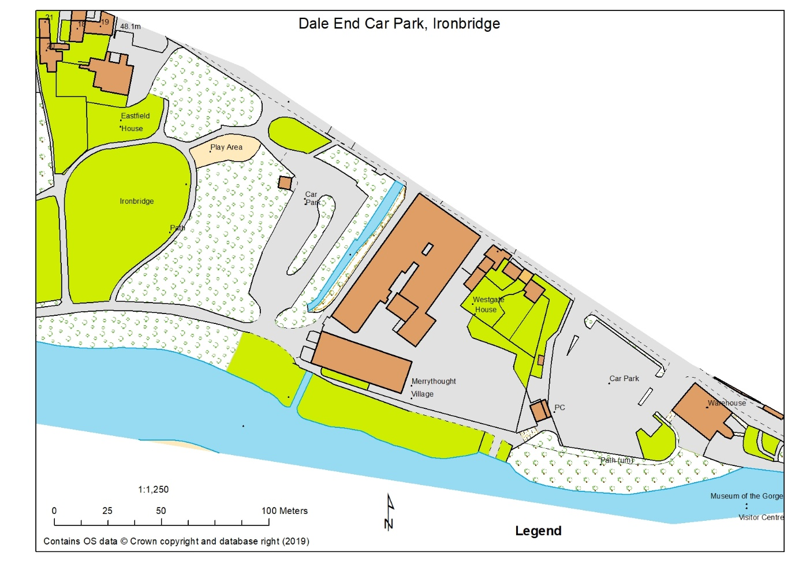

Plan of area provided by D Bennett. Note: Merrythought Village Company (Teddy bears) own the river bank for a 100m from the River Cole running along the “Car Park” into Dale End Park.

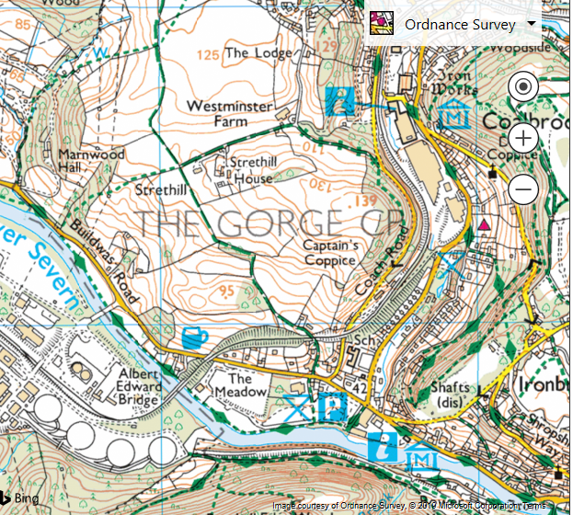
66 67

04

03

666038 Dale End Long Stay Car Park

