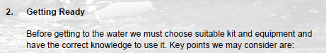
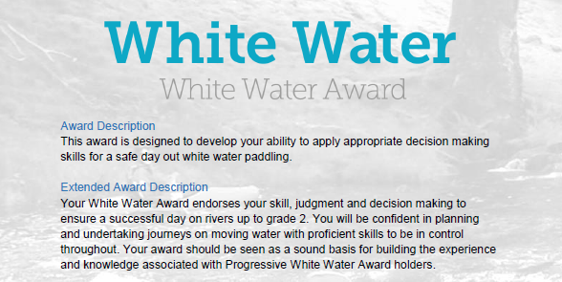
Section 2: Getting ready to paddle:
This section is about how we prepare to get on the water and what we should consider in our choice of kit and how this might affect the paddle. This section can be completed with your own experiences and knowledge and by using the reading resources listed at the end of the document.
However, depending on the individual there are various options to complete this section:
- Complete the Section 2 - Module Guide Questions. Or........
- Provide a “Video”, recording your actions or visual images explaining your knowledge and understanding within the questions asked. Or....
- Plan a “River Trip” during the “Summer” and one for the “Winter” months, providing the necessary information to a “New” club member with limited white-water experience. Or...
- A combination of the “Options” to suit your learning.
Use the available Reference resources listed at the end to support your answers or decision-making for each section.

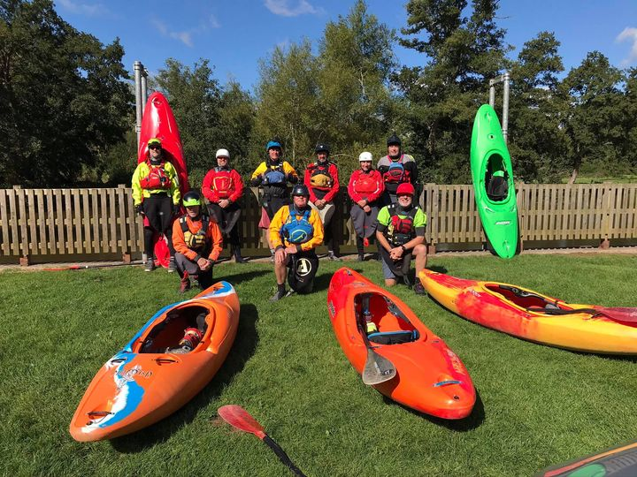
White Water Award

- Getting Ready – What will we wear?

See Reference for supporting information.

- What are the clothing options to us during?

- Winter? ..... List and explain “Advantages” & “Disadvantages”.

- Summer? ..... List and explain “Advantages” & “Disadvantages”.

- Explain your choice of “summer” clothing. What do you use and why?

- Explain your choice of “winter” clothing. What do you use and why?

- What personal safety equipment do you use? How confident are you in the use of your chosen personal safety equipment?

- Getting Ready – What will we use?

See Reference for supporting information.

- What are the different equipment and boat options used in white water? List and briefly describe the difference:

- Creek
- River runner
- Play boat/rodeo
- Long boats
- Paddle

- Explain your choice of boat over another?

- Explain your choice of paddle?

- How might different hull design and types impact your paddling? Example: Rich’s Dagger Mamba is different than my Dagger Nomad?

Bibliography Reference Resources:
Wombourne Kayak Club Resources:
WKC Website – Click on
Kayak & Paddles
- Equipment & Clothing
- Types of Cagoules
- Types of Dry suits
- Types of Wetsuits
- Types of Footwear
- Types of Trousers
- Types of Spray deck
- Types of PFD's - Buoyancy Aids
- Types of Helmets
- Types of Personal Safety Equipment
- Buoyancy Bags
Miscellaneous
- What does a kayak pinned kit consist of?
- How to set up a pinned kayak rescue
- What does a First Aid kit consist of?
- The difference between kayaks?
- Railed or Displacement?
- Different types of kayak blades
British Canoeing Resources:
- Buying a kayak?
- Ten types of kit to carry on a river trip
- Course Authorisation & Results video “How to enter”

