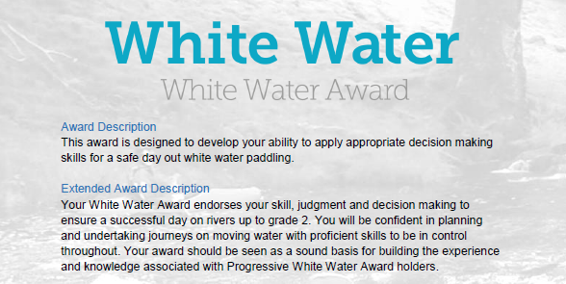
Section 3: At the water:
This section is about what, where and who we should consider when paddling. How do we protect the environment, other paddlers, and ourselves? This section can be completed with your own experiences and knowledge and by using the reading resources listed at the end of the document.
However, depending on the individual there are various options to complete this section:
- Complete the Section 3 - Module Guide Questions. Or........
- Provide a “Video”, recording your actions or visual images explaining your knowledge and understanding within the questions asked. Or.........
- Plan a “River Trip” during the “Summer” and one for the “Winter” months, providing the necessary information to a “New” club member with limited white-water experience. Or...
- A combination of the “Options” to suit your learning.
Use the available Reference resources listed at the end to support your answers or decision-making for each section.

White Water Award

- At the Water: Consideration
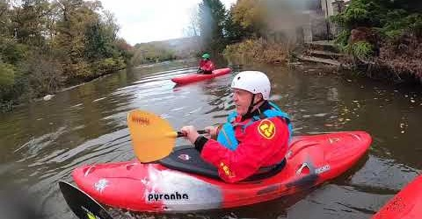

What may we consider?
See the Reference section for supporting information.

- Who should we be considerate of when paddling? For example, what other users may we need to consider at Jackfield? ................. See Video 1 Jackfield Rapids 17/10/20 from 2 minutes

- Is Wombourne Kayak Club using a managed (Company/Organisation: public, private, voluntary) supervised (Club, Peer Recreationalist, Coach) site at Jackfield Rapids? For example –Who is exactly responsible when club members are paddling? .......

- Can you consider other managed or supervised sites? For example – man-made sites (Cardiff Whitewater Centre) or “Dam release” locations (Wales National Whitewater Centre) are they managed or supervised?...........

- How would you describe the paddling “Etiquette” at Jackfield Rapids when using this site? ............

- How can we “Park and change” considerately to other users? For example – Telford Canoe Club site, small public car park or Half Moon Pub

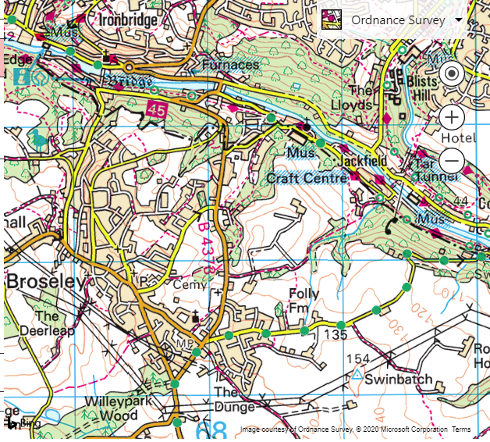

- How would you describe the current paddling ability of club members (p6) Jackfield Rapids? For example, related to the Environment: Sheltered or Moderate Water Areas............

- What do you think motivates (Apply Maslow’s theory) Club members to paddle? .................

Consideration: Safety and Rescue
- How can we protect ourselves and others from any potential River features Palm Bren Orton

- What damage to our health might repeat immersion in cold water cause?

- How can we help prevent this becoming an issue? .......................

- What would we do if someone we are paddling with gets really cold or overheats (p21-22) ..................

- What potential injuries (See Wombourne Kayak Club website, Risk Assessment – Jackfield Rapids) might we need to treat? ..........

- How might we treat these injuries eLearning -1st Aid .....................

Consideration: Getting to the water
We may need to determine:
- How are we going to get to the “Access and Egress” points, do we need to organise a shuttle? For Example – Ludlow Town Rapids, how did we plan these actions – Use map in River Guide . See Wombourne Kayak Club website – River Guides

- What is the best way to carry, load and secure our craft to protect ourselves or others from injury and prevent unnecessary damage? For example, “Access and Egress” points at Jackfields – Use video footage to demonstrate “Good Practice” .......

- How will we get our craft and additional equipment to the water? For example – For example “Access” points at Jackfields – Use video footage to demonstrate “Good Practice” ........

- The water and weather conditions, are they what we expected? ...... For Example – Plan for a trip to a specific location during “winter and summer”. (References)

- What river factors do we need to take into consideration before we get on? For example – Plan for a trip to a specific location during “winter and summer”, do the grades, features change? (References)

Bibliography Reference Resources:
- English River Levels Gov.UK
- Weather Forecast Met. Office
- Weather Report March 2019 Met. Office
- River Hazards Paddling.com
- River Features Palm Bren Orton
- UK Rivers Guide
- “Etiquette” paddling in a group
- Shared space
- Motivation (Maslow’s Theory)

WKC Website – Click on

- Risk Assessment – Jackfield Rapids, Banwy, Usk: Talybont to Crickhowell
- Health & Safety: Emergency Plan - Pre-planning, On the Water Plan
- River Guides
Wombourne Kayak Club: Access issues at dale end car park Link

British Canoeing Resources:
- Course Authorisation & Results video “How to enter”
- Go paddling Paddle points
- Ten types of kit to carry on a river trip
- Tips for Staying Warm in Winter
- Kayaking Safety Checklist
- 1st Aid eLearning
- Immersion in cold water
- Prevent Cold Shock
- Environmental Definitions and Deployment Guidance for Instructors, Coaches and Leaders
- British Canoeing Paddlesafer (p24-30)
- Current paddling ability of club members category of ability levels
- Individual & group safety equipment
- Types of Personal Safety Equipment

Videos

Video Number/ID | Title
Video 1 | Jackfield Rapids 17/10/20

