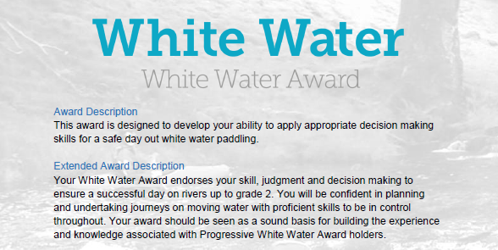
Section 5: After the session:
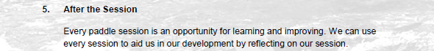

This section is about the continual learning process, how and what do you learn from your paddling experiences? Use videos of club paddles with reference to timings to explain your answers and what you have learnt.

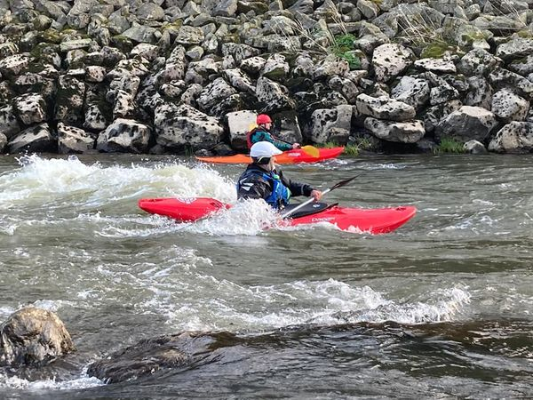

White Water Award
After the Session:
Section 5: After the session:
This section is about the continual learning process, how and what do you learn from your paddling experiences? Use videos of club paddles with reference to timings to explain your answers and what you have learned.
However, depending on the individual there are various options to complete this section:
- Complete the Section 5 - Module Guide Questions. Or........
- Provide a “Video”, recording your actions or visual images explaining your knowledge and understanding within the questions asked. Or....
- Plan a “River Trip” during the “Summer” and one for the “Winter” months, providing the necessary information to a “New” club member with limited white-water experience. Or...
- A combination of the “Options” to suit your learning.
Use the available Reference resources listed at the end to support your answers or decision-making for each section.

Preparation:
- Complete sections in British Canoeing Adapted Coaching & Leadership Logbook

- Personal Particulars
- Paddling Experience: record details of sessions, trips, journeys and expeditions and any other Paddlesport experience
- Courses attended / work with other organisations
- Record the trips, journeys, and expeditions you have led or assisted on.

Write a short reflection on what you have learnt or any developments to consider by answering the set
questions in each section on pages 3, 4, 5, etc. See Wombourne Kayak Club Website
Menu – White Water Award

White Water Award
After the Session:
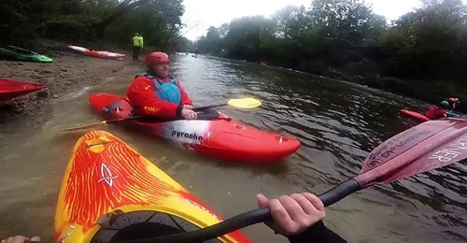

Look around on your next river trip:
Identify video footage that demonstrates with times this skill recorded in your logbook.

- Have conditions changed whilst you were on the water? Identify and explain the changes.

- Explain any other unexpected incidents, which were not expected?

Example: Video 1 from 15.15 minutes. River Usk 15/03/19

- Explain how the group dealt with the unexpected incidents.

Example: Video 1 from 15.15 minutes. River Usk 15/03/19

Watching what others do:
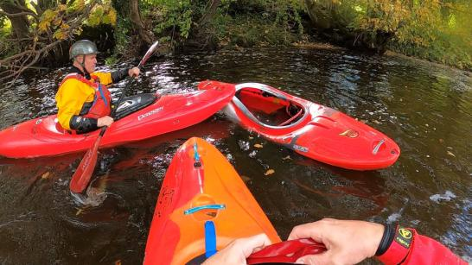

Identify video footage that demonstrates with times this skill recorded in your logbook.

- How was our session or trip in relation to other similar sessions or trips?

- Explain how the more experienced paddlers had good lines down the river?

- Explain how you were able to relate their skills to your personal development?

Consider what you will take away:
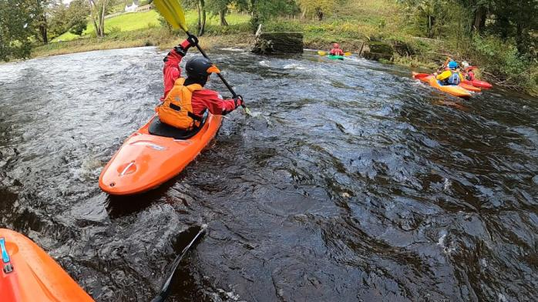

Identify video footage that demonstrates with times this skill recorded in your logbook.
- What have you learnt today? What went well? What needs to be developed?

- How can you focus on your development needs next time?

Reference Resources:
Wombourne Kayak Club Resources:
Wombourne Kayak Club Website
See Menu – White Water Award to access Logbook

British Canoeing
Development Pathway Paddlesup
Paddle Award Instructor
Leadership Moderate Water
Coach Self Analysis
Information on Mentors and Coaches
Videos Paddlesport Safety & Rescue Course
Safety and Personal Development
Coach Award
Changes to “Safeguarding”
Digital Library
Coaching Qualifications Courses
Download British Canoeing Adapted Coaching & Leadership Logbook

Video Number/ID | Title
1 | River Usk Part (A) 15/03/19

