Wombourne Kayak Club Boat Booking Procedure
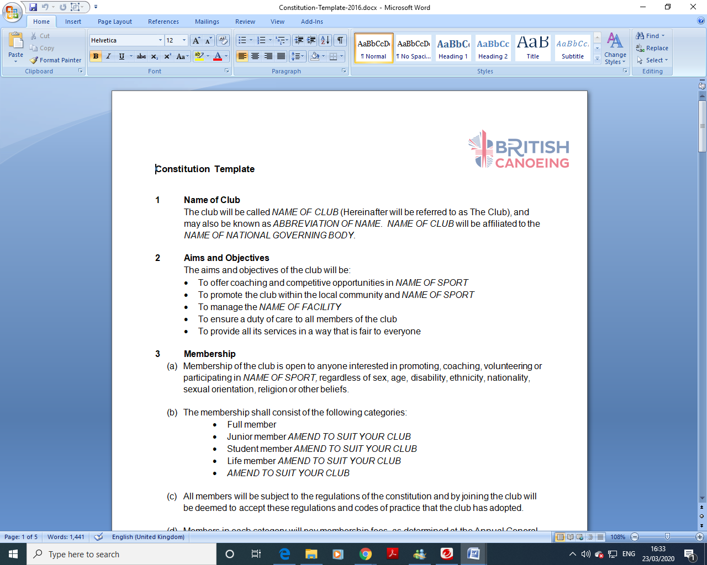

Introduction
Wombourne Kayaking Club (WKC) has several boats stored at Wombourne Leisure centre for the use of its members and prospective members.

Purpose
The boat booking system allows the Club to:

- Manage the availability and location of its boat stock
- Allow fair and reasonable access/use of those boats to any active or prospective member of WKC

How to book
Member to request boat loan from the club Equipment Officer or Committee member, and loan details entered the Equipment Booking spreadsheet.

How long are the Booking Periods?

21 Days Maximum, boat to only be used in a Club managed paddle (Saturday paddle, Thursday Jackfield session, midweek Club paddle, impromptu Jackfield session with a coach or leader)

Club boats are not to be used in salt water unless it is unavoidable, i.e., a WW river trip ends in a sea estuary. If used in a saltwater environment the boat is to be thoroughly rinsed in fresh water as soon as possible

Members are required to contribute £10 for boat repairs and maintenance for each 21-day loan period

There is no contribution required for one-off loan at either a pool session or weekly Jackfield session

Boats are to be checked when leaving the storage area to ensure that they have two rear airbags, a fitted drain bung, rescue handles are present and secure, step out pillars are present where applicable

Note: individuals may have more than one short-term booking to a total period of 3 months, but the boat should be inspected at the end of each 21-day period, and any defects rectified before the boat goes out again

The member loaning the boat will be expected to pay £100 toward boat replacement if the boat is lost, stolen, or damaged beyond repair (split or holed)

Storage

Boats to be stored safe, out of the sunlight and secure from theft or accidental damage i.e., not on the roof of a car overnight in a car park or street.

Booking Contract

Boat Make | Model | Colour | Condition | Location | Notes | Type of Loan: ST/LT | Negotiated with Committee Members | Date booked out | Date returned | Booking Payment

Signed by Committee Member:

Signed by Member:

Updated by Wombourne Kayak Club 08/02/22

British Canoeing, National Water Sports Centre, Adbolton Lane, Holme Pierrepoint, Nottingham, NG12 2LU

