Wombourne Kayak Club River Guide: Town Falls, Llangollen to Ty Mawr Country Park
Location: | River Dee –Town Falls, Llangollen to Ty Mawr Country Park  Post Code: LL20 8AB Mill Street, Llangollen - £3-4 parking/access  Post Code: LL14 3PE Ty Mawr Country Park  Paddle Points: - River Dee  UK Rivers Guide: Town Falls to Ty Mawr Country Park.  River Levels: 0.46 (Low) - 19/06/21, 0.75 (Medium, fast conditions, “Wave Trains”) 04/12/21  River Gauge: Corwen | Grid Reference: | Access:  (Car Park, left bank, Mill St.) Llangollen  OS Ref:  SJ 20797 42824  Egress:  280414
  - 0.45 scrape
  - 0.52 low
  - 0.65 medium
  - 0.95 high
  - 1.25 huge
Types of Trips: | Club recreational kayak trip
Video Footage: | See Videos:  https://www.youtube.com/watch?v=8dKmWFMKepE Part A – Low level John  https://www.youtube.com/watch?v=eA_YnwA5xUw Part B – Low level John  https://youtu.be/d7ivXq0V8DY Medium Level 0.85m John  https://youtu.be/s9Cb82yc67s 8th April 2023 John – Low level 0.56  https://www.youtube.com/watch?v=5kWHdWBSgS8 see 8th April 2023 Rich  https://www.youtube.com/watch?v=BAbVtVR7zxs 29th July 2023 John Medium Level 0.68m | Date: | 08/04/2023  29/07/2023

Feature | Trevor Rapids Falls: Grade 3 Mill section gradual drop take right hand route, wave chain at end.  Section under the bridge; take centre bridge route, sequence of small drops.  Note: Tree across, take outside right route.  https://www.youtube.com/watch?v=8dKmWFMKepE Part A – Low “Mill Falls” - 5.57 minutes, Trevor Bridge 11.15 mins.,  Part B – Low Pontcysyllte Aqueduct (Canal) Bridge 1.15 mins.,  Medium https://youtu.be/d7ivXq0V8DY “Mill Falls”- 11.52 mins., Trevor Bridge - 13.33 mins., Pontcysyllte Aqueduct (Canal) Bridge- 14.57 mins.,
Feature | Over hanging tree or strainers  S = 4 L = 4 = 16 Medium, capsize more likely at low levels.  Identify hazard areas to paddlers. Portage  https://youtu.be/s9Cb82yc67s 8th April 2023 John 6.47 minutes.  Although more experienced paddlers are capable of paddling, see 8th April 2023 Rich 0.45 seconds.  https://www.youtube.com/watch?v=5kWHdWBSgS8  https://www.youtube.com/watch?v=BAbVtVR7zxs 29th July 2023 John Medium Level 0.68m, (3.40 minutes)  Higher level paddle strong to the left to avoid being “Pushed” into over-hanging tree strainers.

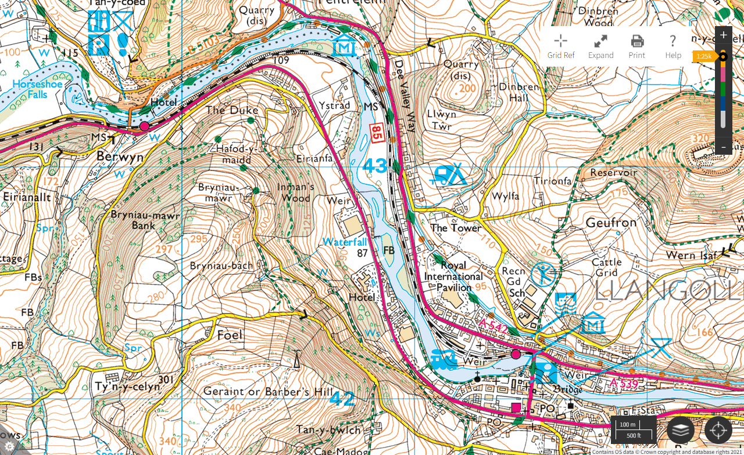
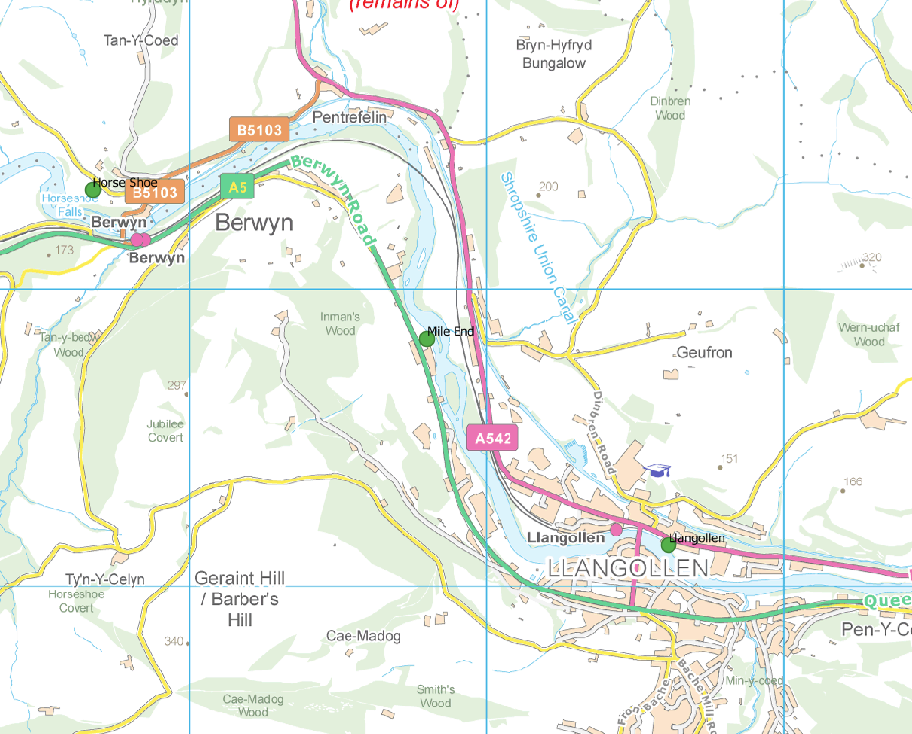

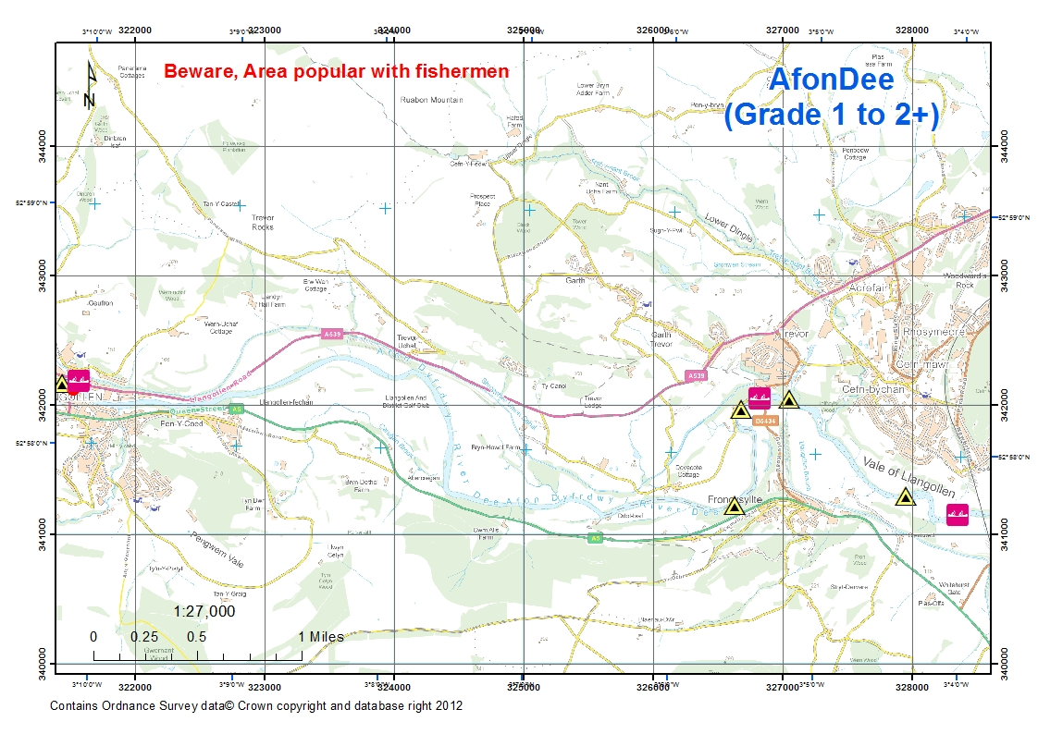
Tree
Hazard

