Wombourne Kayak Club Risk Assessment
Location: | Paddle points – AberGlaslyn – Type in  River Levels: Beddgelert  River Levels: (18/11/23) -1.0m  Post Code: LL55 4NG  Post Code: LL55 4YG  Grid Reference Finder: AberGlaslyn | Grid Reference: | Access:  SH61378,  49550  Spaces for 6 or 7 cars. More parking nearby  Egress:  SH59187,  47281  Spaces for 4 or 5 cars. More parking a mile further along the road. (Shuttle)
Types of Trips: | Club Night or Friends recreational kayak trip
Video Footage: | See Videos:  River Glaslyn: Lake Dinas to above the Gorge. (John - 18/11/23) | Date: | 18th November 2023
Assessor Name: | John Teuwen | Review:
Position in Club: | Health & Safety | Date Checked & updated:
Date Completed: | JohnTeuwen | Signed: | 18th November 2023

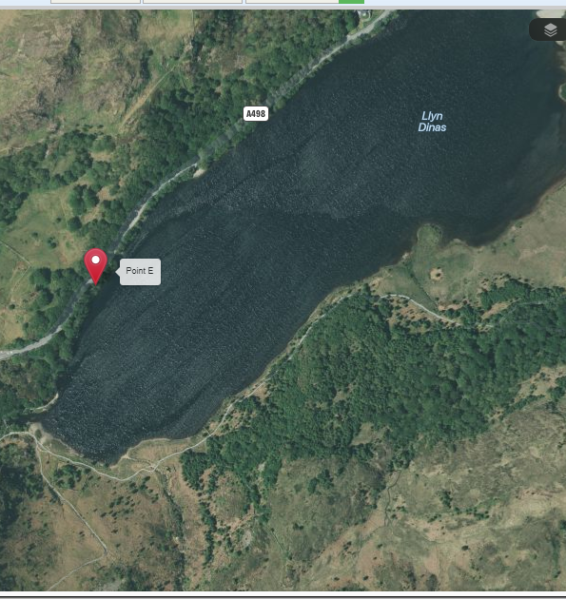
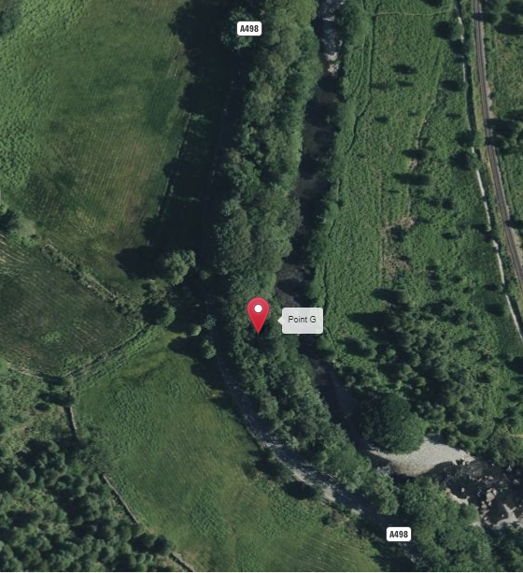
EGRESS:
A498 – large layby on the left opposite signed “get out above the gorge. Advised in high levels to get out a 100m on bend before signed post!
ACCESS:
A498 – layby next to Lake/Llyn Dinas
Wombourne Kayak Club Risk Assessment
Risk ratings Low, medium or high: 3 * 3 Risk Matrix
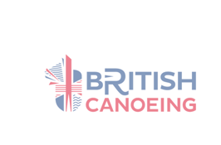


What is the hazard? | Who might be harmed? | How may the risk be adequately controlled? | Risk Ratings:  Low, Medium, High  Grade based 3*3 Risk Matrix & calculation of risk severity chart | Action by whom | What further action is necessary?
Weather & Environmental Conditions: Floods/  Spate conditions | Club Members | Check weather forecast & river levels.  - Dynamic risk assessment.  Re-locate or cancel if inappropriate to group ability  - Weather Forecast: Met Office  - River Levels: Beddgelert | S = 5 L = 5 = 25 High  Likely, Extremely Harmful | - Club coaches & senior members.
Drowning | Club Members | - Buoyancy Aids & Helmets must be worn & fitted correctly for all paddlers.  - All club buoyancy aids & helmets are checked & their condition recorded annually.  - Apply “Buddy” checks on helmets & buoyancy aids, boats  - Parental Consent Forms T4 & Adult T4a Trip Participant Statement signed | S = 3 L = 3 = 9 Medium  Likely, Slightly Harmful | - Club coaches & senior members.  - Club equipment officer to undertake checks.  - Club members.  - Club coach’s/secretary
Weather related injury  Hyperthermia.  Hypothermia | Club Members | - Check weather forecast.  - Dynamic risk assessment  - Advised on appropriate clothing to wear.  - Adjustment to clothing as required, e.g., use of wet to dry suit depending on weather forecast, temperature & time of year.  - Sun block, extra water, change of clothing,  - Hyperthermia; offer a cold drink  - Hypothermia; offer a hot drink, Group shelter or emergency bag | S = 4 L = 4 = 16 Medium  Likely, Harmful | - Club coaches & senior members

Wombourne Kayak Club Risk Assessment
Risk ratings Low, medium or high: 3 * 3 Risk Matrix

What is the hazard? | Who might be harmed? | How may the risk be adequately controlled? | Risk Ratings:  Low, Medium, High  Grade based 3*3 Risk Matrix & calculation of risk severity chart | Action by whom | What further action is necessary?
Sprains, strains, soft tissue injuries | Club Members | Trained to lift boat correctly  - Ask for help.  - Trained to paddle correctly.  Dynamic risk assessment | S = 2 L = 3 = 6 Low  Likely, Slightly Harmful | - Club coaches & senior members.  - Include in initial Induction & Club Training
Medicinal risks | Club Members | - Members inform club on Application form.  - Ensure Members have and are taking necessary medication. | S = 2 L = 2 = 4 Low  Likely, Slightly Harmful | - Agreed action between participants & coaches of routine consumption of necessary medication.  - Coaches may hold any necessary medication on request/agreement of participant involved.
Slips, trips & falls  NB – Steep ground at Egress point | Club Members | - Safety Brief  - Create awareness of river/bank hazards  - Identify hazard areas to paddlers.  - Dynamic risk assessment. | S = 3 L = 3 = 6 Med.  Likely, Slightly Harmful | - Club coaches & senior members.

Wombourne Kayak Club Risk Assessment
Risk ratings Low, medium, or high: 3 * 3 Risk Matrix

What is the hazard? | Who might be harmed? | How may the risk be adequately controlled? | Risk Ratings:  Low, Medium, High  Grade based 3*3 Risk Matrix & calculation of risk severity chart | Action by whom | What further action is necessary?
Pollution & water quality | Club Members | Risks higher in “Spate” conditions  Avoid intentional capsize in poor conditions  Advised to bath/shower after paddle  Made aware of flotsam  Dynamic risk assessment | S = 4 L = 3 = 12 Medium  Likely, Harmful | - Club coaches & senior members.
Water borne disease’s | Club Members | - All paddlers should shower after paddling and wash their hands before eating.  - Cover cuts with waterproof plasters to prevent infection. | S =4 L = 2 = 4 Low  Likely, Harmful | - Club Safety Officer to publicise guidelines and provide hand washing and shower facilities on site
Fisherman; line & hook causing facial injuries. | Club Members | - Identify & inform participants & instructors.  Safety brief  - Dynamic risk assessment | S = 2 L = 2 = 4 Low  Unlikely, Harmful | - Club coaches & senior members.
Swans - | Club Members | - Avoid paddling near them in nesting period in Spring  Safety brief  - Dynamic risk assessment | S = 2 L = 2 = 4  Unlikely, Harmful | - Club coaches & senior members.

Wombourne Kayak Club Risk Assessment
Risk ratings Low, medium or high: 3 * 3 Risk Matrix

What is the hazard? | Who might be harmed? | How may the risk be adequately controlled? | Risk Ratings:  Low, Medium, High  Grade based 3*3 Risk Matrix & calculation of risk severity chart | Action by whom | What further action is necessary?
Other paddlers or users on the river; SUP | Club Members | Safety brief  - Navigation rules of the river & awareness of other craft.  Paddlers instructed to be aware of other uses & how to take appropriate action to avoid them.  - Fraying paddles, boats  - Dynamic risk assessment. | S = 3 L = 3 = 9 Medium  Likely, Slightly Harmful | - Club coaches & senior members.
Illness & fatigue | Club Members | Safety brief  Paddlers to inform instructor  - Dynamic risk assessment  - First aid kit, food and water, evacuation procedures and assistance. | S = 3 L = 3 = 9 Medium  Likely, Slightly Harmful | - Club coaches & senior members.
Road Traffic accident  Breakdown | Club Members | Dynamic risk assessment  - First aid kit, food and water, evacuation procedures and assistance. | S = 5 L = 4 = 20 High  Likely, Harmful to extreme | - Club coaches & senior members.
Equipment: unserviceable | Club Members | - Loose seat, footrest, ratchets, missing bung  - Periodic safety checks of equipment, | S = 2 L = 3 = 6 Low  Likely, Slightly Harmful | - Club coaches & senior members.
Wombourne Kayak Club Risk Assessment
Risk ratings Low, medium or high: 3 * 3 Risk Matrix

What is the hazard? | Who might be harmed? | How may the risk be adequately controlled? | Risk Ratings:  Low, Medium, High  Grade based 3*3 Risk Matrix & calculation of risk severity chart | Action by whom | What further action is necessary?
Bridge Stanchions: | Club Members | Dynamic risk assessment – overhanging branches  - Ability of paddlers – | S = 4 L = 3 = 12 Med  Avoid paddling in front of bridge Stanchions, as this may lead to a capsize. | Correct supervision and group control by instructor, coaches, leaders and senior paddlers (Trainees included) safety brief.  Dynamic risk assessment.
Access: Lake Dinas, layby before entering the river section at the end of the lake. Post Code: LL55 4NG | Club Members | Dynamic risk assessment – overhanging branches  - Ability of paddlers – | S = 2 L = 3 = 6 Low  Likely, Slightly Harmful | Correct supervision and group control by instructor, safety brief. As above
Egress:  On bend 100m. before designated Access point to paddle gorge to prevent being swept down the gorge!  Post Code: LL55 4YG | Club Members | Dynamic risk assessment  Ability of paddlers | S = 3 L = 3 = 9 Medium  Likely, Harmful to extreme in flood conditions. S = 5 L = 4 = 20  High Risk | Correct supervision and group control by instructor, safety brief.  As above  Flood conditions, egress before bridge.

Handout (1) CALCULATION OF RISK SEVERITY

In assessing a RISK you need to take into account two factors:

(1) How serious could an injury be?
(2) How likely is it to occur?

The following would be a rough guideline:

High Risk: A very serious injury that had a high probability of occurring.

Med. Risk:

Either (a) A serious injury unlikely to occur
(b) A lesser injury likely to occur

Low Risk:
Would be a slight injury that was unlikely to occur.

If you take (1) above as a scale of 1 to 5 (5 = high) Seriousness
(2) above as a scale of 1 to 5 (5 = high) Likelihood

Then, multiply them together, this would give a scale as follows:

Translating into: LOW (1-8) MED. (9-17) HIGH RISKS (18-25)

SERIOUSNESS OF INJURY

5 = Very high potential for multiple death and/or wide spread destruction.
4 = High causing death or serious injury to an individual, i.e. reportable accident under the RIDDOR regulations.
3 = Moderate causing injury or disease capable of keeping an individual off work for three days or more, may require reporting under RIDDOR regulations.
2 = Slight causing minor injuries, i.e. person able to continue work after first aid.
1 = No risk of injury or disease.

LIKELIHOOD OF THE EVENT OCCURRING

5 = Very likely, almost certain.
4 = Likely to occur, i.e. easily precipitated with slight carelessness for external event, e.g. vibration.
3 = Quite possible, the accident is only likely to occur with help, i.e. if somebody slips, failure to replace a light, etc.
2 = Possibly - probably is low or minimal.
1 = Not likely at all, there is really no risk and accidents will only occur under freak conditions.

