Location: | Post Code: LL55 4NG  Post Code: LL55 4YG  Paddle points – AberGlaslyn – Type in  Grid Reference Finder: AberGlaslyn  River Levels: (18/11/23) -1.0m  River Gauge: Beddgelert | Grid Reference: | Access:  SH61378,  49550  Spaces for 6 or 7 cars. More parking nearby  Egress:  SH59187,  47281  Spaces for 4 or 5 cars. More parking a mile further along the road. (Shuttle)
Types of Trips: | Club recreational kayak trip
Video Footage: | See Videos:  - River Glaslyn: Lake Dinas to above the Gorge. (John - 18/11/23) | Date: | 18th November 2023
Wombourne Kayak Club River Guide: River Glaslyn – Lake Dinas to above the Gorge

Feature | Grade 2: Be aware of rocks below surface, can trip paddler to capsize.  River Glaslyn: Lake Dinas to above the Gorge. (John - 18/11/23)

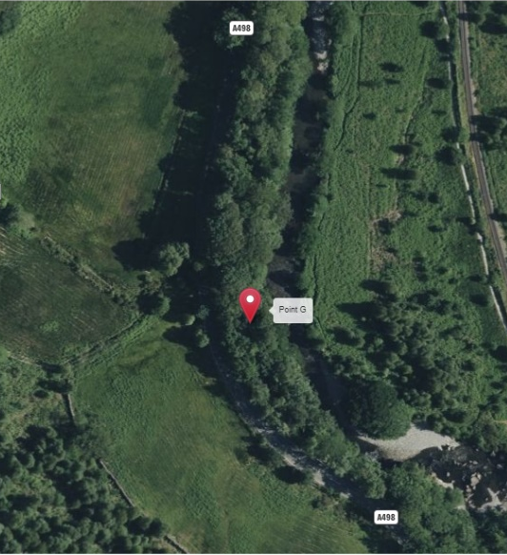
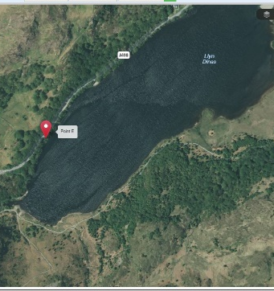
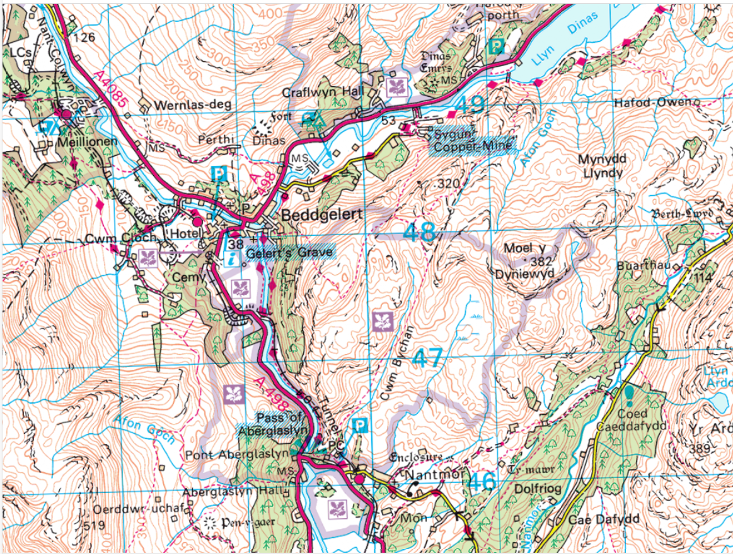
Egress:
Opposite the layby on the other side of road, and sign indicates the beginning of Gorge! Maybe prudent to egress 100m above opposite the bend in the river!

Park in layby and access lake Dinas

