Wombourne Kayak Club River Guide: Lower Tryweryn
Location: | River Lower Tryweryn – National Water Centre Wales to Bala  Post Code: LL23 7NU  Post Code: Bala LL23 7NL – Get off car park by bridge on B4391  Paddle points - River Tryweryn - Lower  UK Rivers Guide – River Tryweryn - Lower  National Water Centre Wales: National Whitewater Centre Wales  Note: check with centre & book with club code (WombKayak2106)1  River Levels: - 12/06/21,  River Gauge: | Grid Reference: | Access:  SH 8925 4010  Egress:  SH 9291 3617
Types of Trips: | Club recreational kayak trip
Video Footage: | See Videos:  - 29th May 2021 https://www.youtube.com/watch?v=U0FF6F8Rfjk – John  - 12th June 2021 https://www.youtube.com/watch?v=vp0bvJAw6fA – John  - 24th July 2021 Lower T 24th July21 - YouTube – John  - 29th May 2021 https://www.youtube.com/watch?v=Mecr17VG508 – Rich  - 12th June 2021 https://www.youtube.com/watch?v=B60HTGaKt7A – Rich  - https://youtu.be/gl3bmDH9UL0 (5) 23rd March 2024 – John | Date: | 28th December 2021

Features | National Water Centre Wales to Bala  “Dog Leg” Eddy Hopping  13.11 Minutes 24th July 2021 Lower T 24th July21 - YouTube – John  Break down “Narrow” section by “Eddy” hopping, with final breakout either right or left of rock (Be aware of strainers” in the centre
Features | National Water Centre Wales to Bala  Rock Garden  4.09 Minutes 29th May 2021 https://www.youtube.com/watch?v=U0FF6F8Rfjk – John  Right-bank route around rocks.  15.27 Minutes 24th July 2021 Lower T 24th July21 - YouTube – John  Centre route weaving through rocks.
Features | National Water Centre Wales to Bala  Grade 4 at Bala Mill Falls -  8.36 Minutes 29th May 2021 https://www.youtube.com/watch?v=U0FF6F8Rfjk – John  To avoid Bala Mill Falls take “The Leet” route, right of river before the 1st drop into the Grade 3 area that leads up to the falls.  Grade 3 section  8.45 Minutes 29th May 2021 https://www.youtube.com/watch?v=U0FF6F8Rfjk – John  Bear left over 1st drop, re-position bear right edging to the left side drop.  Re-position to right centre until you take a left route past the rock over drop. Bear right before bend and drop into eddy onto left bank above Bala Mill Falls.  Grade 4 at Bala Mill Falls  10.30 Minutes 29th May 2021 https://www.youtube.com/watch?v=U0FF6F8Rfjk – John  Route into falls, bear left position about 2/3rds, note “Future Water”, overhanging bent arm tree, just before the “Plume” and drop in river is a narrow strip left of the “Plume”. Keep to this & it makes it easy to drop into the “Big” eddy on the left.

Features | National Water Centre Wales to Bala  Grade 4 at Bala Mill Falls  11.39 Minutes 29th May 2021 https://www.youtube.com/watch?v=U0FF6F8Rfjk – John  Carve out of “Bus Stop” eddy bear to right centre position using small rock on the left as a transit to drop over “falls”.  Alternative route  21.25 Minutes 21st June 2021 Lower T 24th July21 - YouTube – John  Carve out of “Bus Stop” eddy, bear left of rock left side of flow and immediately re-position right to drop into channel, left of falls.  16.00 minutes https://youtu.be/gl3bmDH9UL0 (5) 23rd March 2024 - John  NB. Heavy and chunky level from additional water from tributaries.

Tryweryn River Map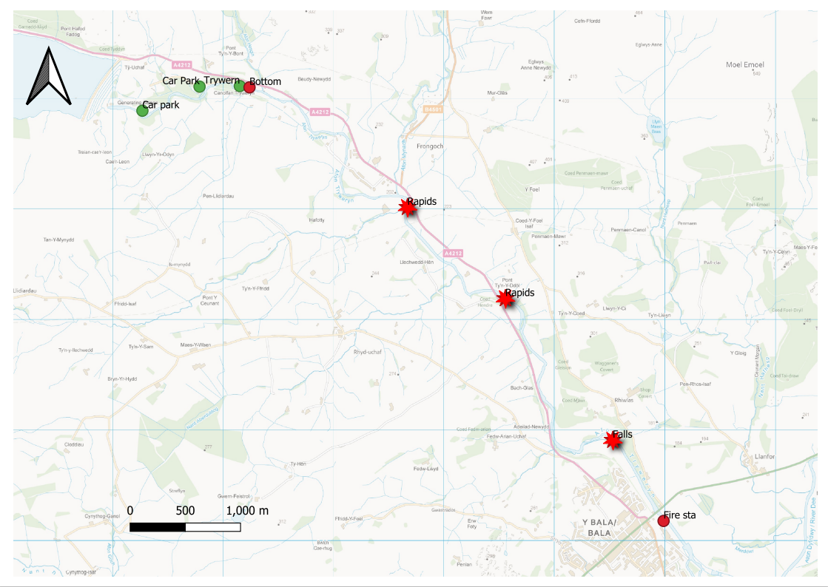
Mapping backdrop from Ordnance Survey open Data, Crown Copyright reserved.
Tryweryn Trail
