Location: | River Usk – Wye Usk Foundation: Click on links River Usk: Talybont to Llangynidr (Aberhowey) Navigation and permitted river levels! March 2nd to October 17th (Fishing season)  Post Code: Talybont on Usk LD3 7JE  Post Code: Llangynidr NP NP8  Paddle points - River Usk  UK Rivers Guide: River Usk-Talybont on Usk to Llangynidr  River Levels: (15/03/19) Flood Conditions -2.4m, 06/11/22, 1.15m - 11/11/23 1.32m  River Gauge: Llandetty | Grid Reference: | Access:  122234  Egress:  167197
  - 0.80 scrape
  - 0.95 low
  - 1.05 medium
  - 2.89 high
  - 3.00+ huge
Types of Trips: | Club recreational kayak trip
Video Footage: | See Videos:  - Talybont on Usk to Crickhowell (John Part A - 15/03/19) 2.50-7.15 minutes - Flood Conditions  - Talybont on Usk to Crickhowell (John Part B - 15/03/19) Flood Conditions -2.4m  - Talybont on Usk to Llangynidr (John Part A - 02/10/21)  - Talybont on Usk to Llangynidr (John Part B - 02/10/21)  - https://youtu.be/Oq3iBldV4X4 (John 05/11/22)  - Talybont on Usk to Llangynidr (Aberhowy) (John 11/11/23) 1.32m  - Talybont to Aberhowy (John 04/05/24) 1.04m river level | Date: | 11th November 2023
Wombourne Kayak Club River Guide: Talybont on Usk to Llangynidr

Feature | Blocked Suspension Bridge – 500m after right Oxbow lake type turning.  Talybont to Aberhowy  0.11-0.32 Minutes. Need to portage just above on beach.
Feature | River left, “Tow back” sticky pour over surfing wave, about 500m above Mill Falls.  Talybont to Aberhowy 1.30 – 2.20 minutes
Feature | Mill Falls - 1st Drop before Llangnidr Bridge:  Take left hand side route by the mill, Grade 3 Rapids: continuous wave trains at this level for 1/2K.  Talybont on Usk to Llangynidr (Aberhowy) (John 11/11/23) 1.32m river level: 0.13 – 3.0 minutes
Feature | 3 Routes Island:  Take left route, tree across centre river path. Right route is also possible.  Talybont on Usk to Llangynidr (Aberhowy) (John 11/11/23) 1.32m river level: 5.56 – 8.19 minutes
Feature | Gradual Drop & wave trains:  Take left side of the river.  Talybont on Usk to Llangynidr (Aberhowy) (John 11/11/23) 1.32m river level: 8.40 – 9.53 minutes

1st Drop after Llangnidr Bridge:
Take river left.
Talybont on Usk to Llangynidr (Aberhowy) (John 11/11/23) 1.32m river level: 12.54 – 15.16 minutes

2nd Drop after Llangnidr Bridge:

Take river left.
Talybont on Usk to Llangynidr (Aberhowy) (John 11/11/23) 1.32m river level: 15.16 – 15.45 minutes

Feature | Gradual Drop & wave trains:  Take left side of the river.  Talybont on Usk to Llangynidr (Aberhowy) (John 11/11/23) 1.32m river level: 8.40 – 9.53 minutes
Feature | 1st Drop after Llangnidr Bridge:  Take river left.  Talybont on Usk to Llangynidr (Aberhowy) (John 11/11/23) 1.32m river level: 12.54 – 15.16 minutes
Feature | 2nd Drop after Llangnidr Bridge:  Take river left.  Talybont on Usk to Llangynidr (Aberhowy) (John 11/11/23) 1.32m river level: 15.16 – 15.45 minutes
Feature | 3rd Drop after Llangnidr Bridge:  Route A - Take river left, note “Sticky Hole”.  Talybont on Usk to Llangynidr (Aberhowy) (John 11/11/23) 1.32m river level: 18.0 – 18.45 minutes  Route B - Take river right.  https://youtu.be/Oq3iBldV4X4 (John 05/11/22)  1.15m river level: 15.30 – 16.21 minutes
Feature | Egress:  See island, take river right, approximately 100m to egress, footpath bt the river, yellow sign on tree.  https://youtu.be/Oq3iBldV4X4 (John 05/11/22) 17.37 – 18.09 minutes

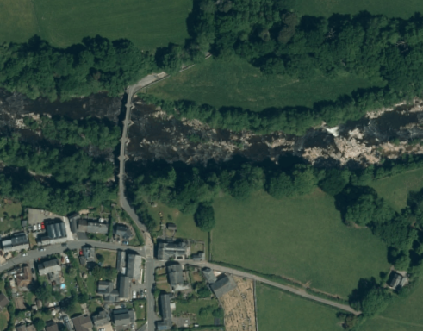
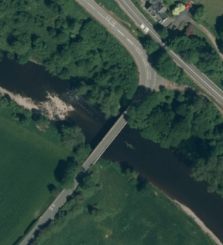
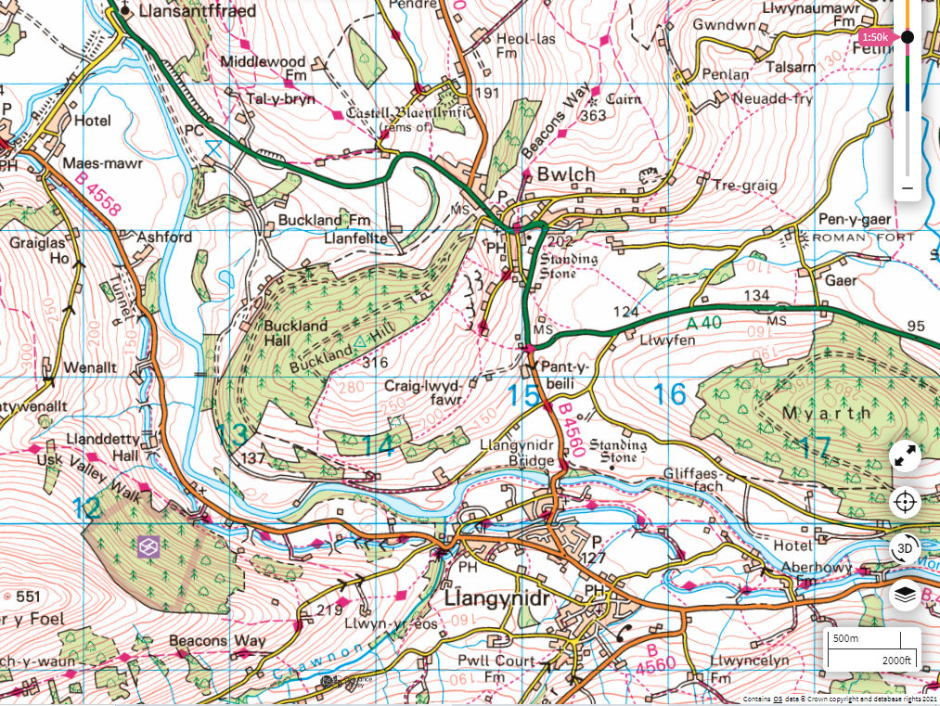
Space for one /two cars.
Change in car park.

