PROVIDER RESULTS PROCESS

Step 1 - Log in to Club Portal https://britishcanoeing.justgo.com/
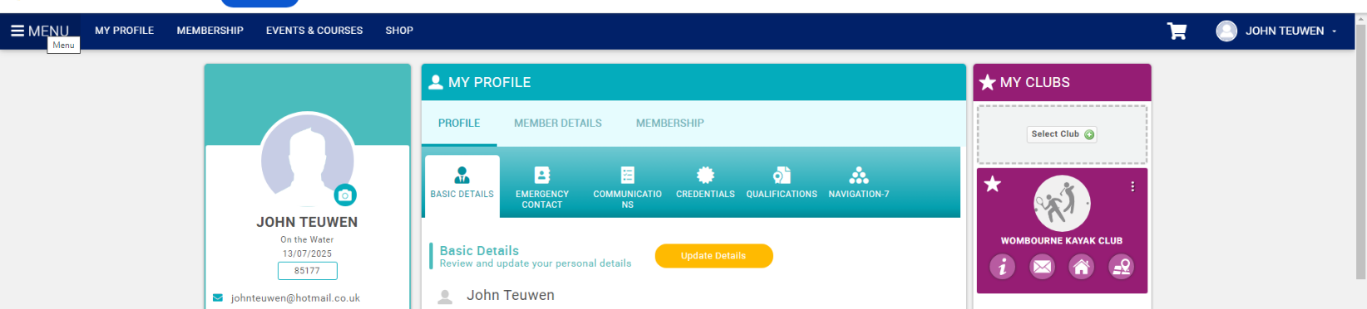
Step 2 – Click onto Menu.

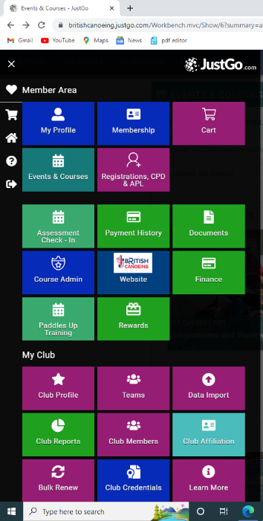
Step 3 – Click on Course Administration.

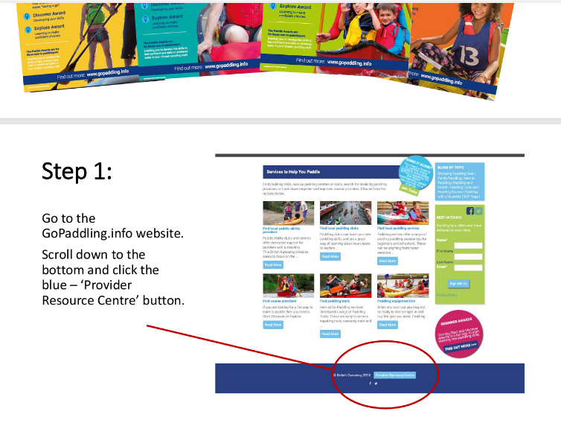
Step 3a – Click onto Certification Process Guidance:

Paddle Awards Start - How to do it.
Paddles Up Training course authorisation and results submission process

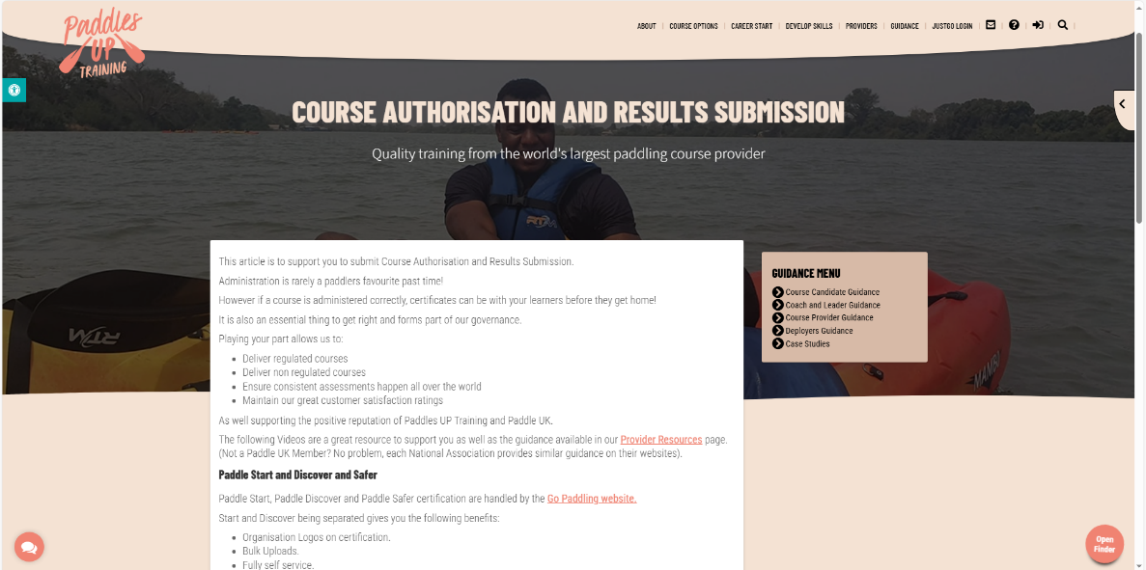

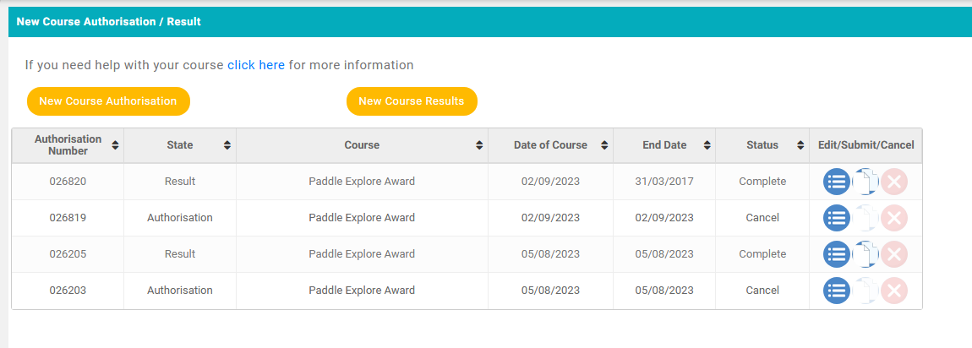
Step 4 – Click onto New Course Authorisation.

Step 4 – Complete Course details (e.g. Jackfields as for Step 5).
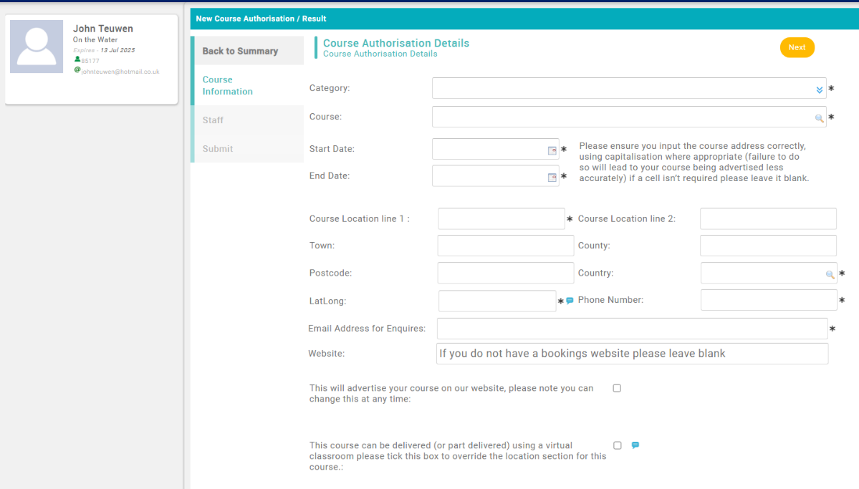

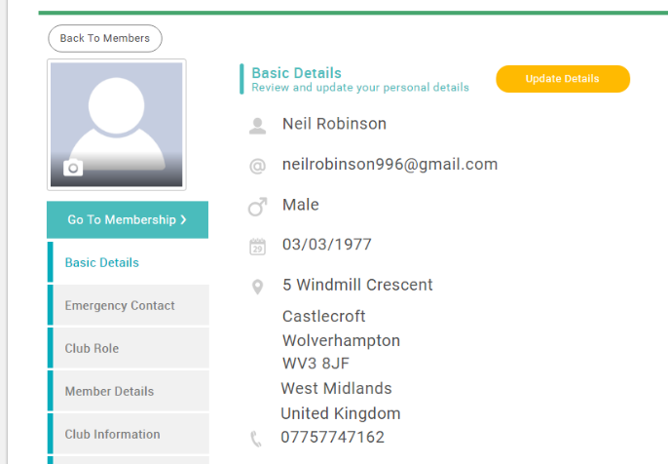
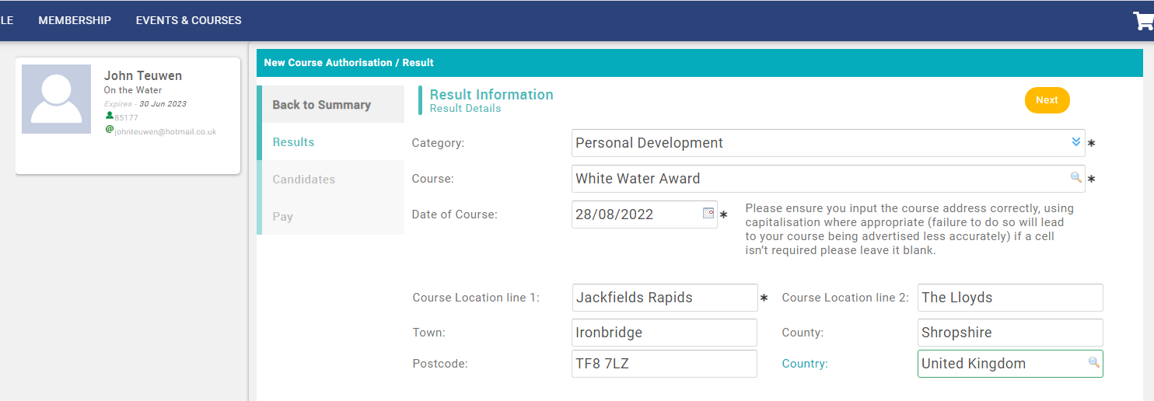
Step 5 – Complete New Course/Results, note have members details below.

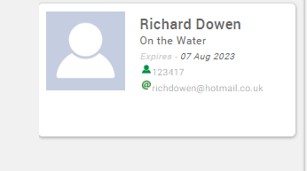

Paddle UK Membership Number 569248

Step 4a – Complete any additional Candidates (e.g. James Wilkinson non-member different fee, use Associate Membership Number)

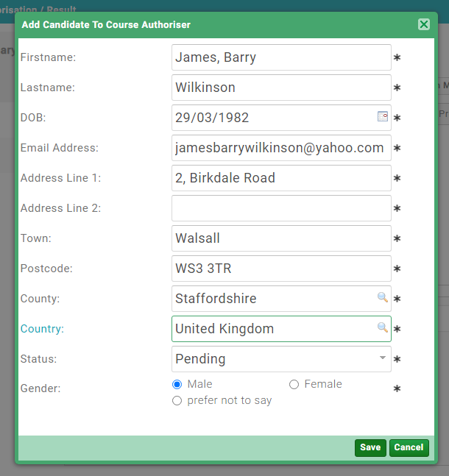
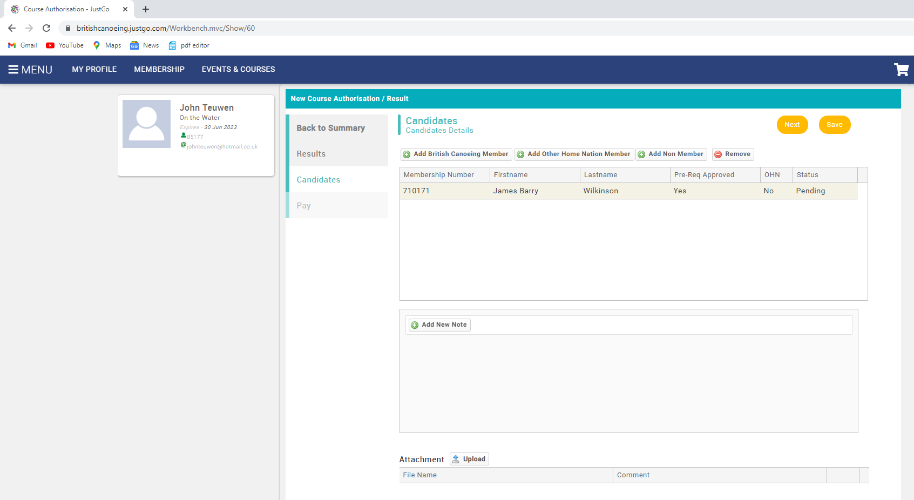

Step 5 – Return to summary and check details. Tick box I agree when satisfied, pay, submit.
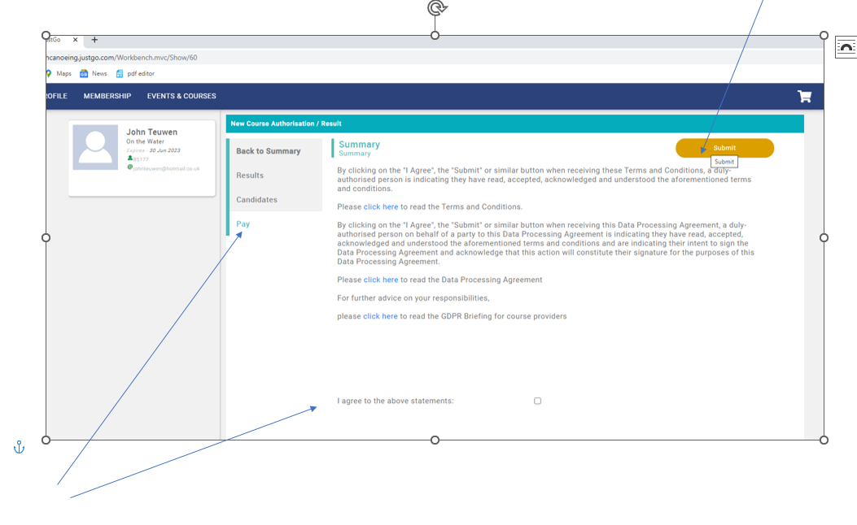

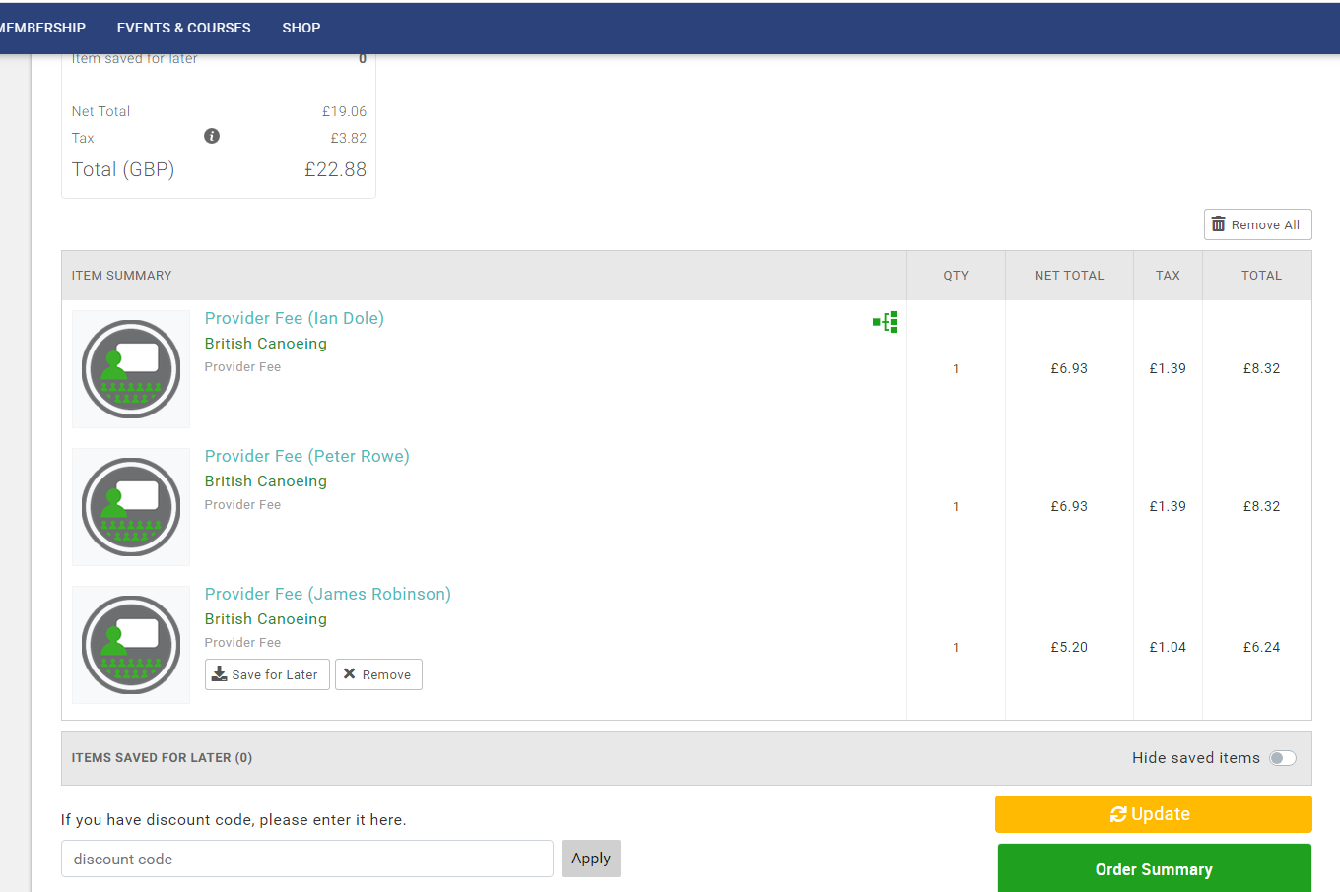
Step 6 – Payment Order Summary and check details, update if necessary. E.g. incorrect payment fee.

Step 6 – Make payment using Club A/c if you have authorisation: Paul Ellington, Rich Dowen, John Teuwen or collect fees from candidates and us your own A/c.
You can pay by Bank Transfer to:
Wombourne Kayak Club
Sort Code: 60 03 30
A/c 79652131
