QUALITY CLUB PROCESS – How to do it?

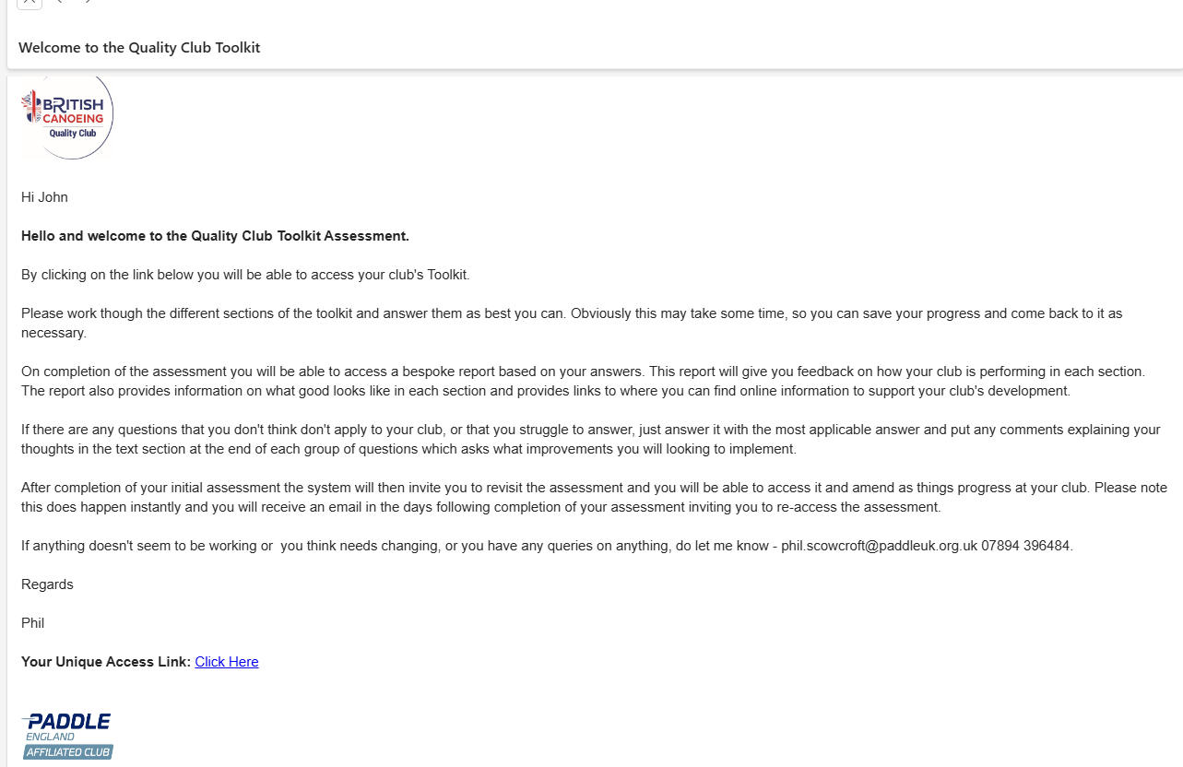
Step 1 – You receive an email with a link to start process.

Step 2 – Click on, start process, tick appropriate boxes.
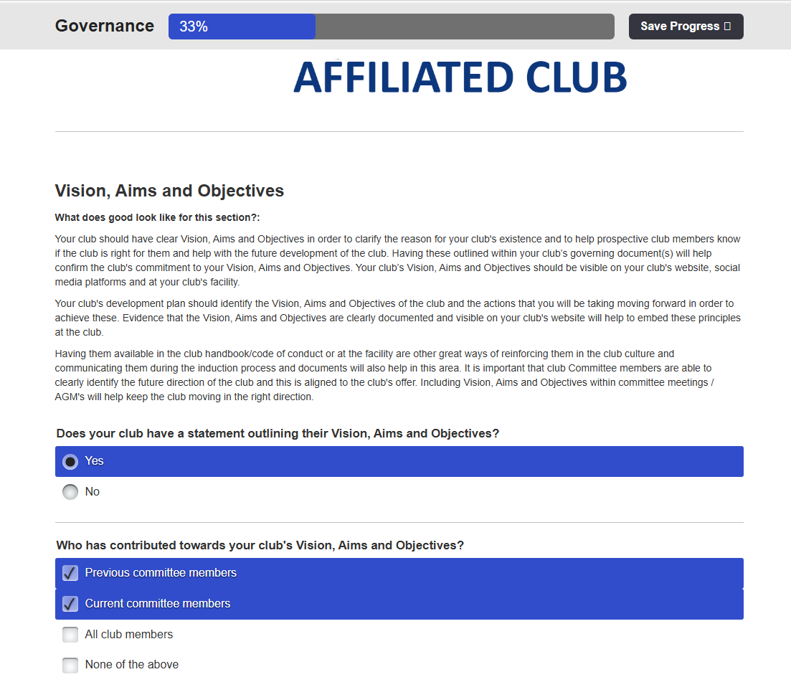

Step 3 – Answer questions, but incorporate into WKC 3 Year Development Plan with links to evidence.
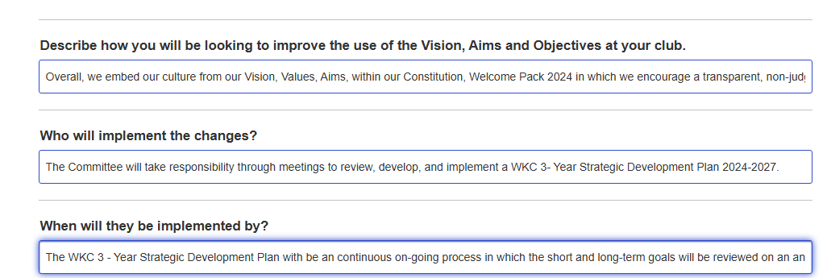

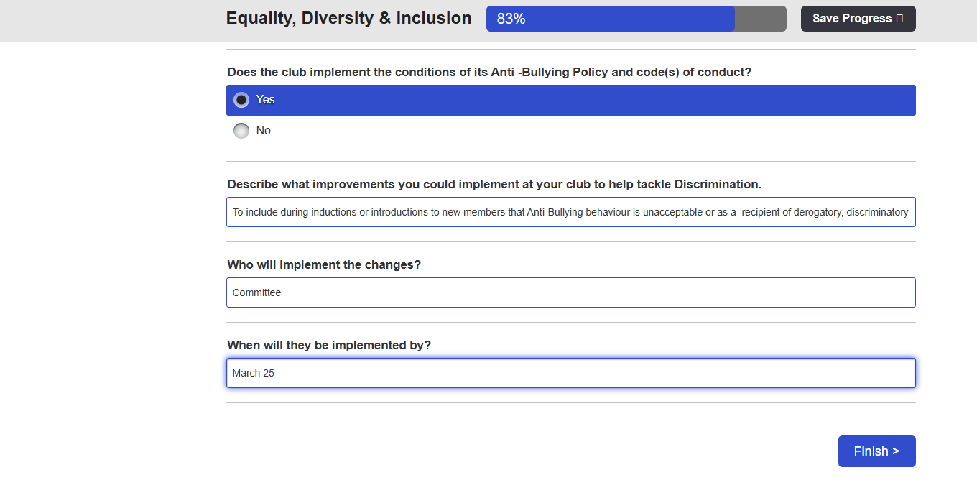
Step 4 – Click onto Finish

Step 5 – Click to view report.
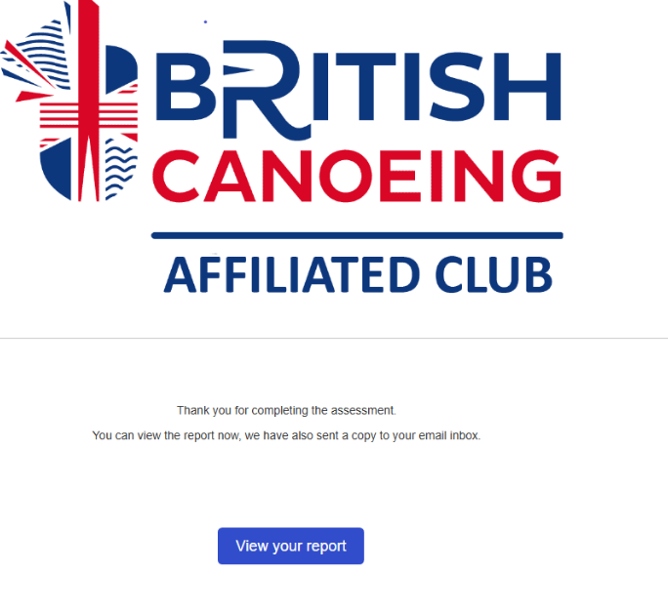

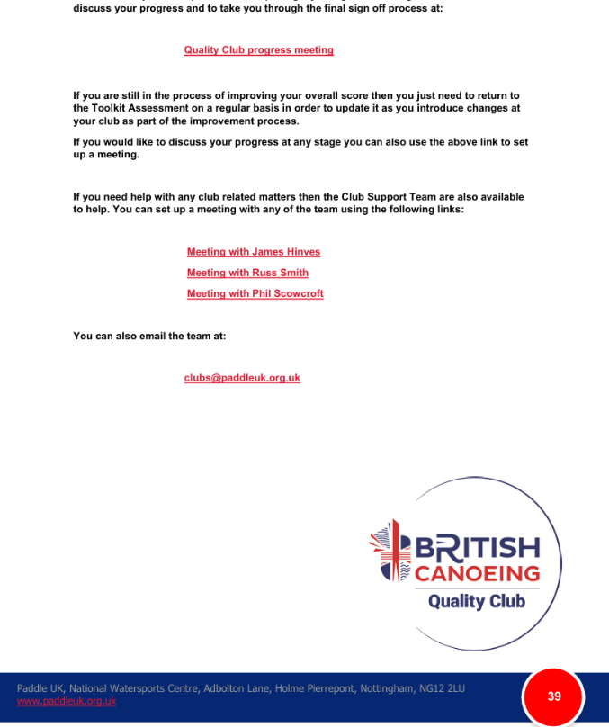
Step 6 – Book an appointment

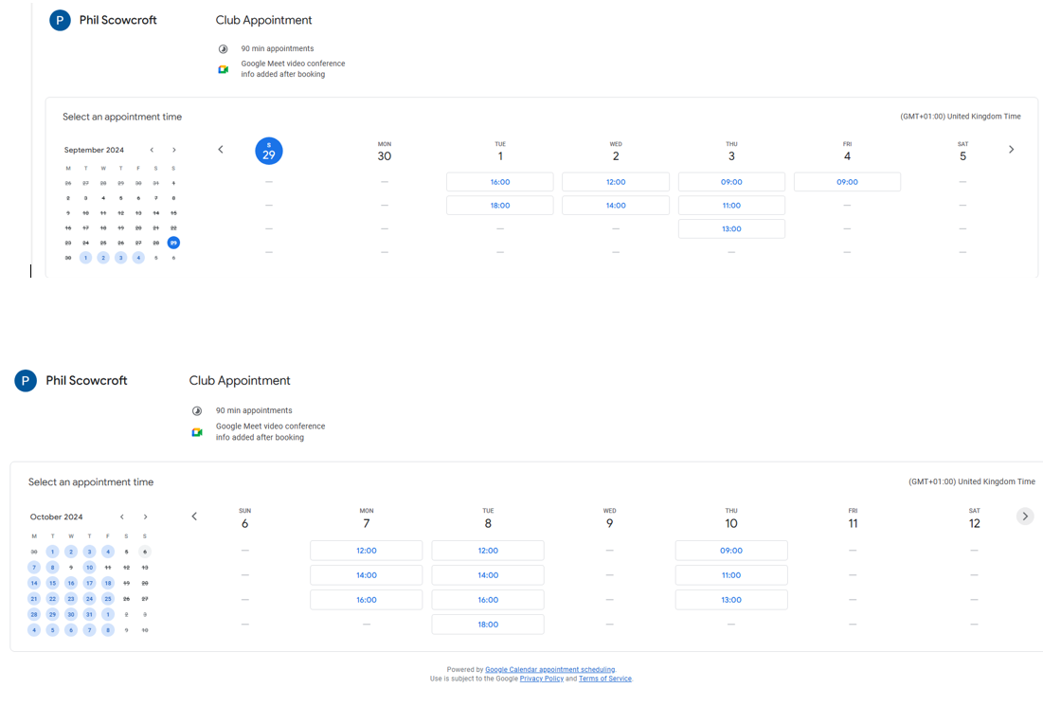

Step 7 – Complete the Quality Club Process Feeback

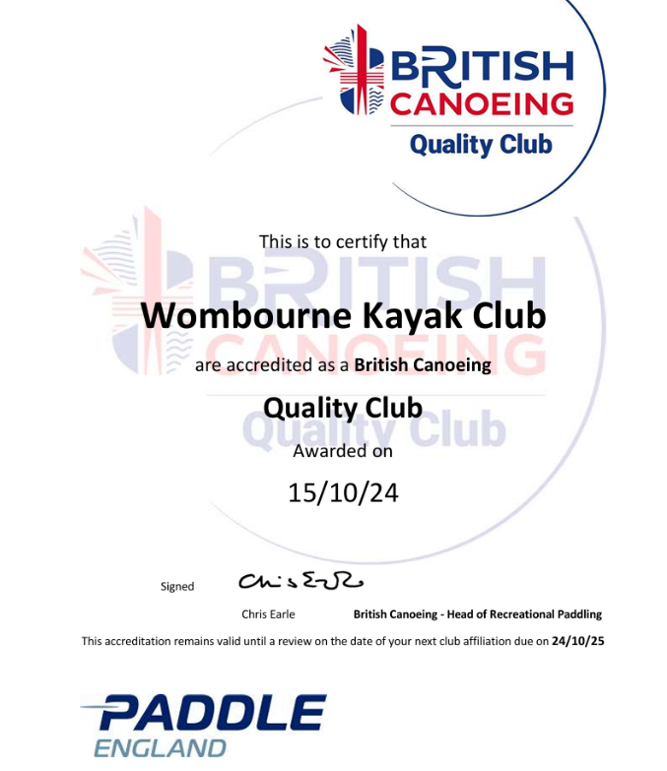
Step 8 – Download onto Website.

