Wombourne Kayak Club River Guide: Pont Llogel to Pont Robert
Location: | River Vyrnwy – Pont Lhogel to Pont Robert  Post Code: Pont Llogel SY21 0QG  Post Code: Pont Robert: Post Office SY22 6HY  Paddle points - River Vyrnwy  UK Rivers Guide – Pont Lhogel to Pont Robert  River Levels: 1.35m - 20/11/21, 13/06/19 1.85m  River Gauge: Pont Robert | Grid Reference: | Access:  SJ 0321 1543  Egress:  SJ 1074 1268
  - 1.30 scrape
  - 1.35 low
  - 1.50 medium
  - 1.85 high
  - 2.00+ huge
Types of Trips: | Club recreational kayak trip
Video Footage: | See Videos:  - 7/11/17 “The Gorge”– John  - 13/06/19 “Pont Lhogal to Dolonog” Flood Conditions – John  - 13/06/19 “The Gorge” Flood conditions – John  - 6/11/21- Pont Lhogal to Pont Robert Rich  - 6/11/21 “Pont Lhogal to Dolonog” – John  - 13/11/21 “The Gorge” – John  - 03/12/22 “Pont Lhogal to Pont Robert” – John  - 28/01/24 “Pont Lhogal to Pont Robert – John  - 05/10/24 “Pont Lhogel to Pont Robert”–John | Date: | 05/10/24

Feature | Pont Llogel to Dolonog  Tree Blockage across river or over hanging tree or strainers Pont Lhogel section. 28/01/24 New Hazard: 500m from start at the same point as previous. 28/01/24 “Pont Lhogal to Dolonog”– John, 0.10 seconds.
Feature | Pont Llogel to Dolonog  “Dog Leg” take left route and move to drop before right above cutting back right to left. 6/11/21 - 2.35 minutes 6/11/21 “Pont Lhogal to Dolonog” – John  Alternative “Boof” off drop in flood conditions (1.85m) instead of taking dogleg. 4.20 minutes 13/06/19 “Pont Lhogal to Dolonog” – John
Feature | Pont Llogel to Dolonog  1st Drop before the bridge, ferry to right side, paddle right of centre avoiding the rock. Flood conditions (1.85m) – paddle centre of river away from rock ahead, rather than normal approach lateral to rock.  13/06/19 – 7.35 minutes “Pont Lhogal to Dolonog” – John  6/11/21 - 2.35 minutes “Pont Lhogal to Dolonog” – John  Tree Blockage channel section by rockface before Dolonog bridge. Take route in the middle of river, not that one can get slammed against the wall. Far left route? 05/10/24 “Pont Lhogel to Pont Robert”–John 1.46 minutes
Feature | Pont Llogel to Dolonog  Drop to pass through bridge, ferry to right side, paddle right of centre avoiding the rock. Flood conditions (1.85m)– maintain same route as remaining drop can be turbulent and cause a capsize.  13/06/19 – 8.00 minutes - Flood conditions “Pont Lhogal to Dolonog” – John  6/11/21 - 7.50 minutes “Pont Lhogal to Dolonog” – John
Pont Llogel to Dolonog

Drop after the bridge next to rockface, paddle left along the sliding wave in a “ferry glide position.
6/11/21 - 8.32 minutes “Pont Lhogal to Dolonog” – John
Tree Blockage after Dolonog bridge, next to rockface, and the sliding wave section, which has been decimated. (Position on river. No footage!) Tree has fallen across the river, need to paddle far right and slip through ledge drop. 6/11/21 - “Pont Lhogal to Dolonog” – John 8.32 minutes

Feature | Weir; Dolonog  Portage to the right 20m. before weir.
Feature | Gorge to Pont Robert  1st Section: “Wave trains”, drops & a bend before gorge.  13/06/19 0.28 – 1.15 minutes, Flood conditions (1.85m) “The Gorge” Flood conditions – John  6/11/21 2.18 minutes Pont Lhogal to Pont Robert Rich
Feature | Gorge to Pont Robert  Gorge 1st Drop; take left route, bearing right.  13/06/19 3.49 – 4.13 minutes, Flood conditions (1.85m) “The Gorge” Flood conditions – John  13/11/21 2.34 minutes “The Gorge”– John
Feature | Gorge to Pont Robert  Gorge 2nd Drop: take left route, bearing right to avoid rock on bank.  13/06/19 4.49 – 5.13 minutes Flood conditions -washed out (1.85m) “The Gorge” Flood conditions – John  13/11/21 0.26 minutes “The Gorge” – John
Feature | Gorge to Pont Robert  Gorge 3rd Drop; take left route, can drop into eddy, or bear right into channel.  13/06/19 5.05 – 6.00 minutes Flood conditions -washed out (1.85m) “The Gorge” Flood conditions – John  13/11/21 1.21 minutes “The Gorge” – John
Feature | Gorge to Pont Robert  Gorge 4th Drop: take central route, can drop into eddy to the right above last two drops.  13/06/19 3.49 – 4.13 minutes Flood conditions -washed out (1.85m) “The Gorge” Flood conditions – John  13/11/21 2.41 minutes “The Gorge” – John

Feature | Gorge to Pont Robert  Gorge 5th Drop before 6th final drop; ferry to left side, ease through close to bank to position route left to right, dropping into large eddy to the right before main drop. If you can’t make it take central route before final drop to position yourself for it, 1.5m from rock on left and avoid “Plume”! Follow tongue but you power through the “Stopper” at the bottom of drop.  13/06/19 - 7.18 minutes Flood conditions -washed out (1.85m) “The Gorge” Flood conditions – John  13/11/21 3.35 minutes “The Gorge” – John
Feature | Gorge to Pont Robert  Tree Blockage, after “Gorge” section, just before Barry’s drop the 1st of two “Ledge” drops. Tree has fallen across the river, need to paddle far right and slip through under tree.  05/10/24 “Pont Lhogel to Pont Robert”–John 7.13 minutes
Feature | Gorge to Pont Robert  Barry’s drop take left hand side route turn right, be aware of bubbly water.  13/11/21 14.00 minutes “The Gorge” – John  Alternative route: far right paddle between two rocks over drop.
Feature | Gorge to Pont Robert  Dave’s route, take narrow slide route on the right. Or take left route near rock face  13/11/21 14.42 minutes “The Gorge” – John  Tree Blockage, left of Pont Robert Bridge, can slip through to access point as normal.

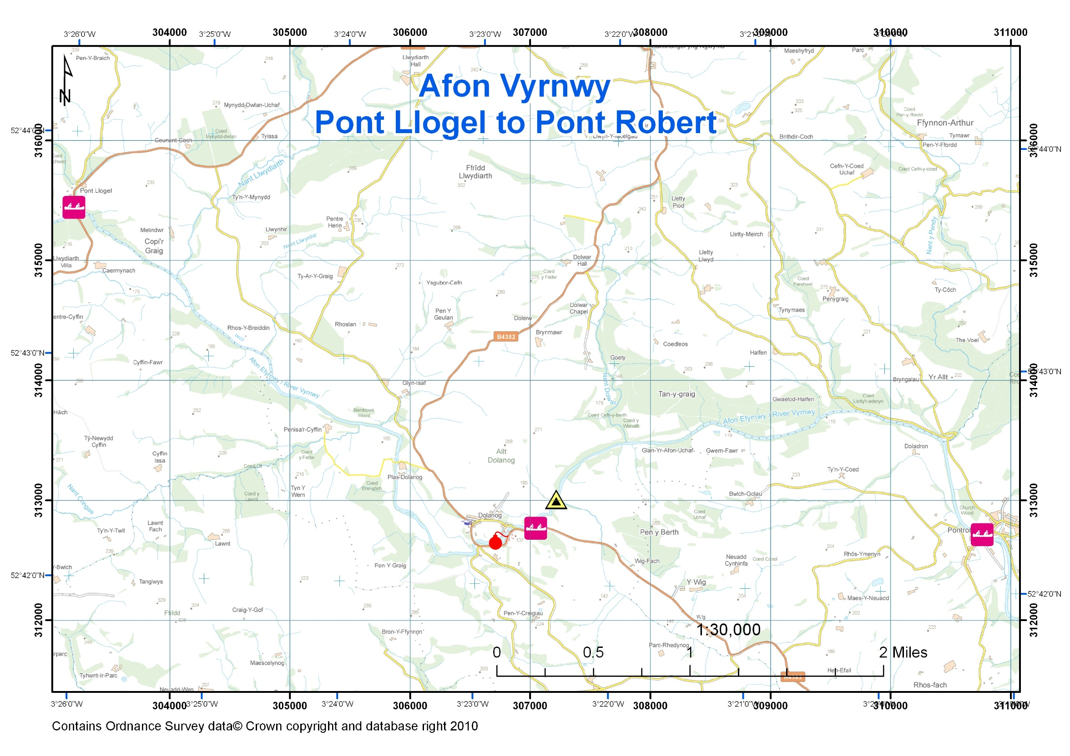
Access Point, Car Park at Pont Llogel Egress Point, Car Park at Pont Robert
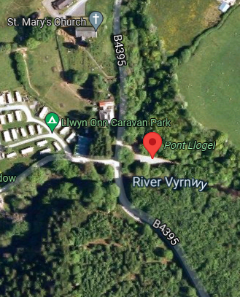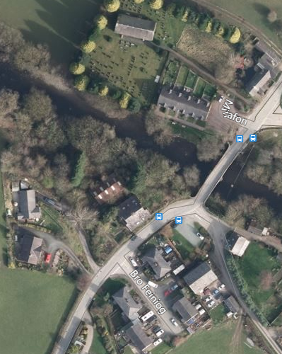
OS Grid Ref SJ 0321 1543 OS Grid Ref SJ 1074 1268
Lat, Long Lat, Long
52.727768, -3.434756 52.704389, -3.322410
Post Code: SY21 0QG Post Code: SY22 6HY
Beware Postcodes in rural areas are not that accurate. These will take to within a few miles of the locations at best. Type in Lat Long if poss.

