WKC Recruitment and Deployment Policy
DBS Process:

Step 1 - To activate your OnlineDisclosures account and create a password, please click on the link below:
http://fadv.onlinedisclosures.co.uk/ActivateAccount.aspx?OrgKey=LzajTBVCUY8%3d&UserKey=pgBTZnb9n%2fzdl3hDqjEiSCP7AwScjOZd9Ayq6FQJD74%3d

Your sign in details is:
Step 2 - Organisation PIN: ask John Teuwen - Wombourne Kayak Club. Need to Register?

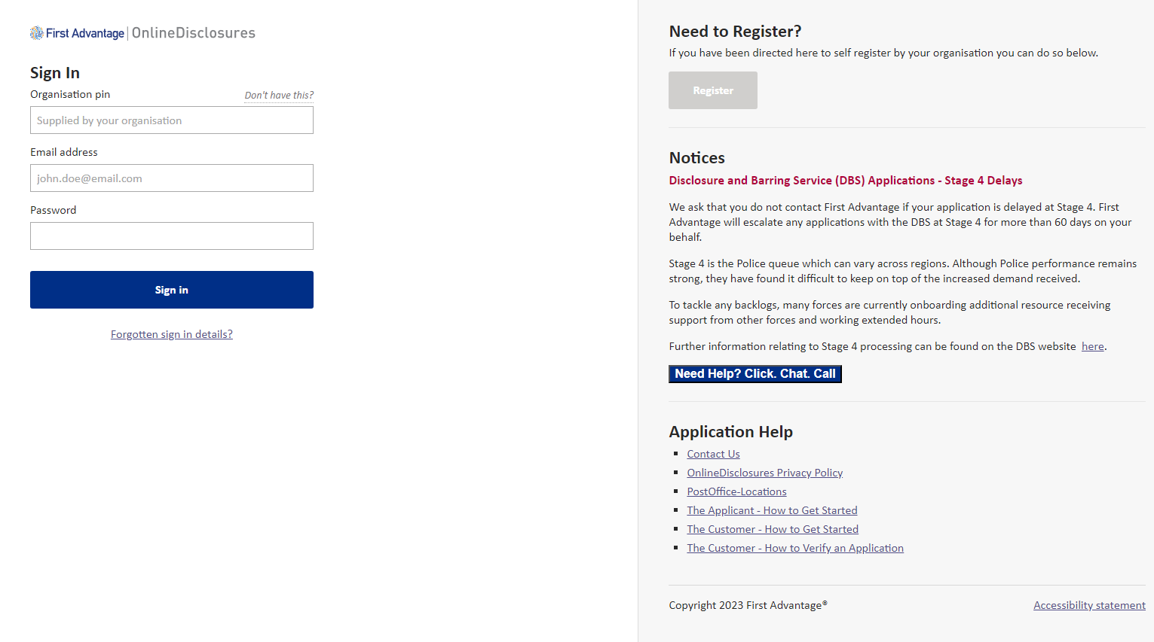

Step 3 - Complete the (BC) Club DBS Internal Verifier Application

Step 4 - Resources: Explanation for process such as applicant and customer (Internal Verifier). Complete process.

RECRUITMENT & DEPLOYMENT Process:

- Safeguarding considerations are covered in induction process and/or induction documentation.

- Welcome Pack
- Members’ Induction process

- To check new members with coaching qualifications who offer to coach or lead trips, if there have been any problems with the person at previous clubs, alongside DBS and G7 Self-declaration form .

- When DBS checks are not undertaken. E.g., Committee Members not involved or irregular contact with U18’s or Vulnerable Adult members, complete the G7 Self-declaration form .

