Add existing Paddle UK (English Member) Add new member

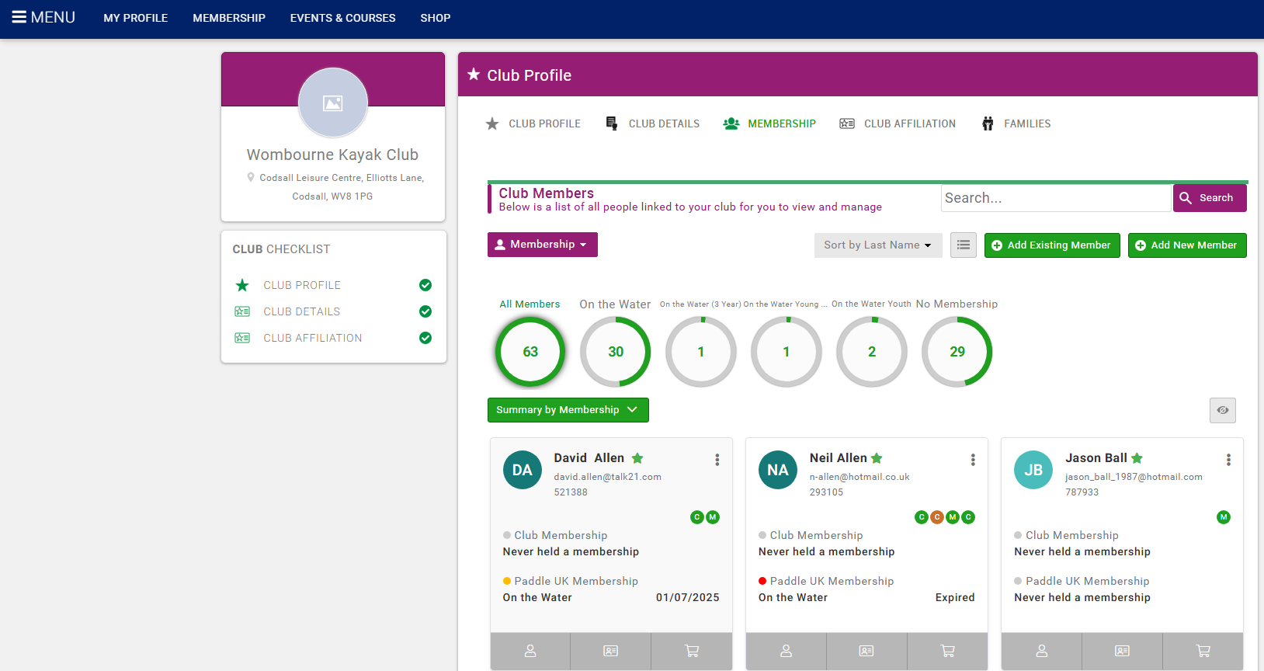
Click –

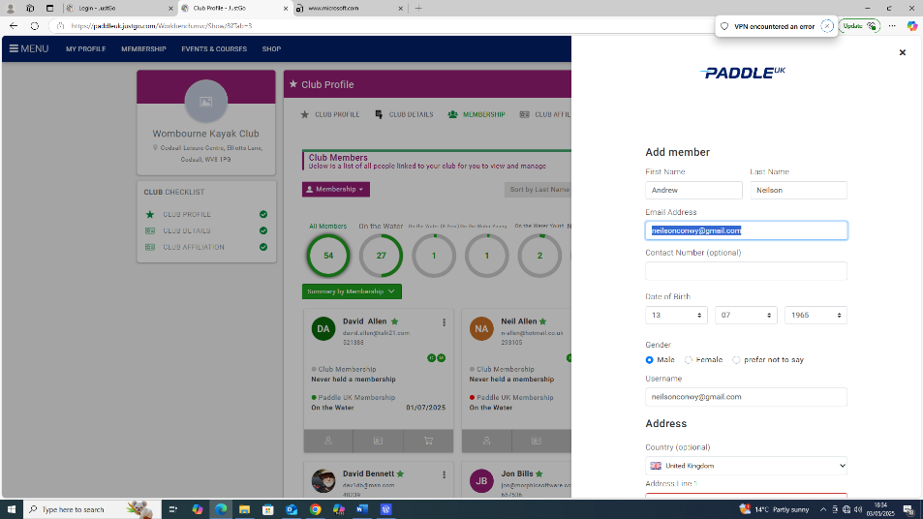
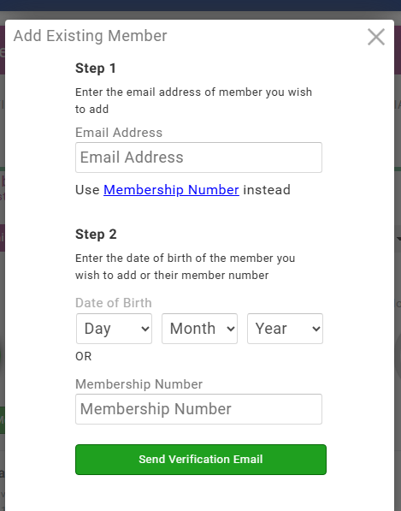
Complete details - Existing Member or Add new member
Add new member, e.g. Paddle UK (Welsh Member)
As a Paddle Cymru member, I have checked with Paddle UK records, and it seems that you have never had a Paddle UK record. Hence, to add you to Wombourne's Club Portal, I will l need to add your details including home address via the Add New Member function to create them a Paddle UK account.
Three important things to note with this-
Step 1
- The new member will need to set themselves a password to access their personal individual account.
Step 2
Once I have your home address and created your account, tell them their username (AndrewN2025) and ask them to follow the 'Forgot Password' steps to set themselves a password to access their account. https://paddleuk.justgo.com/
Step 3
- If the members are volunteering for the club in a role that requires any qualifications or credentials, will need to upload them to their Paddle UK profile as they will not automatically be transferred from their Paddle Cymru account.
Step 4
- A member will require at least a Club Associate membership to be covered to participate in club activity as their Paddle Cymru membership does not insure them for England Club Activity.
Step 5
If we run into any further issues, I or you will contact Paddle UK.

