AFFILIATION PROCESS
Log in - Paddle UK - JustGo
Affiliation is managed via the Menu by selecting Club Affiliation

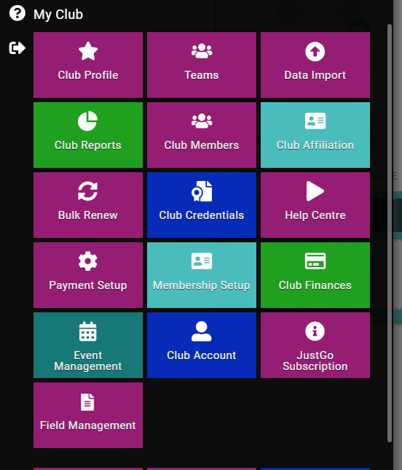

Follow instructions on Paddle UK – Affiliation Guide

