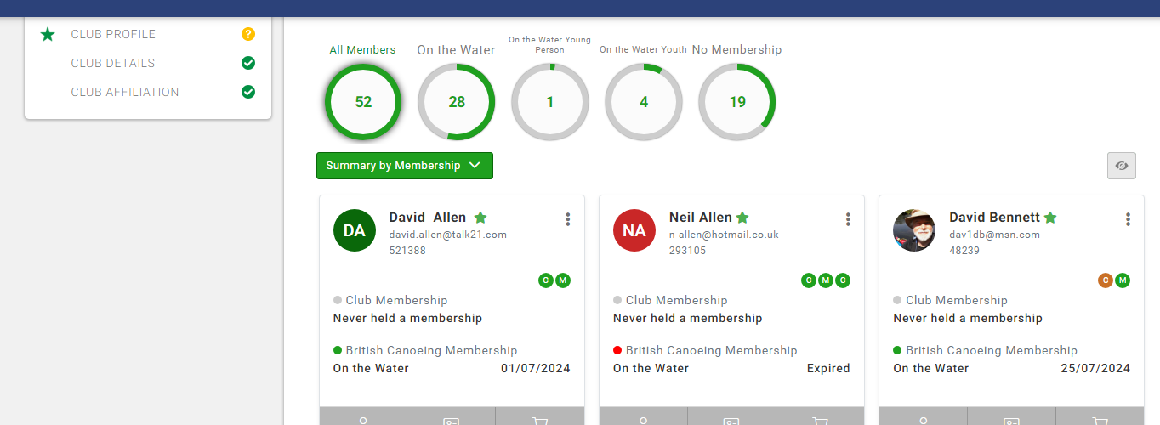
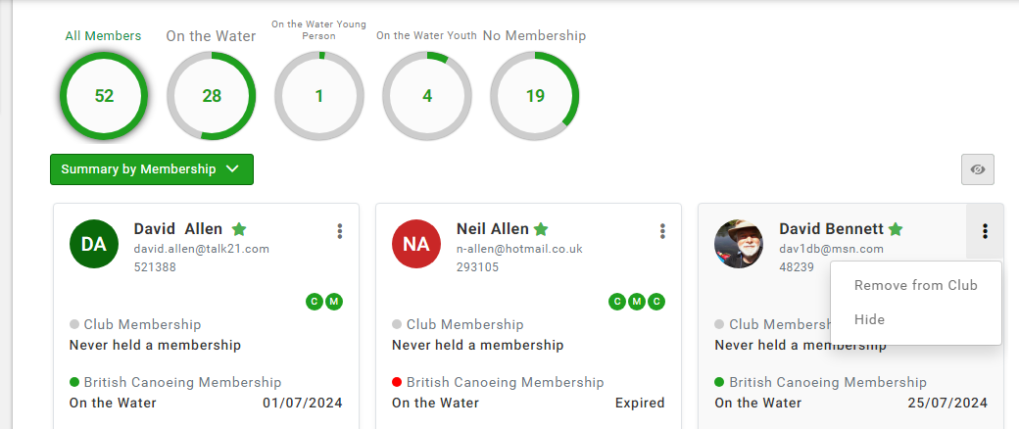
How to “Hide” and click.

How to retrieve a “Hide” member. Click on hidden eye.

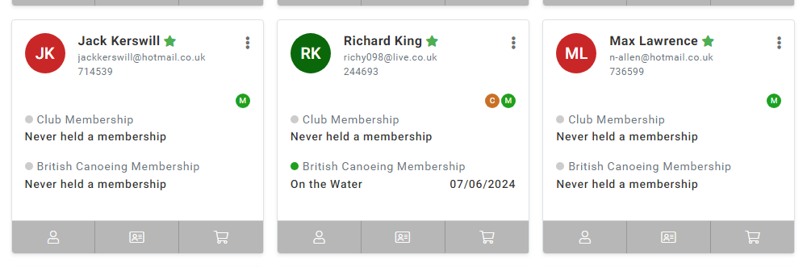
How to retrieve a “Hide” member. Click on three dots & “Unhide”.
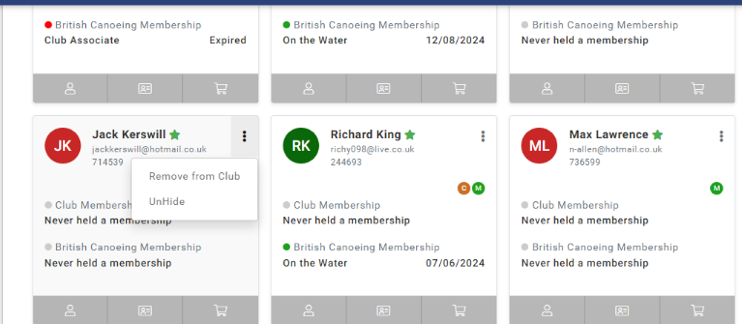

How to do “Pending Approval” for a new member. Click on three dots & “Approve”.
