Job Role: WKC Membership Secretary
Summary: What needs to be done?
Manage membership enquiries:
- Manage/respond to any membership enquires/emails. How do I get these?
- Direct new members to sign up via website.
  - Collate Electronic forms membership information, Adult or Junior consent, Adult or Junior code of conduct, notify coaches/Leaders of any medical information.
  - Send Welcome Pack & Members Induction Procedures to new members.
  - Forward any relevant information to coaches and river leaders.
- Update and maintain Paddle UK Membership Club Portal with membership information.
- Register on individual Paddle UK - JustGo
- Manage annual membership renewals.
How:
- Add your email address to the submission form for any new membership sign ups on the Wombourne Kayak Club Website. Contact Chairman or Website Administrator for support. Any new membership’s will then automatically be sent to you.
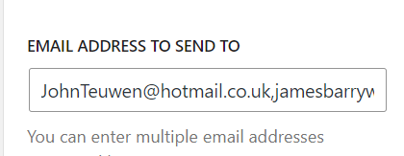
They are also stored on the website under the Dashboard, Feedback, Form Responses. Select e-membership from the sources drop down list.
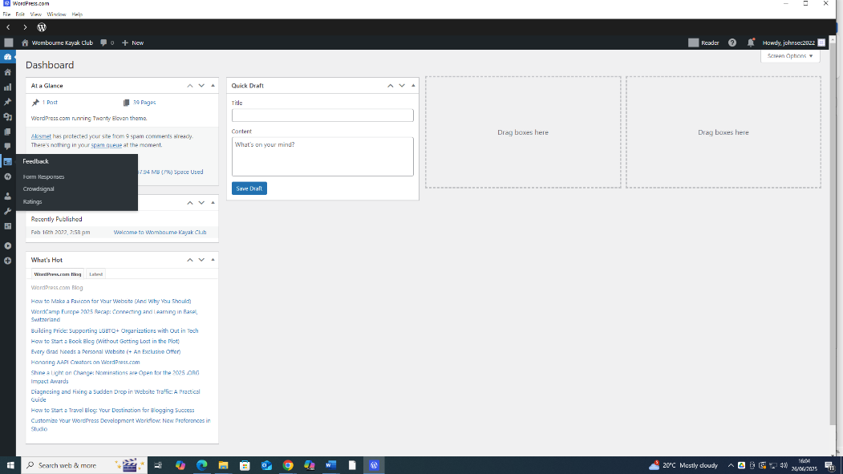
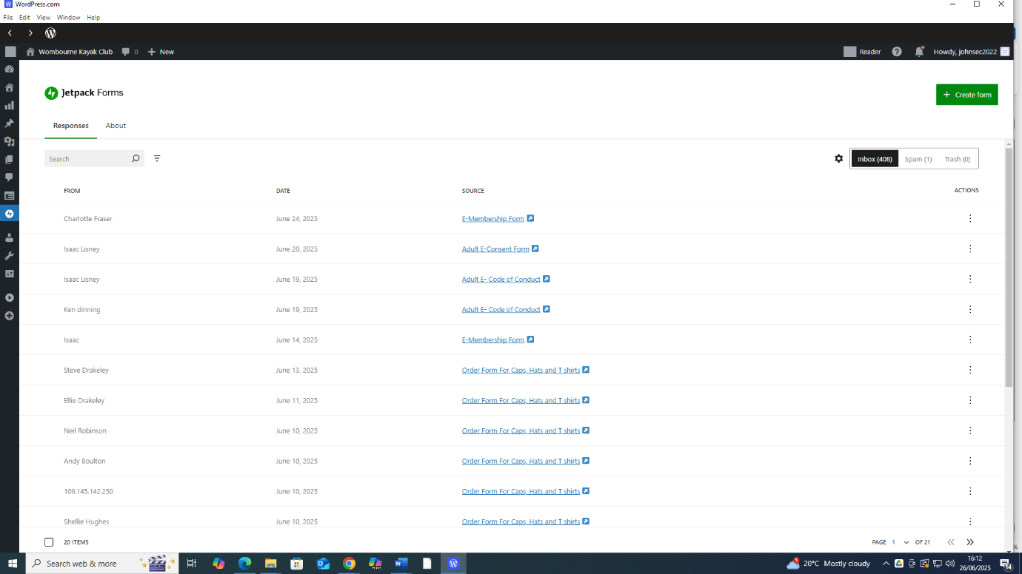
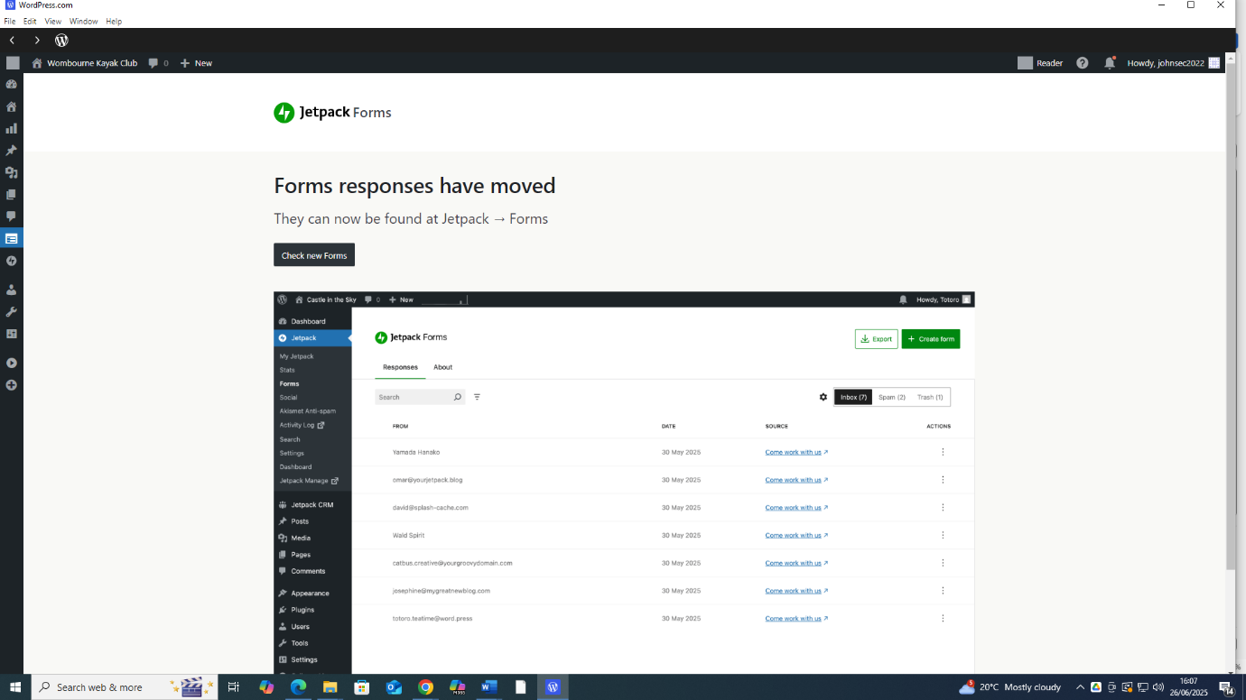
Form responses have moved – click Members individual Forms- click

- Website is https://wombournekayakclub.org/, new members should complete e-membership form, e-consent form and e-medical form.
Further details: How to do membership process?

- Maintain details on Paddle UK – Membership Club Portal once user has completed Wombourne membership process.

- How do you log in here for membership secretary? Paddle UK – Membership Club Portal log in. You need to Register with – Just Go

- How are they granted the role to manage members? John Teuwen will allocate role in individual members portal
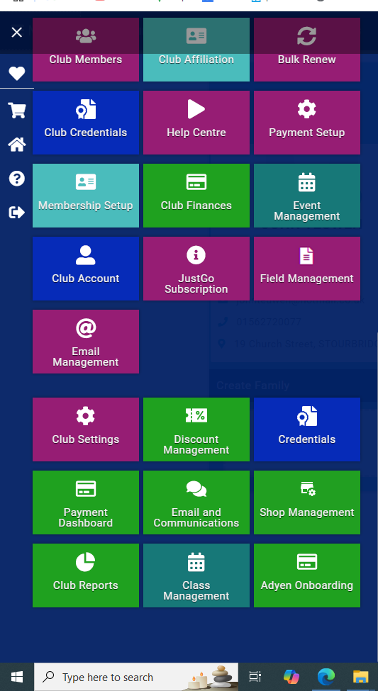
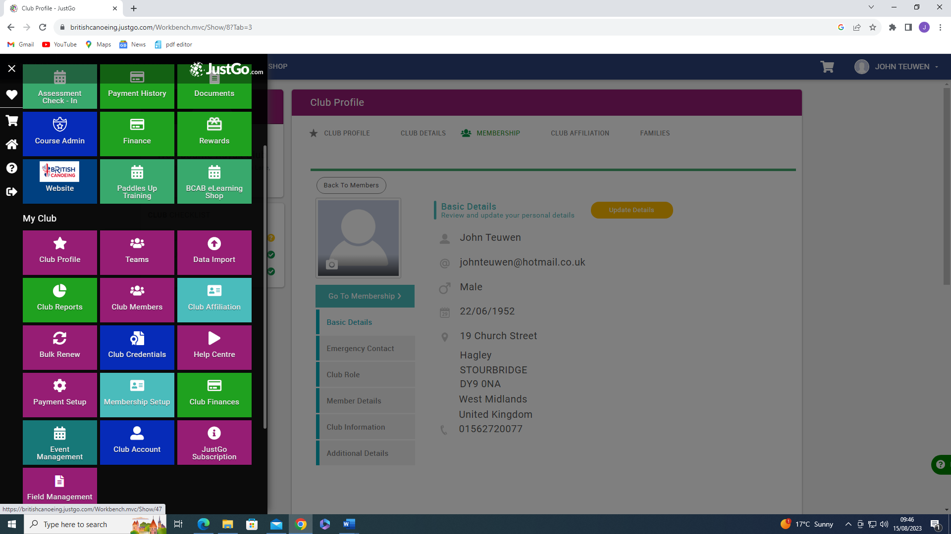
- Membership is managed via the Menu by selecting Club Members
Club Reports, e.g. Quick Coach Validation, has moved to the bottom, hence scroll down, click on.

Club Reports, e.g. Quick Coach Validation, has moved to the bottom, hence scroll down, click on.
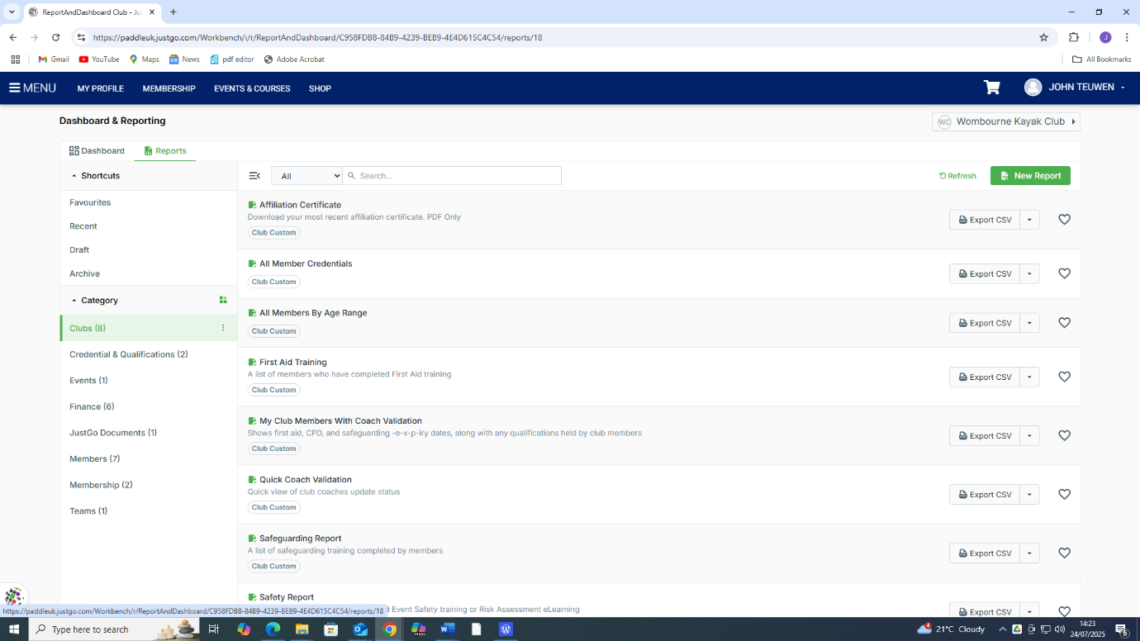

Use these guidelines to Add existing, new or Welsh members
Any other issues go to WKC – Membership Club Portal

- Unresolve issues or problems use the following Paddle UK contacts:
Contact Membership
Tel: 0300 0119 500
Email: "Membership" hello@paddleuk.org.uk
- Membership runs January to January. Each December notifies members that renewals are due, and any change of details needs to be updated via the Wombourne club website. New consent or medical forms should be completed. Notification should be done by social media and email.

- Inform Secretary, River Leaders, Coaches about any individual members medical issues.
Reviewed by John Teuwen 20/06/2025
British Canoeing, National Water Sports Centre, Adbolton Lane, Holme Pierrepoint, Nottingham, NG12 2LU

