Job Role: WKC Club Secretary
Summary: What needs to be done?

- To act as the first point of contact for the club and ensure prompt communication internally and with external organisations, e.g., Paddle UK staff queries.
Contact Membership
Tel: 0300 0119 500
Email: "Membership" hello@paddleuk.org.uk

- To ensure all formal meetings (including the Annual General Meeting are effectively organised and minutes are recorded, e.g., updated on the website.

- To maintain effective and up-to-date club records, e.g., update website policies & procedures, medical records.

- To uphold the legal requirements of the club, e.g., operational standards

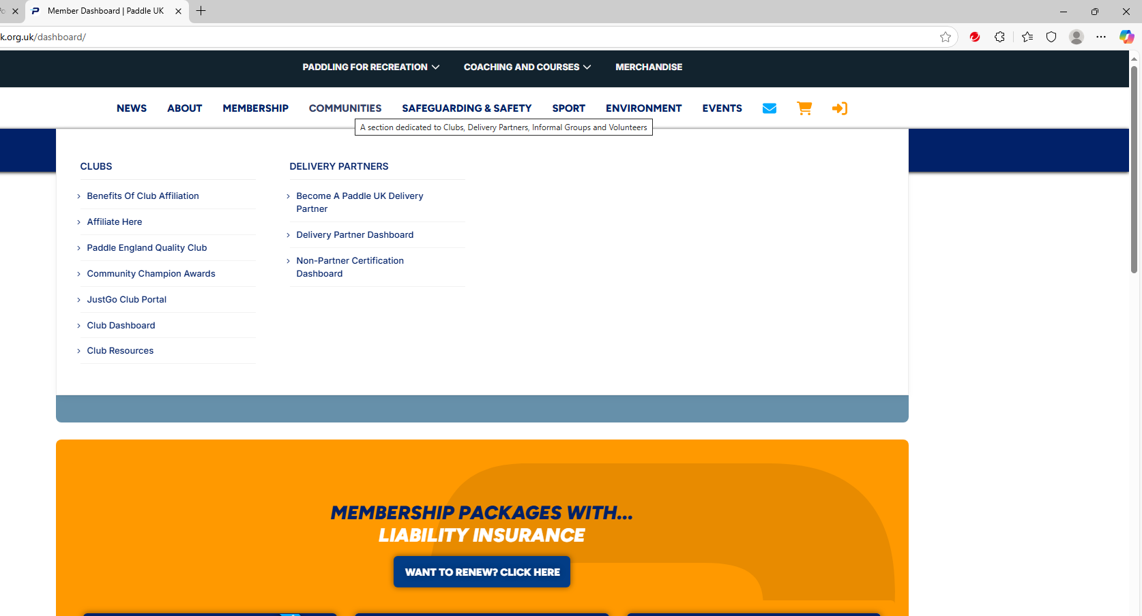
- To deal with or delegate all the administrative duties for the club including ensuring insurance is up-to-date and relevant, e.g., Download WKC website Affiliation Documents, Affiliation Process – How to do it, Club Portal & Paddle UK - website – dashboard: Communities -Resources & links, Quality Club Process

- To work with the treasurer to ensure all membership and/or affiliations are accurate and paid on time, e.g., training budgets, (BC) Bursary.

- To make sure that all members have access to the club handbook, insurance details and officer’s contacts, e.g., Welcome Pack & Induction Procedures.

- To attend and take minutes of committee meetings and the AGM, e.g., email, WhatsApp.

- To ensure agendas are sent out to all committee members in advance of meetings, e.g., email, WhatsApp.

- To provide regular reports on membership numbers to the committee, e.g., email, WhatsApp.

- To be actively involved in creating and delivery of a Club Development Plan, e.g., email, WhatsApp.

- To assist the club to fulfil its responsibilities by supporting the Club Welfare Officer to safeguard children at club level, e.g., policies procedures, concerns.

- To guarantee an understanding of the financial responsibilities of the club to which the Club applies, e.g., (JT) Accounts such as Income and Expenditure, triangulated with Treasurer Income & Expenditure Logbook.

Policies, Procedures, Guidance
Paddle UK: Club Secretary
WKC Website
Paddle UK – Safety Documents e.g. Standards of Deployment, Paddlesafer (2025), Environmental Definitions
Paddle UK – Guidance for Paddlers & Pool Managers
Paddle UK - sign into individual “Club Portal”
Paddle UK - Paddles Up Training
Paddle UK – description of “Club Portal”
Paddle UK – Safety Update
Paddle UK- Paddle safe Away Trips Guidelines
WKC H&S Policies
Reviewed by John Teuwen 28/06/2025
British Canoeing, National Water Sports Centre, Adbolton Lane, Holme Pierrepoint, Nottingham, NG12 2LU

