The process of dealing with a “Safeguarding” issue!
Paddle UK Definition:
Safeguarding describes how we protect adult, children and young people from abuse and neglect. It means proactively protecting those who may be vulnerable or at risk or neglect due to the actions, or lack of action, of another person.
(Paddle UK) Overview of safeguarding to be considered by clubs.

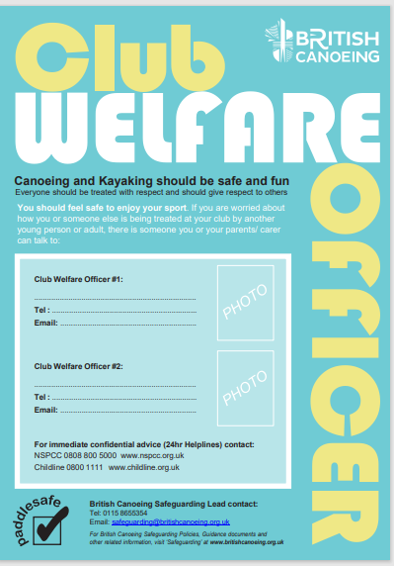
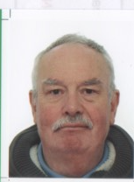
John Teuwen
07960603786
johnteuwen@hotmail.co.uk
Policies, Procedures, Guidance

(Paddle UK) Safeguarding page for Parents

(Paddle UK) Safeguarding Contacts

(Paddle UK) Report a Concern

(Paddle UK) Policies Safeguarding Guide: Children, Anti-bullying, Adult, Recruitment of Volunteers

(Paddle UK) Process Guidance Templates

(Paddle UK) Code of Conduct for Coaching Workforce

Wombourne Kayak Club Safeguarding & Welfare Website page

Wombourne Kayak Club Child Safeguarding Policy
Reviewed by John Teuwen 30/06/2025

